1. In the below elements which of them are values or an expression? eg:- values can be integer or string and expressions will be mathematical operators.

**\***  - Expression

**'hello'** - Values

**-87.8** - Values

**-**  - Expression

**/**  - Expression

* - Expression

**6**  - Values

2. What is the difference between string and variable?

**Variable** is an identifier to store a value in a memory location and to manipulate it if needed.

x = 10

x = 20

Anything you assign to a variable using quotes (single or double) will be considered as a **string**.

a = "10"

b = "20"

print(a+b) #prints 1020

a = 10

b = 20

print(a+b) #prints 30

3. Describe three different data types.

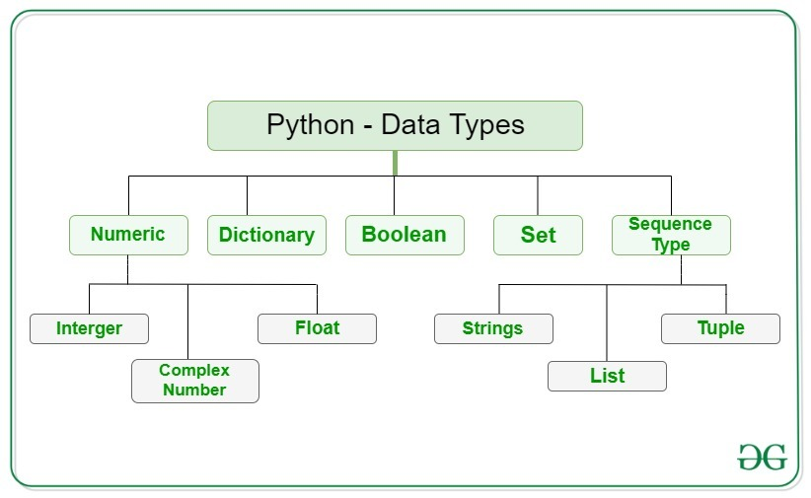

4. What is an expression made up of? What do all expressions do?

An expression is acombination of operators and operands that is interpreted to produce some other value

For example, 2 + 2.

The 2s are integer values and the + is the mathematical operator.

Expressionsspecify which information you want to see.

5. This assignment statements, like spam = 10. What is the difference between an expression and a statement?

An Expression evaluates to a value 10.

A statement does something, like creating a variable or displaying a value, it only does whatever the statement says

6. After running the following code, what does the variable bacon contain?

bacon = 22

bacon + 1

**23**

7. What should the values of the following two terms be?

'spam' + 'spamspam' 🡪 'spamspamspam'

'spam' * 3 🡪 'spamspamspam'

8. Why is eggs a valid variable name while 100 is invalid?

A variable name **cannot start with a number**. A variable name can only contain alpha-numeric characters and underscores (A-z, 0-9, and _)

9. What three functions can be used to get the integer, floating-point number, or string version of a value?

The **int() , float() , and str( )** functions will evaluate to the integer, floating-point number, and string versions of the value passed to them.

10. Why does this expression cause an error? How can you fix it?

'I have eaten ' + 99 + ' burritos.'

can only concatenate str (not "int") to str

'I have eaten ' + **'99'** + ' burritos.'