1.What are the two values of the Boolean data type? How do you write them?

The boolean value can be of two types only i.e. either **True** or **False**.

True and False are written in capital letters with the remainder of the word written in small letters.

2. What are the three different types of Boolean operators?

There are three basic Boolean search commands: **AND**, **OR** and **NOT**.

* AND searches find all of the search terms.  For example, searching on house AND car AND bike  returns only results that contain all three search terms.
* OR searches find one term or the other.  Searching on house OR car OR bike returns all items that contain any of the three search terms.
* NOT eliminates items that contain the specified term.  Searching on house NOT bike returns items that are about house, but will specifically NOT return items that contain the word bike.

3. Make a list of each Boolean operator's truth tables (i.e. every possible combination of Boolean values for the operator and what it evaluate ).

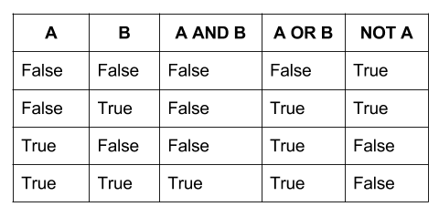

4. What are the values of the following expressions?

(5 > 4) and (3 == 5) -- False

not (5 > 4) -- False

(5 > 4) or (3 == 5) -- True

not ((5 > 4) or (3 == 5)) -- False

(True and True) and (True == False) -- False

(not False) or (not True) -- True

5. What are the six comparison operators?

1. Less than ( < )
2. Less than or equal to ( <= )
3. Greater than ( > )
4. Greater than or equal to ( >= )
5. Equal to ( == )
6. Not equal to ( != )

6. How do you tell the difference between the equal to and assignment operators? Describe a condition and when you would use one.

The “=” is an assignment operator is used to assign the value on the right to the variable on the left. The '==' operator checks whether the two given operands are equal or not. If so, it returns true. Otherwise it returns false

7. Identify the three blocks in this code:

spam = 0

if spam == 10:

print('eggs')

if spam > 5:

print('bacon')

else:

print('ham')

print('spam')

print('spam')

The three blocks are everything inside the if statement and the lines print('bacon') and print('ham').

print('eggs')

if spam > 5:

print('bacon')

else:

print('ham')

print('spam')

8. Write code that prints Hello if 1 is stored in spam, prints Howdy if 2 is stored in spam, and prints Greetings! if anything else is stored in spam.

spam = int(input("enter a number: "))

if spam == 1:

print('Hello')

elif spam == 2:

print('Howdy')

else:

print('Greetings')

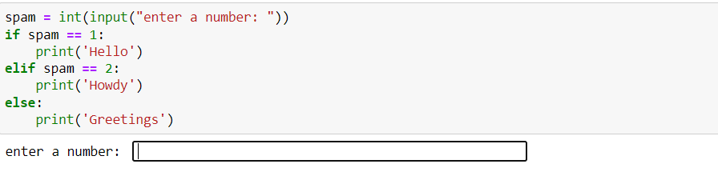

9.If your programme is stuck in an endless loop, what keys you’ll press?

To exit out of infinite loops on the command line, press **CTRL + C** .

10. How can you tell the difference between break and continue?

When break keyword comes, it terminates the execution of the current loop and passes the control over the next loop or main body, whereas when continue keyword is encountered, it skips the current iteration and executes the very next iteration in the loop

11. In a for loop, what is the difference between range(10), range(0, 10), and range(0, 10, 1)?

Range(10) - user will get a series of numbers that starts at 0 and includes every whole number up to, but not including 10

|  |  |  |  |  |  |  |  |  |  |  |
| --- | --- | --- | --- | --- | --- | --- | --- | --- | --- | --- |
| 0 | 1 | 2 | 3 | 4 | 5 | 6 | 7 | 8 | 9 | Stop |

Range(0, 10) - user get to decide not only where the series of numbers stops but also where it starts, so user don’t have to start at 0 all the time.

|  |  |  |  |  |  |  |  |  |  |  |  |
| --- | --- | --- | --- | --- | --- | --- | --- | --- | --- | --- | --- |
| Start | 0 | 1 | 2 | 3 | 4 | 5 | 6 | 7 | 8 | 9 | Stop |

**Range(0, 10, 1)** - user can choose not only where the series of numbers will start and stop but also how big the difference will be between one number and the next.

|  |  |  |  |  |  |  |  |  |  |  |  |
| --- | --- | --- | --- | --- | --- | --- | --- | --- | --- | --- | --- |
| Start | 0 | 1 | 2 | 3 | 4 | 5 | 6 | 7 | 8 | 9 | Stop |



1 Step 1 Step 1 Step 1 Step

12. Write a short program that prints the numbers 1 to 10 using a for loop. Then write an equivalent program that prints the numbers 1 to 10 using a while loop.

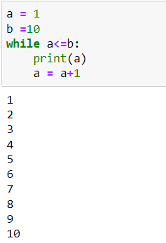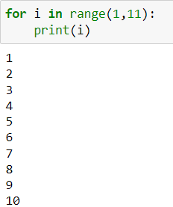

13. If you had a function named bacon() inside a module named spam, how would you call it after importing spam?

This function can be called with **spam.** **bacon()**