**Real-time Object Detection using YOLOv8 in a Graphical User Interface**

**Introduction**

Object detection is a fundamental task in computer vision with diverse applications, including surveillance, autonomous driving, and image analysis. This report presents the development of a real-time object detection system using the YOLOv8 model, integrated into a user-friendly graphical user interface (GUI) built with Tkinter.

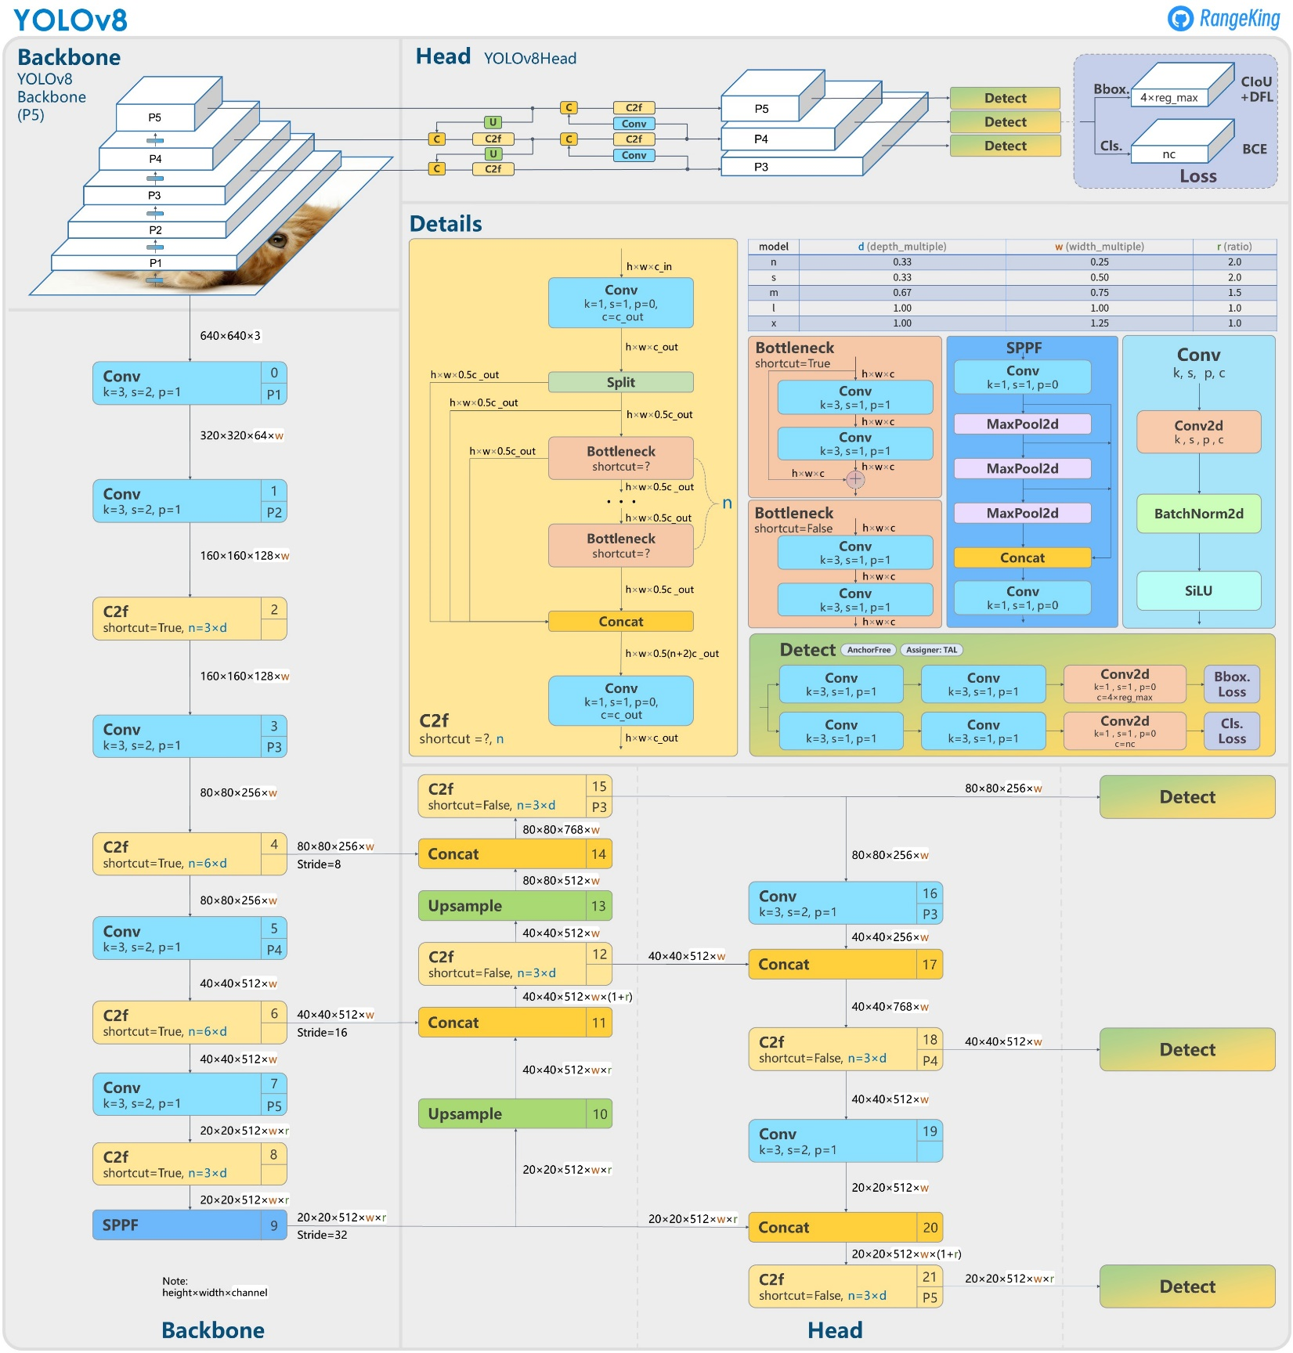

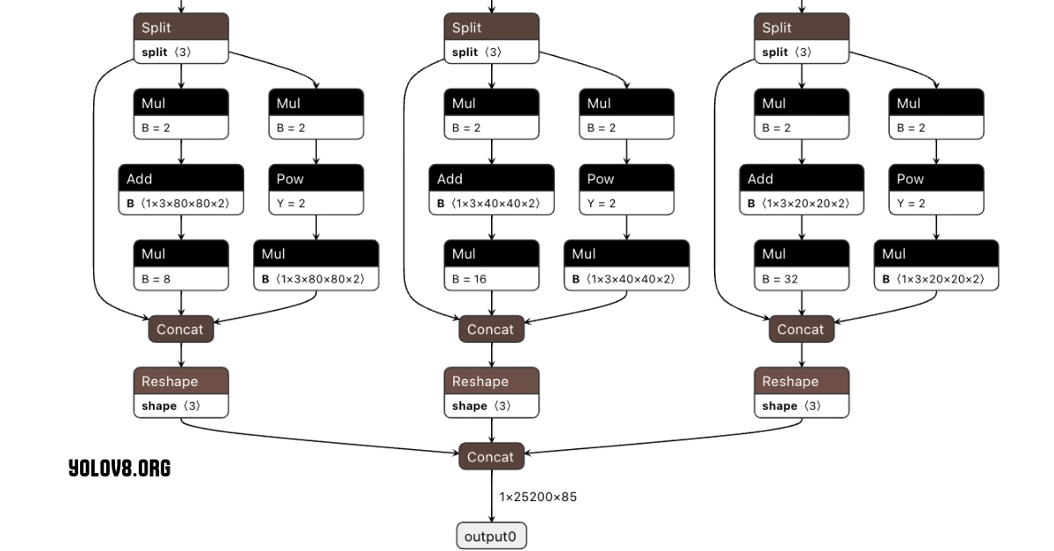

**Background**

YOLO (You Only Look Once) is renowned for its speed and accuracy in real-time object detection. YOLOv8, the latest iteration, offers improved performance over its predecessors. Existing implementations of YOLO often lack user-friendly interfaces, limiting their accessibility. This project aims to bridge this gap by providing an intuitive GUI for non-expert users.

**Learning Objectives**

1. Understand the principles of real-time object detection.

2. Learn to integrate a deep learning model (YOLOv8) with a GUI framework (Tkinter).

3. Develop skills in image processing and GUI development.

4. Evaluate the performance of an object detection system.

**Activities and Tasks**

1. Model Integration: Load and utilize the pre-trained YOLOv8 model.

2. GUI Development: Design and implement a Tkinter-based GUI.

3. Image Processing: Develop functions for image upload, resizing, and processing.

4. Results Visualization: Implement methods to display detection results with bounding boxes and class labels.

5. Performance Evaluation: Assess the model's accuracy and speed on test datasets

**Skills and Competencies**

- Deep Learning: Understanding of YOLO architecture and object detection principles.

- Python Programming: Proficiency in Python, including libraries such as OpenCV, PIL, and Tkinter.

- Image Processing: Skills in image manipulation and analysis.

- GUI Development: Experience in creating user interfaces with Tkinter.

- Evaluation Metrics: Knowledge of precision, recall, and mAP for model evaluation.

**Feedback and Evidence**

Feedback was collected through user testing and performance metrics. Users appreciated the simplicity of the interface and the quick processing times. The evidence of success includes user testimonials and quantitative performance data, indicating the model's high accuracy and low latency.

**Challenges and Solutions**

1. Challenge: Integrating YOLOv8 with Tkinter.

- Solution: Carefully manage dependencies and ensure compatibility between libraries.

2. Challenge: Handling large image files and maintaining performance.

- Solution: Implement image resizing and optimization techniques.

3. Challenge: Ensuring accurate detection and labeling.

- Solution: Fine-tune the model and improve image preprocessing steps.

**Outcomes and Impact**

The project successfully delivered a real-time object detection system with an intuitive GUI. Users can upload images, detect objects, and visualize results efficiently. The system demonstrated high accuracy and responsiveness, making advanced computer vision techniques accessible to a broader audience. The impact is evident in the positive user feedback and the potential applications in various fields.

**Conclusion**

This report outlines the successful implementation of a real-time object detection system using YOLOv8 and Tkinter. The project achieved its objectives, providing a powerful yet user-friendly tool for object detection. Future work could explore extending the system to support video input and enhancing the user interface for better usability. The project showcases the potential of combining deep learning models with GUI frameworks to create accessible and impactful applications in computer vision.