DB Design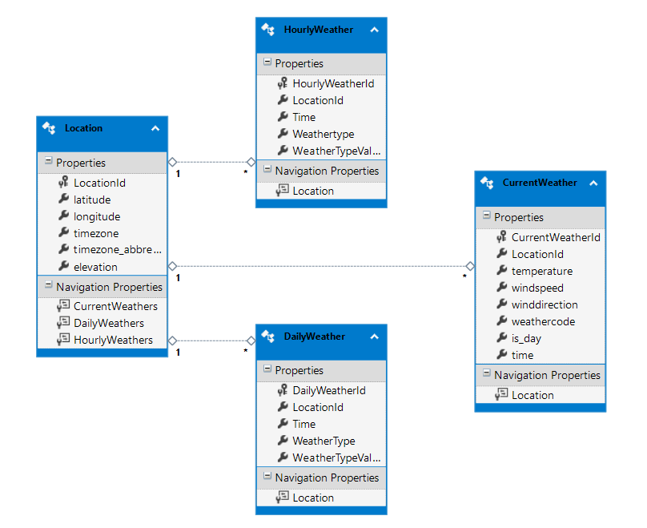

Locations is parent table.

HourlyWeather, DailyWeather & CurrentWeather are child tables of Location

* Web API to get all Location added in DB

http://localhost:55367/api/weatherforecast/GetAllLocationsWeatherForecast

* Web API to get location for latitude & longitude

http://localhost:55367/api/weatherforecast?latitude={latitude}&longitude={longitude}

eg http://localhost:55367/api/weatherforecast?latitude=18.625&longitude=73.875

If any location which not present in DB, will get weather forecast from https://open-meteo.com API.

eg https://api.open-meteo.com/v1/forecast?latitude=18.625&longitude=73.875&hourly=temperature_2m,rain,surface_pressure,visibility&daily=temperature_2m_max,temperature_2m_min,rain_sum&current_weather=true&timezone=Asia%2FTokyo

This will add output object in DB and return location object.

If 'hourly' are selected to get data from API, then it will store in HourlyWeather table

There will be separate entry for each list item for time, with specific weatherType and weatherTypeValue

If 'daily' are selected to get data from API, then it will store in DailyWeather table

There will be separate entry for each list item for time, with specific weatherType and weatherTypeValue

If 'CurrentWeather' set to true and its item is saved in ' CurrentWeather' table.

Unit Test Project is missing in solution

I am not able to add Unit test project in solution at my environment.

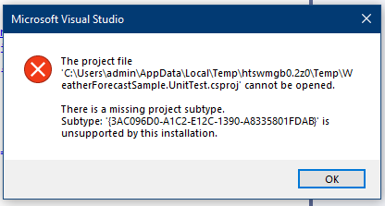

I have tried to upgrade visual studio but still same error. May be there is error in installable file.