COVID-19 Patient Outcomes: An Advanced Data Visualization and Storytelling Analysis
Week 2 – Advanced Data Visualization and Storytelling with Python
Dataset size: 1,048,575 records × 22 variables

1. Introduction
This project demonstrates how Python-based visualization can transform a large COVID-19 clinical dataset into an understandable visual narrative. The analysis focuses on demographics, clinical characteristics, risk factors, ICU status and intubation.

2. Objectives
The objectives are to explore patient demographics, identify patterns in clinical characteristics, examine relationships among risk factors, compare ICU and intubation indicators, and communicate findings to a non-technical audience.

3. Dataset and Methodology
The uploaded dataset contains 1,048,575 records and 22 variables. Important variables include AGE, SEX, PNEUMONIA, DIABETES, COPD, ASTHMA, HIPERTENSION, OBESITY, TOBACCO, ICU and INTUBED. Common coded unknown values (97, 98 and 99) were treated as missing for correlation analysis. Ages were grouped into six interpretable categories. Python libraries used were Pandas, NumPy, Matplotlib and Seaborn.

Visualization 1 – Age Distribution
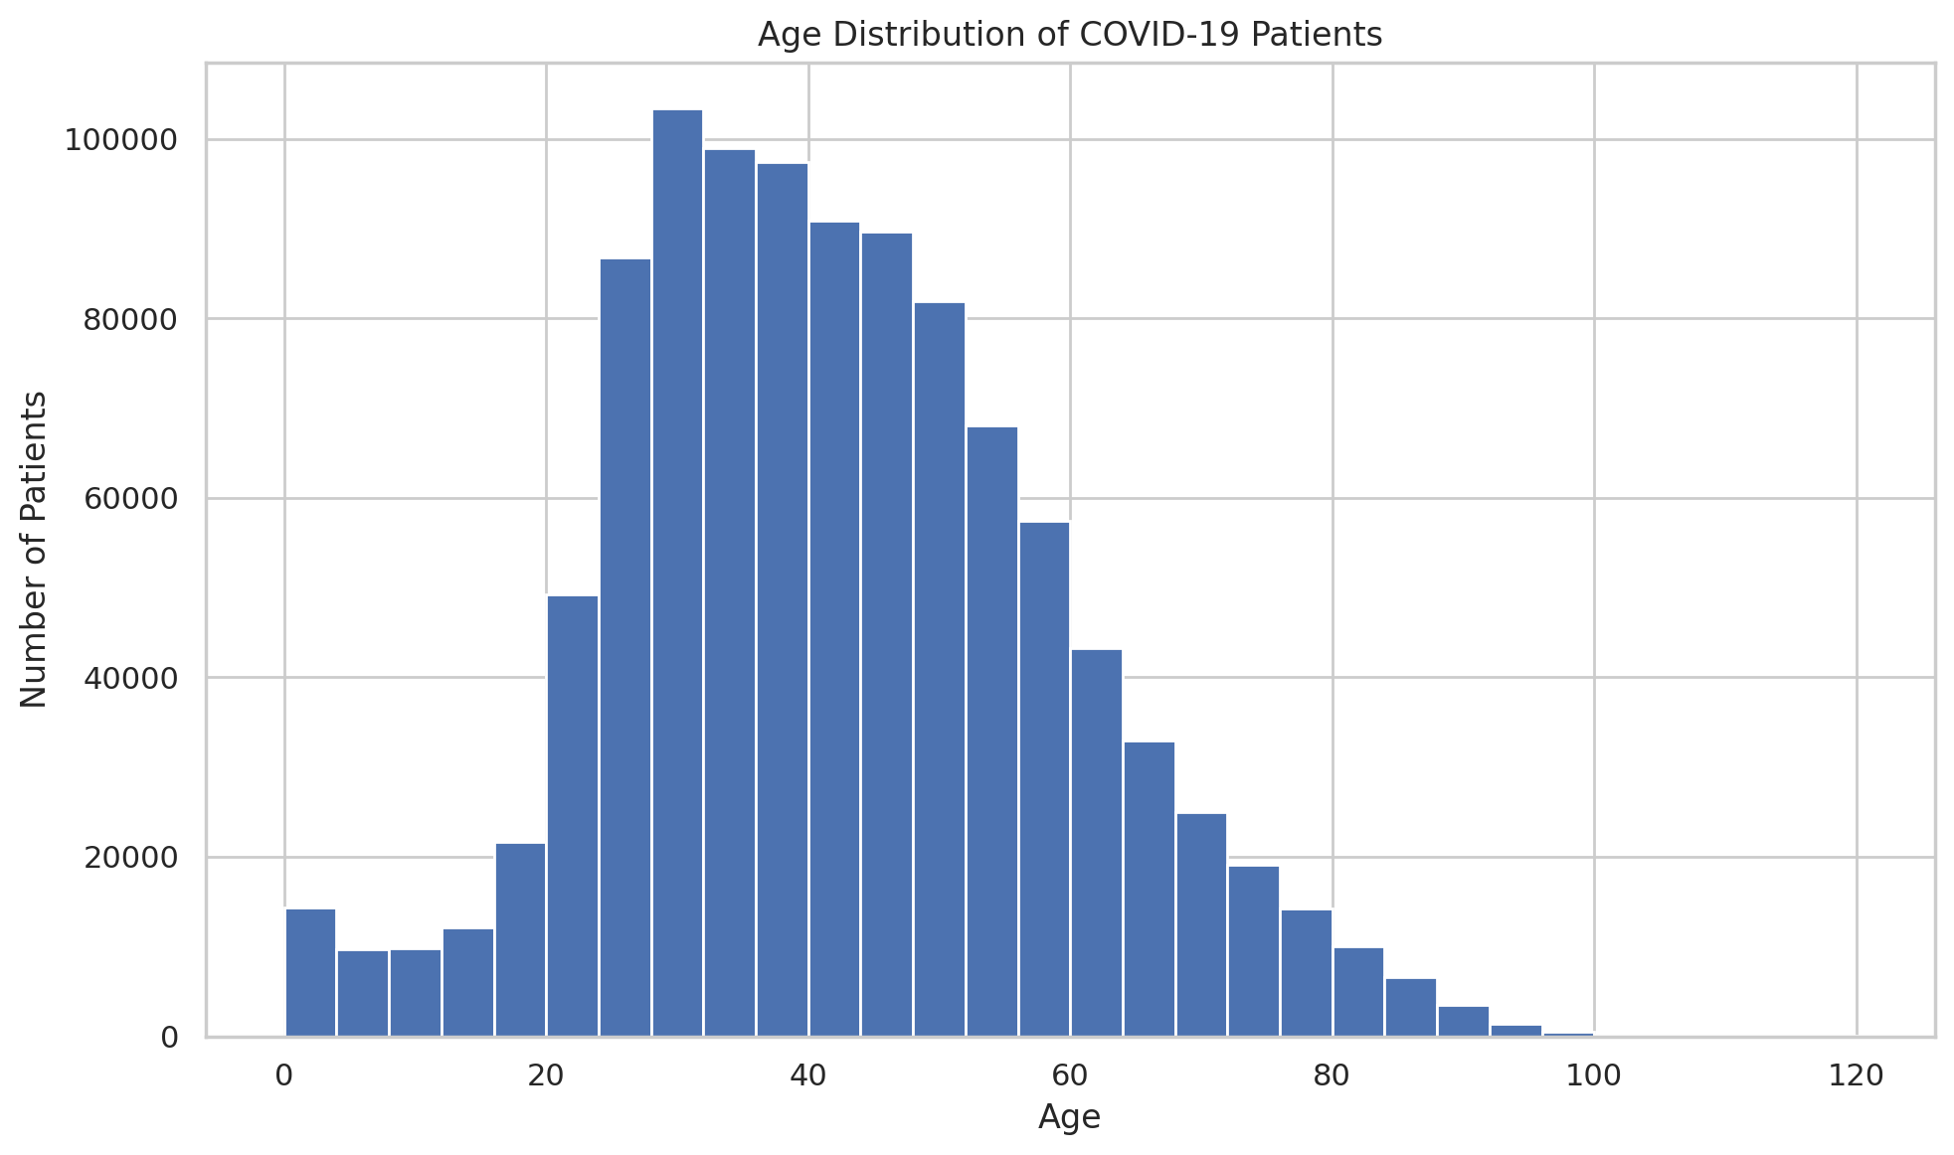
Why this visualization: A histogram is appropriate for showing the distribution of a continuous variable. It establishes the demographic foundation of the story.
Key insight: Interpret the visible pattern using the chart values and avoid claiming causation.
Storytelling contribution: This visualization adds another layer to the progression from demographics to clinical characteristics and severity.

Visualization 2 – Age Groups
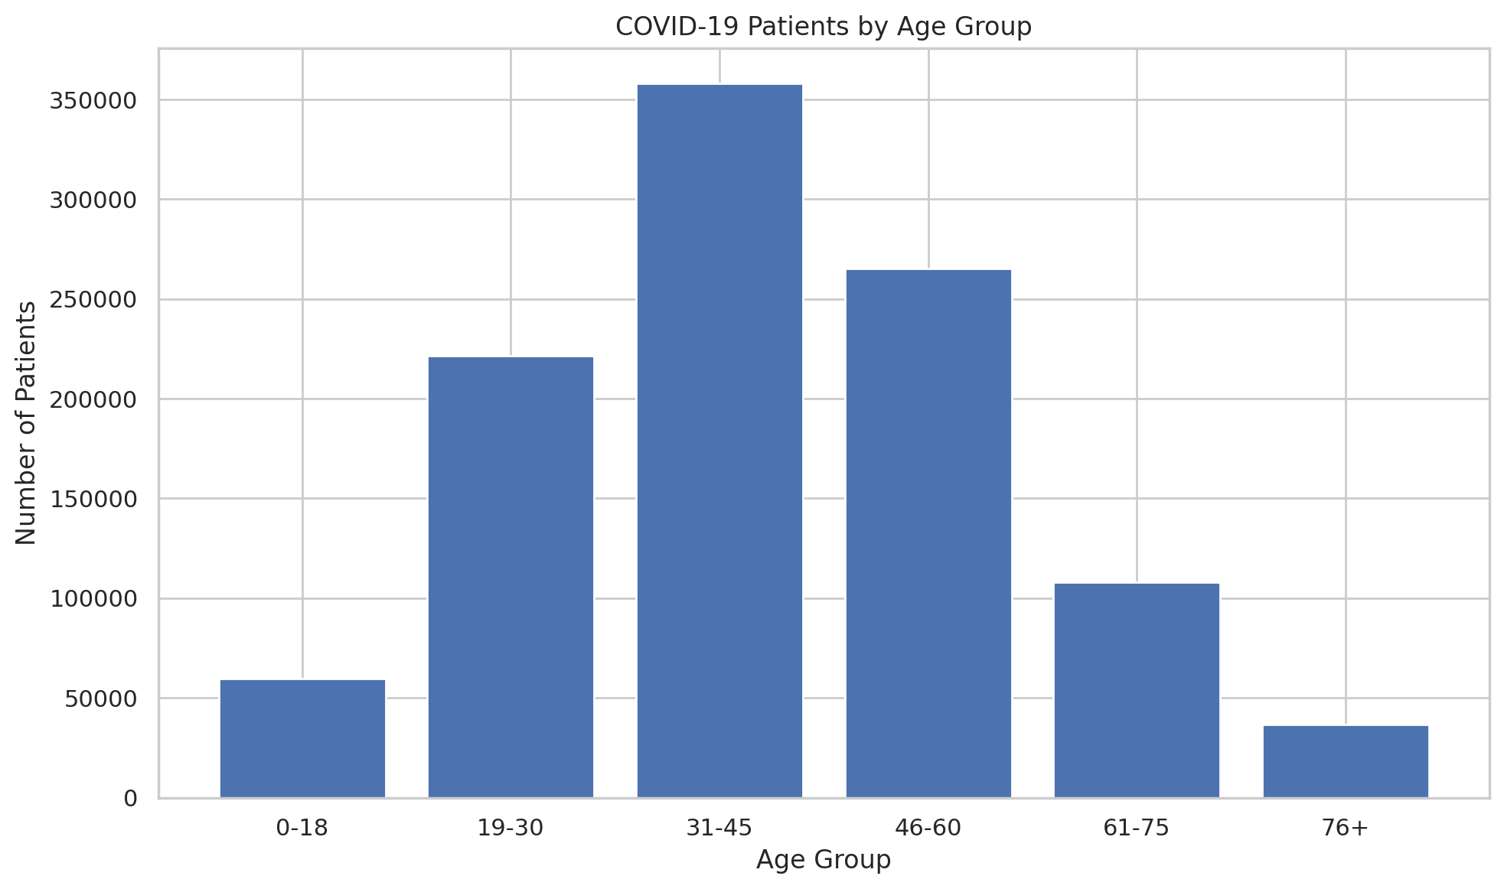
Why this visualization: Age groups make comparisons easier for a non-technical audience and provide meaningful segments for later severity analysis.
Key insight: Interpret the visible pattern using the chart values and avoid claiming causation.
Storytelling contribution: This visualization adds another layer to the progression from demographics to clinical characteristics and severity.

Visualization 3 – ICU Status Across Age Groups
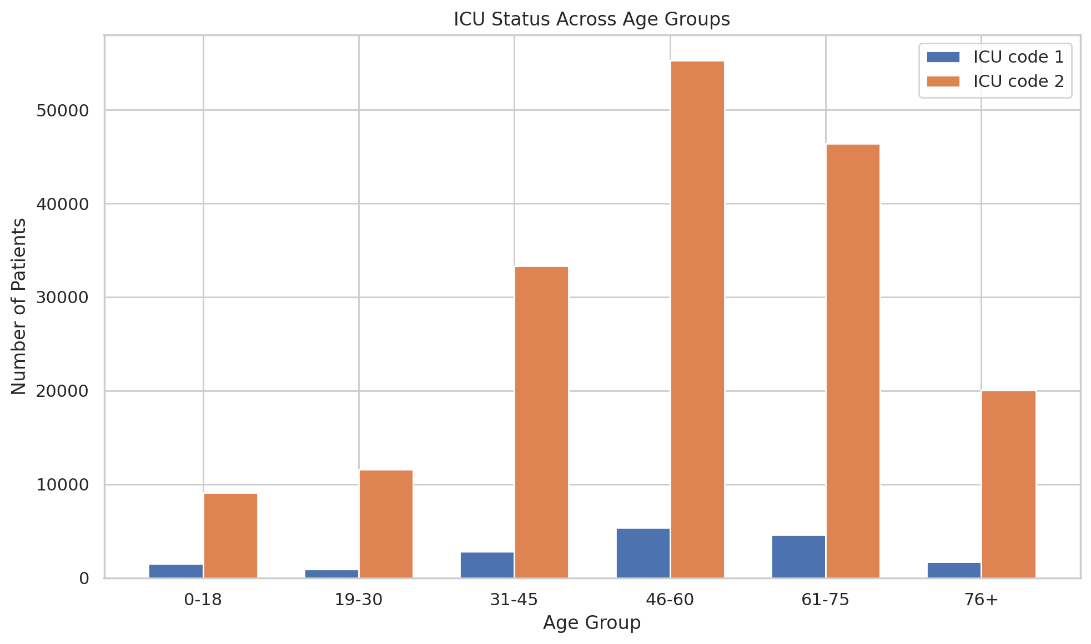
Why this visualization: This chart connects demographics with a clinical-severity indicator. It should be interpreted as association, not causation.
Key insight: Interpret the visible pattern using the chart values and avoid claiming causation.
Storytelling contribution: This visualization adds another layer to the progression from demographics to clinical characteristics and severity.

Visualization 4 – Pneumonia Status
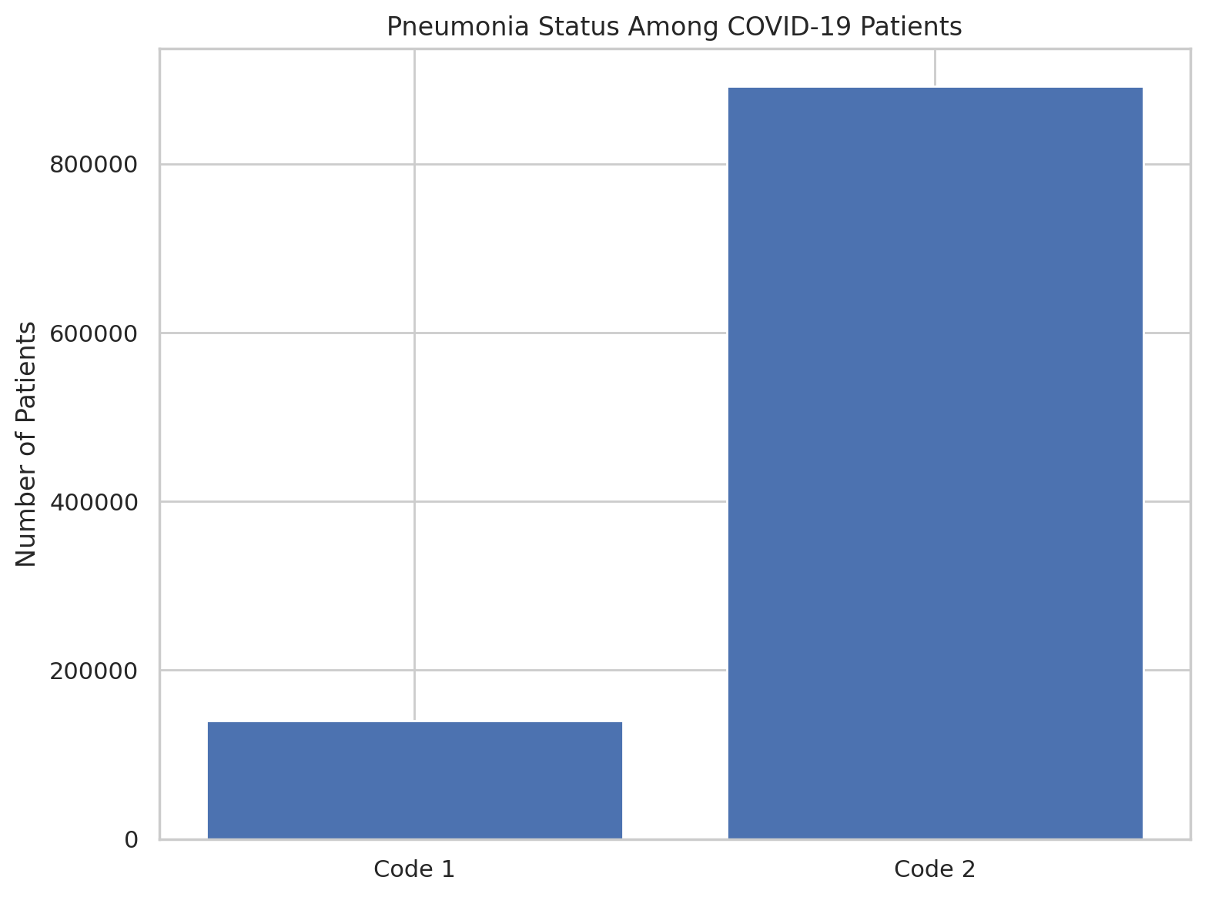
Why this visualization: Pneumonia is an important clinical characteristic. The chart moves the narrative from patient demographics toward clinical condition.
Key insight: Interpret the visible pattern using the chart values and avoid claiming causation.
Storytelling contribution: This visualization adds another layer to the progression from demographics to clinical characteristics and severity.

Visualization 5 – Risk Factor Heatmap
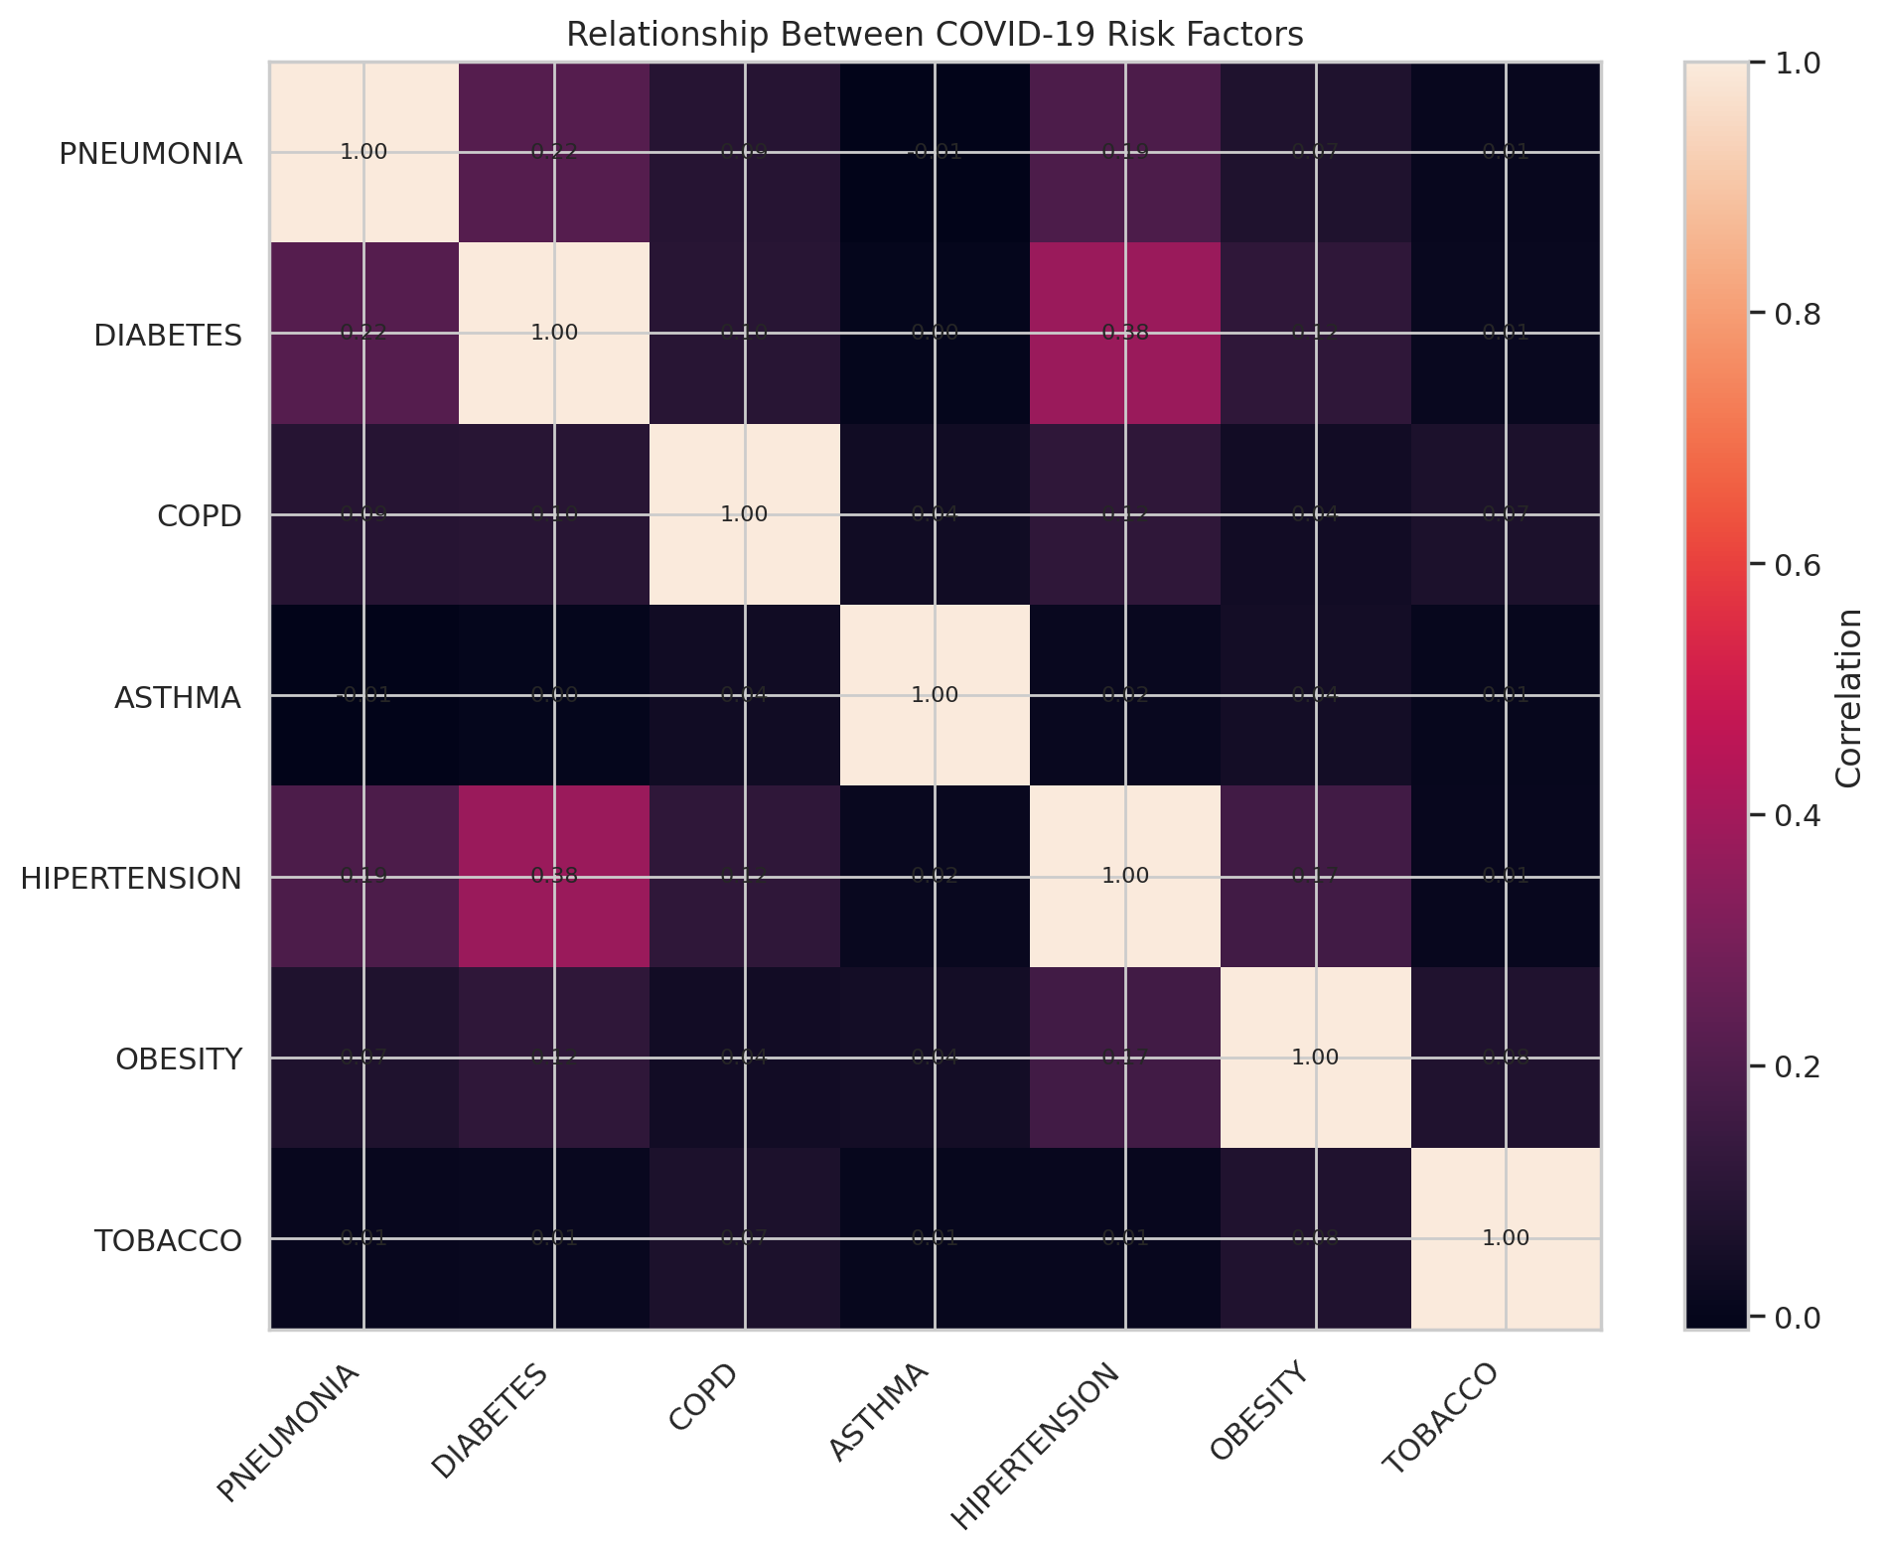
Why this visualization: The heatmap summarizes relationships among several risk factors simultaneously and helps identify variables that tend to occur together.
Key insight: Interpret the visible pattern using the chart values and avoid claiming causation.
Storytelling contribution: This visualization adds another layer to the progression from demographics to clinical characteristics and severity.

Visualization 6 – Sex Distribution
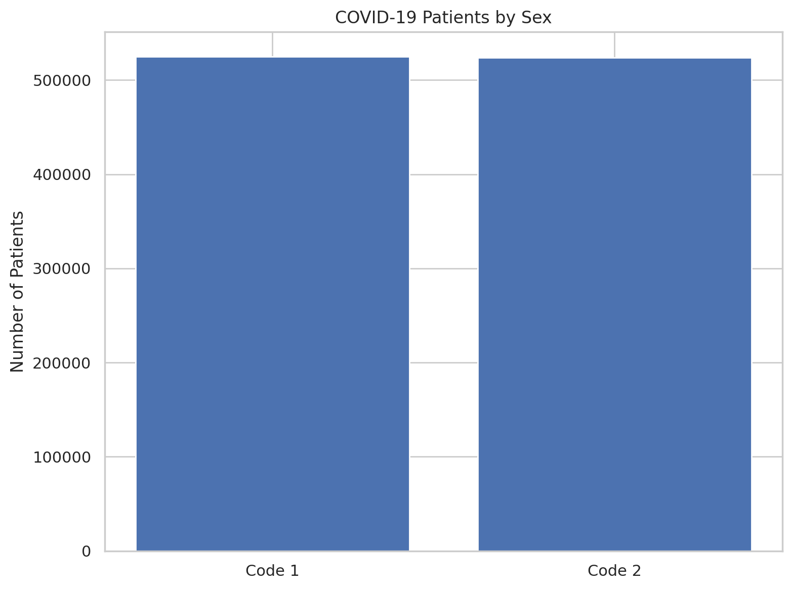
Why this visualization: This comparison adds another demographic dimension and helps characterize the dataset population.
Key insight: Interpret the visible pattern using the chart values and avoid claiming causation.
Storytelling contribution: This visualization adds another layer to the progression from demographics to clinical characteristics and severity.

Visualization 7 – Intubation vs ICU
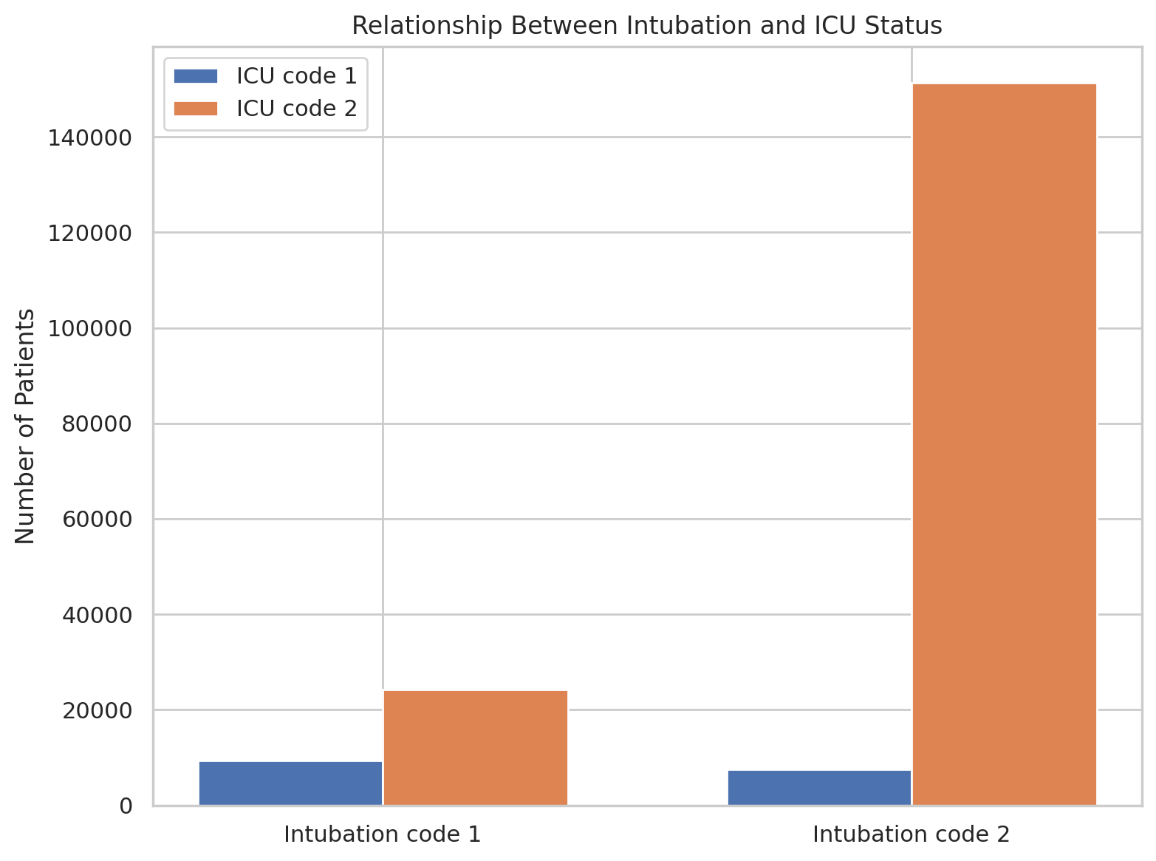
Why this visualization: This visualization examines two clinical-intervention indicators together and completes the narrative with a severity-focused comparison.
Key insight: Interpret the visible pattern using the chart values and avoid claiming causation.
Storytelling contribution: This visualization adds another layer to the progression from demographics to clinical characteristics and severity.

4. Overall Data Story
The story begins with who is represented in the dataset through age and sex. It then moves toward clinical characteristics such as pneumonia and multiple comorbidities. Finally, ICU status and intubation connect the patient profile to indicators of clinical intervention. The visualizations are therefore arranged as a progression from population description to risk factors and clinical severity.

5. Scientific and Practical Implications
- The analysis can identify patterns that may be investigated in further clinical research.
- Similar visual analyses can support healthcare resource-planning discussions.
- Comparing several comorbidities together can reveal patterns that are difficult to see in isolated charts.
- Results should be treated as descriptive associations rather than causal conclusions.

6. Limitations
- The dataset is observational, so associations do not prove causation.
- Several variables use coded values for unknown or unavailable information.
- The dataset may not represent every patient population or healthcare setting.
- Clinical variables require interpretation using the original dataset codebook.

7. Conclusion
Python visualization provides an effective way to communicate complex COVID-19 clinical data. By combining demographic analysis, clinical characteristics, risk-factor relationships, ICU status and intubation, the project creates a coherent visual narrative while emphasizing careful interpretation of observational data.

8. References
Original dataset source: add the Kaggle/public dataset URL used to download the uploaded CSV.
Python libraries: Pandas, NumPy, Matplotlib, Seaborn.

