WEEK 4 INTERNSHIP REPORT
Machine Learning Model Development and Evaluation
Iris Flower Classification using Logistic Regression
Dataset: Iris Dataset
Model: Logistic Regression
Task: Multiclass Classification
Programming Language: Python

1. Introduction
The objective of this Week 4 project was to develop and evaluate a basic machine learning model using Python. The Iris dataset was selected because it is a standard multiclass classification dataset containing measurements of flowers from three species: Setosa, Versicolor, and Virginica. The project follows a complete machine learning workflow including data inspection, preprocessing, visualization, model training, prediction, and evaluation.

2. Objectives
- Understand the Iris dataset and check data quality.
- Visualize class distribution and feature relationships.
- Preprocess numerical features using standardization.
- Train a Logistic Regression classifier.
- Evaluate performance using Accuracy, Precision, Recall, F1-Score and ROC-AUC.
- Analyze errors and possible overfitting/underfitting.
- Discuss model strengths, limitations and improvements.

3. Dataset Description
The dataset contains 150 observations and 5 columns. Four columns are numerical input features and the species column is the target.
Column | Type | Description
sepal_length | Numerical | Sepal length
sepal_width | Numerical | Sepal width
petal_length | Numerical | Petal length
petal_width | Numerical | Petal width
species | Categorical | Target species
The three species are balanced, with 50 observations per class. No missing values are present in the dataset.

4. Data Preprocessing
The species column was separated as the target variable (y), while the four numerical measurements were used as features (X). The dataset was split into 80% training data and 20% testing data using stratification. StandardScaler was fitted only on the training data and then applied to both training and testing features.

5. Exploratory Data Analysis and Visualizations
The project used class distribution, feature relationship plots, and a correlation heatmap to understand the dataset before training.
Figure 1: Distribution of Iris Species
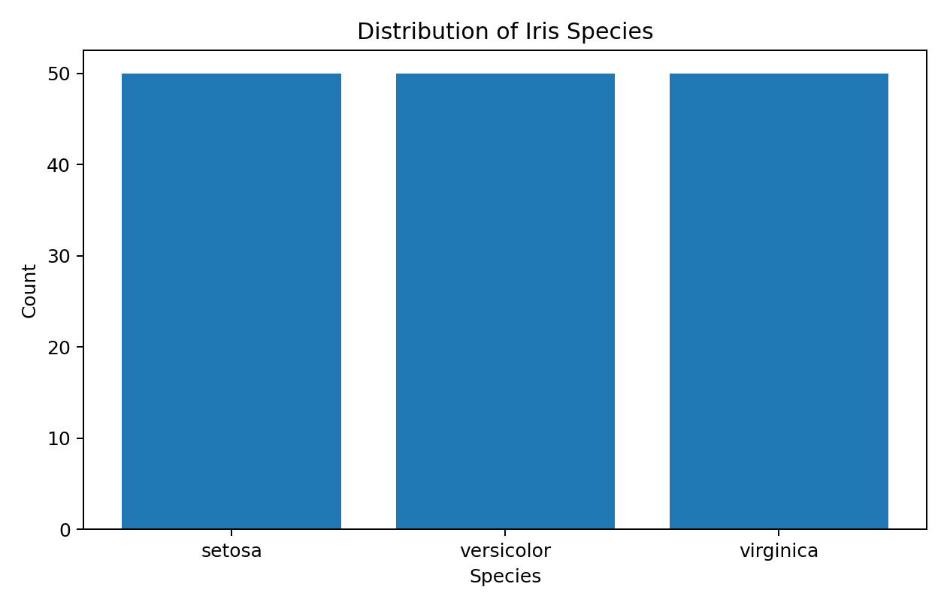
Figure 2: Iris Feature Relationships
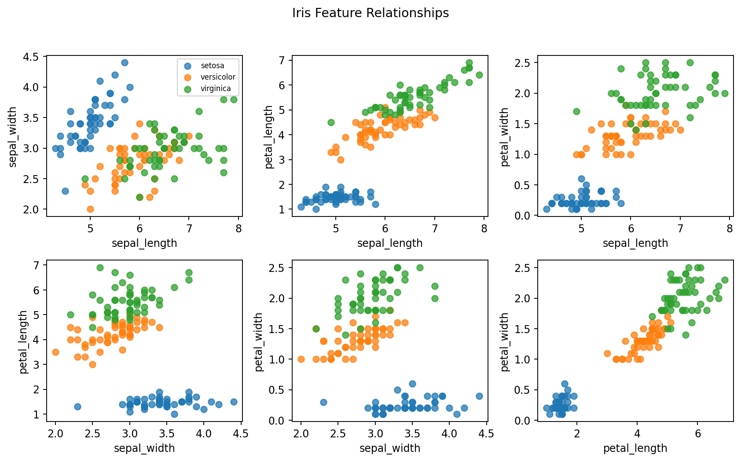
Figure 3: Feature Correlation Heatmap
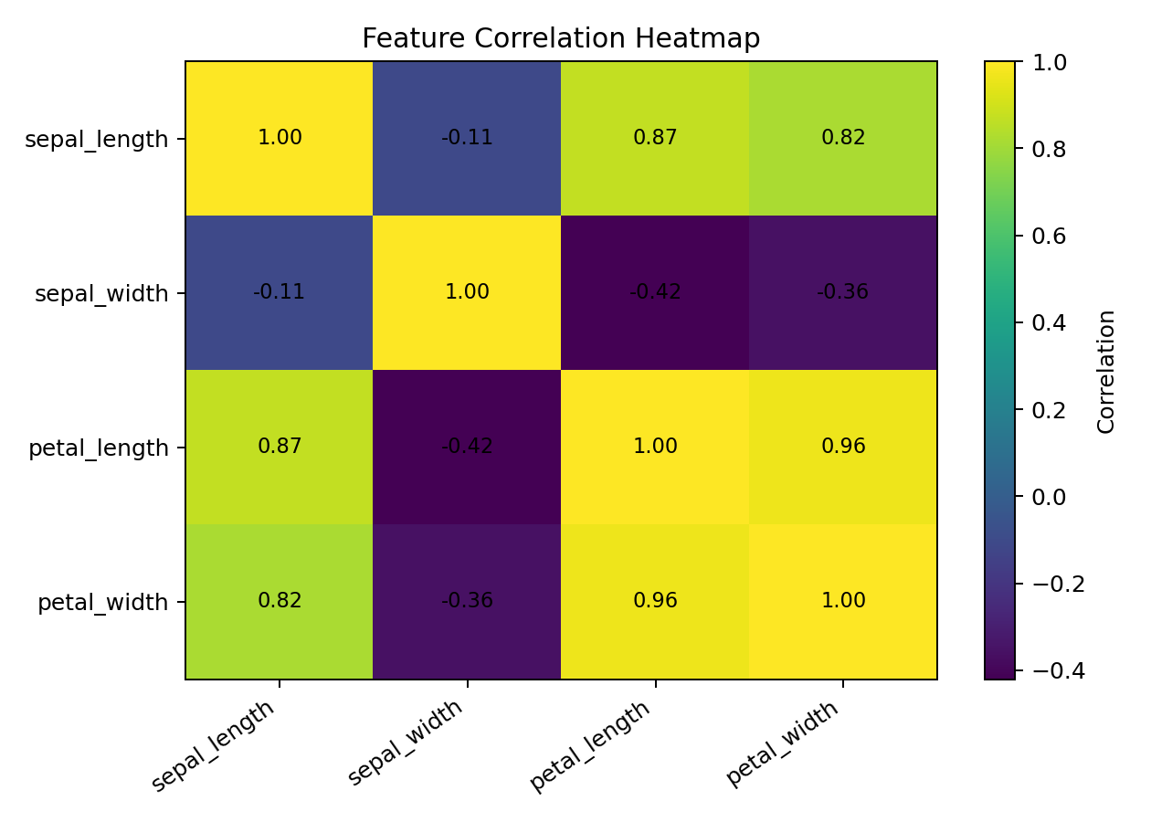

6. Model Selection
Logistic Regression was selected because the task is multiclass classification. It is simple, efficient, interpretable, and appropriate as a baseline classifier for the Iris dataset.

7. Model Training and Python Code
df = pd.read_csv("iris.csv")
X = df.drop("species", axis=1)
y = df["species"]
X_train, X_test, y_train, y_test = train_test_split(
X, y, test_size=0.20, random_state=42, stratify=y
)
scaler = StandardScaler()
X_train_scaled = scaler.fit_transform(X_train)
X_test_scaled = scaler.transform(X_test)
model = LogisticRegression(max_iter=1000, random_state=42)
model.fit(X_train_scaled, y_train)
y_pred = model.predict(X_test_scaled)

8. Model Evaluation Results
The Logistic Regression model achieved 95.83% training accuracy and 93.33% testing accuracy. Weighted Precision, Recall and F1-Score were all approximately 93.33%. The weighted multiclass ROC-AUC was 99.67%.
Metric | Result
Training Accuracy | 95.83%
Testing Accuracy | 93.33%
Precision | 93.33%
Recall | 93.33%
F1-Score | 93.33%
ROC-AUC | 99.67%
Incorrect Predictions | 2 out of 30
Figure 4: Confusion Matrix
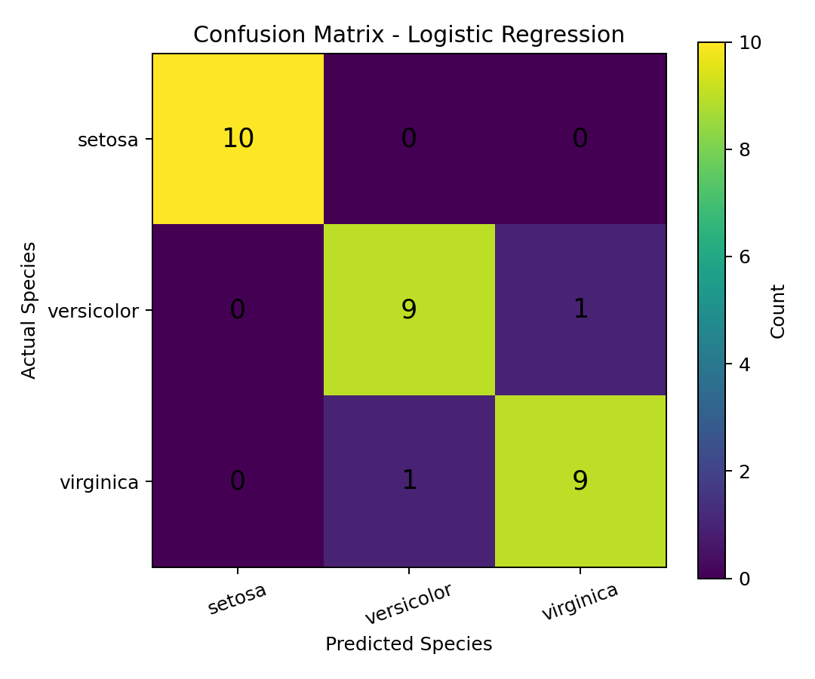
All 10 Setosa samples were classified correctly. One Versicolor was classified as Virginica and one Virginica was classified as Versicolor.
Figure 5: Multiclass ROC Curve
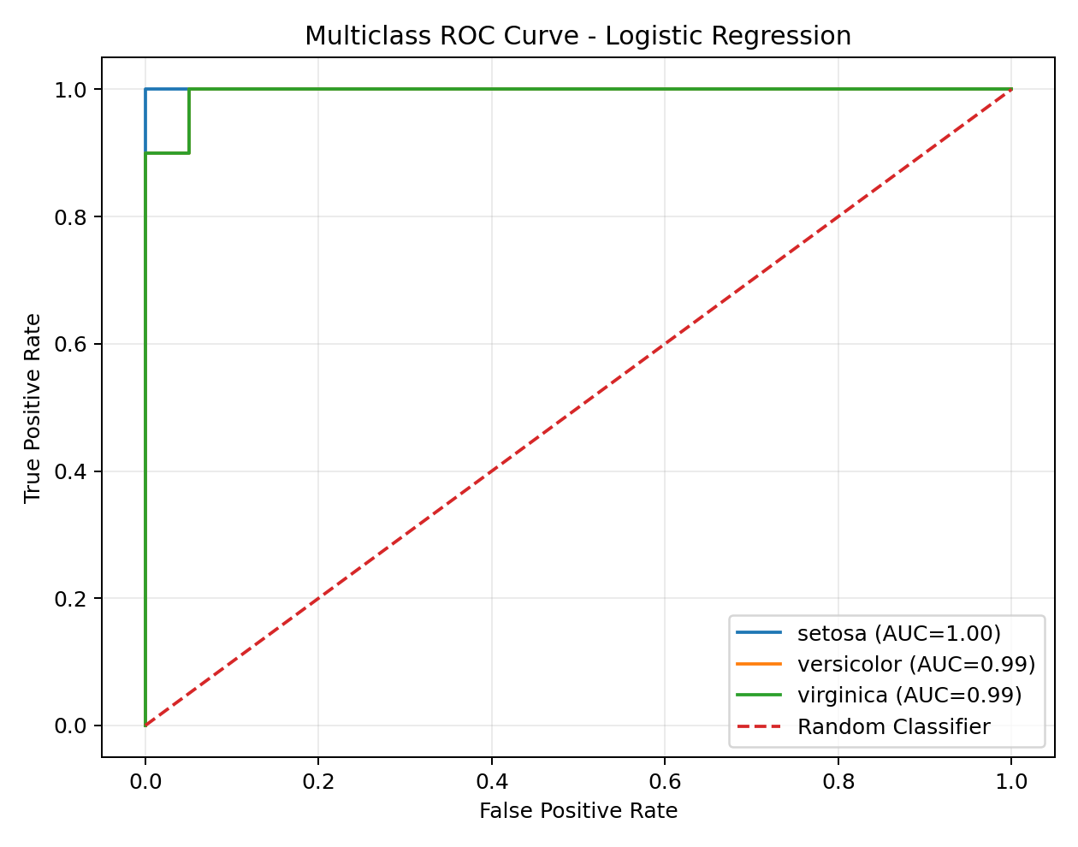
The overall weighted ROC-AUC is 0.9967, indicating excellent discrimination among the three species.
Figure 6: Model Performance Metrics
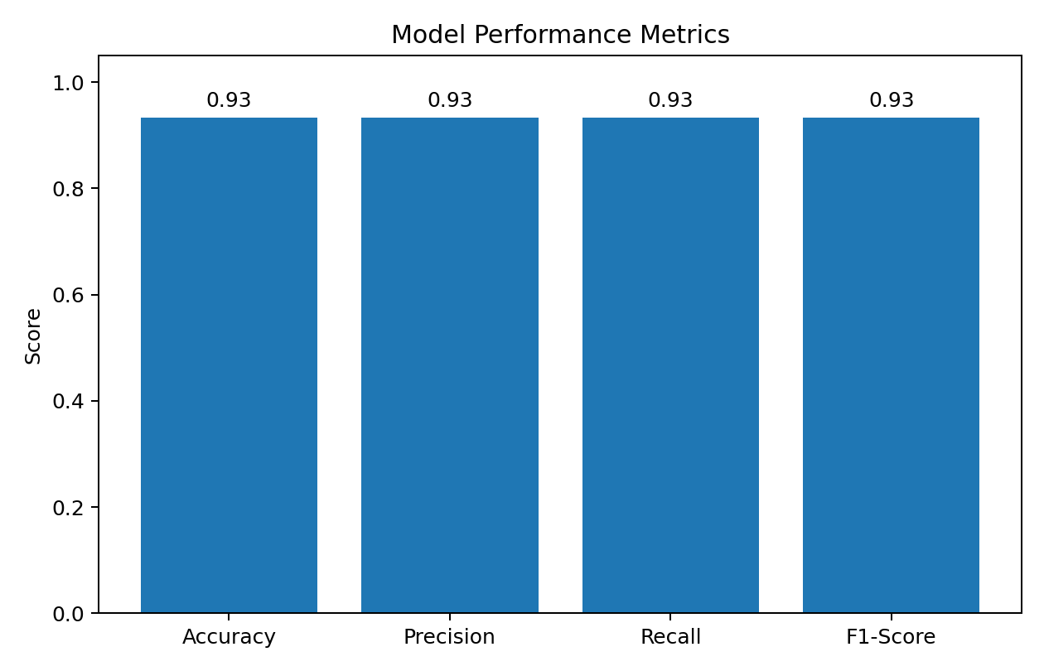

9. Error Analysis
The model made 2 incorrect predictions on the 30 test observations. The errors occurred between Versicolor and Virginica, whose measurements are more similar and can overlap. Setosa was classified correctly in every test observation.

10. Overfitting and Underfitting
Training accuracy was 95.83% and testing accuracy was 93.33%, a difference of 2.50 percentage points. The small gap suggests good generalization and no strong evidence of overfitting.
Figure 7: Training vs Testing Accuracy
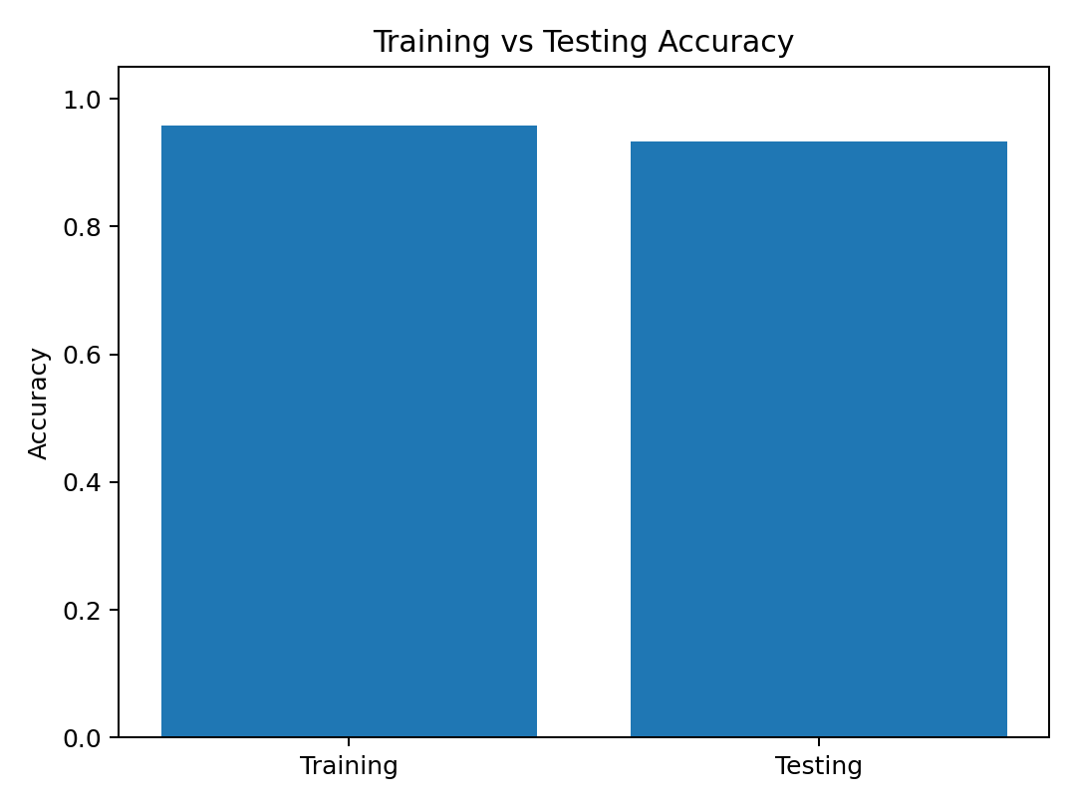

11. Strengths
- Simple and efficient baseline classifier.
- Easy to implement and interpret.
- High testing accuracy of 93.33%.
- Only two incorrect predictions.
- Excellent ROC-AUC performance.
- Small training-testing accuracy gap.

12. Limitations
- Logistic Regression may not capture complex nonlinear relationships.
- The Iris dataset is small and clean compared with many real-world datasets.
- Versicolor and Virginica have overlapping measurements.
- Performance depends on feature quality and dataset representativeness.

13. Suggestions for Improvement
- Compare Logistic Regression with Decision Tree, KNN, SVM and Random Forest.
- Use cross-validation for more reliable evaluation.
- Perform hyperparameter tuning.
- Investigate feature selection and feature engineering.
- Use larger and more diverse datasets for real-world validation.

14. Conclusion
This project successfully demonstrated the complete machine learning model development and evaluation process. Logistic Regression achieved 93.33% testing accuracy, with weighted Precision, Recall and F1-Score of approximately 93.33%. The weighted ROC-AUC score was 99.67%. The confusion matrix showed perfect classification of Setosa and only two errors between Versicolor and Virginica. The small difference between training and testing accuracy indicates good generalization. Overall, Logistic Regression is an effective baseline model for the Iris dataset, while comparison with additional algorithms and cross-validation can be used for further improvement.

15. Final Findings
Dataset: 150 rows × 5 columns | Classes: 3 | Training samples: 120 | Testing samples: 30 | Testing Accuracy: 93.33% | ROC-AUC: 99.67% | Errors: 2

