Statistical Analysis and Hypothesis Testing Using Python
Week 3 Task

1. Introduction
This project investigates whether completing a test preparation course is associated with a significant difference in students' mathematics scores. The analysis uses the provided student performance dataset and Python statistical libraries.

2. Problem Statement
To determine whether students who completed the test preparation course have a different average Math Score from students who did not complete the course.

3. Research Question
Is there a statistically significant difference in the average Math Scores of students who completed test preparation and those who did not?

4. Objectives
- To understand and summarize the student performance dataset.
- To compare Math Scores between the two test-preparation groups.
- To formulate and test statistical hypotheses.
- To calculate the t-statistic, p-value, and 95% confidence interval.
- To interpret the results and draw a statistical conclusion.

5. Dataset Description
The dataset contains 30,641 observations and 9 original variables. The main variables used in this study are TestPrep and MathScore. TestPrep identifies whether a student completed test preparation, while MathScore records the student's mathematics score.

6. Hypotheses
H₀ (Null Hypothesis): There is no statistically significant difference in mean Math Scores between the two test-preparation groups.
H₁ (Alternative Hypothesis): There is a statistically significant difference in mean Math Scores between the two test-preparation groups.
Significance level: α = 0.05

7. Methodology
The data were cleaned by converting MathScore to numeric values and removing missing values for the variables used in the test. Descriptive statistics and visualizations were produced first. A Welch independent-samples t-test was then used because the study compares the means of two independent groups and does not require equal population variances.

8. Descriptive Statistics
Group | N | Mean | Std. Dev. | Median
completed | 10,573 | 69.76 | 14.95 | 70.00
none | 20,068 | 65.16 | 15.10 | 65.00

9. Visualizations
Histogram of Math Scores:
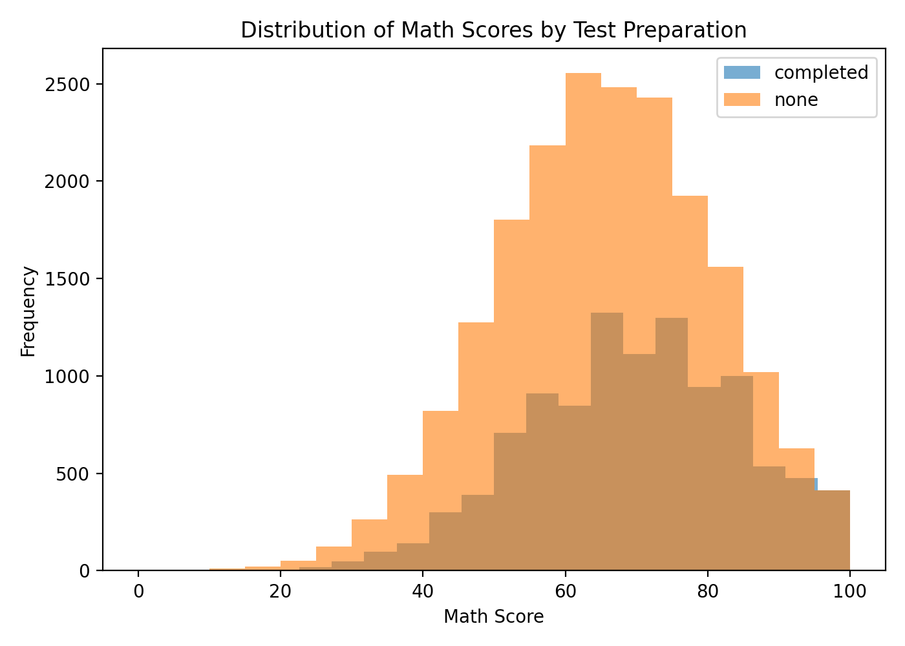
Boxplot of Math Scores:
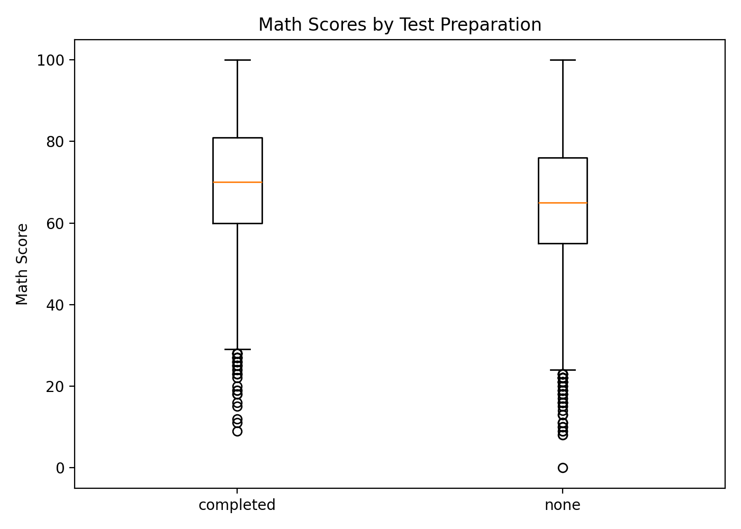

10. Hypothesis Test Results
Welch t-statistic = 25.5092
p-value = 1.89495e-141
Mean difference (completed − none) = 4.5991
95% Confidence Interval for the mean difference = [4.2457, 4.9525]
Cohen's d = 0.3056

11. Interpretation
The p-value (1.89495e-141) is less than the significance level of 0.05. Therefore, the null hypothesis is rejected. There is statistically significant evidence of a difference in average Math Scores between students in the two TestPrep groups. The observed mean difference is 4.60 points, and the 95% confidence interval for the difference is [4.25, 4.95].

12. Python Code
import pandas as pd
from scipy import stats
df = pd.read_csv("Original_data_with_more_rows.csv")
df["MathScore"] = pd.to_numeric(df["MathScore"], errors="coerce")
group1 = df[df["TestPrep"] == "completed"]["MathScore"].dropna()
group2 = df[df["TestPrep"] == "none"]["MathScore"].dropna()
t_stat, p_value = stats.ttest_ind(group1, group2, equal_var=False)
print("t-statistic:", t_stat)
print("p-value:", p_value)

13. Conclusion
The hypothesis testing results show a statistically significant difference in average Math Scores between the two test-preparation groups (p < 0.05). Thus, the null hypothesis is rejected in favor of the alternative hypothesis. In this dataset, students in the 'completed' group have an average Math Score of 69.76, compared with 65.16 for the 'none' group. This finding indicates an association between test preparation status and mathematics performance; however, the test alone does not establish causation.

14. Limitations
- The analysis is based on observational data, so a statistically significant difference should not automatically be interpreted as causation.
- Other factors such as parental education, lunch type, or study habits may also influence scores.
- The conclusion applies to this dataset and its sampling context.

15. Workload Plan (30–35 Hours)
Topic and hypothesis formulation: 3 hours
Dataset understanding and collection: 4 hours
Data cleaning and preparation: 4 hours
Exploratory data analysis: 4 hours
Statistical testing: 6 hours
Python coding: 4 hours
Visualization: 3 hours
Interpretation and conclusion: 3 hours
Report preparation: 4 hours
Total planned workload: 35 hours

16. References
Python documentation and SciPy statistical methods were used for the analysis. Dataset source: the CSV file provided for this project.

