WEEK 1 INTERNSHIP TASK
Data Acquisition, Cleaning, and Exploratory Data Analysis
Dataset: Titanic-Dataset.csv
Tools: Python, Pandas, Matplotlib

1. Objective
The objective of this task is to demonstrate the basic data science workflow using a publicly available Titanic dataset. The work includes data acquisition, initial inspection, missing-value treatment, duplicate checking, data preprocessing, exploratory data analysis, visualization, and interpretation of findings.

2. Dataset Description
The Titanic dataset contains information about passengers who travelled on the Titanic. The uploaded dataset contains 891 observations and 12 variables. Important variables include PassengerId, Survived, Pclass, Name, Sex, Age, SibSp, Parch, Ticket, Fare, Cabin, and Embarked.

3. Data Acquisition
The Titanic dataset was provided as a CSV file and loaded into Python using the Pandas library. CSV is a common format for structured tabular data and can be easily processed using Pandas.

Python Code
import pandas as pd
df = pd.read_csv("Titanic-Dataset.csv")
print(df.head())
print(df.shape)

4. Initial Data Inspection
The first few records, dataset dimensions, data types, and descriptive statistics were examined. This step helps understand the structure and quality of the dataset before cleaning.

Python Code
print(df.head())
print(df.shape)
print(df.info())
print(df.describe())

5. Missing Value Analysis
Missing values were checked using Pandas. The original dataset contains missing values in several columns. Age has 177 missing values, Cabin has 687 missing values, and Embarked has 2 missing values.

Python Code
print(df.isnull().sum())

6. Data Cleaning and Preprocessing
Age missing values were replaced with the median because median is less sensitive to extreme values. Missing Embarked values were replaced with the mode because Embarked is categorical. Cabin was removed because it contains a large number of missing observations and would provide limited reliable information in this basic analysis. Duplicate records were also checked and removed if present.

Python Code
df['Age'] = df['Age'].fillna(df['Age'].median())
df['Embarked'] = df['Embarked'].fillna(df['Embarked'].mode()[0])
df = df.drop(columns=['Cabin'])
df = df.drop_duplicates()

7. Exploratory Data Analysis
Exploratory Data Analysis (EDA) was performed to identify distributions, relationships, and patterns in the dataset. Numerical summaries and graphical visualizations were used.

Figure 1: Passenger Survival Distribution
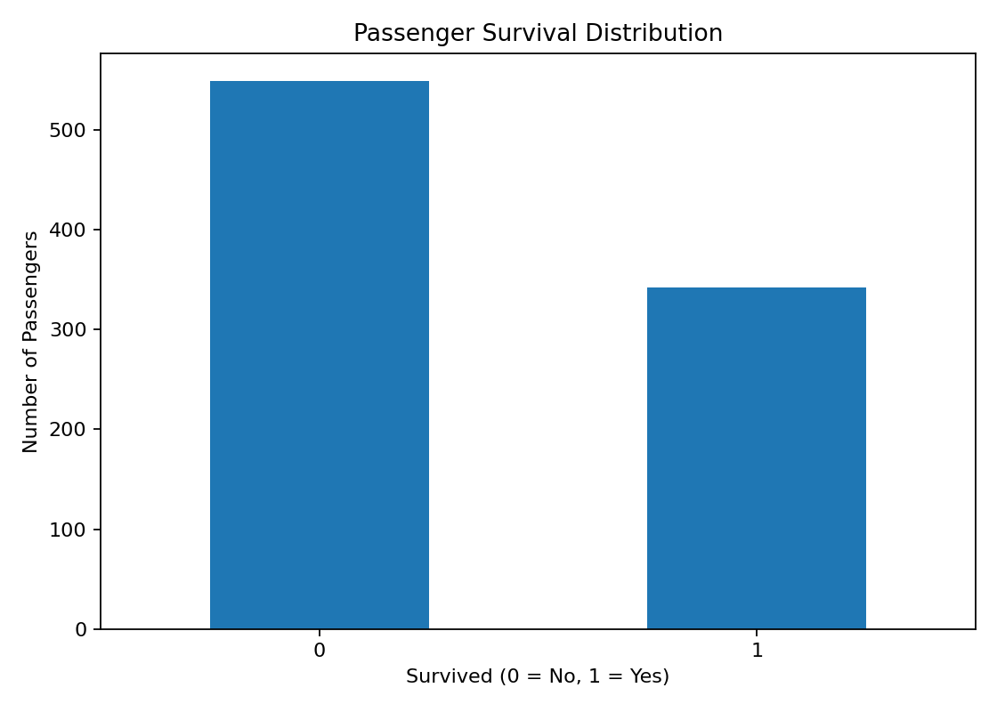

Figure 2: Distribution of Passenger Age
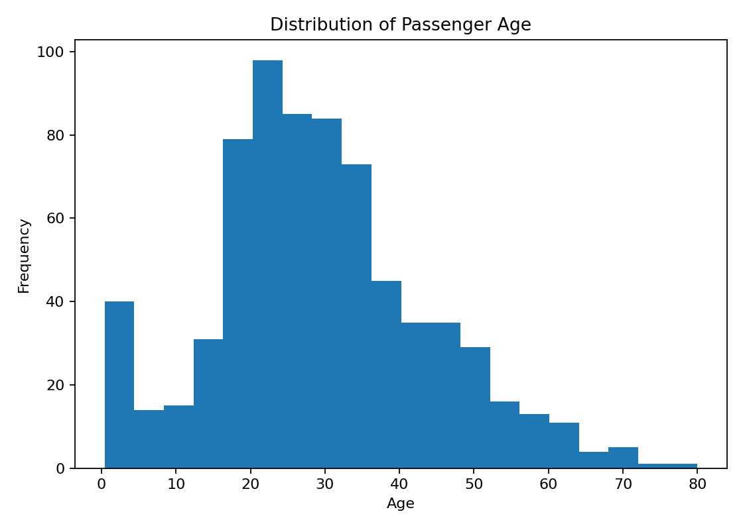

Figure 3: Survival by Passenger Class
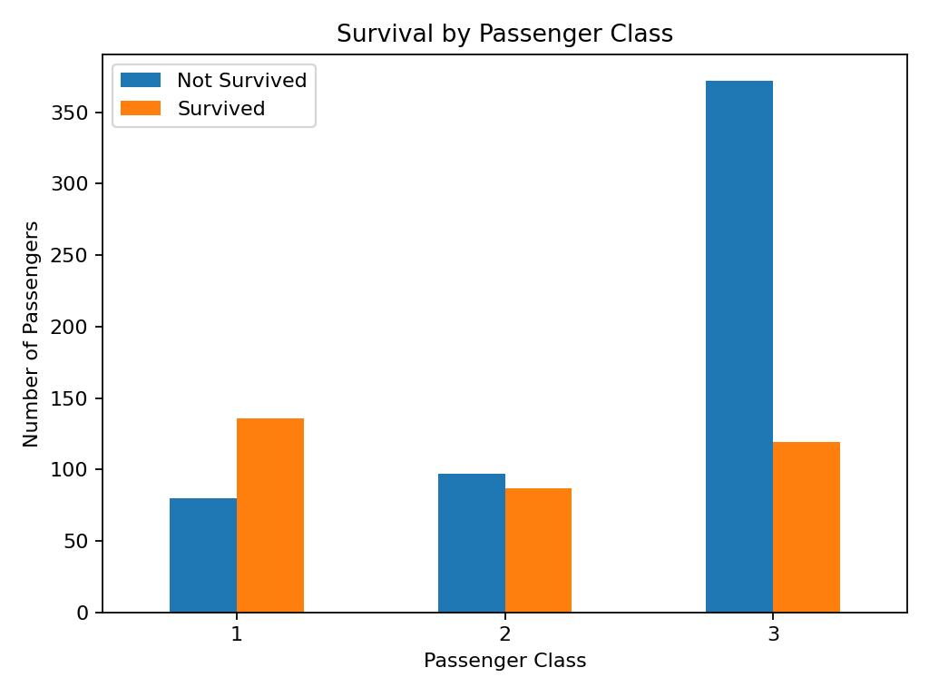

Figure 4: Age vs Fare
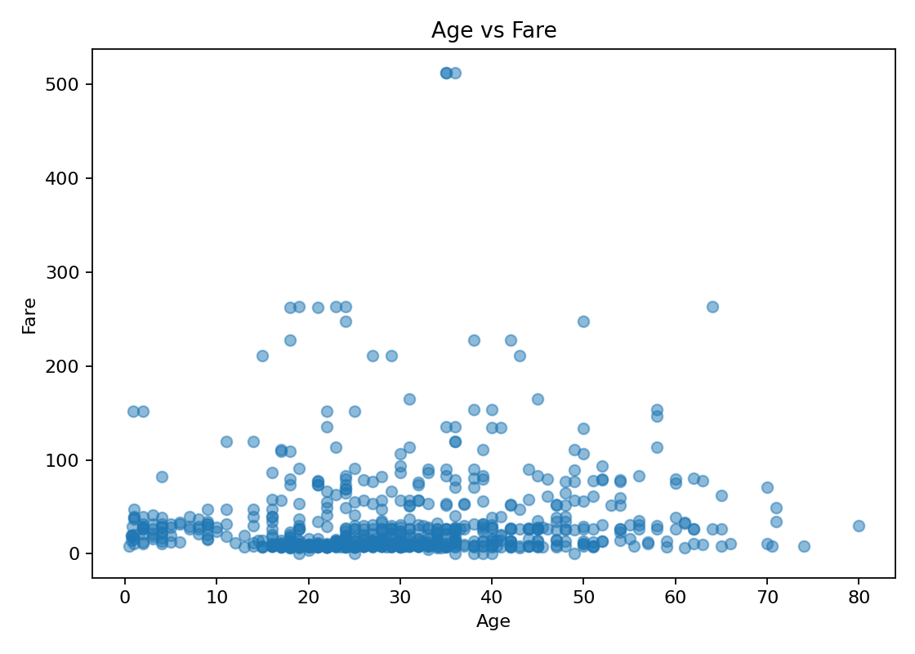

8. Key Insights
1. The dataset contains both numerical and categorical variables.
2. Missing values were present mainly in Age, Cabin, and Embarked.
3. Age missing values were handled using the median, while Embarked was handled using the mode.
4. Cabin was removed because a substantial portion of its observations were missing.
5. The survival distribution shows that the number of passengers who did not survive was greater than the number who survived.
6. Passenger age covers a broad range, with many passengers concentrated in younger and middle-age groups.
7. Survival patterns vary across passenger classes, suggesting that Pclass is an important variable for further investigation.
8. Age and Fare do not show a strong simple linear relationship from the scatter plot alone.

9. Conclusion
The Week 1 task demonstrated the complete basic workflow of data acquisition, cleaning, preprocessing, and exploratory analysis using Python. The Titanic dataset was inspected for structure and quality, missing values were handled using suitable methods, duplicate records were checked, and multiple visualizations were created. The EDA revealed useful patterns in survival, age, fare, and passenger class. The cleaned dataset can be used for further statistical analysis or machine-learning tasks such as survival prediction.

10. Future Scope
Future analysis can include survival prediction using classification algorithms, analysis of the effect of gender and passenger class, feature engineering, statistical hypothesis testing, and model evaluation using appropriate performance measures.

11. References
1. Titanic dataset provided for the internship task.
2. Python Pandas documentation and standard data-analysis practices.
3. Matplotlib library for data visualization.

