WEEK 5 INTERNSHIP REPORT
Model Evaluation and Optimization
Titanic Survival Prediction using Python
Dataset: Titanic-Dataset.csv
Observations: 891
Variables: 12
Target: Survived
Model: Logistic Regression
Split: 80% Train / 20% Test
Validation: 5-Fold Stratified Cross-Validation

1. Introduction
This report evaluates and optimizes a Logistic Regression classification model using the Titanic dataset. The objective is to predict whether a passenger survived. Accuracy, precision, recall, F1-score, confusion matrix, ROC-AUC and five-fold stratified cross-validation are used to assess performance. GridSearchCV is then used for hyperparameter optimization.

2. Objectives
- Evaluate the baseline classification model.
- Measure accuracy, precision, recall, F1-score and ROC-AUC.
- Analyze prediction errors using a confusion matrix.
- Assess stability using 5-fold cross-validation.
- Optimize Logistic Regression hyperparameters.
- Compare baseline and optimized performance.

3. Dataset Description
The dataset contains 891 observations and 12 variables. The target variable is Survived (0 = did not survive, 1 = survived). Predictors are Pclass, Sex, Age, SibSp, Parch, Fare and Embarked. Numerical missing values are imputed using the median, categorical missing values using the most frequent category, numerical features are standardized, and categorical variables are one-hot encoded.

4. Methodology
- Load the Titanic dataset.
- Select target and predictor variables.
- Split data into 80% training and 20% testing sets using stratification.
- Apply preprocessing through a pipeline.
- Train baseline Logistic Regression.
- Calculate classification metrics and create visualizations.
- Perform 5-fold stratified cross-validation.
- Tune C and solver using GridSearchCV.
- Evaluate the optimized model.

5. Baseline Model Results
Metric | Score
Accuracy | 0.8045
Precision | 0.7931
Recall | 0.6667
F1-score | 0.7244
AUC | 0.8437
The baseline model achieved accuracy 0.8045, precision 0.7931, recall 0.6667, F1-score 0.7244, and ROC-AUC 0.8437 on the test set.

6. Confusion Matrix
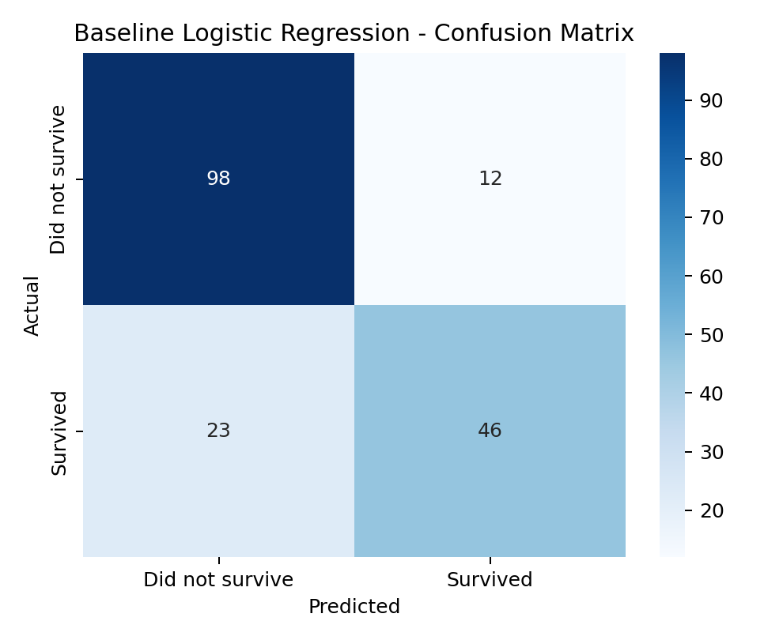
Figure 1: Baseline Logistic Regression Confusion Matrix.
Baseline confusion matrix: TN=98, FP=12, FN=23, TP=46.

7. ROC Curve and AUC
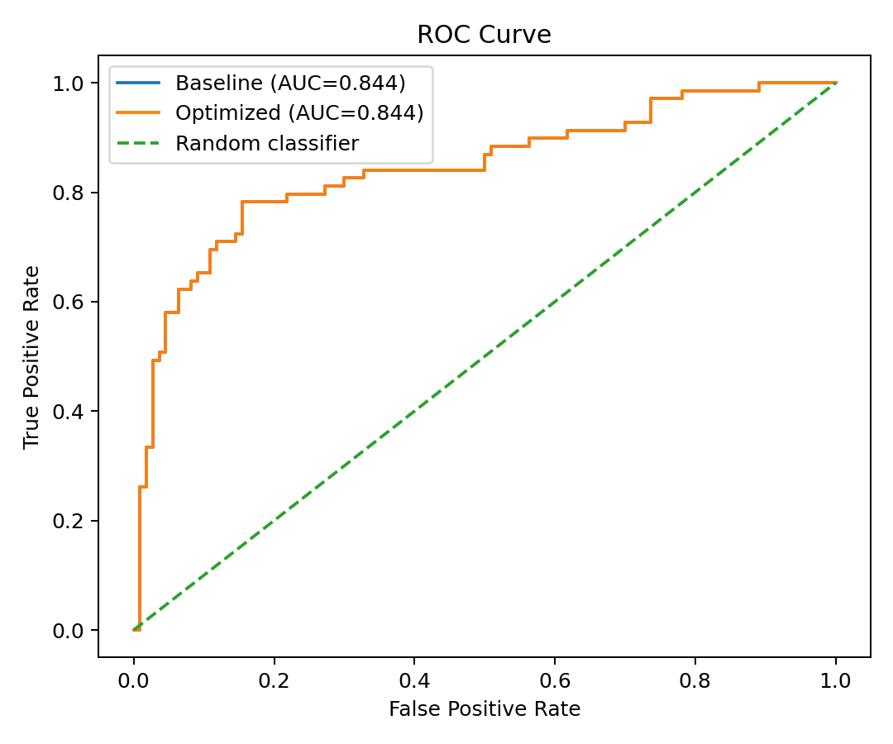
Figure 2: ROC Curve comparing baseline and optimized Logistic Regression.

8. Cross-Validation
Baseline five-fold accuracy scores: 0.7709, 0.8034, 0.7921, 0.7809, 0.8202
Mean CV accuracy = 0.7935; standard deviation = 0.0172.

9. Optimization Strategy
GridSearchCV tested C values 0.01, 0.1, 1, 10 and 100 with liblinear and lbfgs solvers using five-fold stratified cross-validation.
Best parameters: {'clf__C': 1, 'clf__solver': 'liblinear'}
Best cross-validation accuracy: 0.7963

10. Optimized Model Results
Metric | Baseline | Optimized
Accuracy | 0.8045 | 0.8045
Precision | 0.7931 | 0.7931
Recall | 0.6667 | 0.6667
F1-score | 0.7244 | 0.7244
AUC | 0.8437 | 0.8437
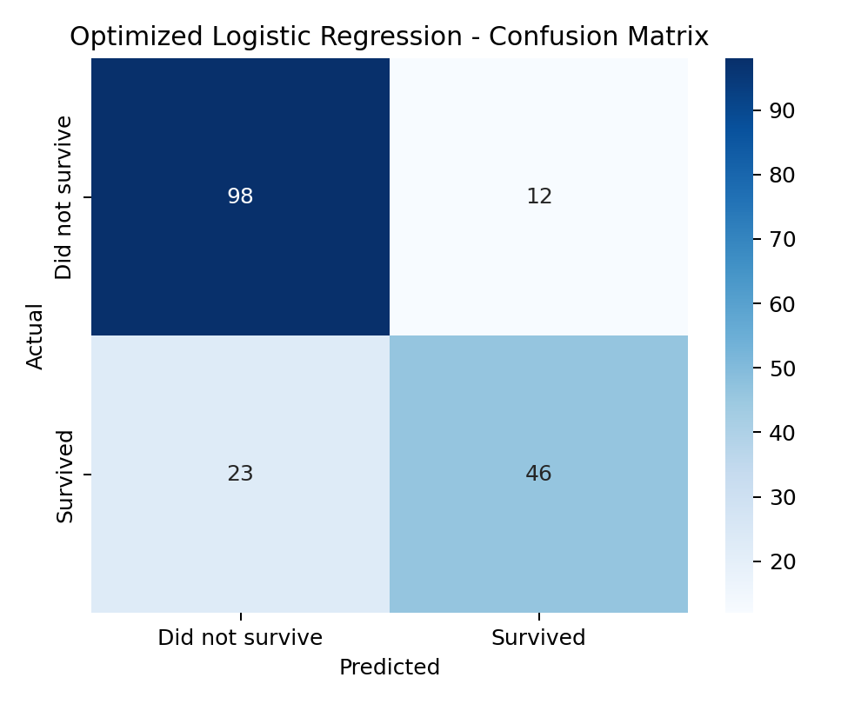
Figure 3: Optimized Logistic Regression Confusion Matrix.
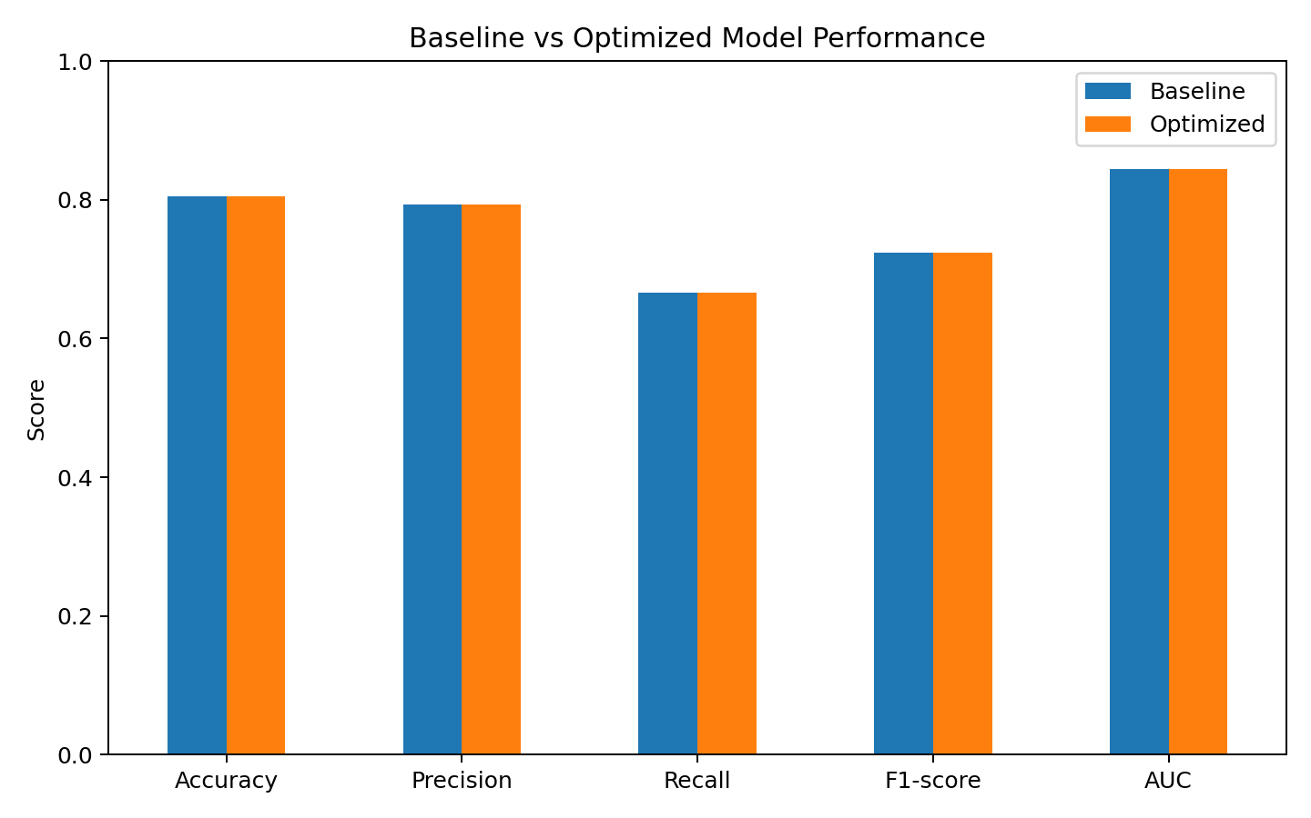
Figure 4: Baseline and Optimized Model Performance Comparison.

11. Optimized Cross-Validation Results
Optimized five-fold accuracy scores: 0.7709, 0.8034, 0.7921, 0.7809, 0.8202
Mean optimized CV accuracy = 0.7935; standard deviation = 0.0172.

12. Findings and Performance Issues
- Accuracy alone does not describe all classification errors.
- Missing values require consistent preprocessing.
- Categorical variables require encoding.
- Logistic Regression may not capture complex non-linear relationships.
- Feature engineering and alternative models can be explored.

13. Optimization and Improvement Strategies
- Hyperparameter tuning using GridSearchCV.
- Stratified splitting and cross-validation.
- Median and most-frequent imputation.
- Standardization and one-hot encoding.
- Feature engineering such as family size and travelling-alone indicators.
- Comparison with Decision Tree, Random Forest, SVM, KNN or Gradient Boosting.

14. Conclusion
This Week 5 project evaluated and optimized Logistic Regression for Titanic survival prediction. The baseline achieved 0.8045 test accuracy and 0.8437 ROC-AUC. The optimized model achieved 0.8045 test accuracy and 0.8437 ROC-AUC. Confusion matrices, ROC analysis and five-fold cross-validation provide a broader assessment than accuracy alone. Further improvement can be explored through feature engineering and alternative machine learning algorithms.

15. Tools and Technologies
Python, Pandas, NumPy, Scikit-learn, Matplotlib, Seaborn and Microsoft Word.

