WEEK 4 TASK
DATA VISUALIZATION AND STORYTELLING
Titanic Dataset Analysis
Submitted by: Suhas Bibhishan Phate

1. Introduction
Data visualization is an effective method for converting numerical and categorical data into clear visual information. The purpose of this assignment is to demonstrate how Python-based visualizations can be used to explore a real-world dataset and communicate meaningful findings to a non-technical audience. The Titanic dataset is used as the case study because it contains passenger information such as age, sex, passenger class, fare, family-related variables, and survival status. These variables provide an opportunity to examine patterns and relationships through charts. In this project, a bar chart, an age distribution plot, and a correlation heat map are used to build a connected data story. The visualizations help identify differences in survival across passenger classes, examine age patterns associated with survival, and understand relationships among selected numerical variables. The objective is not only to create graphs, but also to interpret the evidence and explain how visual findings can support data-driven conclusions.

2. Dataset Overview
The Titanic dataset contains 891 passenger records. Important fields include Survived, Pclass, Sex, Age, SibSp, Parch, and Fare. Survived indicates whether a passenger survived, while Pclass represents passenger class. Age records passenger age, SibSp and Parch represent family relationships aboard the ship, and Fare represents ticket fare. The dataset was prepared for visual analysis by ensuring relevant numerical variables were available in numeric form. Missing age values were excluded from age-distribution calculations. The analysis is descriptive and focuses on patterns visible in the dataset.

3. Objectives
- Explore the Titanic dataset using clear and informative visualizations.
- Compare survival patterns across passenger classes.
- Examine the distribution of passenger ages by survival status.
- Identify relationships among important numerical variables.
- Develop a coherent data story connecting the visual findings.
- Demonstrate how visual evidence can support data-driven interpretation.

4. Visualization 1 – Bar Chart: Survival Rate by Passenger Class
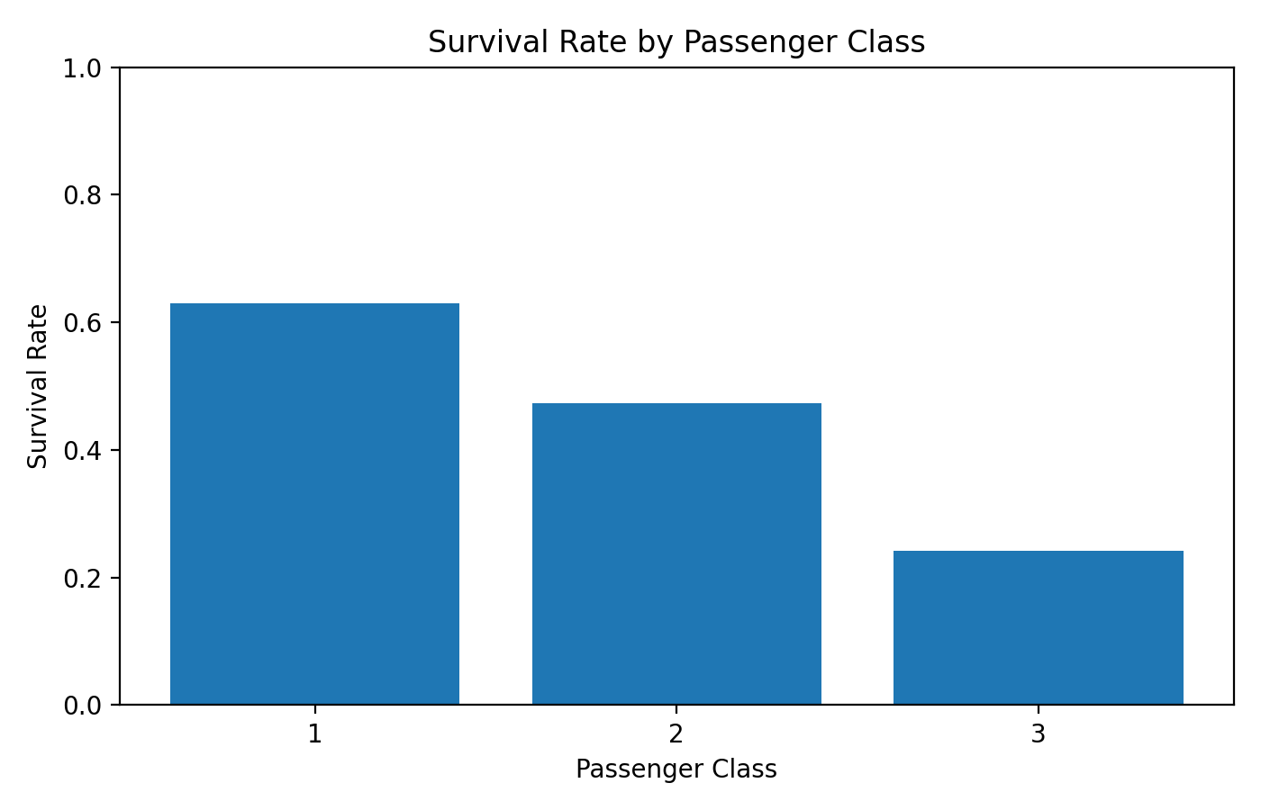
Figure 1. Survival rate by passenger class.
A bar chart was selected because it provides a direct comparison between discrete passenger classes. The overall survival rate in the dataset is approximately 38.4%. The class-specific rates are Class 1: 63.0%, Class 2: 47.3%, Class 3: 24.2%.
Interpretation: The visualization shows noticeable differences in survival rates between passenger classes. Passenger class is therefore an important descriptive variable when examining survival patterns in this dataset. The chart makes these differences easier to recognize than a table of percentages.

5. Visualization 2 – Age Distribution by Survival Status
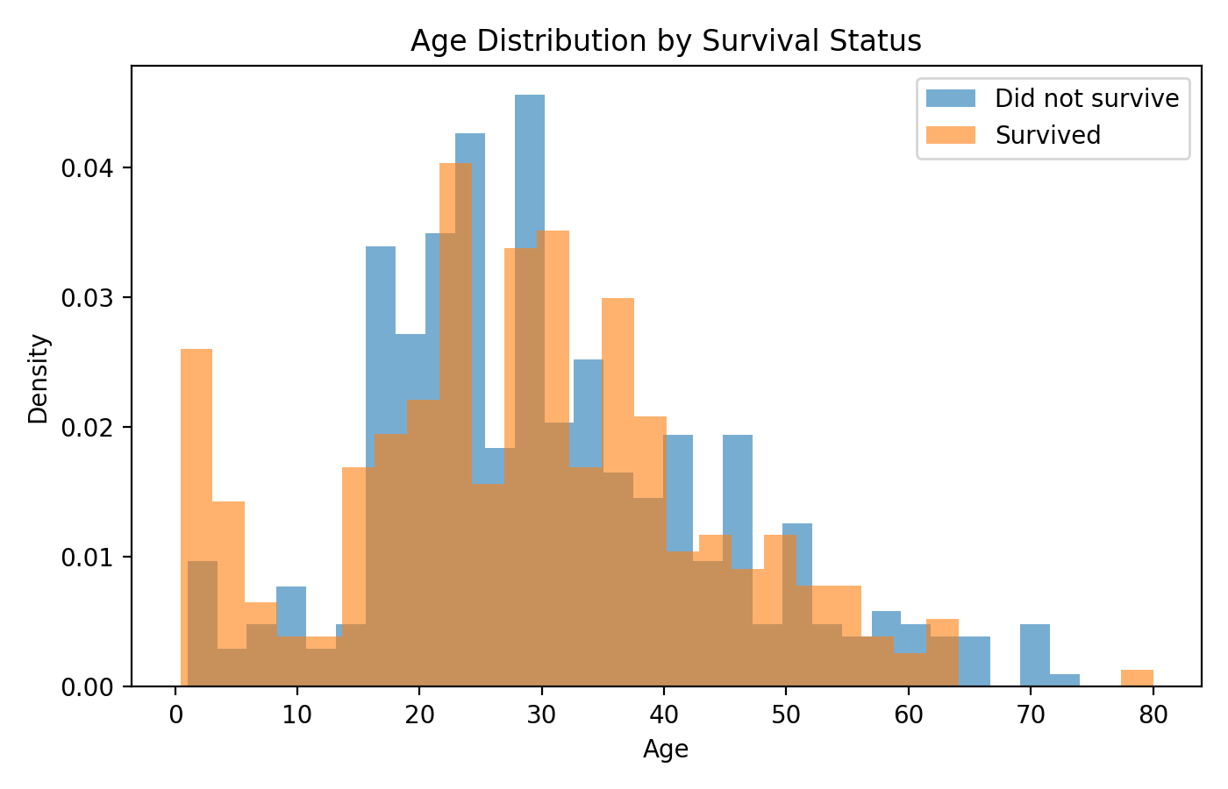
Figure 2. Age distribution of passengers by survival status.
A distribution plot was selected to show how passenger ages are spread across the two survival groups. It helps identify the concentration and spread of ages and whether the distributions differ visually between survivors and non-survivors.
Interpretation: Passengers covered a wide range of ages, and both survival groups occur across several age ranges. Age therefore provides useful descriptive context, but this visualization should not be interpreted as proof that age alone determined survival. Other passenger characteristics and circumstances also contributed to the observed outcomes.

6. Visualization 3 – Correlation Heat Map
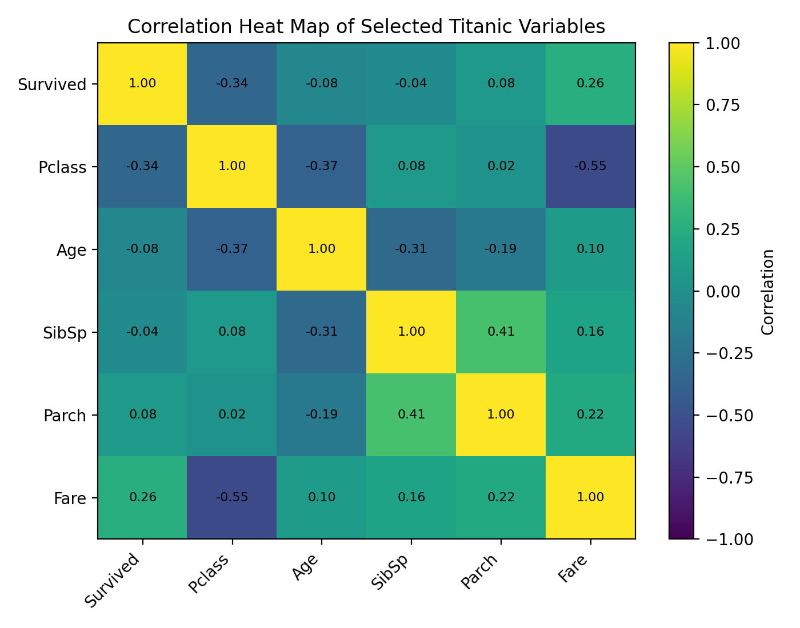
Figure 3. Correlation heat map of selected numerical variables.
A heat map was selected because it summarizes the strength and direction of pairwise linear relationships among several numerical variables in one compact visual. Values closer to +1 indicate a stronger positive linear relationship, values closer to -1 indicate a stronger negative relationship, and values near 0 indicate a weak linear relationship.
Interpretation: The heat map provides a quick overview of relationships among survival, class, age, family-related variables, and fare. It can help identify variables that deserve further investigation. Correlation represents association rather than causation, so the heat map should be interpreted as descriptive evidence.

7. Data Storytelling
The three visualizations create a logical story about Titanic passengers. The first visualization begins with a group comparison and shows that survival rates differed across passenger classes. The second moves from group-level comparison to an individual characteristic by examining age distributions for survivors and non-survivors. The final visualization broadens the analysis by showing relationships among several numerical variables. This sequence moves from a simple comparison to distributional understanding and then to a multivariable relationship view. Together, the charts demonstrate how multiple visual perspectives can provide a more complete understanding than a single graph.

8. Data-Driven Insights
- Passenger class shows noticeable differences in survival rates.
- Passenger ages are distributed across a broad range, with survivors and non-survivors appearing across several age groups.
- The correlation heat map gives a compact overview of relationships among survival, class, age, fare, and family-related variables.
- Different chart types reveal different aspects of the same dataset, making a multi-visualization approach useful for storytelling.
- Visual evidence can support further investigation and communicate findings clearly to audiences who may not be comfortable with raw tables.

9. Strategic and Scientific Significance
The project demonstrates how visual analytics can reveal patterns that may be difficult to recognize in raw data. In a business context, the same approach can be used to compare customer groups, examine trends, and investigate relationships among performance indicators. In a scientific context, visualization can help researchers explore distributions, associations, and unusual patterns before conducting more detailed statistical analysis. For the Titanic dataset, the charts provide descriptive evidence about survival patterns but should not be treated as a complete causal explanation.

10. Conclusion
This project demonstrates the role of Python-based data visualization in communicating complex information clearly. Using the Titanic dataset, three complementary visualizations were developed: a bar chart comparing survival by passenger class, an age distribution plot comparing survival groups, and a correlation heat map showing relationships among selected numerical variables. Together, these visualizations create a coherent data story and demonstrate how different chart types can answer different analytical questions. The main lesson is that effective data storytelling combines accurate visual representation with clear interpretation and careful distinction between association and causation.

