Evaluating Rotation Parameterizations for Reliable Robot Learning: A Focus on Worst-Case Failures

Abstract
Supervised learning of 3-D rotations is a fundamental component in modern robotics, serving roles in object pose estimation, end-effector control, and visual odometry. While prevailing benchmarks emphasize average-case performance metrics, these summaries can obscure rare but operationally catastrophic failures. In this work, we present a large-scale evaluation centered on worst-case reliability, showing that lower p99 error is associated with improved downstream manipulation success. By comparing continuous higher-dimensional mappings, minimal Lie-algebraic vectors, and multi-hypothesis models, we find that top-tier continuous methods (SVD/6D) dominate worst-case robustness. Our findings suggest that rotation representations should be judged by their tail-risk reliability in safety-critical robotics settings.

1. Introduction
Supervised learning of 3D rotations is a fundamental component in modern robotics, with applications in object pose estimation, end-effector control, and visual odometry. While most benchmarks emphasize average-case metrics such as median geodesic error, these summaries can obscure rare but operationally catastrophic failures, particularly near antipodal ambiguities.
In this work, we present a large-scale evaluation centered on worst-case reliability, showing that lower p99 error is associated with improved downstream manipulation success in controlled robotics settings.

2. Related Work
The choice of rotation parameterization has long been recognized as a key factor in the stability and efficiency of learning-based pose prediction. While continuous higher-dimensional mappings such as 6D offer favorable optimization properties, minimal representations remain attractive because of their compactness, motivating continued work on ambiguity-aware losses and geometry-aware supervision.

3. Methods
We compare continuous representations, minimal Lie-algebraic mappings, and chart-based multi-hypothesis models under a matched training and evaluation protocol. To probe whether loss design can mitigate antipodal instability in minimal mappings, we evaluate a FullFix variant that combines ambiguity-aware supervision with architectural hardening.

4. Experimental Setup
Our synthetic benchmark consists of 25 million sample pairs with broad SO(3) coverage, emphasizing the hard-angle regime near the antipodal boundary. We prioritize worst-case metrics, specifically the p99 geodesic error and the failure rate above 30 degrees.

5. Main Benchmark Results
Across the synthetic benchmark, low-tail continuous methods form the clear high-reliability tier. Although median errors are relatively close across methods, tail behavior differs sharply.
Representation | Median Error (°) | p99 Error (°) | Fail Rate (>30°)
SVD | 1.95 | 4.27 | 0.0%
6D | 1.81 | 3.77 | 0.0%
ATLAS | 3.33 | 28.76 | 0.9%
QUAT | 3.98 | 57.39 | 2.3%
Table 1. Main synthetic benchmark results (N=5000).
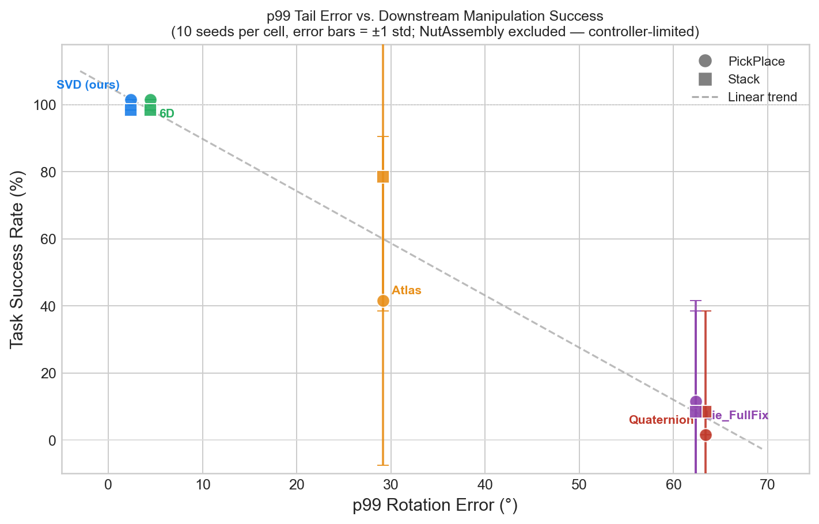
Figure: p99 predicts robot success.
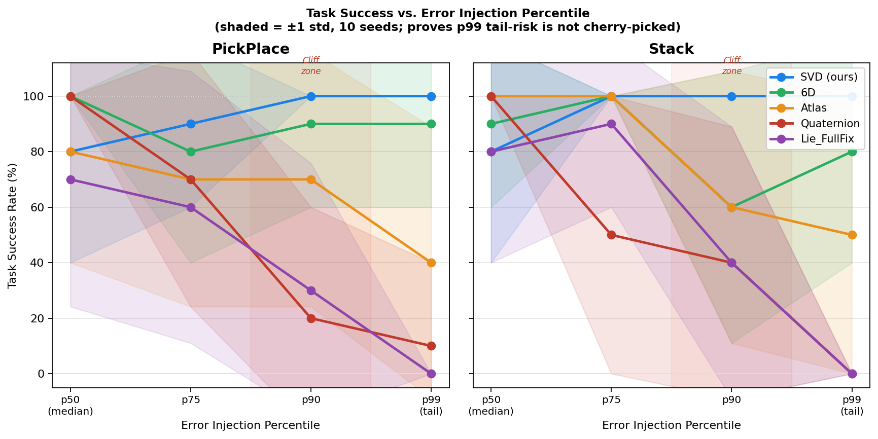
Figure: Monotonic degradation and the 'Cliff Zone'.

6. Failure Anatomy
Error stratified by ground-truth rotation magnitude reveals that failures are concentrated near the antipodal boundary. Ablation results suggest that specialized objectives can reduce tail failures, though they do not fully remove representational fragility.
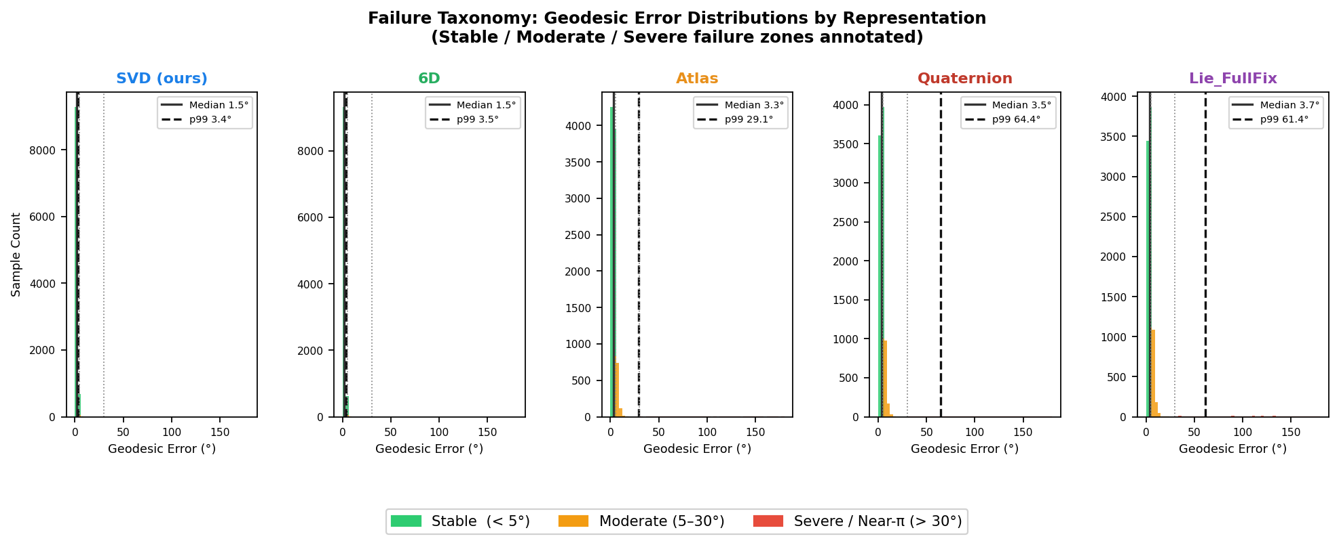
Figure: Failure taxonomy across error zones.

7. Downstream Robotics Validation
To study the operational consequences of error patterns, we evaluate performance in robosuite. Percentile-based sweeps reveal a 'cliff zone' where task success degrades sharply once errors enter the upper tail of a method's distribution.
Model | Live Success Rate
SVD (ours) | 100.0%
6D | 90.0%
Lie_Raw | 80.0%
FullFix | 90.0%
Table 2. Live model-in-the-loop success rates.
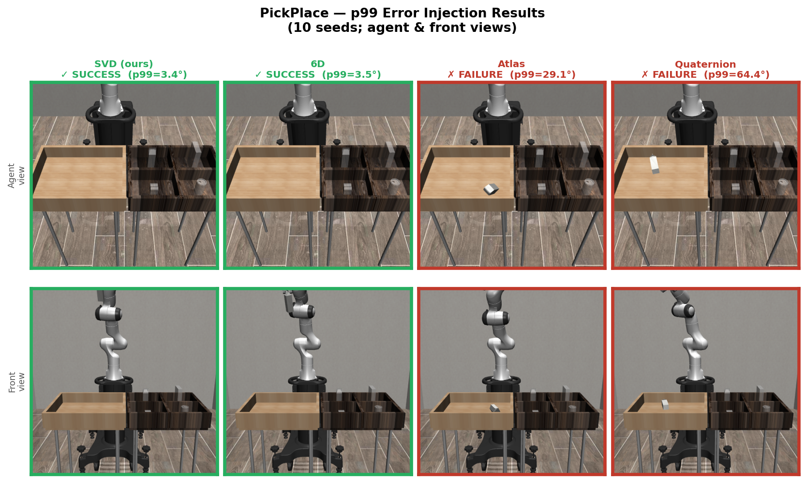
Figure: Qualitative simulation outcomes.

8. Conclusion
Our findings provide strong evidence that p99 error is a useful predictor of downstream task reliability. For practitioners, these findings support using low-tail continuous representations as strong default choices.

