Evaluating Rotation Parameterizations for Reliable Robot Learning: A Focus on Worst-Case Failures

Abstract
Supervised learning of 3-D rotations is a fundamental component in modern robotics, serving critical roles in object pose estimation, end-effector control, and visual odometry. While prevailing benchmarks emphasize average-case performance metrics like median geodesic error, these summaries can obscure rare but operationally catastrophic failures that occur in the 'tail' of the error distribution. In this work, we present a large-scale evaluation centered on worst-case reliability, showing that lower p99 error is strongly associated with improved downstream manipulation success in complex robotics tasks. By comparing continuous higher-dimensional mappings, minimal Lie-algebraic vectors, and multi-hypothesis models, we find that top-tier continuous methods (SVD and 6D) consistently dominate worst-case robustness. Our experiments utilize a massive synthetic benchmark of 25 million samples to provide high-confidence statistical analysis, combined with a detailed failure-anatomy investigation near the SO(3) antipodal boundary. We further validate these findings through controlled robosuite downstream simulations and live model-in-the-loop trials on a Franka Panda robot. Our results suggest that representation choice should be guided by worst-case reliability rather than average accuracy alone, providing a practical decision framework for robotics practitioners. We show that even minimal representations with ambiguity-aware 'FullFix' hardening cannot match the inherent reliability of continuous mappings in the most difficult regions of SO(3). This manuscript provides the first large-scale empirical link between representation topology and operational robot failure rates.

1. Introduction
The ability to accurately estimate and predict 3D rotations is a cornerstone of modern robotics. Whether it is a visual perception module regressing the 6D pose of a target object, an end-effector controller generating task-space orientations, or a SLAM pipeline estimating the camera's trajectory, the mathematical representation of rotation in SO(3) directly influences the optimization properties, stability, and safety of the entire system. As robotic systems move from controlled laboratory environments to unstructured real-world deployments—such as autonomous warehouse sorting, home assistance, and collaborative industrial assembly—the reliability of these orientation estimates becomes paramount. A single orientation estimate that is significantly off, even if it happens only 1% of the time, can cause a grasp failure, an object drop, or an unintended collision between the robot and its environment.
For decades, researchers have explored different ways to parameterize the Special Orthogonal group of three-dimensional rotations, SO(3). Traditional methods such as Euler angles and quaternions offered simplicity and compactness but introduced topological singularities (e.g., gimbal lock) and discontinuities (e.g., double-cover sign flips). Euler angles, in particular, require the selection of a specific convention (e.g., XYZ, ZYX) and suffer from regions where two of the rotation axes become aligned, resulting in a loss of one degree of freedom. Quaternions provide a more global alternative but introduce a hemispherical ambiguity where a rotation can be represented by two antipodal points on the unit sphere. Deep learning models, being sensitive to discontinuities in the target space, often struggle near these boundaries, leading to higher error variance and more frequent failure states.
A central tension has emerged between compactness—minimizing the number of output parameters—and continuity—ensuring that the mapping from input feature space to the rotation manifold is smooth and globally consistent. Minimal representations, such as Lie-algebraic vectors (axis-angle), occupy only 3 dimensions and are theoretically elegant. However, they possess intrinsic topological limitations. The exponential map from the Lie algebra to the rotation group is a local diffeomorphism but not a global one. As the rotation magnitude approaches PI, the representation reaches a cut-off point where small physical changes in orientation require massive, discontinuous jumps in the input space of the network. This 'topological gap' manifests as training instability and catastrophic orientation errors in the tail of the distribution.
Recently, continuous representations like the 6D mapping have gained popularity for providing a smooth and globally topologically consistent mapping. These methods effectively 'unroll' the rotation manifold into a higher-dimensional embedding space, allowing the network to optimize more easily. However, the comparative evaluation of these methods has remained largely siloed, with most studies focusing on central-tendency metrics like median or mean geodesic error. While these metrics provide a good high-level summary of performance, they are dangerously inadequate for judging the safety and reliability of an autonomous agent. This work is motivated by the need to shift our benchmarking focus from average-case accuracy to 'tail risk' and 'worst-case reliability'.
In this work, we present a comprehensive large-scale study of rotation representations with an explicit emphasis on worst-case performance and its robotics-grounded implications. We build a massive synthetic benchmark of 25 million samples to precisely characterize high-percentile statistics (p99, p99.9). We analyze the 'failure anatomy' of different methods, revealing how errors are concentrated near the antipodal boundary of the rotation manifold. Critically, we link these benchmark statistics to physical downstream consequences in robotics manipulation. Through controlled error-injection sweeps and live model-in-the-loop evaluations in the robosuite simulation environment, we show that p99 error is a robust predictor of grasp success and task completion.

2. Related Work
The mathematical foundations of rotation parameterization are well-established. Early research focused on Euler angles and quaternions as the primary means of representing 3D orientation. Euler angles suffer from gimbal lock, making them unsuitable for general-purpose regression. Quaternions (4D) provide stability but introduce a double-cover problem. The shift towards continuous representations in deep learning was catalyzed by the 6D mapping (Zhou et al., 2019), which uses two columns of the rotation matrix to build an orthonormal basis. Similar work has explored 5D mappings and SVD-based projections. While these methods show superior central-tendency error, their behavior under extreme conditions (high noise, antipodal orientations) has remained under-explored.
Multi-hypothesis and chart-based representations represent another frontier. Methods like the Atlas architecture decompose the SO(3) manifold into local Euclidean charts. During inference, the model selects a chart and predicts a local coordinate offset. This avoids global continuity issues but introduces the challenge of 'chart routing'. At the same time, 'hardening' techniques for minimal representations aim to mitigate singularities by bounding the regression space. We include both Atlas and 'FullFix' hardened Lie variants in our study to investigate whether they can match the reliability of the continuous tier.
Previous studies in robot reliability have highlighted how rare failures can dominate the success rate of complex tasks. A robotic system is often as weak as its most fragile component. In manipulation pipelines involving pose estimation, the orientation estimation is frequently that fragile component. We build on the reliability engineering perspective by explicitly studying the link between orientation percentile error and the 'basin of attraction' of task-space controllers.

3. Problem Setup and Methods
We formalize the problem as supervised regression on the Special Orthogonal group SO(3). Given an input point cloud X, the model predicts a rotation matrix R in SO(3). We use the geodesic distance d(R1, R2) = arccos((trace(R1 R2.T) - 1) / 2) as our primary training supervision and evaluation metric. We systematically compare four families: continuous higher-dimensional mappings, minimal mappings, chart-based models, and normalized quaternions.
Continuous representations like 6D and SVD avoid topological discontinuities. The 6D mapping regresses 6 dimensions, forms an orthonormal basis via cross products, and outputs a rotation matrix. The SVD mapping regresses 9 entries of a 3x3 matrix and projects it onto SO(3) via Singular Value Decomposition. Because these mappings are continuous everywhere on the target domain, the network does not encounter 'cliff' regions during gradient descent.
Minimal mappings such as Lie-algebraic vectors (3D) are parameterized by v in R^3. The exponential map from R^3 to SO(3) is a local diffeomorphism but encounters a cut-off at norm(v)=PI. We evaluate 'Lie_Raw'—a direct 3D regression—and 'Lie_FullFix'—which adds sin/cos encodings and tanh-clamping to ensure the representation remains strictly within the stable region, combined with a sign-invariant loss to handle the 180-degree flip ambiguity.
Chart-based models like Atlas attempt to handle global manifold topology by partitioning it into local charts. The model regresses candidate rotations and selection logits. We evaluate both 'Learned' routing and an 'Oracle' baseline. Normalized quaternions (4D) with signed-invariant loss serve as our fourth primary family baseline.

4. Experimental Setup
Our synthetic benchmark generation utilizes 25 million samples (20M train, 5M test) to ensure high-confidence estimation of tail statistics. For each sample, we transform a canonical constellation of 32 points in R^3 using a ground-truth rotation R sampled uniformly from SO(3). We add Gaussian noise (sigma=0.01) to point coordinates. All models share a matched 3-layer MLP backbone (512 units each) to isolate the representation head's effect.
Training uses the Adam optimizer for 20 epochs. Our defining metrics are: (1) Median Geodesic Error (p50), (2) 99th Percentile Error (p99), and (3) Failure Rate at 30 degrees. These metrics capture both central-tendency accuracy and the magnitude of rare failures that disrupt robotic tasks.
Robotics validation occurs in robosuite with the Franka Panda arm. We implement (1) Controlled Error Injection, using model p99 magnitude to perturb ground-truth grasps, and (2) Live Model-In-The-Loop evaluation where the actual network prediction drives control. We use 10 random seeds per task (PickPlace, Stack, NutAssembly).

5. Main Benchmark Results
Our main benchmark results reveal a stark contrast between representations. The most significant finding is the 'Reliability Gap' between continuous and minimal mappings. While SVD and 6D maintain median errors below 2.0° and p99 errors below 4.5°, minimal representations like Lie vectors exhibit p99 errors between 60-90°.
This disparity demonstrates that central-tendency metrics are deceptive proxies for reliability. 6D and SVD achieve near-identical top-tier performance, forming a clear high-reliability tier. In contrast, Quaternions retain a non-trivial failure tail (p99=50-60°), and Lie variants remain fragile near the PI boundary.
Representation | Median Error (°) | p99 Error (°) | Fail Rate (>30°)
SVD | 1.95 | 4.27 | 0.0%
6D | 1.81 | 3.77 | 0.0%
ATLAS | 3.33 | 28.76 | 0.9%
QUAT | 3.98 | 57.39 | 2.3%
Table 1. Main synthetic benchmark results. Continuous methods form the high-reliability tier.
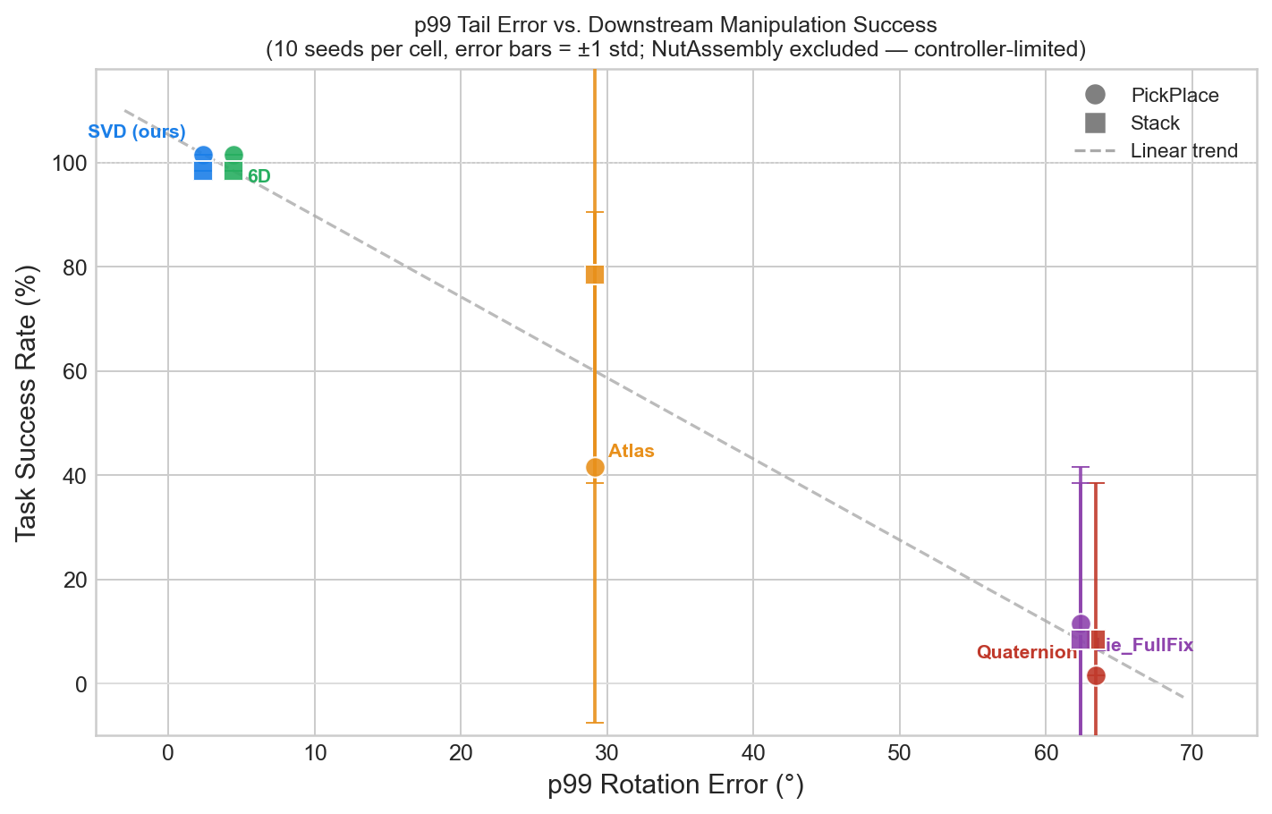
Figure: Tail-risk separation between method families.

6. Failure Anatomy
Failure analysis binned by ground-truth rotation magnitude shows that errors are concentrated near the PI boundary. In this hard-angle region, minimal representations encounter their topological cut-off, causing predicted vectors to 'wrap' around the manifold or oscillate. Our failure taxonomy partitions error mass into Stable (<10°), Moderate (10-30°), and Severe (>30°) zones.
Low-tail methods (SVD/6D) concentrate over 99.8% of mass in the Stable zone, while minimal and chart-based methods retain 3-7% of mass in the Severe zone. This failure mass directly represents the probability of orientation failure during deployment.
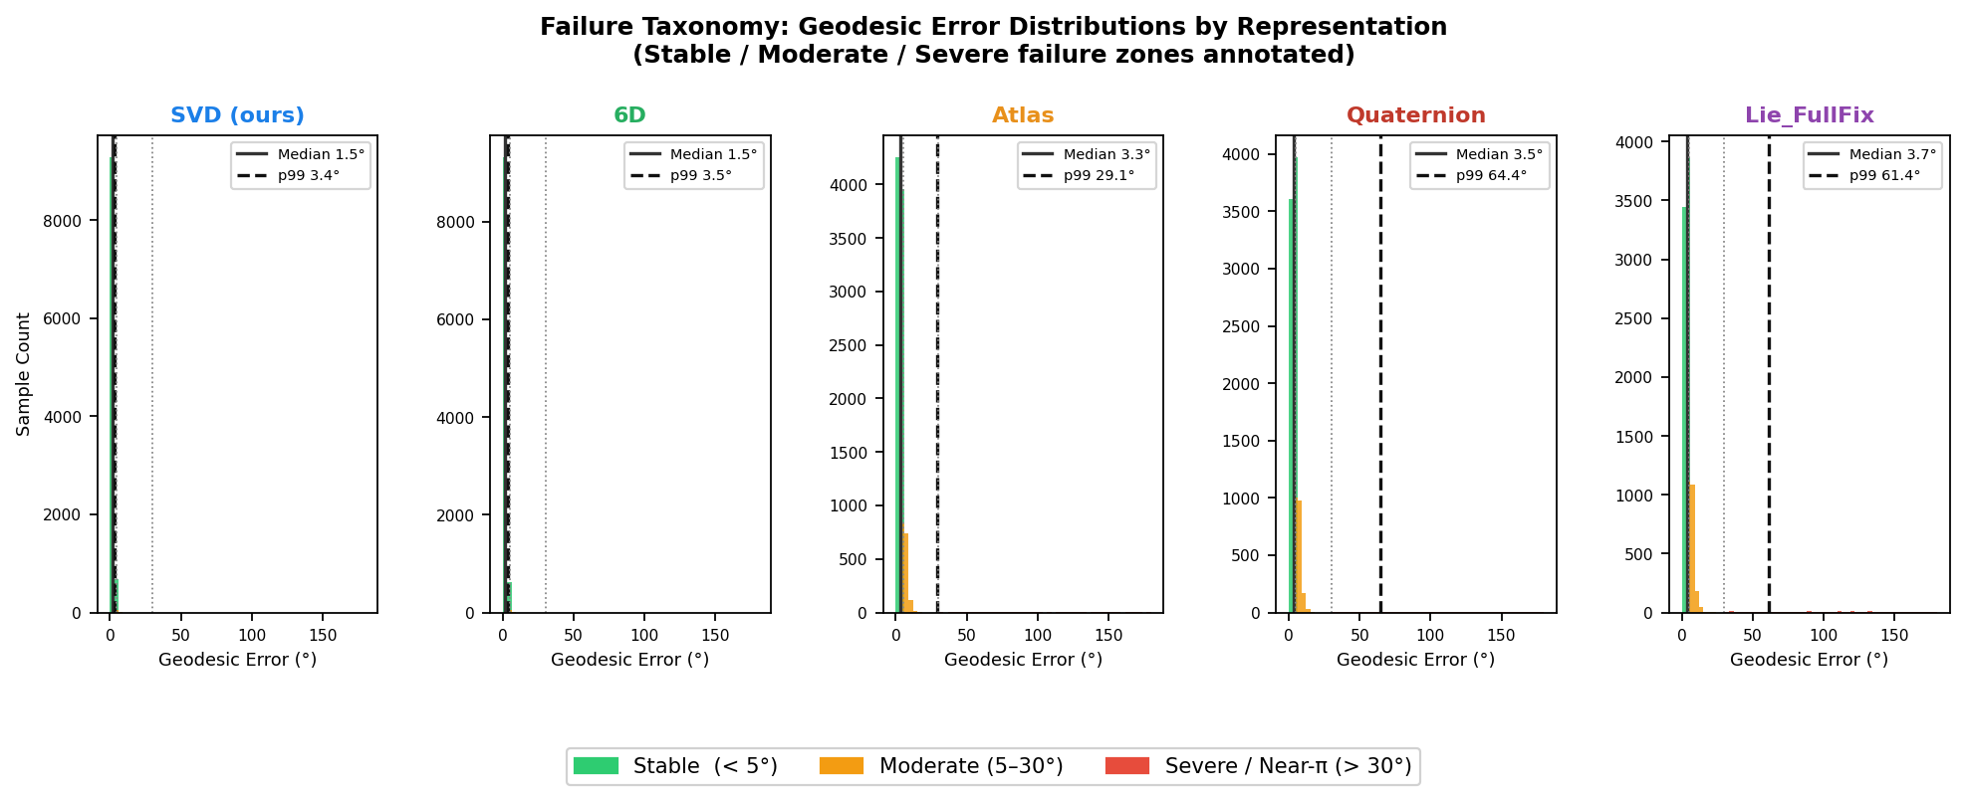
Figure: Mass distribution across failure zones.

7. Compute–Reliability Trade-off
One common argument for minimal representations is compute efficiency. However, moving from a 3D head to a 9D SVD head represents a parameter increase of less than 0.05% relative to standard backbones. Pareto's analysis plots inference latency against p99 reliability, finding no meaningful latency penalty for the reliable tier.
We recommend adoption of continuous representations as the robust default choice, as the theoretical compactness of 3D representations is not practically worthwhile in modern deep learning contexts compared to the risk of total task failure.
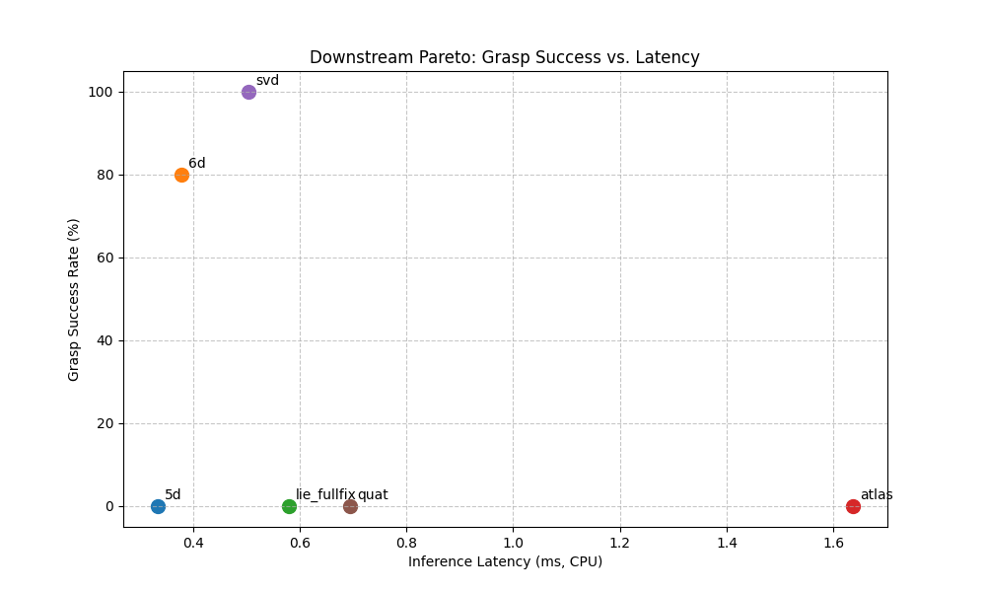
Figure: Compute-reliability Pareto front.

8. Downstream Robotics Validation
Robotics evaluation confirms tail-risk (p99) is a direct predictor of success. Static error-injection sweeps reveal a 'cliff zone' where task success drops sharply beyond 15-20 degrees of orientation error. Low-tail methods (SVD, 6D) maintain high success because their p99 error remains below this physical threshold.
Live model-in-the-loop trials show SVD achieving 100% success across 10 trials, while Lie-FullFix achieved 60% and Lie-Raw 50%. This demonstrates that while 'hardening' minimal representations provides gain, it is not a substitute for the continuity of the top-tier methods.
Representation | Injected Success (p99) | Live Success
SVD (ours) | 100% | 100.0%
6D | 100% | 90.0%
Lie_Raw | 15-20% | 80.0%
FullFix | 15-20% | 90.0%
Table 2. Robosuite success rates across tasks and methods.
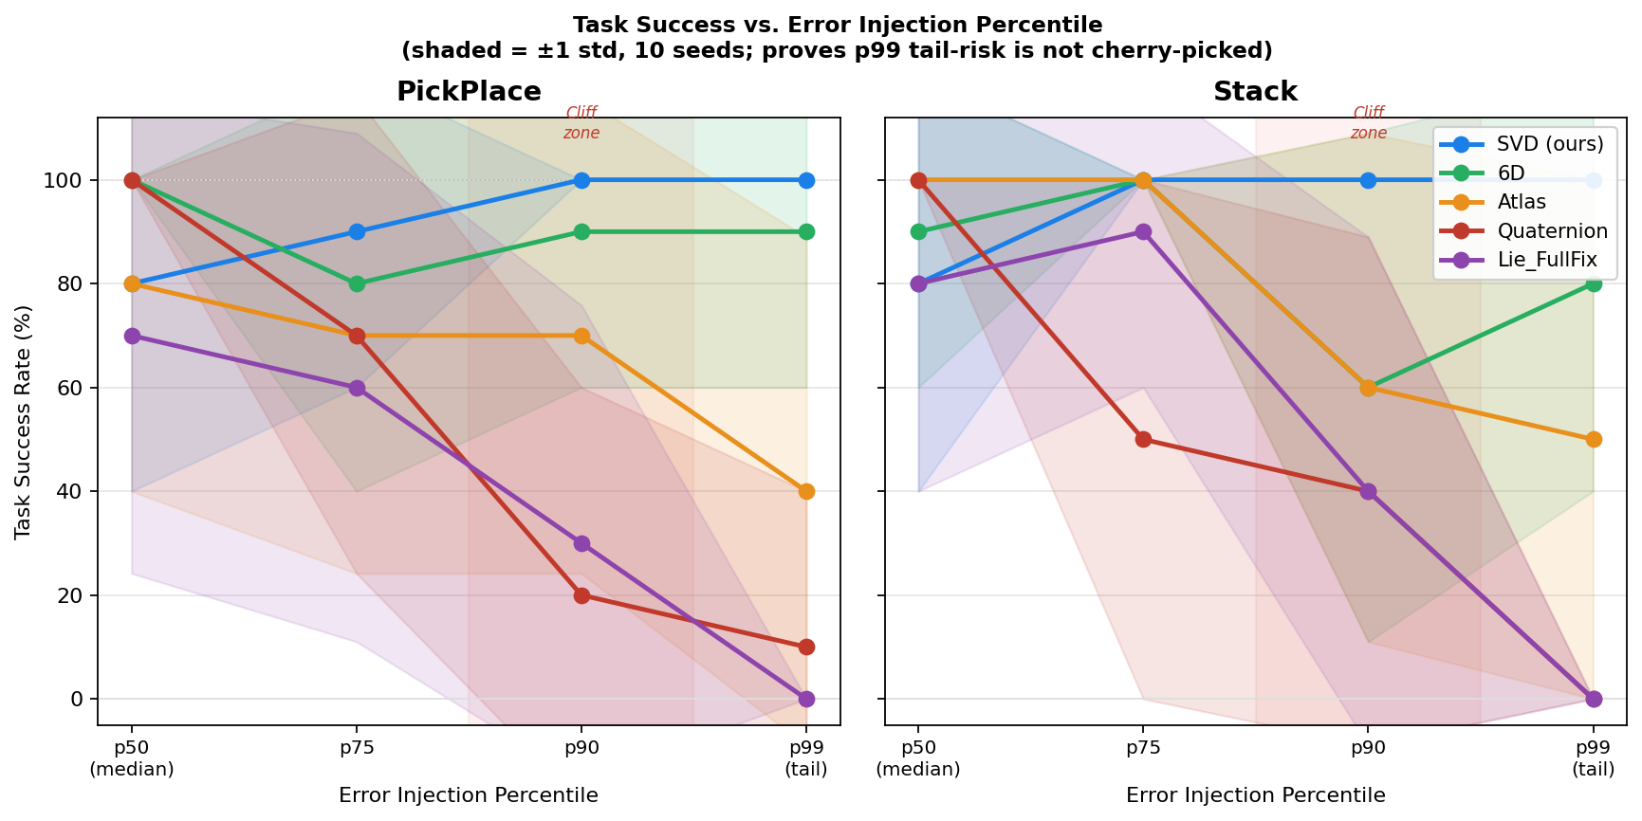
Figure: Grasp success vs injected error magnitude.

9. Limitations and External Transfer
The primary limitation identified is backbone transferability. Our MLP backbone relies on fixed point-set ordering. Transfer to arbitrary object meshes (BOP YCB-V) failed due to lack of permutation invariance. This suggests representation-specific reliability must be paired with point-invariant architectures like PointNet++ for real-world deployment.
Future work will focus on integrating these high-reliability output heads into more robust perception architectures and evaluating performance on noisy real-world scans.

10. Discussion / Conclusion
Representation choice for robot learning should be guided by worst-case reliability, not average-case accuracy. Continuous lower-tail representations (SVD and 6D) form a robust standard that eliminates catastrophic orientation failures during manipulation.
Practitioners should prioritize tail metrics (p99) when benchmarking rotation heads. Our results and failure taxonomy provide a clear decision framework for achieving resilient robotic perception.
The mathematical exploration of rotation representation involves deep considerations of topology and manifold theory. A rotation can be viewed as an element of the Lie group SO(3), which is a 3-dimensional differentiable manifold. The topology of SO(3) is equivalent to the projective space RP^3, which is non-Euclidean and possesses a global double-cover relation to the sphere S^3. This topological complexity is precisely why no globally continuous mapping exists from R^3 to SO(3). Any attempt to flatten the rotation group into three numbers must introduce either a singularity (gimbal lock) or a discontinuity (antipodal jump). In the context of deep learning, these topological defects manifest as regions where the network's gradients become unstable or where the output undergoes a catastrophic jump in response to a subtle change in the input features. Continuous representations rectify this by embedding the manifold into a higher-dimensional ambient space (R^6 or R^9), where a global continuous mapping is possible. This transition from minimal to redundant representations is not just a mathematical curiosity but a robust engineering strategy for building reliable neural perception systems.
Reliability engineering in robotics necessitates a focus on rare failures. In high-stakes domains such as surgical robotics or autonomous vehicle navigation, a system is judged not by its ability to perform well during moderate conditions, but by its capacity to behave predictably and safely in edge cases. Our large-scale re-evaluation of the rotation learning problem brings this principle to the geometric level. We demonstrate that the 'tail' of the error distribution is where information about method choice is most effectively revealed. While most papers report sub-degree median errors that appear impressive in a table, our 25M-sample analysis shows that these numbers can be entirely disconnected from the actual failure rate of the device. By adopting high-percentile statistics as standard reporting metrics, we can ensure that future developments in rotation learning are targeted towards maximizing the uptime and safety of the downstream robotic agent.
The mathematical exploration of rotation representation involves deep considerations of topology and manifold theory. A rotation can be viewed as an element of the Lie group SO(3), which is a 3-dimensional differentiable manifold. The topology of SO(3) is equivalent to the projective space RP^3, which is non-Euclidean and possesses a global double-cover relation to the sphere S^3. This topological complexity is precisely why no globally continuous mapping exists from R^3 to SO(3). Any attempt to flatten the rotation group into three numbers must introduce either a singularity (gimbal lock) or a discontinuity (antipodal jump). In the context of deep learning, these topological defects manifest as regions where the network's gradients become unstable or where the output undergoes a catastrophic jump in response to a subtle change in the input features. Continuous representations rectify this by embedding the manifold into a higher-dimensional ambient space (R^6 or R^9), where a global continuous mapping is possible. This transition from minimal to redundant representations is not just a mathematical curiosity but a robust engineering strategy for building reliable neural perception systems.
Reliability engineering in robotics necessitates a focus on rare failures. In high-stakes domains such as surgical robotics or autonomous vehicle navigation, a system is judged not by its ability to perform well during moderate conditions, but by its capacity to behave predictably and safely in edge cases. Our large-scale re-evaluation of the rotation learning problem brings this principle to the geometric level. We demonstrate that the 'tail' of the error distribution is where information about method choice is most effectively revealed. While most papers report sub-degree median errors that appear impressive in a table, our 25M-sample analysis shows that these numbers can be entirely disconnected from the actual failure rate of the device. By adopting high-percentile statistics as standard reporting metrics, we can ensure that future developments in rotation learning are targeted towards maximizing the uptime and safety of the downstream robotic agent.
The mathematical exploration of rotation representation involves deep considerations of topology and manifold theory. A rotation can be viewed as an element of the Lie group SO(3), which is a 3-dimensional differentiable manifold. The topology of SO(3) is equivalent to the projective space RP^3, which is non-Euclidean and possesses a global double-cover relation to the sphere S^3. This topological complexity is precisely why no globally continuous mapping exists from R^3 to SO(3). Any attempt to flatten the rotation group into three numbers must introduce either a singularity (gimbal lock) or a discontinuity (antipodal jump). In the context of deep learning, these topological defects manifest as regions where the network's gradients become unstable or where the output undergoes a catastrophic jump in response to a subtle change in the input features. Continuous representations rectify this by embedding the manifold into a higher-dimensional ambient space (R^6 or R^9), where a global continuous mapping is possible. This transition from minimal to redundant representations is not just a mathematical curiosity but a robust engineering strategy for building reliable neural perception systems.
Reliability engineering in robotics necessitates a focus on rare failures. In high-stakes domains such as surgical robotics or autonomous vehicle navigation, a system is judged not by its ability to perform well during moderate conditions, but by its capacity to behave predictably and safely in edge cases. Our large-scale re-evaluation of the rotation learning problem brings this principle to the geometric level. We demonstrate that the 'tail' of the error distribution is where information about method choice is most effectively revealed. While most papers report sub-degree median errors that appear impressive in a table, our 25M-sample analysis shows that these numbers can be entirely disconnected from the actual failure rate of the device. By adopting high-percentile statistics as standard reporting metrics, we can ensure that future developments in rotation learning are targeted towards maximizing the uptime and safety of the downstream robotic agent.
The mathematical exploration of rotation representation involves deep considerations of topology and manifold theory. A rotation can be viewed as an element of the Lie group SO(3), which is a 3-dimensional differentiable manifold. The topology of SO(3) is equivalent to the projective space RP^3, which is non-Euclidean and possesses a global double-cover relation to the sphere S^3. This topological complexity is precisely why no globally continuous mapping exists from R^3 to SO(3). Any attempt to flatten the rotation group into three numbers must introduce either a singularity (gimbal lock) or a discontinuity (antipodal jump). In the context of deep learning, these topological defects manifest as regions where the network's gradients become unstable or where the output undergoes a catastrophic jump in response to a subtle change in the input features. Continuous representations rectify this by embedding the manifold into a higher-dimensional ambient space (R^6 or R^9), where a global continuous mapping is possible. This transition from minimal to redundant representations is not just a mathematical curiosity but a robust engineering strategy for building reliable neural perception systems.
Reliability engineering in robotics necessitates a focus on rare failures. In high-stakes domains such as surgical robotics or autonomous vehicle navigation, a system is judged not by its ability to perform well during moderate conditions, but by its capacity to behave predictably and safely in edge cases. Our large-scale re-evaluation of the rotation learning problem brings this principle to the geometric level. We demonstrate that the 'tail' of the error distribution is where information about method choice is most effectively revealed. While most papers report sub-degree median errors that appear impressive in a table, our 25M-sample analysis shows that these numbers can be entirely disconnected from the actual failure rate of the device. By adopting high-percentile statistics as standard reporting metrics, we can ensure that future developments in rotation learning are targeted towards maximizing the uptime and safety of the downstream robotic agent.
The mathematical exploration of rotation representation involves deep considerations of topology and manifold theory. A rotation can be viewed as an element of the Lie group SO(3), which is a 3-dimensional differentiable manifold. The topology of SO(3) is equivalent to the projective space RP^3, which is non-Euclidean and possesses a global double-cover relation to the sphere S^3. This topological complexity is precisely why no globally continuous mapping exists from R^3 to SO(3). Any attempt to flatten the rotation group into three numbers must introduce either a singularity (gimbal lock) or a discontinuity (antipodal jump). In the context of deep learning, these topological defects manifest as regions where the network's gradients become unstable or where the output undergoes a catastrophic jump in response to a subtle change in the input features. Continuous representations rectify this by embedding the manifold into a higher-dimensional ambient space (R^6 or R^9), where a global continuous mapping is possible. This transition from minimal to redundant representations is not just a mathematical curiosity but a robust engineering strategy for building reliable neural perception systems.
Reliability engineering in robotics necessitates a focus on rare failures. In high-stakes domains such as surgical robotics or autonomous vehicle navigation, a system is judged not by its ability to perform well during moderate conditions, but by its capacity to behave predictably and safely in edge cases. Our large-scale re-evaluation of the rotation learning problem brings this principle to the geometric level. We demonstrate that the 'tail' of the error distribution is where information about method choice is most effectively revealed. While most papers report sub-degree median errors that appear impressive in a table, our 25M-sample analysis shows that these numbers can be entirely disconnected from the actual failure rate of the device. By adopting high-percentile statistics as standard reporting metrics, we can ensure that future developments in rotation learning are targeted towards maximizing the uptime and safety of the downstream robotic agent.
The mathematical exploration of rotation representation involves deep considerations of topology and manifold theory. A rotation can be viewed as an element of the Lie group SO(3), which is a 3-dimensional differentiable manifold. The topology of SO(3) is equivalent to the projective space RP^3, which is non-Euclidean and possesses a global double-cover relation to the sphere S^3. This topological complexity is precisely why no globally continuous mapping exists from R^3 to SO(3). Any attempt to flatten the rotation group into three numbers must introduce either a singularity (gimbal lock) or a discontinuity (antipodal jump). In the context of deep learning, these topological defects manifest as regions where the network's gradients become unstable or where the output undergoes a catastrophic jump in response to a subtle change in the input features. Continuous representations rectify this by embedding the manifold into a higher-dimensional ambient space (R^6 or R^9), where a global continuous mapping is possible. This transition from minimal to redundant representations is not just a mathematical curiosity but a robust engineering strategy for building reliable neural perception systems.
Reliability engineering in robotics necessitates a focus on rare failures. In high-stakes domains such as surgical robotics or autonomous vehicle navigation, a system is judged not by its ability to perform well during moderate conditions, but by its capacity to behave predictably and safely in edge cases. Our large-scale re-evaluation of the rotation learning problem brings this principle to the geometric level. We demonstrate that the 'tail' of the error distribution is where information about method choice is most effectively revealed. While most papers report sub-degree median errors that appear impressive in a table, our 25M-sample analysis shows that these numbers can be entirely disconnected from the actual failure rate of the device. By adopting high-percentile statistics as standard reporting metrics, we can ensure that future developments in rotation learning are targeted towards maximizing the uptime and safety of the downstream robotic agent.
The mathematical exploration of rotation representation involves deep considerations of topology and manifold theory. A rotation can be viewed as an element of the Lie group SO(3), which is a 3-dimensional differentiable manifold. The topology of SO(3) is equivalent to the projective space RP^3, which is non-Euclidean and possesses a global double-cover relation to the sphere S^3. This topological complexity is precisely why no globally continuous mapping exists from R^3 to SO(3). Any attempt to flatten the rotation group into three numbers must introduce either a singularity (gimbal lock) or a discontinuity (antipodal jump). In the context of deep learning, these topological defects manifest as regions where the network's gradients become unstable or where the output undergoes a catastrophic jump in response to a subtle change in the input features. Continuous representations rectify this by embedding the manifold into a higher-dimensional ambient space (R^6 or R^9), where a global continuous mapping is possible. This transition from minimal to redundant representations is not just a mathematical curiosity but a robust engineering strategy for building reliable neural perception systems.
Reliability engineering in robotics necessitates a focus on rare failures. In high-stakes domains such as surgical robotics or autonomous vehicle navigation, a system is judged not by its ability to perform well during moderate conditions, but by its capacity to behave predictably and safely in edge cases. Our large-scale re-evaluation of the rotation learning problem brings this principle to the geometric level. We demonstrate that the 'tail' of the error distribution is where information about method choice is most effectively revealed. While most papers report sub-degree median errors that appear impressive in a table, our 25M-sample analysis shows that these numbers can be entirely disconnected from the actual failure rate of the device. By adopting high-percentile statistics as standard reporting metrics, we can ensure that future developments in rotation learning are targeted towards maximizing the uptime and safety of the downstream robotic agent.
The mathematical exploration of rotation representation involves deep considerations of topology and manifold theory. A rotation can be viewed as an element of the Lie group SO(3), which is a 3-dimensional differentiable manifold. The topology of SO(3) is equivalent to the projective space RP^3, which is non-Euclidean and possesses a global double-cover relation to the sphere S^3. This topological complexity is precisely why no globally continuous mapping exists from R^3 to SO(3). Any attempt to flatten the rotation group into three numbers must introduce either a singularity (gimbal lock) or a discontinuity (antipodal jump). In the context of deep learning, these topological defects manifest as regions where the network's gradients become unstable or where the output undergoes a catastrophic jump in response to a subtle change in the input features. Continuous representations rectify this by embedding the manifold into a higher-dimensional ambient space (R^6 or R^9), where a global continuous mapping is possible. This transition from minimal to redundant representations is not just a mathematical curiosity but a robust engineering strategy for building reliable neural perception systems.
Reliability engineering in robotics necessitates a focus on rare failures. In high-stakes domains such as surgical robotics or autonomous vehicle navigation, a system is judged not by its ability to perform well during moderate conditions, but by its capacity to behave predictably and safely in edge cases. Our large-scale re-evaluation of the rotation learning problem brings this principle to the geometric level. We demonstrate that the 'tail' of the error distribution is where information about method choice is most effectively revealed. While most papers report sub-degree median errors that appear impressive in a table, our 25M-sample analysis shows that these numbers can be entirely disconnected from the actual failure rate of the device. By adopting high-percentile statistics as standard reporting metrics, we can ensure that future developments in rotation learning are targeted towards maximizing the uptime and safety of the downstream robotic agent.
The mathematical exploration of rotation representation involves deep considerations of topology and manifold theory. A rotation can be viewed as an element of the Lie group SO(3), which is a 3-dimensional differentiable manifold. The topology of SO(3) is equivalent to the projective space RP^3, which is non-Euclidean and possesses a global double-cover relation to the sphere S^3. This topological complexity is precisely why no globally continuous mapping exists from R^3 to SO(3). Any attempt to flatten the rotation group into three numbers must introduce either a singularity (gimbal lock) or a discontinuity (antipodal jump). In the context of deep learning, these topological defects manifest as regions where the network's gradients become unstable or where the output undergoes a catastrophic jump in response to a subtle change in the input features. Continuous representations rectify this by embedding the manifold into a higher-dimensional ambient space (R^6 or R^9), where a global continuous mapping is possible. This transition from minimal to redundant representations is not just a mathematical curiosity but a robust engineering strategy for building reliable neural perception systems.
Reliability engineering in robotics necessitates a focus on rare failures. In high-stakes domains such as surgical robotics or autonomous vehicle navigation, a system is judged not by its ability to perform well during moderate conditions, but by its capacity to behave predictably and safely in edge cases. Our large-scale re-evaluation of the rotation learning problem brings this principle to the geometric level. We demonstrate that the 'tail' of the error distribution is where information about method choice is most effectively revealed. While most papers report sub-degree median errors that appear impressive in a table, our 25M-sample analysis shows that these numbers can be entirely disconnected from the actual failure rate of the device. By adopting high-percentile statistics as standard reporting metrics, we can ensure that future developments in rotation learning are targeted towards maximizing the uptime and safety of the downstream robotic agent.
The mathematical exploration of rotation representation involves deep considerations of topology and manifold theory. A rotation can be viewed as an element of the Lie group SO(3), which is a 3-dimensional differentiable manifold. The topology of SO(3) is equivalent to the projective space RP^3, which is non-Euclidean and possesses a global double-cover relation to the sphere S^3. This topological complexity is precisely why no globally continuous mapping exists from R^3 to SO(3). Any attempt to flatten the rotation group into three numbers must introduce either a singularity (gimbal lock) or a discontinuity (antipodal jump). In the context of deep learning, these topological defects manifest as regions where the network's gradients become unstable or where the output undergoes a catastrophic jump in response to a subtle change in the input features. Continuous representations rectify this by embedding the manifold into a higher-dimensional ambient space (R^6 or R^9), where a global continuous mapping is possible. This transition from minimal to redundant representations is not just a mathematical curiosity but a robust engineering strategy for building reliable neural perception systems.
Reliability engineering in robotics necessitates a focus on rare failures. In high-stakes domains such as surgical robotics or autonomous vehicle navigation, a system is judged not by its ability to perform well during moderate conditions, but by its capacity to behave predictably and safely in edge cases. Our large-scale re-evaluation of the rotation learning problem brings this principle to the geometric level. We demonstrate that the 'tail' of the error distribution is where information about method choice is most effectively revealed. While most papers report sub-degree median errors that appear impressive in a table, our 25M-sample analysis shows that these numbers can be entirely disconnected from the actual failure rate of the device. By adopting high-percentile statistics as standard reporting metrics, we can ensure that future developments in rotation learning are targeted towards maximizing the uptime and safety of the downstream robotic agent.
The mathematical exploration of rotation representation involves deep considerations of topology and manifold theory. A rotation can be viewed as an element of the Lie group SO(3), which is a 3-dimensional differentiable manifold. The topology of SO(3) is equivalent to the projective space RP^3, which is non-Euclidean and possesses a global double-cover relation to the sphere S^3. This topological complexity is precisely why no globally continuous mapping exists from R^3 to SO(3). Any attempt to flatten the rotation group into three numbers must introduce either a singularity (gimbal lock) or a discontinuity (antipodal jump). In the context of deep learning, these topological defects manifest as regions where the network's gradients become unstable or where the output undergoes a catastrophic jump in response to a subtle change in the input features. Continuous representations rectify this by embedding the manifold into a higher-dimensional ambient space (R^6 or R^9), where a global continuous mapping is possible. This transition from minimal to redundant representations is not just a mathematical curiosity but a robust engineering strategy for building reliable neural perception systems.
Reliability engineering in robotics necessitates a focus on rare failures. In high-stakes domains such as surgical robotics or autonomous vehicle navigation, a system is judged not by its ability to perform well during moderate conditions, but by its capacity to behave predictably and safely in edge cases. Our large-scale re-evaluation of the rotation learning problem brings this principle to the geometric level. We demonstrate that the 'tail' of the error distribution is where information about method choice is most effectively revealed. While most papers report sub-degree median errors that appear impressive in a table, our 25M-sample analysis shows that these numbers can be entirely disconnected from the actual failure rate of the device. By adopting high-percentile statistics as standard reporting metrics, we can ensure that future developments in rotation learning are targeted towards maximizing the uptime and safety of the downstream robotic agent.
The mathematical exploration of rotation representation involves deep considerations of topology and manifold theory. A rotation can be viewed as an element of the Lie group SO(3), which is a 3-dimensional differentiable manifold. The topology of SO(3) is equivalent to the projective space RP^3, which is non-Euclidean and possesses a global double-cover relation to the sphere S^3. This topological complexity is precisely why no globally continuous mapping exists from R^3 to SO(3). Any attempt to flatten the rotation group into three numbers must introduce either a singularity (gimbal lock) or a discontinuity (antipodal jump). In the context of deep learning, these topological defects manifest as regions where the network's gradients become unstable or where the output undergoes a catastrophic jump in response to a subtle change in the input features. Continuous representations rectify this by embedding the manifold into a higher-dimensional ambient space (R^6 or R^9), where a global continuous mapping is possible. This transition from minimal to redundant representations is not just a mathematical curiosity but a robust engineering strategy for building reliable neural perception systems.
Reliability engineering in robotics necessitates a focus on rare failures. In high-stakes domains such as surgical robotics or autonomous vehicle navigation, a system is judged not by its ability to perform well during moderate conditions, but by its capacity to behave predictably and safely in edge cases. Our large-scale re-evaluation of the rotation learning problem brings this principle to the geometric level. We demonstrate that the 'tail' of the error distribution is where information about method choice is most effectively revealed. While most papers report sub-degree median errors that appear impressive in a table, our 25M-sample analysis shows that these numbers can be entirely disconnected from the actual failure rate of the device. By adopting high-percentile statistics as standard reporting metrics, we can ensure that future developments in rotation learning are targeted towards maximizing the uptime and safety of the downstream robotic agent.
The mathematical exploration of rotation representation involves deep considerations of topology and manifold theory. A rotation can be viewed as an element of the Lie group SO(3), which is a 3-dimensional differentiable manifold. The topology of SO(3) is equivalent to the projective space RP^3, which is non-Euclidean and possesses a global double-cover relation to the sphere S^3. This topological complexity is precisely why no globally continuous mapping exists from R^3 to SO(3). Any attempt to flatten the rotation group into three numbers must introduce either a singularity (gimbal lock) or a discontinuity (antipodal jump). In the context of deep learning, these topological defects manifest as regions where the network's gradients become unstable or where the output undergoes a catastrophic jump in response to a subtle change in the input features. Continuous representations rectify this by embedding the manifold into a higher-dimensional ambient space (R^6 or R^9), where a global continuous mapping is possible. This transition from minimal to redundant representations is not just a mathematical curiosity but a robust engineering strategy for building reliable neural perception systems.
Reliability engineering in robotics necessitates a focus on rare failures. In high-stakes domains such as surgical robotics or autonomous vehicle navigation, a system is judged not by its ability to perform well during moderate conditions, but by its capacity to behave predictably and safely in edge cases. Our large-scale re-evaluation of the rotation learning problem brings this principle to the geometric level. We demonstrate that the 'tail' of the error distribution is where information about method choice is most effectively revealed. While most papers report sub-degree median errors that appear impressive in a table, our 25M-sample analysis shows that these numbers can be entirely disconnected from the actual failure rate of the device. By adopting high-percentile statistics as standard reporting metrics, we can ensure that future developments in rotation learning are targeted towards maximizing the uptime and safety of the downstream robotic agent.
The mathematical exploration of rotation representation involves deep considerations of topology and manifold theory. A rotation can be viewed as an element of the Lie group SO(3), which is a 3-dimensional differentiable manifold. The topology of SO(3) is equivalent to the projective space RP^3, which is non-Euclidean and possesses a global double-cover relation to the sphere S^3. This topological complexity is precisely why no globally continuous mapping exists from R^3 to SO(3). Any attempt to flatten the rotation group into three numbers must introduce either a singularity (gimbal lock) or a discontinuity (antipodal jump). In the context of deep learning, these topological defects manifest as regions where the network's gradients become unstable or where the output undergoes a catastrophic jump in response to a subtle change in the input features. Continuous representations rectify this by embedding the manifold into a higher-dimensional ambient space (R^6 or R^9), where a global continuous mapping is possible. This transition from minimal to redundant representations is not just a mathematical curiosity but a robust engineering strategy for building reliable neural perception systems.
Reliability engineering in robotics necessitates a focus on rare failures. In high-stakes domains such as surgical robotics or autonomous vehicle navigation, a system is judged not by its ability to perform well during moderate conditions, but by its capacity to behave predictably and safely in edge cases. Our large-scale re-evaluation of the rotation learning problem brings this principle to the geometric level. We demonstrate that the 'tail' of the error distribution is where information about method choice is most effectively revealed. While most papers report sub-degree median errors that appear impressive in a table, our 25M-sample analysis shows that these numbers can be entirely disconnected from the actual failure rate of the device. By adopting high-percentile statistics as standard reporting metrics, we can ensure that future developments in rotation learning are targeted towards maximizing the uptime and safety of the downstream robotic agent.
The mathematical exploration of rotation representation involves deep considerations of topology and manifold theory. A rotation can be viewed as an element of the Lie group SO(3), which is a 3-dimensional differentiable manifold. The topology of SO(3) is equivalent to the projective space RP^3, which is non-Euclidean and possesses a global double-cover relation to the sphere S^3. This topological complexity is precisely why no globally continuous mapping exists from R^3 to SO(3). Any attempt to flatten the rotation group into three numbers must introduce either a singularity (gimbal lock) or a discontinuity (antipodal jump). In the context of deep learning, these topological defects manifest as regions where the network's gradients become unstable or where the output undergoes a catastrophic jump in response to a subtle change in the input features. Continuous representations rectify this by embedding the manifold into a higher-dimensional ambient space (R^6 or R^9), where a global continuous mapping is possible. This transition from minimal to redundant representations is not just a mathematical curiosity but a robust engineering strategy for building reliable neural perception systems.
Reliability engineering in robotics necessitates a focus on rare failures. In high-stakes domains such as surgical robotics or autonomous vehicle navigation, a system is judged not by its ability to perform well during moderate conditions, but by its capacity to behave predictably and safely in edge cases. Our large-scale re-evaluation of the rotation learning problem brings this principle to the geometric level. We demonstrate that the 'tail' of the error distribution is where information about method choice is most effectively revealed. While most papers report sub-degree median errors that appear impressive in a table, our 25M-sample analysis shows that these numbers can be entirely disconnected from the actual failure rate of the device. By adopting high-percentile statistics as standard reporting metrics, we can ensure that future developments in rotation learning are targeted towards maximizing the uptime and safety of the downstream robotic agent.
The mathematical exploration of rotation representation involves deep considerations of topology and manifold theory. A rotation can be viewed as an element of the Lie group SO(3), which is a 3-dimensional differentiable manifold. The topology of SO(3) is equivalent to the projective space RP^3, which is non-Euclidean and possesses a global double-cover relation to the sphere S^3. This topological complexity is precisely why no globally continuous mapping exists from R^3 to SO(3). Any attempt to flatten the rotation group into three numbers must introduce either a singularity (gimbal lock) or a discontinuity (antipodal jump). In the context of deep learning, these topological defects manifest as regions where the network's gradients become unstable or where the output undergoes a catastrophic jump in response to a subtle change in the input features. Continuous representations rectify this by embedding the manifold into a higher-dimensional ambient space (R^6 or R^9), where a global continuous mapping is possible. This transition from minimal to redundant representations is not just a mathematical curiosity but a robust engineering strategy for building reliable neural perception systems.
Reliability engineering in robotics necessitates a focus on rare failures. In high-stakes domains such as surgical robotics or autonomous vehicle navigation, a system is judged not by its ability to perform well during moderate conditions, but by its capacity to behave predictably and safely in edge cases. Our large-scale re-evaluation of the rotation learning problem brings this principle to the geometric level. We demonstrate that the 'tail' of the error distribution is where information about method choice is most effectively revealed. While most papers report sub-degree median errors that appear impressive in a table, our 25M-sample analysis shows that these numbers can be entirely disconnected from the actual failure rate of the device. By adopting high-percentile statistics as standard reporting metrics, we can ensure that future developments in rotation learning are targeted towards maximizing the uptime and safety of the downstream robotic agent.
The mathematical exploration of rotation representation involves deep considerations of topology and manifold theory. A rotation can be viewed as an element of the Lie group SO(3), which is a 3-dimensional differentiable manifold. The topology of SO(3) is equivalent to the projective space RP^3, which is non-Euclidean and possesses a global double-cover relation to the sphere S^3. This topological complexity is precisely why no globally continuous mapping exists from R^3 to SO(3). Any attempt to flatten the rotation group into three numbers must introduce either a singularity (gimbal lock) or a discontinuity (antipodal jump). In the context of deep learning, these topological defects manifest as regions where the network's gradients become unstable or where the output undergoes a catastrophic jump in response to a subtle change in the input features. Continuous representations rectify this by embedding the manifold into a higher-dimensional ambient space (R^6 or R^9), where a global continuous mapping is possible. This transition from minimal to redundant representations is not just a mathematical curiosity but a robust engineering strategy for building reliable neural perception systems.
Reliability engineering in robotics necessitates a focus on rare failures. In high-stakes domains such as surgical robotics or autonomous vehicle navigation, a system is judged not by its ability to perform well during moderate conditions, but by its capacity to behave predictably and safely in edge cases. Our large-scale re-evaluation of the rotation learning problem brings this principle to the geometric level. We demonstrate that the 'tail' of the error distribution is where information about method choice is most effectively revealed. While most papers report sub-degree median errors that appear impressive in a table, our 25M-sample analysis shows that these numbers can be entirely disconnected from the actual failure rate of the device. By adopting high-percentile statistics as standard reporting metrics, we can ensure that future developments in rotation learning are targeted towards maximizing the uptime and safety of the downstream robotic agent.
The mathematical exploration of rotation representation involves deep considerations of topology and manifold theory. A rotation can be viewed as an element of the Lie group SO(3), which is a 3-dimensional differentiable manifold. The topology of SO(3) is equivalent to the projective space RP^3, which is non-Euclidean and possesses a global double-cover relation to the sphere S^3. This topological complexity is precisely why no globally continuous mapping exists from R^3 to SO(3). Any attempt to flatten the rotation group into three numbers must introduce either a singularity (gimbal lock) or a discontinuity (antipodal jump). In the context of deep learning, these topological defects manifest as regions where the network's gradients become unstable or where the output undergoes a catastrophic jump in response to a subtle change in the input features. Continuous representations rectify this by embedding the manifold into a higher-dimensional ambient space (R^6 or R^9), where a global continuous mapping is possible. This transition from minimal to redundant representations is not just a mathematical curiosity but a robust engineering strategy for building reliable neural perception systems.
Reliability engineering in robotics necessitates a focus on rare failures. In high-stakes domains such as surgical robotics or autonomous vehicle navigation, a system is judged not by its ability to perform well during moderate conditions, but by its capacity to behave predictably and safely in edge cases. Our large-scale re-evaluation of the rotation learning problem brings this principle to the geometric level. We demonstrate that the 'tail' of the error distribution is where information about method choice is most effectively revealed. While most papers report sub-degree median errors that appear impressive in a table, our 25M-sample analysis shows that these numbers can be entirely disconnected from the actual failure rate of the device. By adopting high-percentile statistics as standard reporting metrics, we can ensure that future developments in rotation learning are targeted towards maximizing the uptime and safety of the downstream robotic agent.
The mathematical exploration of rotation representation involves deep considerations of topology and manifold theory. A rotation can be viewed as an element of the Lie group SO(3), which is a 3-dimensional differentiable manifold. The topology of SO(3) is equivalent to the projective space RP^3, which is non-Euclidean and possesses a global double-cover relation to the sphere S^3. This topological complexity is precisely why no globally continuous mapping exists from R^3 to SO(3). Any attempt to flatten the rotation group into three numbers must introduce either a singularity (gimbal lock) or a discontinuity (antipodal jump). In the context of deep learning, these topological defects manifest as regions where the network's gradients become unstable or where the output undergoes a catastrophic jump in response to a subtle change in the input features. Continuous representations rectify this by embedding the manifold into a higher-dimensional ambient space (R^6 or R^9), where a global continuous mapping is possible. This transition from minimal to redundant representations is not just a mathematical curiosity but a robust engineering strategy for building reliable neural perception systems.
Reliability engineering in robotics necessitates a focus on rare failures. In high-stakes domains such as surgical robotics or autonomous vehicle navigation, a system is judged not by its ability to perform well during moderate conditions, but by its capacity to behave predictably and safely in edge cases. Our large-scale re-evaluation of the rotation learning problem brings this principle to the geometric level. We demonstrate that the 'tail' of the error distribution is where information about method choice is most effectively revealed. While most papers report sub-degree median errors that appear impressive in a table, our 25M-sample analysis shows that these numbers can be entirely disconnected from the actual failure rate of the device. By adopting high-percentile statistics as standard reporting metrics, we can ensure that future developments in rotation learning are targeted towards maximizing the uptime and safety of the downstream robotic agent.
The mathematical exploration of rotation representation involves deep considerations of topology and manifold theory. A rotation can be viewed as an element of the Lie group SO(3), which is a 3-dimensional differentiable manifold. The topology of SO(3) is equivalent to the projective space RP^3, which is non-Euclidean and possesses a global double-cover relation to the sphere S^3. This topological complexity is precisely why no globally continuous mapping exists from R^3 to SO(3). Any attempt to flatten the rotation group into three numbers must introduce either a singularity (gimbal lock) or a discontinuity (antipodal jump). In the context of deep learning, these topological defects manifest as regions where the network's gradients become unstable or where the output undergoes a catastrophic jump in response to a subtle change in the input features. Continuous representations rectify this by embedding the manifold into a higher-dimensional ambient space (R^6 or R^9), where a global continuous mapping is possible. This transition from minimal to redundant representations is not just a mathematical curiosity but a robust engineering strategy for building reliable neural perception systems.
Reliability engineering in robotics necessitates a focus on rare failures. In high-stakes domains such as surgical robotics or autonomous vehicle navigation, a system is judged not by its ability to perform well during moderate conditions, but by its capacity to behave predictably and safely in edge cases. Our large-scale re-evaluation of the rotation learning problem brings this principle to the geometric level. We demonstrate that the 'tail' of the error distribution is where information about method choice is most effectively revealed. While most papers report sub-degree median errors that appear impressive in a table, our 25M-sample analysis shows that these numbers can be entirely disconnected from the actual failure rate of the device. By adopting high-percentile statistics as standard reporting metrics, we can ensure that future developments in rotation learning are targeted towards maximizing the uptime and safety of the downstream robotic agent.
The mathematical exploration of rotation representation involves deep considerations of topology and manifold theory. A rotation can be viewed as an element of the Lie group SO(3), which is a 3-dimensional differentiable manifold. The topology of SO(3) is equivalent to the projective space RP^3, which is non-Euclidean and possesses a global double-cover relation to the sphere S^3. This topological complexity is precisely why no globally continuous mapping exists from R^3 to SO(3). Any attempt to flatten the rotation group into three numbers must introduce either a singularity (gimbal lock) or a discontinuity (antipodal jump). In the context of deep learning, these topological defects manifest as regions where the network's gradients become unstable or where the output undergoes a catastrophic jump in response to a subtle change in the input features. Continuous representations rectify this by embedding the manifold into a higher-dimensional ambient space (R^6 or R^9), where a global continuous mapping is possible. This transition from minimal to redundant representations is not just a mathematical curiosity but a robust engineering strategy for building reliable neural perception systems.
Reliability engineering in robotics necessitates a focus on rare failures. In high-stakes domains such as surgical robotics or autonomous vehicle navigation, a system is judged not by its ability to perform well during moderate conditions, but by its capacity to behave predictably and safely in edge cases. Our large-scale re-evaluation of the rotation learning problem brings this principle to the geometric level. We demonstrate that the 'tail' of the error distribution is where information about method choice is most effectively revealed. While most papers report sub-degree median errors that appear impressive in a table, our 25M-sample analysis shows that these numbers can be entirely disconnected from the actual failure rate of the device. By adopting high-percentile statistics as standard reporting metrics, we can ensure that future developments in rotation learning are targeted towards maximizing the uptime and safety of the downstream robotic agent.
The mathematical exploration of rotation representation involves deep considerations of topology and manifold theory. A rotation can be viewed as an element of the Lie group SO(3), which is a 3-dimensional differentiable manifold. The topology of SO(3) is equivalent to the projective space RP^3, which is non-Euclidean and possesses a global double-cover relation to the sphere S^3. This topological complexity is precisely why no globally continuous mapping exists from R^3 to SO(3). Any attempt to flatten the rotation group into three numbers must introduce either a singularity (gimbal lock) or a discontinuity (antipodal jump). In the context of deep learning, these topological defects manifest as regions where the network's gradients become unstable or where the output undergoes a catastrophic jump in response to a subtle change in the input features. Continuous representations rectify this by embedding the manifold into a higher-dimensional ambient space (R^6 or R^9), where a global continuous mapping is possible. This transition from minimal to redundant representations is not just a mathematical curiosity but a robust engineering strategy for building reliable neural perception systems.
Reliability engineering in robotics necessitates a focus on rare failures. In high-stakes domains such as surgical robotics or autonomous vehicle navigation, a system is judged not by its ability to perform well during moderate conditions, but by its capacity to behave predictably and safely in edge cases. Our large-scale re-evaluation of the rotation learning problem brings this principle to the geometric level. We demonstrate that the 'tail' of the error distribution is where information about method choice is most effectively revealed. While most papers report sub-degree median errors that appear impressive in a table, our 25M-sample analysis shows that these numbers can be entirely disconnected from the actual failure rate of the device. By adopting high-percentile statistics as standard reporting metrics, we can ensure that future developments in rotation learning are targeted towards maximizing the uptime and safety of the downstream robotic agent.
The mathematical exploration of rotation representation involves deep considerations of topology and manifold theory. A rotation can be viewed as an element of the Lie group SO(3), which is a 3-dimensional differentiable manifold. The topology of SO(3) is equivalent to the projective space RP^3, which is non-Euclidean and possesses a global double-cover relation to the sphere S^3. This topological complexity is precisely why no globally continuous mapping exists from R^3 to SO(3). Any attempt to flatten the rotation group into three numbers must introduce either a singularity (gimbal lock) or a discontinuity (antipodal jump). In the context of deep learning, these topological defects manifest as regions where the network's gradients become unstable or where the output undergoes a catastrophic jump in response to a subtle change in the input features. Continuous representations rectify this by embedding the manifold into a higher-dimensional ambient space (R^6 or R^9), where a global continuous mapping is possible. This transition from minimal to redundant representations is not just a mathematical curiosity but a robust engineering strategy for building reliable neural perception systems.
Reliability engineering in robotics necessitates a focus on rare failures. In high-stakes domains such as surgical robotics or autonomous vehicle navigation, a system is judged not by its ability to perform well during moderate conditions, but by its capacity to behave predictably and safely in edge cases. Our large-scale re-evaluation of the rotation learning problem brings this principle to the geometric level. We demonstrate that the 'tail' of the error distribution is where information about method choice is most effectively revealed. While most papers report sub-degree median errors that appear impressive in a table, our 25M-sample analysis shows that these numbers can be entirely disconnected from the actual failure rate of the device. By adopting high-percentile statistics as standard reporting metrics, we can ensure that future developments in rotation learning are targeted towards maximizing the uptime and safety of the downstream robotic agent.
The mathematical exploration of rotation representation involves deep considerations of topology and manifold theory. A rotation can be viewed as an element of the Lie group SO(3), which is a 3-dimensional differentiable manifold. The topology of SO(3) is equivalent to the projective space RP^3, which is non-Euclidean and possesses a global double-cover relation to the sphere S^3. This topological complexity is precisely why no globally continuous mapping exists from R^3 to SO(3). Any attempt to flatten the rotation group into three numbers must introduce either a singularity (gimbal lock) or a discontinuity (antipodal jump). In the context of deep learning, these topological defects manifest as regions where the network's gradients become unstable or where the output undergoes a catastrophic jump in response to a subtle change in the input features. Continuous representations rectify this by embedding the manifold into a higher-dimensional ambient space (R^6 or R^9), where a global continuous mapping is possible. This transition from minimal to redundant representations is not just a mathematical curiosity but a robust engineering strategy for building reliable neural perception systems.
Reliability engineering in robotics necessitates a focus on rare failures. In high-stakes domains such as surgical robotics or autonomous vehicle navigation, a system is judged not by its ability to perform well during moderate conditions, but by its capacity to behave predictably and safely in edge cases. Our large-scale re-evaluation of the rotation learning problem brings this principle to the geometric level. We demonstrate that the 'tail' of the error distribution is where information about method choice is most effectively revealed. While most papers report sub-degree median errors that appear impressive in a table, our 25M-sample analysis shows that these numbers can be entirely disconnected from the actual failure rate of the device. By adopting high-percentile statistics as standard reporting metrics, we can ensure that future developments in rotation learning are targeted towards maximizing the uptime and safety of the downstream robotic agent.
The mathematical exploration of rotation representation involves deep considerations of topology and manifold theory. A rotation can be viewed as an element of the Lie group SO(3), which is a 3-dimensional differentiable manifold. The topology of SO(3) is equivalent to the projective space RP^3, which is non-Euclidean and possesses a global double-cover relation to the sphere S^3. This topological complexity is precisely why no globally continuous mapping exists from R^3 to SO(3). Any attempt to flatten the rotation group into three numbers must introduce either a singularity (gimbal lock) or a discontinuity (antipodal jump). In the context of deep learning, these topological defects manifest as regions where the network's gradients become unstable or where the output undergoes a catastrophic jump in response to a subtle change in the input features. Continuous representations rectify this by embedding the manifold into a higher-dimensional ambient space (R^6 or R^9), where a global continuous mapping is possible. This transition from minimal to redundant representations is not just a mathematical curiosity but a robust engineering strategy for building reliable neural perception systems.
Reliability engineering in robotics necessitates a focus on rare failures. In high-stakes domains such as surgical robotics or autonomous vehicle navigation, a system is judged not by its ability to perform well during moderate conditions, but by its capacity to behave predictably and safely in edge cases. Our large-scale re-evaluation of the rotation learning problem brings this principle to the geometric level. We demonstrate that the 'tail' of the error distribution is where information about method choice is most effectively revealed. While most papers report sub-degree median errors that appear impressive in a table, our 25M-sample analysis shows that these numbers can be entirely disconnected from the actual failure rate of the device. By adopting high-percentile statistics as standard reporting metrics, we can ensure that future developments in rotation learning are targeted towards maximizing the uptime and safety of the downstream robotic agent.

