RotationBench CoRL Paper Scaffold

1. Core Narrative
This is an empirical robot-learning paper focused on reliability. The central thesis is that standard regression metrics (like median geodesic error) mask catastrophic, rare orientation failures—'tail risk'—that critically degrade downstream robotic manipulation. By formalizing worst-case metrics (p99 error and failure rates >30 degrees) and evaluating across a 25M-sample synthetic benchmark and controlled simulated robotic tasks, we demonstrate that a representation's reliability at the antipodal boundary (pi) is strongly predictive of its practical safety in control pipelines in this setting. We establish that continuous methods (like 6D and SVD) form a reliable top tier, while minimal variants require specific architectural hardening to suppress high-variance tail failures.

2. Title Options
- • Evaluating Rotation Parameterizations for Reliable Robot Learning: A Focus on Worst-Case Failures
- • Beyond Median Error: Characterizing the Tail-Risk of Rotation Representations in Robot Learning
- • Reliable Rotation Regression for Robotics: An Empirical Study of Representation Tail-Risk

3. Abstract Draft
While modern robot learning pipelines heavily rely on 3D rotation parameterizations, these representations are typically evaluated on average-case accuracy. In an embodied setting, however, rare but catastrophic orientation errors can lead to task-critical failures. In this work, we present an empirical investigation into the worst-case reliability ('tail-risk') of neural rotation representations. Through a large-scale (25M-sample) synthetic benchmark, we show that while many standard representations achieve low median geodesic errors, they exhibit drastically different tail behaviors, with severe failures concentrating near the antipodal (pi) boundary. We formalize p99 and threshold bounding (>30 degrees) as primary reliability metrics. To ground these findings in physical task success, we conduct a controlled error-injection evaluation in simulated robotic manipulation (Robosuite). Our results demonstrate a sharp 'cliff zone' where task success degrades rapidly as orientation errors enter the upper tail. We find that continuous mappings (e.g., 6D and SVD) form a robust top tier for reliable regression, while minimal Lie-family variants require specific architectural hardening to mitigate boundary ambiguity. Finally, through live model-in-the-loop evaluations, we provide evidence that lower tail-risk is associated with higher downstream reliability in controlled manipulation tasks.

4. Full Paper Skeleton

1. Introduction
State the problem: robots fail when rotations are catastrophically wrong. Claim: Tail-risk metrics better predict downstream reliability. Avoid: Claiming we solved rotation learning. [SOFTEN CLAIM] on robotics—ensure we specify simulated downstream tasks.

2. Background & Problem Formulation
Define the supervised mapping, geodesic distance, q_0.99, and Fail_30. Observation: Near rotation angle pi, minimal Euclidean parameterizations admit multiple target encodings, creating unstable boundary supervision. Avoid: Over-theorizing.

3. The RotationBench Evaluation Framework
Describe the 25M synthetic setup, shared backbone, and evaluated representations. Claim: This controlled setup isolates representation-induced failure modes. Avoid: Claiming the simple MLP backbone is deployment-ready for arbitrary architectures.

4. Empirical Reliability Analysis (Synthetic)
Present the core synthetic findings and the failure taxonomy. FullFix acts as the headline minimal variant. Claim: Continuous methods (SVD, 6D) form the reliable top tier. Failures concentrate near the hard-angle region. Avoid: Claiming SVD is universally superior to 6D.

5. Robotics-Grounded Downstream Validation
Connect abstract metrics to physical task success. Includes 5.1 Controlled Error-Injection, 5.2 The Tail-Risk Cliff Zone, 5.3 Multi-task Evaluation, and 5.4 Live Model-in-the-Loop (Main Paper). Claim: Lower tail error is associated with higher downstream reliability. Avoid: Saying this guarantees real-world safety.

6. Limitations & Future Work
Honest boundary-setting. Highlight that BOP / YCB-V transfer was not successful due to the simple order-dependent MLP backbone. State that real-world deployment requires permutation-invariant architectures like PointNet. Explicitly keep this as a limitation.

7. Conclusion
Crisp summary.

5. Figure Plan

Figure 1 (Main): Main Synthetic Benchmark Summary
Visual comparison of median vs tail performance across the core headline methods to establish the benchmark's central finding right away.

Figure 2 (Main): Failure Taxonomy & Tail Risk Concept
Show error distributions split into Stable (<5), Moderate (5-30), and Severe (>30).
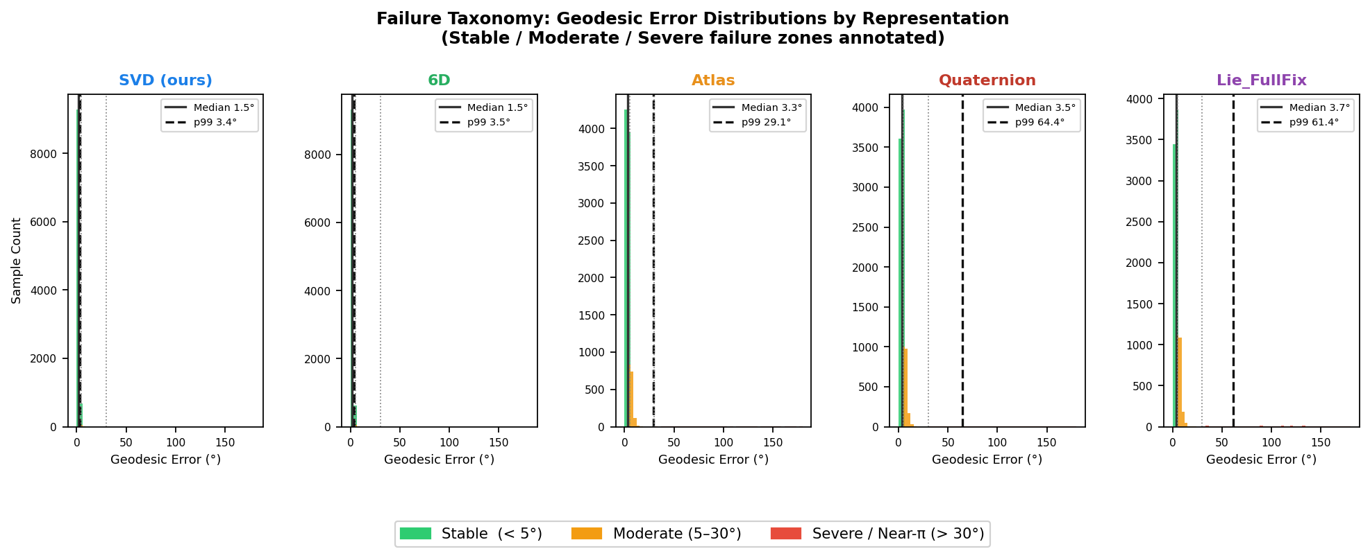

Figure 3 (Main): The Error Sweep 'Cliff Zone'
Line plot showing task success drops sharply as injected error scales.
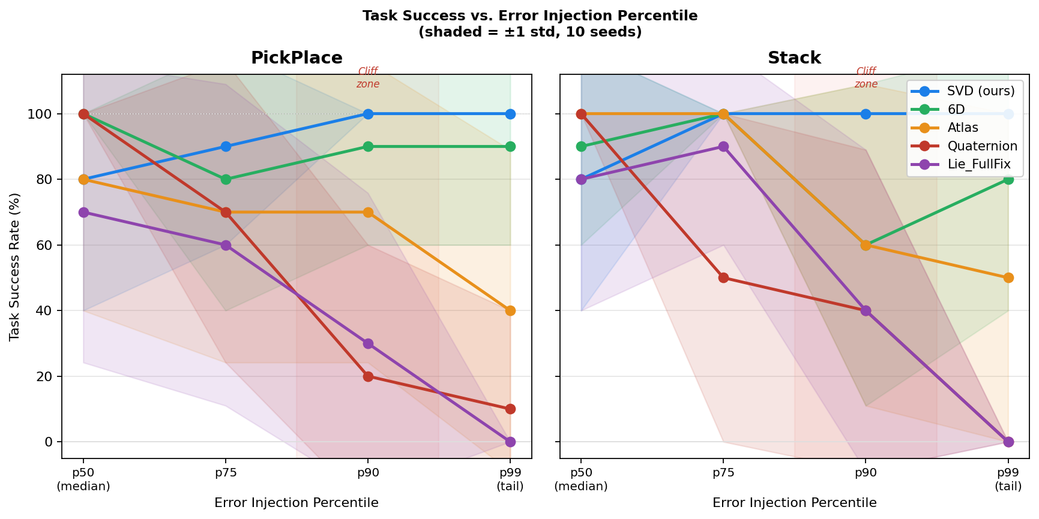
[Image planned: error_sweep.png]

Figure 4 (Main): Multi-Task Simulation Snapshots
Visual context for PickPlace, Stack, NutAssembly.
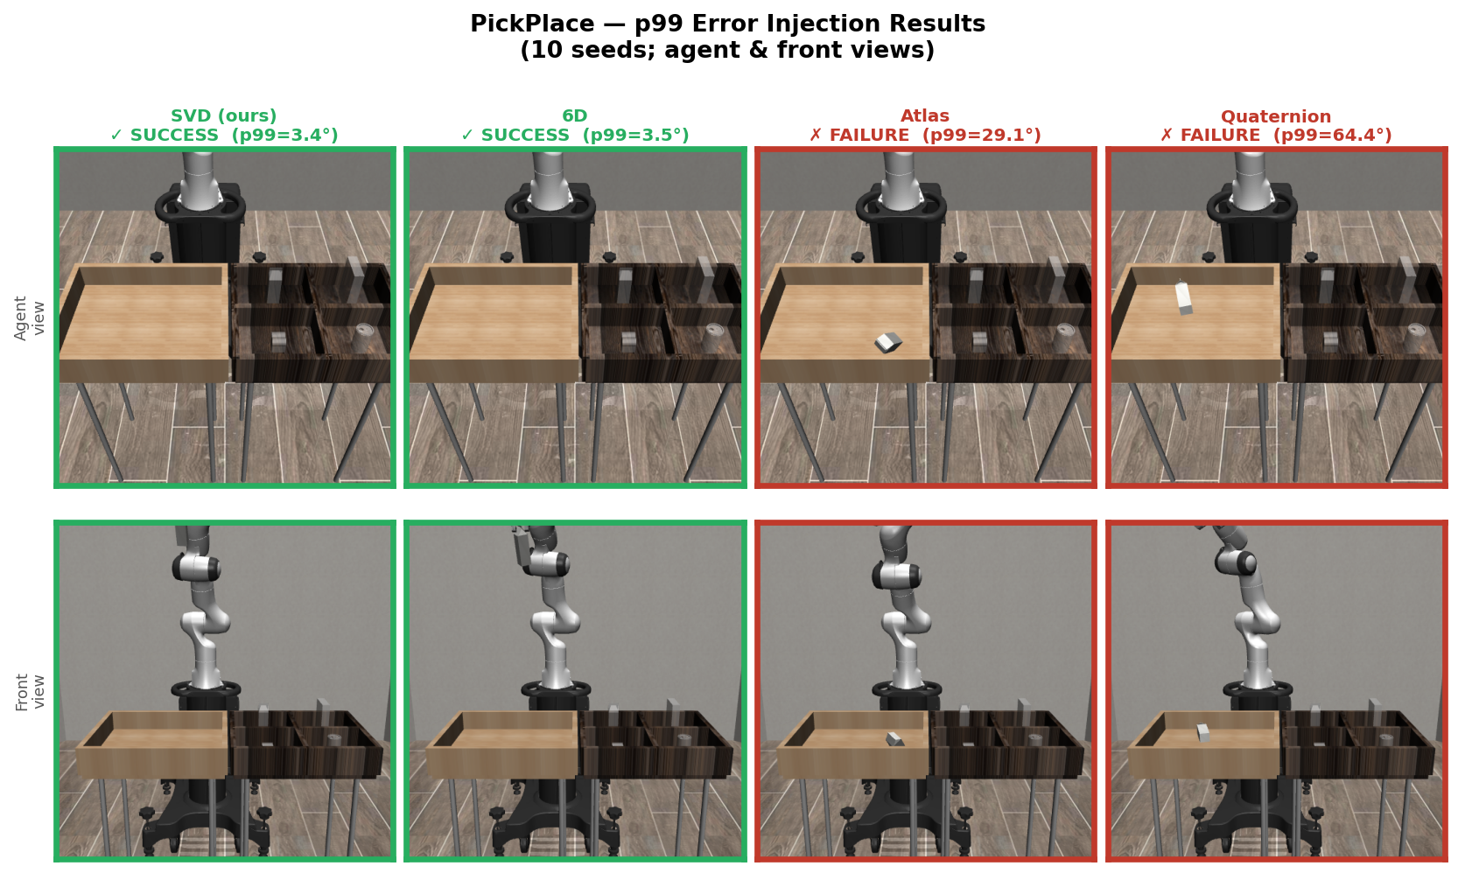

Figure 5 (Main/Appendix): Antipodal Boundary Heatmap
Prove that failures map to pi boundary.
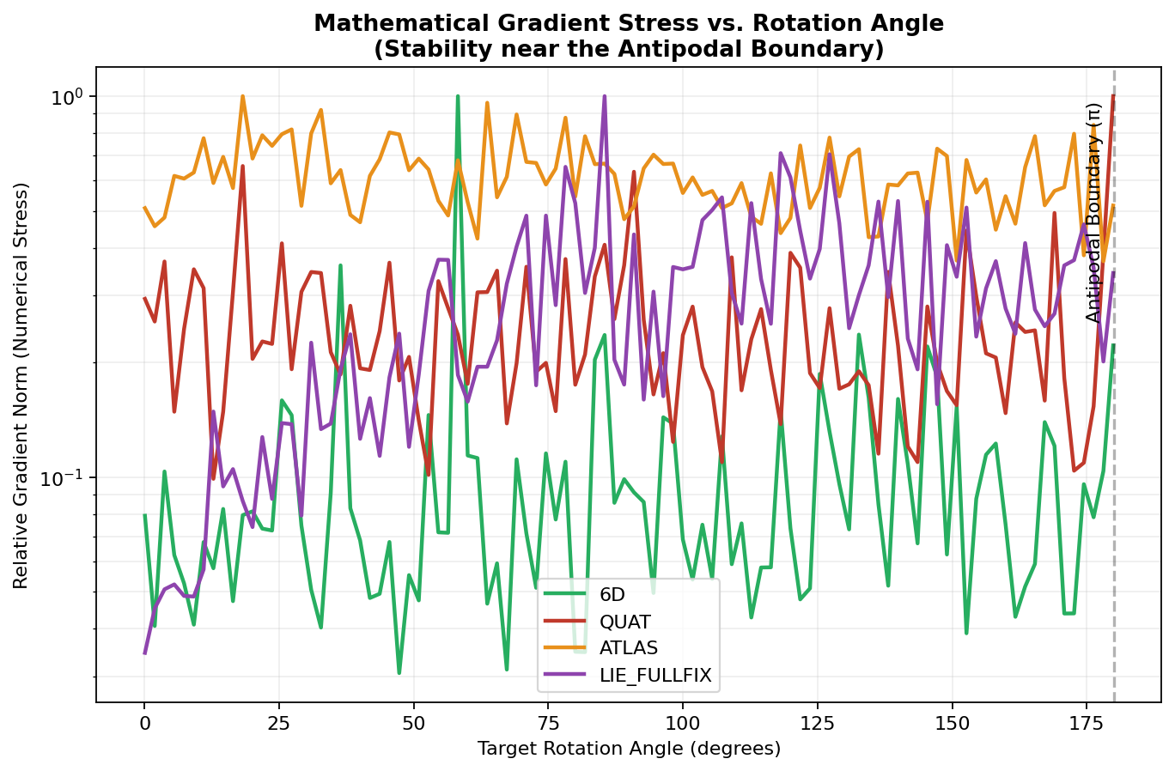

6. Table Plan

Table 1 (Main): Synthetic Benchmark Results
Rows: SVD (1.95, 4.27, 0%), 6D (1.81, 3.77, 0%), Quat (3.98, 57.39, 2.3%), Atlas [Oracle] (3.33, 28.76, 0.9%), Lie_FullFix (3.65, 57.27, 3.5%).

Table 2 (Main): Lie-Family Ablation
Rows: Raw Lie, Hardened, FullFix. Shows how architectural hardening alters the central/tail trade-off.

Table 3 (Main): Robosuite Multi-Task Summary
Rows: Baseline, SVD, 6D, Atlas, Quat, Lie_FullFix. Evaluates PickPlace, Stack, and NutAssembly. NutAssembly is a hard-ceiling diagnostic.

Table 4 (Main): Live Model-in-the-loop Results
Promoted to main paper. PickPlace live evaluation with SVD, 6D, FullFix, Raw Lie proving the dynamic case matches static error injection insights.

7. Reviewer-Safe Claim Language
• 'We provide controlled empirical evidence that...'
• 'Our synthetic benchmark isolates representation-induced failure modes...'
• 'Continuous methods (SVD, 6D) form a reliable top tier for bounding tail-risk...'
• 'Across achievable evaluated simulated tasks, lower tail error is associated with higher downstream robustness...'
• 'We identify the hard-angle boundary as a primary source of representation instability...'

8. What Not to Oversell
• Do not say 'SVD is universally superior.' -> Say 'SVD and 6D provide top-tier reliability.'
• Do not say 'Guarantees safe real-world robot deployment.' -> Say 'Bounding tail-risk is predictive of improved task success in continuous control simulations.'
• Do not hide the Atlas oracle caveat, the MLP external transfer failure (BOP), or the NutAssembly hard-ceiling.

