# REDHAT 7 PRACTICE

1. Reset root password

Press button ‘e’

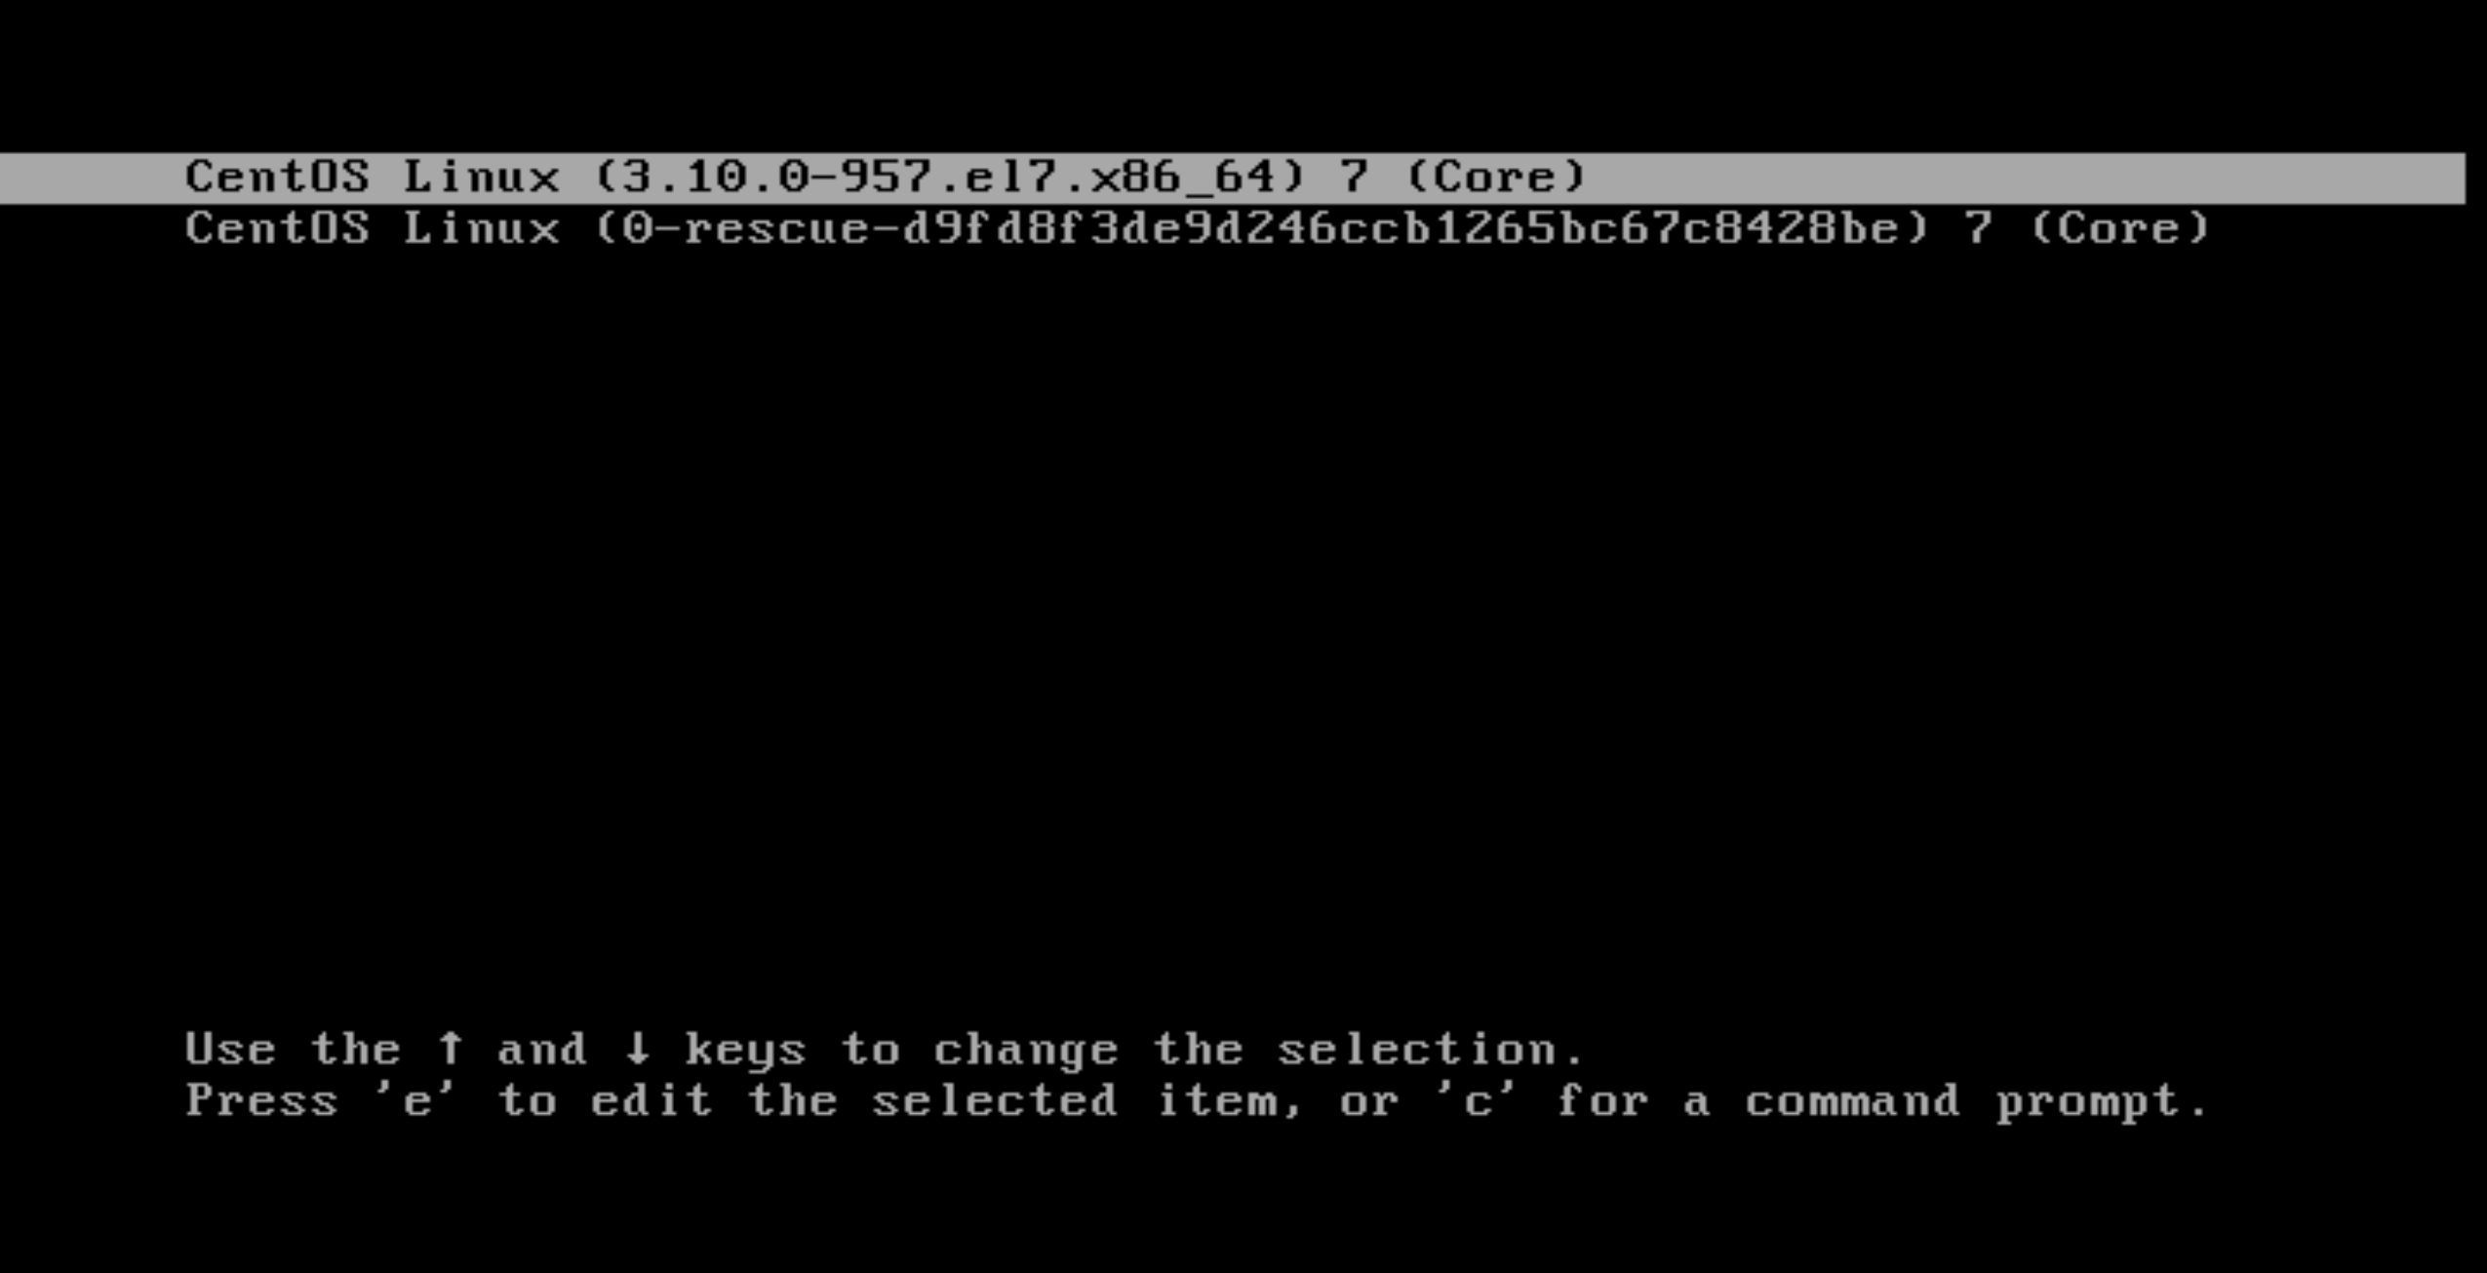

Find linux16 line, add highlighted content and then ctrl-X to save.

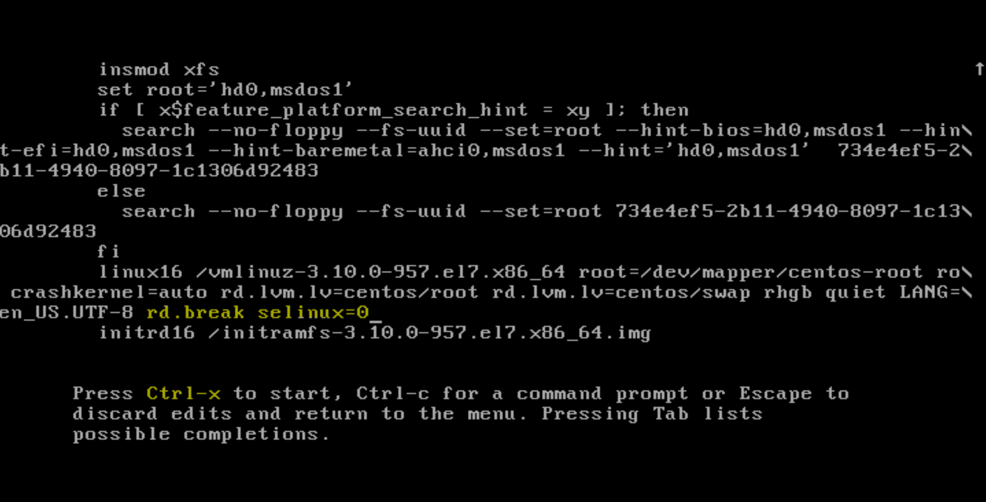

Once you do ctrl+x from the above step, it will take to the root terminal. Here, we need to remount /sysroot partition from read-only to read-write. And then chroot on /sysroot to make sysroot as a root directory. After which we can reset the root passwd as shown below:

Note: After reset the passwd, ‘exit’ a couple times, then the terminal should prompt to enter the passwd, where we need to type the new passwd.

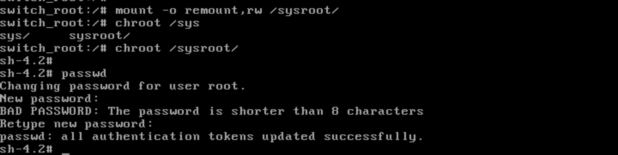

If you’re not using SELinux, you could reboot at this point and everything would be fine, however by default CentOS/RHEL 7 use SELinux in enforcing mode, so we need to fix the context of the /etc/shadow file. This is because when the ‘passwd’ command is run, it creates a new /etc/shadow file. As SELinux is not running in this mode the file is created with no SELinux contexts, which can cause problems when we reboot. Create the /.autorelabel command using ‘touch’.

[Linux Reset Root Password SELinux Autorelabel File System](http://www.rootusers.com/wp-content/uploads/2016/08/reset-root-password-7.png)