EXP.NO: 2 Write JavaScript Programme to validate the following fields of the HTML
Registration Page.

AIM:
To write JavaScript code to validate user input in a registration form. The validation will
ensure that the data entered by the user meets specific criteria for each field. This will help in maintaining data integrity and prevent invalid submissions.

ALGORITHM:
1. Input:
• The user fills in the following fields: First Name, Password, E-mail, Mobile
Number, Last Name, and Address.
2. Validation Steps:
1. Validate First Name:
o Check if the first name contains only alphabets.
o Ensure the length of the First Name is at least 6 characters.
o If any of these conditions fail, display an error message indicating the required
input.
2. Validate Password:
o Check if the password is at least 6 characters long.
o If it is less than 6 characters, display an error message.
3. Validate E-mail:
o Use a regular expression to check if the email follows the standard pattern:
name@domain.com.
o Ensure that the email contains no invalid characters and matches the required
pattern.
o If it doesn&#39;t match, display an error message indicating an invalid email
format.

4. Validate Mobile Number:
o Check if the mobile number contains exactly 10 digits.
o Ensure there are no alphabets or special characters.
o If the number is invalid, display an error message indicating the correct
format.
5. Validate Last Name:
o Ensure the Last Name field is not empty.
o If it is empty, display an error message.
6. Validate Address:
o Ensure the Address field is not empty.
o If it is empty, display an error message.

CODE:
Index.html:
<!DOCTYPE html>
<html>
<head>
<title>Online Music Streaming - Registration</title>
<link rel="stylesheet" href="style.css">
</head>

<body>

<!-- Header Section -->
<div class="header">
<img src="spotify.png" alt="Music Logo" class="logo-img">
<h1>Online Music Streaming</h1>
<p>Registration Form</p>
</div>

<!-- Registration Form -->
<div class="form-container">
<form onsubmit="return validateForm()">

<label>First Name:</label>
<input type="text" id="fname">

<label>Last Name:</label>
<input type="text" id="lname">

<label>Password:</label>
<input type="password" id="password">

<label>E-mail:</label>
<input type="text" id="email">

<label>Mobile Number:</label>
<input type="text" id="mobile">

<label>Address:</label>
<textarea id="address"></textarea>

<button type="submit">Register</button>

</form>
</div>

<script>
function validateForm() {

let fname = document.getElementById("fname").value;
let lname = document.getElementById("lname").value;
let password = document.getElementById("password").value;
let email = document.getElementById("email").value;
let mobile = document.getElementById("mobile").value;
let address = document.getElementById("address").value;

let namePattern = /^[A-Za-z]+$/;
let emailPattern = /^[a-zA-Z0-9._%+-]+@[a-zA-Z0-9.-]+\.[a-zA-Z]{2,}$/;
let mobilePattern = /^[0-9]{10}$/;

if (!namePattern.test(fname) || fname.length < 6) {
alert("First Name must contain only alphabets and minimum 6 characters.");
return false;
}

if (lname == "") {
alert("Last Name cannot be empty.");
return false;
}

if (password.length < 6) {
alert("Password must be at least 6 characters long.");
return false;
}

if (!emailPattern.test(email)) {
alert("Enter valid Email (example: name@domain.com).");
return false;
}

if (!mobilePattern.test(mobile)) {
alert("Mobile number must contain exactly 10 digits.");
return false;
}

if (address == "") {
alert("Address cannot be empty.");
return false;
}

// Redirect to success page
window.location.href = "success.html";
return false;
}
</script>

</body>
</html>

Next page.html:
<!DOCTYPE html>
<html>
<head>
<title>Registration Successful</title>
<link rel="stylesheet" href="style.css">
</head>
<body>

<div class="header">
<img src="spotify.png" alt="Logo" class="logo-img">
<h1>Registration Successful </h1>
<p>Welcome to Online Music Streaming!</p>
</div>

<div class="form-container">
<div style="
background: white;
padding: 40px;
border-radius: 25px;
box-shadow: 0 15px 35px rgba(0,128,0,0.15);
text-align: center;
width: 420px;
">
<h2 style="color:#2e7d32;">Your Account Has Been Created Successfully!</h2>
<p style="color:#388e3c;">Start enjoying your music now 🎵</p>
<br>
<a href="index.html">
<button>Go Back</button>
</a>
</div>
</div>

</body>
</html>

Style.css:
/* Body */
body {
margin: 0;
font-family: 'Segoe UI', sans-serif;
background: linear-gradient(135deg, #e8f5e9, #ffffff);
background-size: 200% 200%;
animation: bgMove 6s ease infinite;
}

/* Background Animation */
@keyframes bgMove {
0% { background-position: left; }
50% { background-position: right; }
100% { background-position: left; }
}

/* Header */
.header {
text-align: center;
padding: 40px 0 20px;
animation: fadeDown 1s ease;
}

.logo-img {
width: 120px;
height: auto;
display: block;
margin: 0 auto 15px;
}

.header h1 {
margin: 5px 0;
color: #1b5e20;
}

.header p {
color: #388e3c;
font-size: 18px;
}

/* Header Animation */
@keyframes fadeDown {
from { opacity: 0; transform: translateY(-300px); }
to { opacity: 1; transform: translateY(0); }
}

/* Form Container */
.form-container {
display: flex;
justify-content: center;
margin-bottom: 50px;
animation: slideUp 1s ease;
}

@keyframes slideUp {
from { opacity: 0; transform: translateY(250px); }
to { opacity: 1; transform: translateY(0); }
}

/* Form Box */
form {
width: 420px;
background: rgba(255,255,255,0.95);
padding: 35px;
border-radius: 25px;
box-shadow: 0 15px 35px rgba(0,128,0,0.15);
}

/* Labels */
label {
font-weight: 600;
color: #2e7d32;
font-size: 14px;
}

/* Inputs */
input, textarea {
width: 100%;
padding: 12px;
margin: 8px 0 18px;
border: 1px solid #c8e6c9;
border-radius: 15px;
outline: none;
transition: 0.3s;
}

input:focus, textarea:focus {
border-color: #2e7d32;
box-shadow: 0 0 10px rgba(46,125,50,0.25);
transform: scale(1.02);
}

/* Button */
button {
width: 100%;
padding: 14px;
background: linear-gradient(135deg, #43a047, #2e7d32);
color: white;
border: none;
border-radius: 20px;
font-size: 16px;
cursor: pointer;
transition: 0.3s;
}

button:hover {
transform: translateY(-3px);
box-shadow: 0 10px 20px rgba(0,128,0,0.3);
}

button:active {
transform: scale(0.97);
}

OUTPUT:
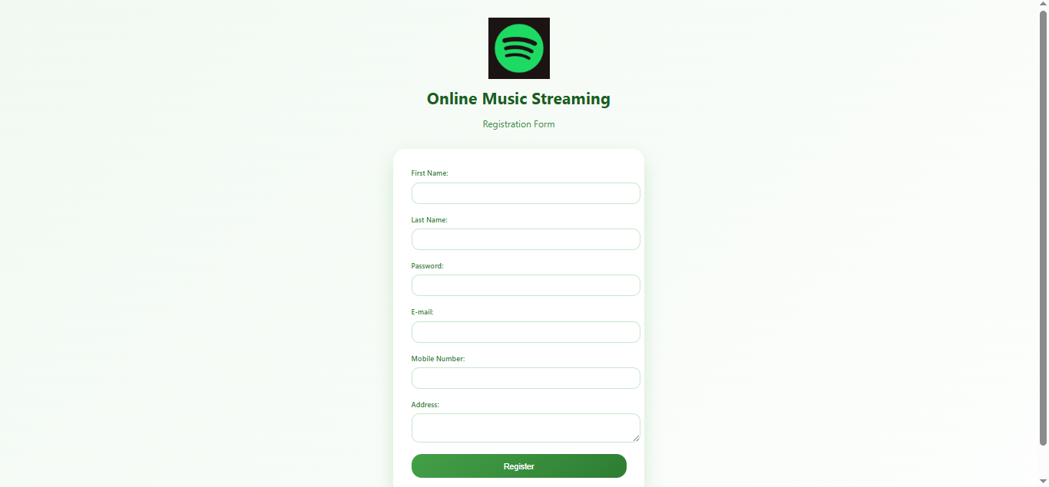



RESULT:
HTML page with Form is created and is validated using Javascript.

