

Create a web form that accepts a user's name and age. EXP.NO: 4 Write a Servlet to process the form data and display it
back on the browser.

AIM:

To create a simple web application that includes a form to accept a user's name and age, and then use a Servlet to process the submitted data. The Servlet will retrieve the form data, process it, and display the values back on the browser.

ALGORITHM:

1. Input:

• The user fills out a web form with their name and age and submits it.

2. Form Handling and Servlet Processing:

1. Create the Web Form:

o Create an HTML form with two input fields: one for the user's name and one for the user's age.

o Add a submit button to the form.

o Set the form's action attribute to the URL of the Servlet and the method to POST (or GET).

2. Create the Servlet Class:

o Write a Servlet that processes the form data submitted by the user.

o The Servlet will override the doPost() (or doGet() depending on the form method) to handle form submissions.

o The Servlet will retrieve the name and age parameters from the request object using request.getParameter("name") and request.getParameter("age").

3. Process the Data in the Servlet:

o Extract the name and age values submitted from the form.

o Validate the input (e.g., check if the age is a valid number).

o Prepare a response that will display the user's name and age back on the browser.

4. Send Response to the Browser:

o The Servlet will send a response to the browser containing a message like:

"Hello, [name]! You are [age] years old."
The response will be displayed to the user in the browser.

5. Deploy the Servlet:

o Compile the Servlet and deploy it to a Servlet container (like Apache Tomcat).

o Ensure the web.xml file or Servlet annotations are used to map the Servlet to the URL defined in the form's action attribute.

6. Test the Application:

o Open the web browser, fill in the form with the name and age, and submit it.

o The Servlet will process the data and display the message back to the user in the browser.

HTML File ( index.html ):

<html>
<head>
<title>Music App Login</title>

<style>
body {
font-family: Arial, sans-serif;
background: linear-gradient(to right, #1f4037, #99f2c8);
margin: 0;
padding: 0;
}

.container {
width: 350px;
margin: 120px auto;
padding: 30px;
background: white;
border-radius: 12px;
box-shadow: 0px 0px 15px rgba(0,0,0,0.3);
text-align: center;
}

h2 {
margin-bottom: 20px;
color: #333;
}

input {
width: 90%;
padding: 10px;
margin: 10px 0;
border-radius: 6px;
border: 1px solid #ccc;
}

button {
padding: 10px 20px;
background: #28a745;
border: none;
color: white;
border-radius: 6px;
cursor: pointer;
font-weight: bold;
}

button:hover {
background: #218838;
}
</style>

<script>
function showPopup() {
alert("Login Successful");
return true;
}
</script>

</head>

<body>

<div class="container">

<h2>Music Streaming Login</h2>

<form action="/Exp04/login" method="post" onsubmit="return showPopup()">

<input type="text" name="name" placeholder="Enter your name" required>

<input type="number" name="age" placeholder="Enter your age" required>

<br>

<button type="submit">Login</button>

</form>

</div>

</body>
</html>

Java File ( UserServlet.java ) :

import java.io.*;
import javax.servlet.*;
import javax.servlet.http.*;

public class LoginServlet extends HttpServlet {

public void doPost(HttpServletRequest request, HttpServletResponse response)
throws ServletException, IOException {

response.setContentType("text/html");
PrintWriter out = response.getWriter();

String name = request.getParameter("name");
String age = request.getParameter("age");
String song = request.getParameter("song");

out.println("<html><body style='background:#0f2027; color:white; text-align:center;'>");

out.println("<div style='margin-top:100px;'>");

out.println("<h2>Hello, " + name + "! You are " + age + " years old.</h2>");

// Extra UI (your music app part)
out.println("<h3>🎧 Welcome to Music World 🎧</h3>");
out.println("<h3>🎵 Your Favorite Song: " + song + "</h3>");

out.println("<br><button onclick='history.back()'>🔙 Back</button>");
out.println("</div>");

out.println("</body></html>");
}
}

File ( web.xml) :

<webapp> <servlet>
<servlet-name>UserServlet</servlet-name> <servlet-class>UserServlet</servlet-class>
</servlet>

<servlet-mapping>
<servlet-name>UserServlet</servlet-name> <url-pattern>/UserServlet</url-pattern>
</servlet-mapping> </webapp>

OUTPUT:

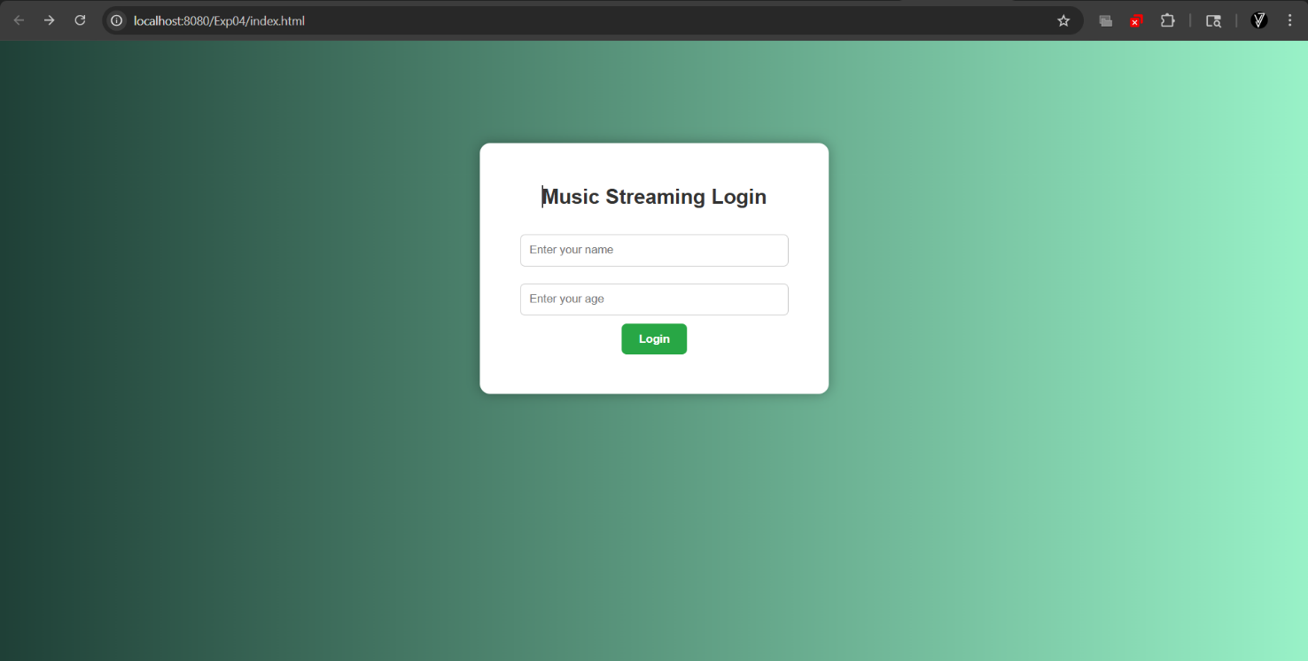

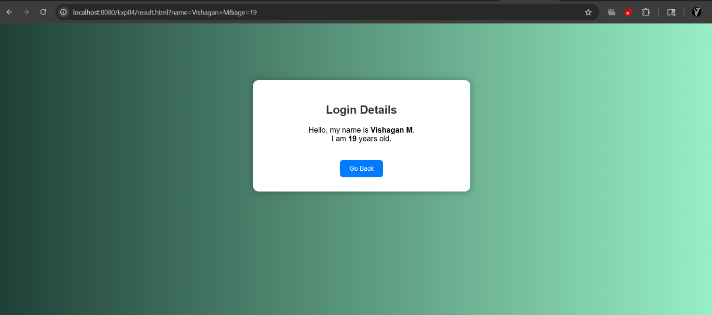

RESULT:

Thus A Servlet was created to process the HTML form data and display it back on the browser.

