**Project Topic**

**System Information with Open-Source Software**

**LOVELY PROFESSIONAL UNIVERSITY**

**PHAGWARA, PUNJAB**



**Presented By**

**Name: Suhel Khan**

**Registration Number: 11904509**

**Section: KE023**

**Roll Number: 5**

**Project GitHub Link: -** <https://github.com/suhelkhan2001/Sys_Info_Open_Source.git>

**Q. Use any Open-Source Software displays details about various system information tools, like the CPU, motherboard, monitor, audio, network, and other components. Also display the current and average speed/rate of the memory, hard drive, and CPU.**

**Introduction**

**Description of the project: -**

🡪 ASTRA32 is another free system information tool that shows amazing detail on numerous devices and other parts of the system.

There are several categories to separate the information it gathers on hardware, like that of a motherboard, storage, and monitor information.

A system summary section is perfect for seeing an overview of all the hardware and operating system details. Also, a dedicated section for live monitoring is included to show the temperature and current usage of various hardware components.

ASTRA32 works as a demo program, but it does not really mean much because it still provides lots of useful information.

It can be used on Windows 11, 10, 8, 7, Vista, XP, 2000, and Windows Server 2008 and 2003.

**Objective of the project: -**

The objective of the topic is to provide information about open-source software that can display system information and performance metrics. The topic suggests using a software called "ASTRA32" to display details about various system information tools such as the CPU, motherboard, monitor, audio, network, and other components.

Additionally, the topic suggests using commands such as "mpstat", "free", and "iostat" to display current and average speed/rate of the memory, hard drive, and CPU.

The objective of this topic is to help users monitor their system performance and identify potential performance issues. By using open-source software, users can access detailed system information without having to purchase proprietary software.

This can be particularly useful for individuals and organizations that need to monitor the performance of multiple systems, as open-source software is often free and can be installed on multiple systems.

**Scope of the project: -**

The scope of the project is to provide information about open-source software that can display system information and performance metrics. Specifically, the topic focuses on a software called "ASTRA32" and commands such as "mpstat", "free", and "iostat" to display details about various system components and the current and average speed/rate of the memory, hard drive, and CPU.

The project does not cover other open-source software or proprietary software that can be used to monitor system performance. Additionally, the topic does not cover in-depth analysis of system performance or specific techniques for optimizing system performance. Instead, the topic provides a high-level overview of tools that can be used to monitor system performance and identify potential performance issues.

**CPU Current Details**

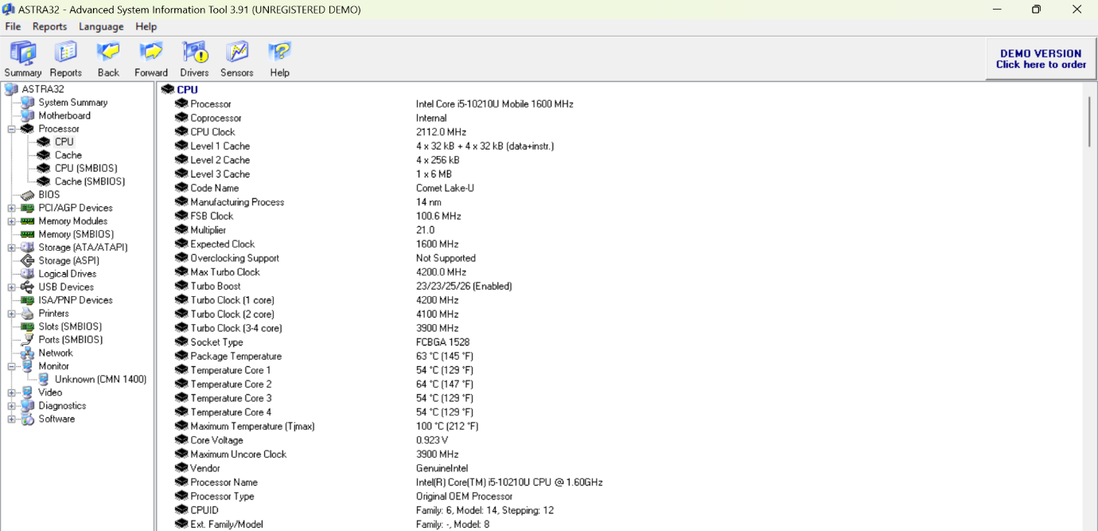

**Motherboard Details**

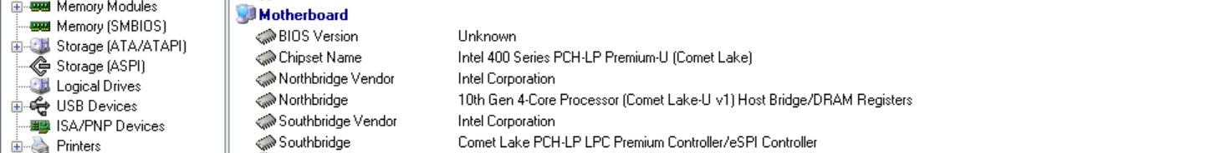

**Memory and Storage Details**

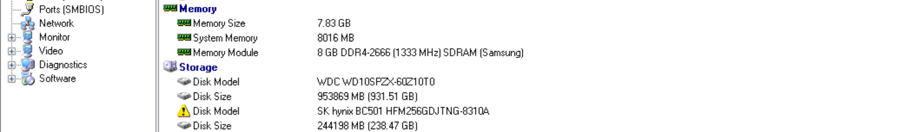

**Network Details**

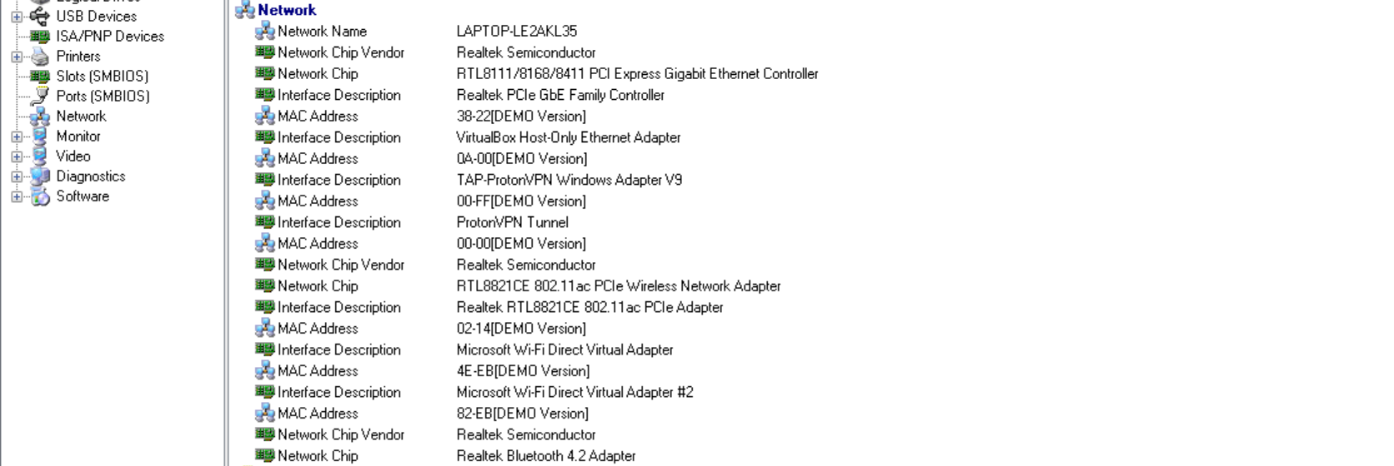

**Another way to display all the system information of the device is with the help of some UBUNTU Command**

One example of an open-source software that can display system information is "hwinfo".

To install hwinfo on Ubuntu-based systems, you can run the following command:

* **sudo apt-get install hwinfo**

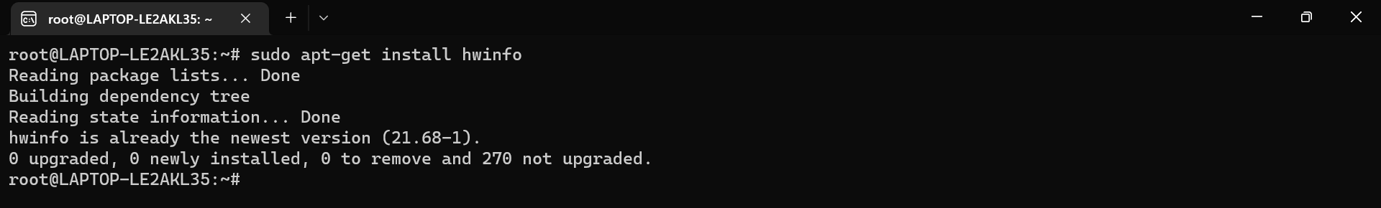

Once installed, you can use the following command to display detailed system information:

* **sudo hwinfo**

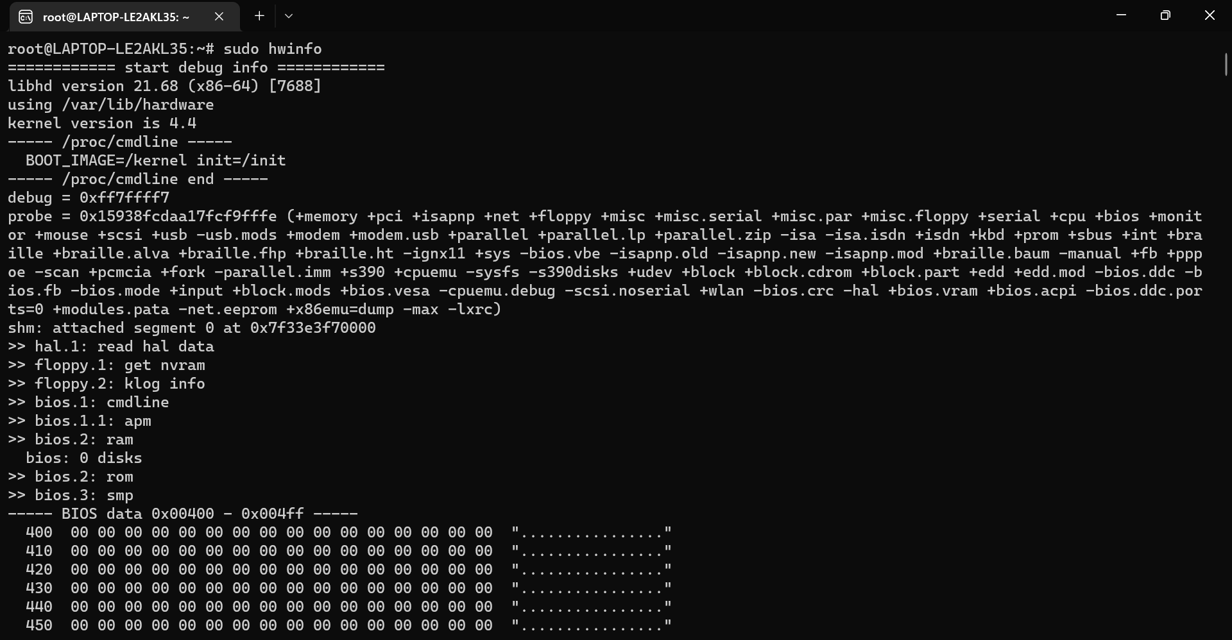

**To display CPU speed and usage:**

**🡪sudo apt-get install sysstat**

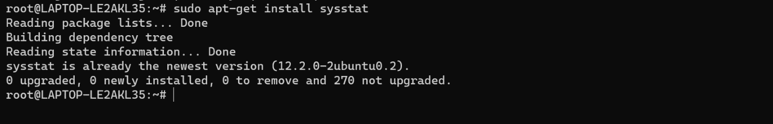

**🡪sudo mpstat -P ALL**

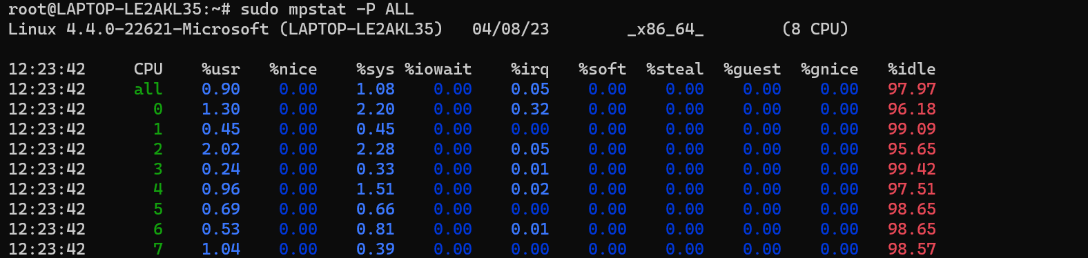

**To display memory usage and speed:**

**🡪sudo free -m**



**To display hard drive usage and speed:**

**🡪sudo iostat -dx /dev/sda**

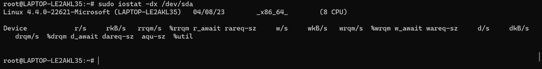

**Reference/ Bibliography**

Some general references and resources related to the topic of open-source software for system information and performance monitoring:

"hwinfo" official website: https://www.hwinfo.com/

"mpstat" man page: https://linux.die.net/man/1/mpstat

"free" man page: https://linux.die.net/man/1/free

"iostat" man page: https://linux.die.net/man/1/iostat

"sysstat" official website: <https://github.com/sysstat/sysstat>

"Top 10 Linux Performance Monitoring Tools" by Ravi Saive, published on Tecmint: https://www.tecmint.com/top-linux-performance-monitoring-tools/

"10 Tools to Monitor Your Linux Server – Network and System Monitoring" by Magesh Maruthamuthu, published on LinuxTechi: https://www.linuxtechi.com/10-tools-monitor-linux-server-performance/

"Linux System Monitoring: Top 12 Tools" by Jeffry R. Davis, published on Datamation: https://www.datamation.com/open-source/linux-system-monitoring-tools.html

"Linux Performance Monitoring and Tuning" by Brendan Gregg, published on the Oracle Technology Network: https://docs.oracle.com/cd/E37670_01/E37355/html/ol_perfmon_tuning.html

"Linux Performance Monitoring with perf" by Brendan Gregg, published on his website: http://www.brendangregg.com/linuxperf.html

