Expt 1: outputs

1] date
Tue Aug 23 15:51:54 IST 2022
date +%m 08
date +%h Aug
date +%d 23
date +%y 22
date +%H 15
date +%M 51
date +%S 54
date +%T 15:51:54
date +%D 08/23/22

2]cal
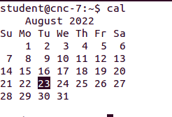

cal 10 2002

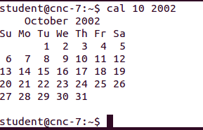

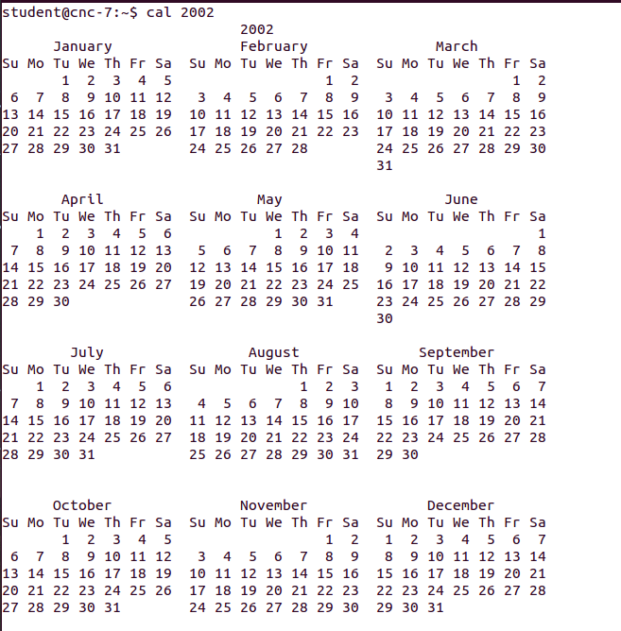

cal 2002

3]who

student@cnc-7:~$ who
student :0 2022-08-23 15:08 (:0)
student pts/0 2022-08-23 16:43 (:0)
student@cnc-7:~$

WHO M I
student@cnc-7:~$ who m i
student pts/0 2022-08-23 16:43 (:0)
student@cnc-7:~$

4]ps
student@cnc-7:~$ ps
PID TTY TIME CMD
4029 pts/0 00:00:00 bash
4110 pts/0 00:00:00 ps
student@cnc-7:~$

5]ls
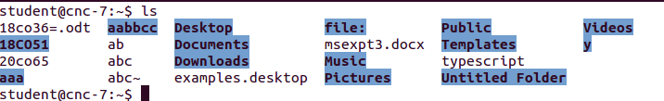

6]WC
student@cnc-7:~$ wc abc
1 2 13 abc
student@cnc-7:~$ wc -l abc
1 abc
student@cnc-7:~$ wc -w abc
2 abc
student@cnc-7:~$ wc -c abc
13 abc

7]cat
ALL THE FILE COMMANDS

8]man
student@cnc-7:~$ man ls
OPENS THE MANUAL

9] echo
student@cnc-7:~$ echo "hello world"
hello world
student@cnc-7:~$

10]BC
student@cnc-7:~$ bc
bc 1.06.95
Copyright 1991-1994, 1997, 1998, 2000, 2004, 2006 Free Software Foundation, Inc.
This is free software with ABSOLUTELY NO WARRANTY.
For details type `warranty'.
2+3
5
CTRL +D TO EXIT

11] type

student@cnc-7:~$ type ls
ls is aliased to `ls --color=auto'
student@cnc-7:~$

12] script
student@cnc-7:~$ script 20co65
Script started, file is 20co65
Script done on Tuesday 23 August 2022 04:17:41 PM IST

13]passwd
student@cnc-7:~$ passwd
Enter new UNIX password:
Retype new UNIX password:
passwd: Authentication token manipulation error
passwd: password unchanged

14]uname
student@cnc-7:~$ uname
Linux
VERSION
student@cnc-7:~$ uname -r
3.16.0-30-generic

meta characters (*,>,|)
student@cnc-7:~$ ls a*
ab abc abc~

aaa:
SHOWS NUMBER OF FILES IN THE DIRECTORY
student@cnc-7:~$ ls |wc -l
20

15]tty
student@cnc-7:~$ tty
/dev/pts/10

16]twd
student@cnc-7:~$ pwd
/home/student

17]mkdir
student@cnc-7:~$ mkdir aabbcc
MAKE ONE FOLDER WITHIN ANOTHER FOLDER
student@cnc-7:~$ mkdir a/b
MAKE 2 SIMULTANEOUS FOLDERS
student@cnc-7:~$ mkdir x y

18]CHANGE DIRECTORIES
student@cnc-7:~$ cd aabbcc
COME BACK TO PREVIOUS DIRECTORY
student@cnc-7:~/aabbcc$ cd ..

19]REMOVE DIRECTORY
student@cnc-7:~$ rmdir x
REMOVES FILE
student@cnc-7:~$ mkdir -p os/unit1/intro
student@cnc-7:~$ rmdir os/unit1/intro

20] CP
student@cnc-7:~$ cp test3.txt test
GIVE THE EXTENTION AND COPY THE CONTENT OF THE FILE TO NEW FILE IF FILE DOSENT EXIST THEN IT CREATES THE NEW FILE

student@cnc-7:~$ cp -r os as

student@cnc-7:~$ cp -i test3.txt ab

student@cnc-7:~$ cp -i test2.txt ab // INTERACTIVE
cp: overwrite ‘ab’? Y

student@cnc-7:~$ cp -R test3.txt ab

21]RM
student@cnc-7:~$ rm -i test
rm: remove regular file ‘test’? Y

student@cnc-7:~$ rm -R as

-I -> IS FOR THE FILE
-R-> IS FOR THE FOLDER
-F -> FORCEFUL REMOVAL

22]MV
RENAMING FILE
student@cnc-7:~$ mv ab ba

MOVING THE FILE BOTH THE FILES TO THE FOLDER
student@cnc-7:~$ mv test2.txt test3.txt os
FILE1 FILE2 FOLDER

23]CMP

IF DIFFERENT FILE
student@cnc-7:~$ cmp ba ab
ba ab differ: byte 4, line 1

IF SAME FILE
student@cnc-7:~$ cmp ba ab

24]CHMOD
CHANGING THE MODE
CHANGES THE PERMISSION OF FILES

d -> folder
- (dash) -> file

r read
w write
x execute

1]owner /user u
2] group owner g
3] others o
* a for all 3
eg:
-rw-rw-r-- 1 student student 15 Aug 26 11:41 ba~
drwxr-xr-x 6 student student 4096 Aug 25 09:28 Desktop

assigning +
removing -

RELATIVE
remove writting from group owner and assign writting for others and assign execution to all

student@cnc-7:~$ chmod u-w,g-w,o+w,a+x ab
student@cnc-7:~$ ls -l ab
-r-xr-xrwx 1 student student 15 Aug 26 11:57 ab

ABSOLUTE

for user i want to give reading and execution
group owner reading and writing
other only reading

student@cnc-7:~$ chmod 564 ab
student@cnc-7:~$ ls -l ab
-r-xrw-r-- 1 student student 15 Aug 26 11:57 ab

BITS TABLE
000|0
001|1
010|2
011|3
100|4
101|5
110|6
111|7

*RELATIVE the permissions are changed selectively
*ABSOLUTE all the permissions are changed

25]WILDCARDS
TO FIND THE SIMILAR PATTERN IN THE FILE NAME
a] *
* indicates 0 or more
ls a*
student@cnc-7:~$ ls a*
a1bc ab abb abc abc~ abcd
aaa:
aabbcc:

b] ?
MATCH A SINGLE CHARACTER
student@cnc-7:~$ ls a?
ab
student@cnc-7:~$ ls a?c
abc

c] [ijk]
student@cnc-7:~$ ls a[123]bc
a1bc

d] [!ijk]
student@cnc-7:~$ ls a[!123]bc
ls: cannot access a[!123]bc: No such file or directory

e] [a-c]
f][!a-c]

student@cnc-7:~$ ls a[b-c]
ab
student@cnc-7:~$ ls a[!c-f]
ab
student@cnc-7:~$ ls a[123]bc
a1bc
student@cnc-7:~$ ls a[!123]bc
a4bc
student@cnc-7:~$

THIS DISPLAYS THE FILES WHICH DOES NOT HAVE 123
student@cnc-7:~$ ls a[!123]bc
a4bc a*bc

g] escaping

student@cnc-7:~$ echo i have $100
i have 00
student@cnc-7:~$ echo i have \$100
i have $100

echo
student@cnc-7:~$ s=9
student@cnc-7:~$ echo $s
9

