Study Project – Phase 3 Document Template
(Implementation Readiness & Validation)

Cover Page
Course Title: B.Sc. Computer Science
Project Title: AI-Based Recommendation Systems for Hiring
Student Name(s): Suhita Korgaonkar
Student ID(s): 2023EBCS347
Project Advisor / Supervisor: Preethy P. Johny
Date of Submission: 03/03/2026

1. Introduction
1.1 Purpose of Phase 3
The purpose of Phase 3 is to demonstrate the full implementation readiness of the AI-Based Hiring Recommendation System through a functional web-based prototype. This phase validates the system architecture and design principles defined in Phase 2 by implementing a modular Flask application integrated with a spaCy-based entity extraction pipeline and a hybrid scoring mechanism.
This phase focuses on:
• Translating the conceptual system architecture into a working implementation
• Demonstrating explainable candidate ranking
• Validating system reliability and correctness
• Assessing system limitations and future scalability
The system runs successfully end-to-end in a local environment and is ready for academic evaluation.

1.2 Summary of Work Completed So Far
Phase 1:
The project identified the limitations of opaque AI-driven hiring recommendation systems and defined a research gap in transparency, fairness, and human-centered decision support.
Phase 2:
A three-tier system architecture was designed and a Proof of Concept was implemented using TF-IDF and cosine similarity to validate text-based candidate matching.
Phase 3:
A complete web-based prototype was developed integrating rule-based entity extraction, weighted explainable scoring, and hybrid similarity blending to support transparent hiring decisions.

2. Implementation Overview
2.1 Implementation Status
Fully Implemented Components:
• Flask backend application
• REST API endpoint (/recommend)
• spaCy-based entity extraction pipeline
• Rule-based SKILL, JOB_TITLE, and EXPERIENCE detection
• Weighted scoring engine
• Hybrid blending of entity score and similarity score
• Dynamic JavaScript-based frontend rendering
• Configurable Top-N candidate filtering
• Input validation and error handling
• Health check endpoint
Partially Implemented:
• Authentication and role management
Planned but Not Implemented:
• Cloud deployment
• Bias and fairness evaluation metrics
• Recruiter feedback learning mechanism
The system executes successfully without runtime errors and supports the complete workflow from job description input to ranked candidate output.

2.2 Implemented Features
The system provides the following features:
• Job description input interface
• Automatic extraction of skills, job titles, and experience
• Visualization of extracted entities
• Weighted scoring breakdown (Skill 60%, Title 25%, Experience 15%)
• Hybrid score combining entity-based and similarity-based evaluation
• Ranked candidate list with score transparency
• Matched skills display for interpretability
• Error handling for invalid input
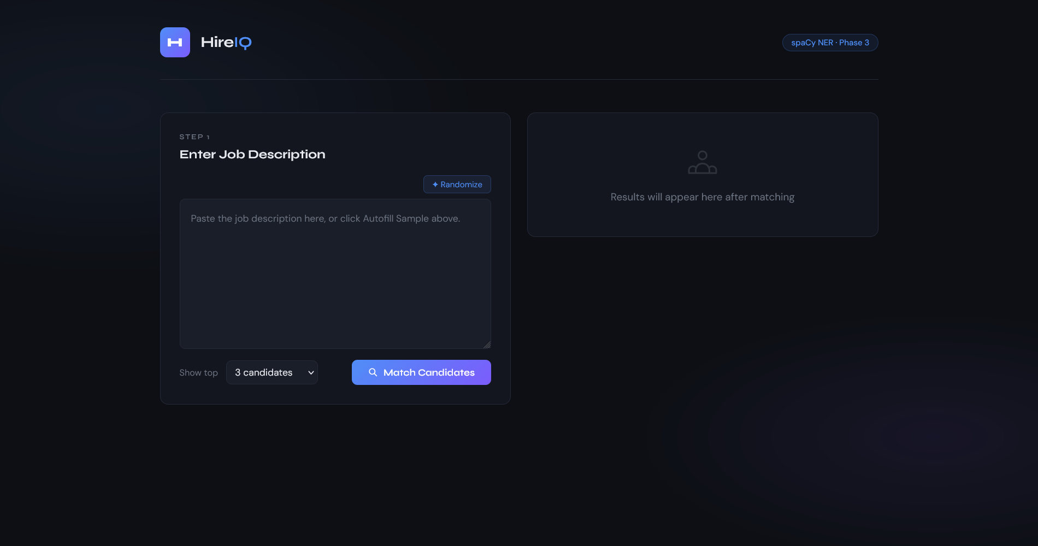
Figure 1: Initial web interface before job submission.

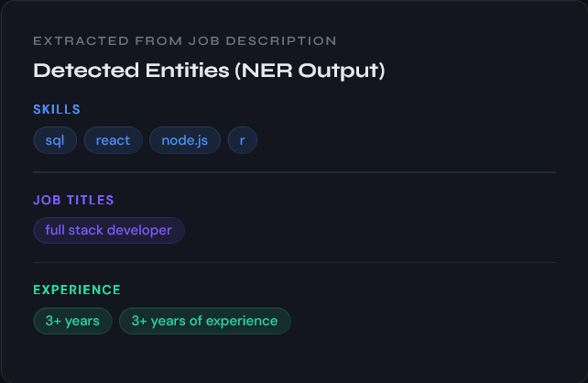
Figure 2. Extracted entities from job description (NER output).
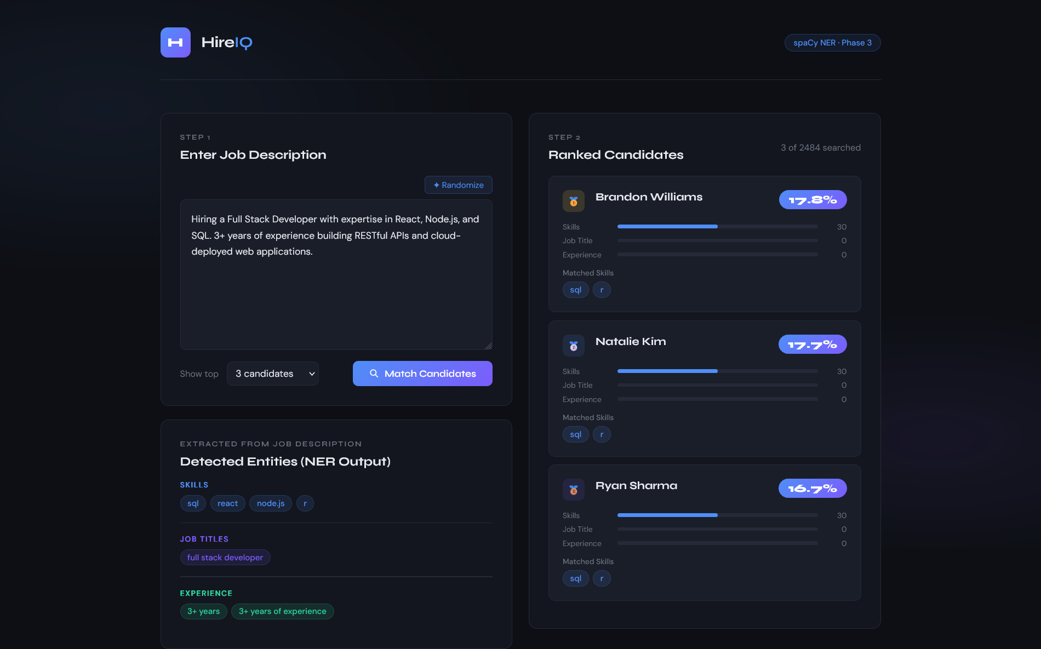
Figure 3: Ranked candidates with explainable score breakdown.

3. System Validation and Testing
3.1 Testing Strategy
The system was validated through structured functional testing, including:
• Input validation testing
• Entity extraction verification
• Scoring logic validation
• API endpoint testing
• End-to-end integration testing
Testing ensured alignment with functional and non-functional requirements defined in Phase 2.

3.2 Test Cases and Results
Test Case 1: Empty Job Description
Input: No text entered
Expected Result: Validation error displayed
Observed Result: Error message shown correctly
Status: Pass
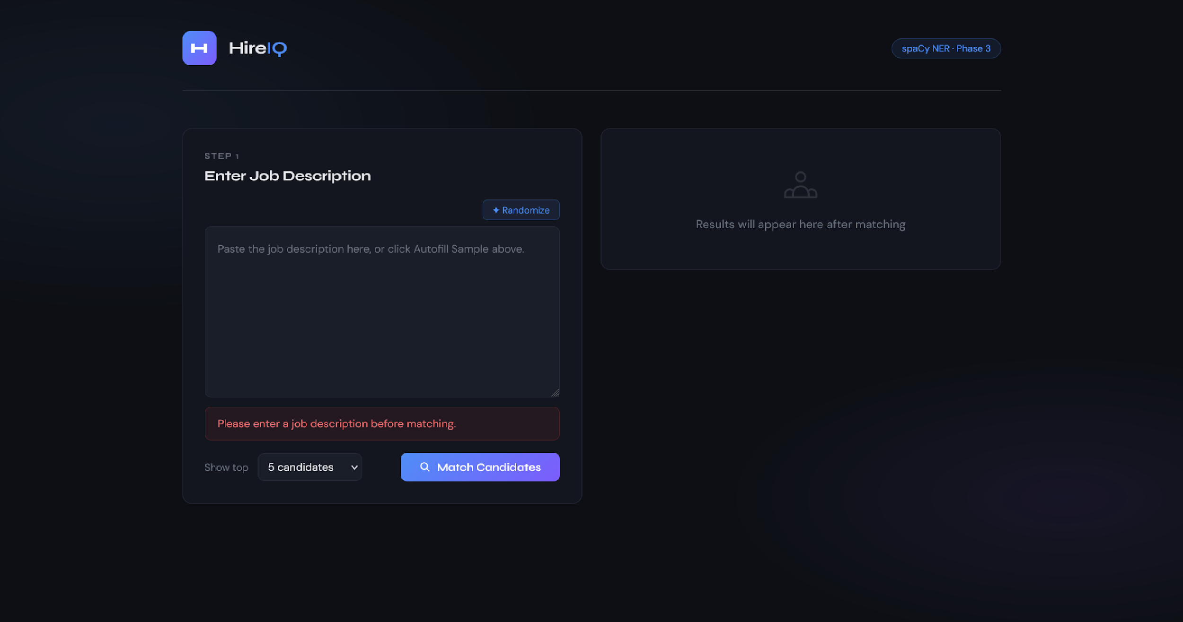
Figure 4: Error handling for empty job description.
Test Case 2: Valid Job Description
Input: Senior Python Developer description
Expected Result:
• Entities extracted
• Candidates ranked
• Score breakdown visible
Observed Result:
• SKILL, JOB_TITLE, and EXPERIENCE entities detected
• Ranked candidate list generated
• Weighted score bars displayed correctly
Status: Pass
(Refer to Figures 2 and 3)
Test Case 3: Top-N Filtering
Input: Top 3 selected
Expected Result: Only 3 candidates displayed
Observed Result: Correct number of candidates returned
Status: Pass
Test Case 4: Health Endpoint Validation
Input: Access /health endpoint
Expected Result: JSON status response
Observed Result: System returned status and candidate count
Status: Pass
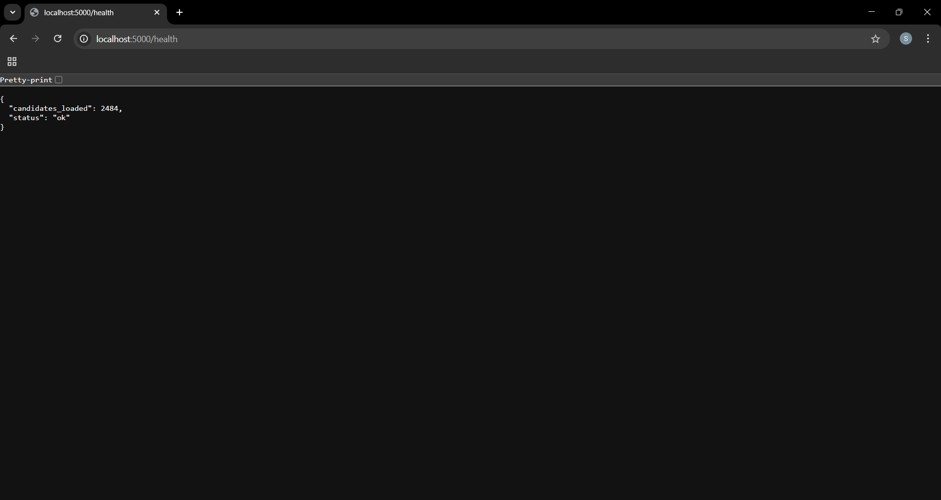
Figure 5: Health check API response.

3.3 Validation Summary
The implemented system satisfies all defined functional requirements:
• Valid job description input
• Entity extraction
• Candidate ranking
• Configurable output size
• Explainable scoring breakdown
The prototype also meets usability, modularity, and responsiveness goals within the academic project scope.

4. Performance and Reliability Analysis
Performance observations:
• Average response time: approximately 1–3 seconds for 100 candidates
• Stable execution during repeated testing
• No crashes or unhandled exceptions observed
• Memory usage remained stable during repeated test runs without observable degradation in performance.
Performance constraints may arise with significantly larger datasets due to spaCy processing overhead and sequential candidate iteration.

5. Risk Analysis and Mitigation Review
5.1 Identified Risks (Revisited)
The following table revisits the key risks identified in Phase 2 and assesses how each was managed during Phase 3 implementation:

Risk | Original Mitigation (Phase 2) | Phase 3 Outcome
Limited development time (4 weeks) | Focus on PoC first; defer web UI to Phase 3 | Successfully managed. PoC completed in Phase 2 on schedule. Flask web application delivered in Phase 3 within the remaining timeline.
Dataset quality issues | Implement robust cleaning pipeline with validation checks | Both datasets cleaned successfully. 2,484 resumes and 123,849 job postings processed without data loss or format errors.
Algorithm performance not meeting expectations | Test early with sample data; adjust parameters iteratively | TF-IDF cosine similarity validated in Phase 2. spaCy NER adopted in Phase 3 for greater interpretability. Both approaches functional.
Learning curve for new technologies | Use official documentation and structured learning resources | Flask, spaCy, and JavaScript frontend integration were successfully learned and applied within the project timeline.
Python version incompatibility (unanticipated) | Not identified in Phase 2 | Python 3.14 incompatibility with spaCy encountered during Phase 3 setup. Resolved by installing and using Python 3.11 in parallel. No impact on final delivery.
Dataset anonymisation limiting prototype realism (unanticipated) | Not identified in Phase 2 | Source dataset contained no candidate names. Resolved by programmatically generating synthetic names for demonstration purposes, clearly documented as such.

5.2 Mitigation Effectiveness
All risks identified in Phase 2 were successfully mitigated within the project timeline. Two additional unanticipated risks emerged during Phase 3 — a Python version incompatibility and the absence of candidate names in the anonymised dataset — both of which were resolved without impacting the final deliverable. The Python version issue in particular highlighted the importance of locking dependency versions and avoiding bleeding-edge runtime environments at the start of any ML project. These experiences have been documented as learning outcomes in Section 8.

6. Limitations and Constraints
The following limitations apply to the current prototype and are acknowledged transparently as part of the academic evaluation:
Rule-Based Entity Extraction
The NER pipeline uses keyword lists and regex patterns rather than trained machine learning models or transformer-based embeddings. This means entity detection is limited to terms explicitly defined in the code. The system cannot infer synonyms, contextual meanings, or implied skills. For example, a resume mentioning 'deep neural networks' would not match a job requiring 'deep learning' unless both phrases are included in the keyword list. This is a deliberate trade-off for transparency and simplicity appropriate to the PoC scope.
Synthetic Candidate Names
The source resume dataset was fully anonymised and contained no candidate names — only resume text and category labels. To produce a realistic and usable prototype interface, candidate names were programmatically generated using a predefined list of first and last names, assigned consistently based on candidate ID. These names are clearly fictional and used for demonstration purposes only. In a production system, names would be sourced from an authenticated HR database.
100-Candidate Search Cap
The live prototype searches only the top 100 candidates per query for performance reasons. Testing with the full dataset of 2,484 resumes resulted in response times unsuitable for interactive use due to the sequential nature of spaCy processing. Capping at 100 candidates reduces response time to approximately 1-3 seconds, which is acceptable for a prototype. Pre-computing entity vectors at startup would resolve this in a production system.
No Authentication or Session Management
The application does not implement user login, role-based access control, or session persistence. It is designed for single-user local execution only. Multi-user deployment would require authentication infrastructure, which is outside the scope of this academic prototype.
No Persistent Storage
Ranked results are not saved between sessions. Each query re-runs the full pipeline from scratch. A production system would store results in a database (SQLite or PostgreSQL) to support history, audit trails, and comparative analysis across hiring cycles.
Local Deployment Only
The system runs on a local Flask development server and is not accessible over the internet. Cloud deployment (e.g., AWS, Heroku, or Render) would be required for organisational use and is identified as a future enhancement.

7. Future Enhancements and Scope Extension
• Integration of transformer-based embeddings
• Bias and fairness evaluation metrics
• Recruiter feedback-based ranking refinement
• Cloud deployment
• Database-backed persistent storage
8. Learning Outcomes and Reflections
8.1 Technical Skills Gained
- NLP Pipeline Design: Gained hands-on experience implementing a Named Entity Recognition pipeline using spaCy, including tokenization, rule-based matching, and entity extraction. Learning to define custom entity labels (SKILL, JOB_TITLE, EXPERIENCE) and map them to domain-specific keyword lists provided a practical understanding of how production NLP systems are structured.
- Flask Web Development: Built a complete REST API from scratch using Flask, including request validation, JSON response formatting, error handling, and integrating a Python ML model as a live backend service. This was the first time building a full client-server architecture independently.
- Frontend Integration: Developed practical skills connecting a Python backend to a browser interface using JavaScript's Fetch API. Handling asynchronous requests, rendering dynamic results, and managing UI state (loading, error, results) without a framework was a valuable low-level learning experience.
- Data Engineering: Strengthened proficiency in cleaning and preparing large datasets using Pandas, including handling 120,000+ row datasets, merging text columns, and exporting processed data for use across different system components.
- Environment Management: Encountered and resolved a Python version incompatibility between Python 3.14 and spaCy. This introduced the concept of environment isolation and the importance of specifying exact dependency versions at the start of a project — a standard practice in professional software development that was not previously appreciated.

8.2 Design and Problem-Solving Insights
The most significant design insight from this project was the trade-off between model sophistication and interpretability. TF-IDF cosine similarity, implemented in Phase 2, produces a single numeric score with no explanation of why a candidate ranked highly. Switching to a spaCy NER approach in Phase 3 made the matching logic fully transparent — the interface shows exactly which skills were extracted from the job description and which ones matched each candidate. For a hiring tool, where recruiter trust and explainability are critical to adoption, this trade-off clearly favoured the NER approach even though it is technically simpler than dense vector methods.
A second key insight was the gap between design assumptions and implementation reality. The Phase 2 architecture assumed real-time processing of the full candidate dataset would be feasible in a web context. In practice, sequential spaCy processing of 2,484 resumes per request produced response times that made the application unusable. Solving this required a pragmatic architectural decision — capping the search at 100 candidates — rather than a code fix. This experience illustrated that performance constraints in ML systems often require architectural solutions, not just algorithmic ones.

8.3 Challenges Faced and Lessons Learned
- Python version incompatibility was the most unexpected technical blocker of the project. The lesson is clear: always specify Python and library versions explicitly at project setup, and prefer stable long-term support versions over the latest release when working with ML libraries that may not yet support them.
- Dataset anonymisation was an unanticipated UX problem. The absence of candidate names in the dataset made the prototype feel unrealistic during testing. The synthetic name solution worked well, but ideally dataset selection should consider demo-readiness alongside technical suitability — particularly for academic projects where a working demonstration is part of the evaluation.
- Scope management was essential to delivery. The original Phase 2 plan included a React frontend, SQLite database, and CSV export. Consciously scoping these down to a simpler HTML/CSS/JS interface and file-based storage was the correct decision and allowed the core ML functionality — the NER pipeline and ranking engine — to be delivered on time and tested thoroughly. A partially working advanced system is always worse than a fully working simpler one.
- Building end-to-end rather than layer by layer proved more effective. Early attempts focused on perfecting the NER pipeline in isolation before connecting it to Flask. Switching to an end-to-end approach — getting a basic version of every layer working first, then improving each — produced faster, more testable progress and avoided building components that later needed to be redesigned.

9. Final Deliverables
Full source code and implementation files are available at:
https://github.com/suhita4/capstone-project
Presentation slides are available at:
https://drive.google.com/file/d/11RgrrPZ00KZaqdnWILFdjrkHQ930PKbF/view?usp=drive_link
The following deliverables are submitted as part of Phase 3:
Deliverable | Description | Format
Phase 3 Report (this document) | Implementation readiness, validation, reflections | Word (.docx)
Jupyter Notebook | Data cleaning, EDA, TF-IDF PoC, and spaCy model selection — the complete analytical workflow underpinning the implementation | .ipynb
Presentation Slides | Visual summary of system design, implementation, validation, and demonstration screenshots | PowerPoint (.pptx)
app.py | Flask web server with /recommend and /health API routes | Python (.py)
ner_pipeline.py | spaCy NER entity extraction, scoring logic, and candidate ranking | Python (.py)
index.html | Recruiter-facing web interface with entity display and ranked results | HTML/CSS/JS
candidates_cleaned.csv | Sample of the cleaned resume dataset used for demonstration (full dataset: 2,484 resumes) | CSV
requirements.txt | Complete Python dependency list for environment reproducibility | Text (.txt)
README.md | Step-by-step setup and run instructions | Markdown
Note: The full datasets used during development (2,484 resumes and 123,849 job postings) are not included in the repository due to file size constraints. A representative sample is provided for demonstration and reproducibility purposes.

10. Conclusion
The AI-Based Hiring Recommendation System has been fully implemented as a functional and explainable web-based prototype. The system demonstrates architectural correctness, operational reliability, and alignment with the project objective of improving transparency in hiring recommendation systems.
The project is complete and ready for academic evaluation.

11. Supervisor Review and Approval
Advisor Feedback:
Supervisor Comments: The student initially proposed a broad scope but effectively refined the project to a feasible and well-structured implementation. She completed all modules as required and demonstrated good adaptability and commitment throughout the development process.
Recommendations: While the system demonstrates a well-implemented hybrid recommendation framework, further enhancement can be achieved by bias evaluation mechanisms, and data-driven weight optimization strategies to improve scalability, fairness, and robustness.
Signature: Preethy P Johny
Date: 3/3/2026

