1. **ReactJS-HOL:**

**App.js:**

import React from 'react';

function App() {

return (

<div>

<h1>Welcome to the first session of React</h1>

</div>

);

}

export default App;

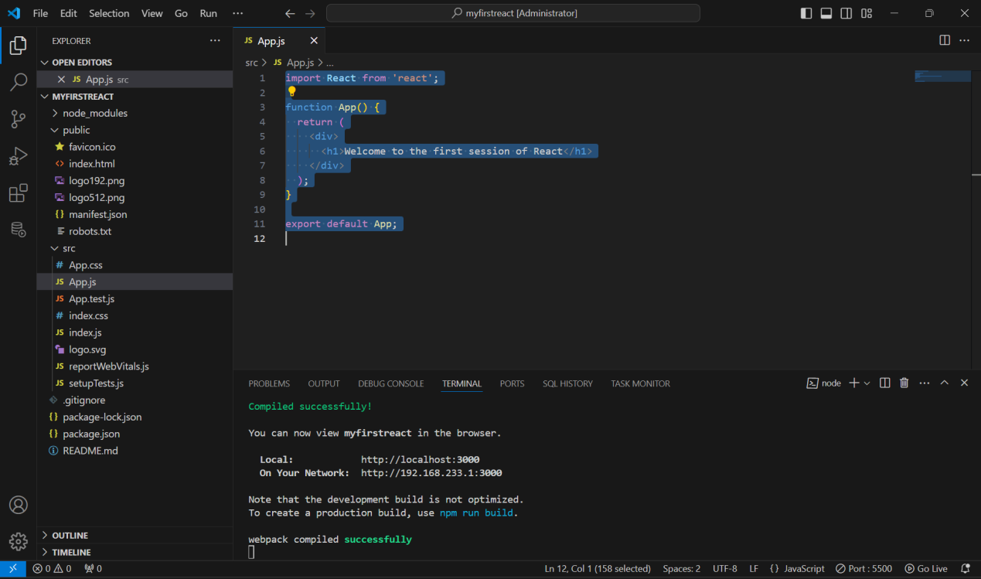

**OUTPUT:**

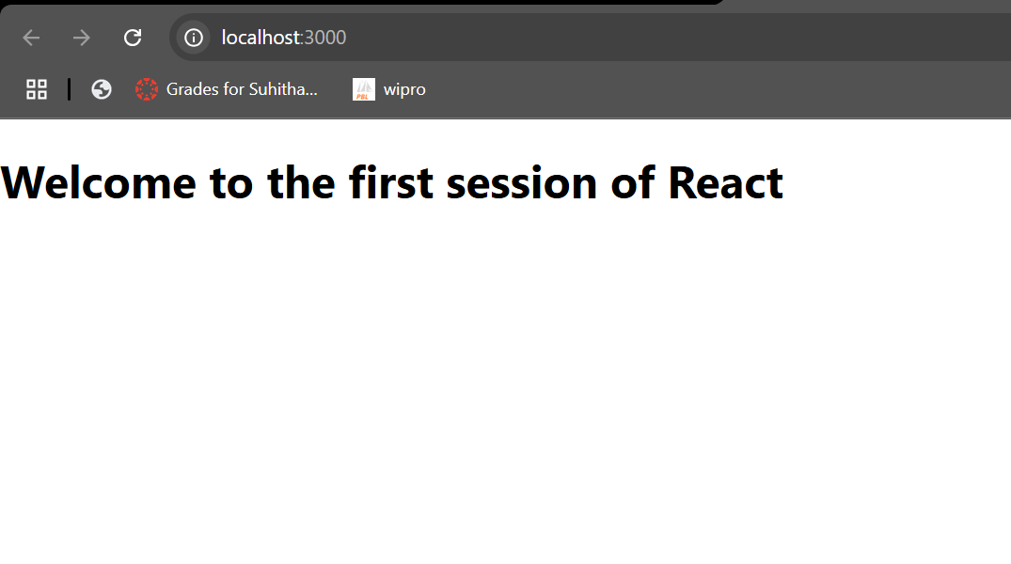

1. **ReactJS-HOL:**

**Home.js:**

import React, { Component } from 'react';

class Home extends Component {

render() {

return (

<div>

<h3>Welcome to the Home Page of Student Management Portal</h3>

</div>

); }

}

export default Home;

**About.js:**

import React, { Component } from 'react';

class About extends Component {

render() {

return (

<div>

<h3>Welcome to the About Page of Student Management Portal</h3>

</div>

);

}

}

export default About;

**Contact.js:**

import React, { Component } from 'react';

class Contact extends Component {

render() {

return (

<div>

<h3>Welcome to the Contact Page of Student Management Portal</h3>

</div>

);

}

}

export default Contact;

**App.js:**

import './App.css';

import Home from './Components/Home';

import About from './Components/About';

import Contact from './Components/Contact';

function App() {

return (

<div className="container">

<Home />

<About />

<Contact />

</div>

);

}

export default App;

**OUTPUT:**

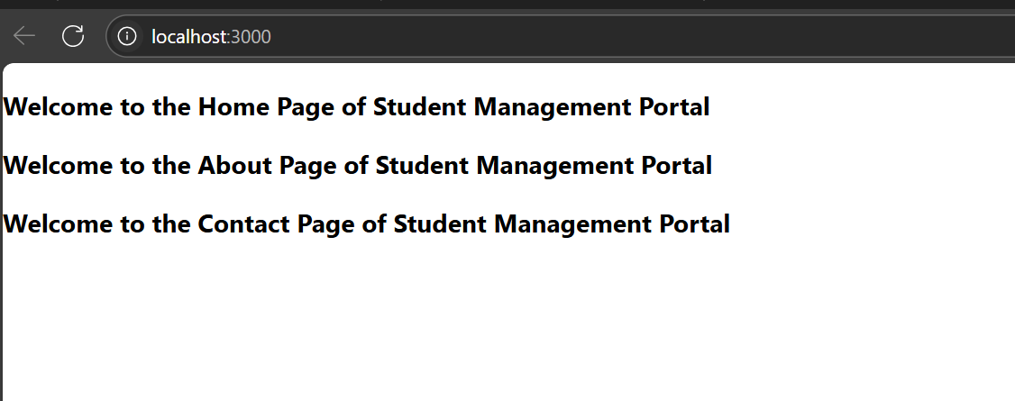

1. **ReactJS-HOL:**

**CalculatorScore.js:**

import React from 'react';

import '../Stylesheets/mystyle.css';

const CalculateScore = ({ name, school, total, goal }) => {

const percentage = ((total / goal) * 100).toFixed(2);

return (

<div className="score-box">

<h1>Student Details:</h1>

<p><b><span className="label name">Name:</span></b> <span className="value name">{name}</span></p>

<p><b><span className="label school">School:</span></b> <span className="value school">{school}</span></p>

<p><b><span className="label total">Total:</span></b> <span className="value total">{total} Marks</span></p>

<p><b><span className="label score">Score:</span></b> <span className="value score">{percentage}%</span></p>

</div>

);

};

export default CalculateScore;

**mystyle.css:**

.score-box {

text-align: center;

margin-top: 50px;

}

h1 {

color: brown;

}

.label.name {

color: blue;

}

.value.name {

color: cornflowerblue;

}

.label.school {

color: purple;

}

.value.school {

color: palevioletred;

}

.label.total {

color: darkred;

}

.value.total {

color: mediumvioletred;

}

.label.score {

color: darkgreen;

}

.value.score {

color: limegreen;

}

**App.js:**

import React from 'react';

import './App.css';

import CalculateScore from './Components/CalculateScore';

function App() {

return (

<div className="App">

<CalculateScore

name="Steeve"

school="DNV Public School"

total={284}

goal={3} // 284/3 = 94.67%

/>

</div>

);

}

export default App;

**OUTPUT:**

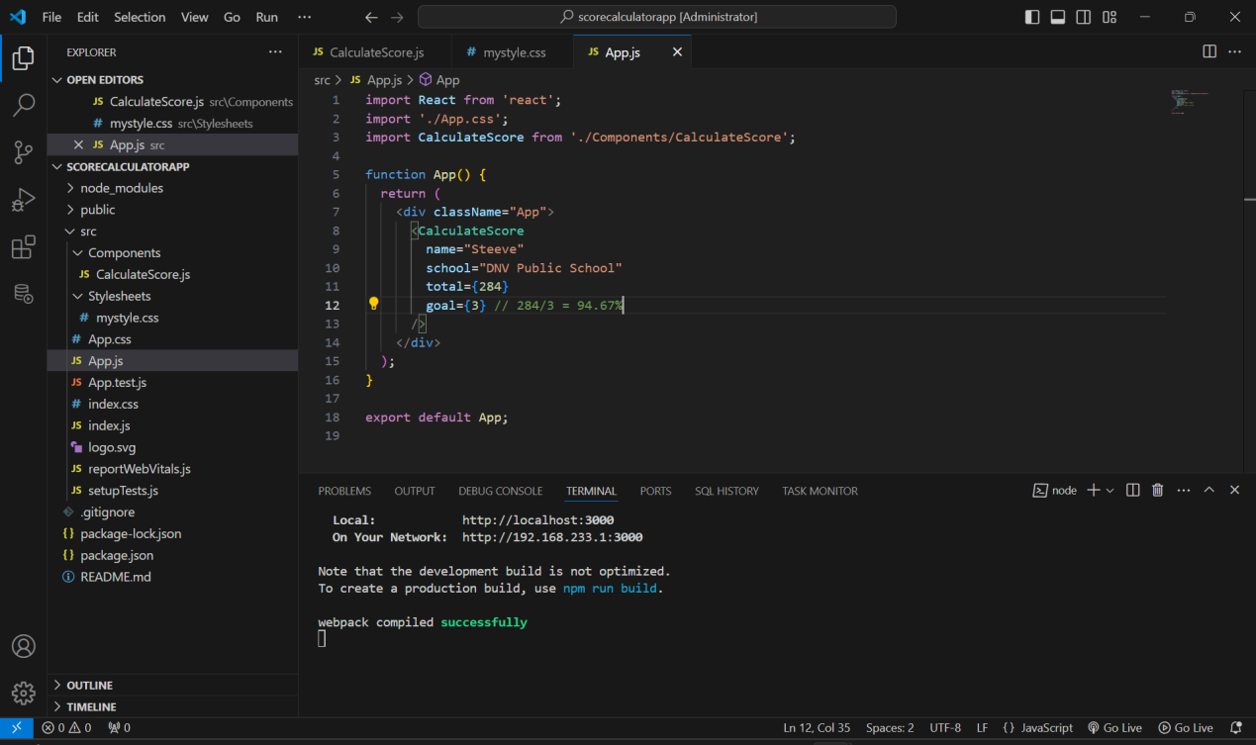

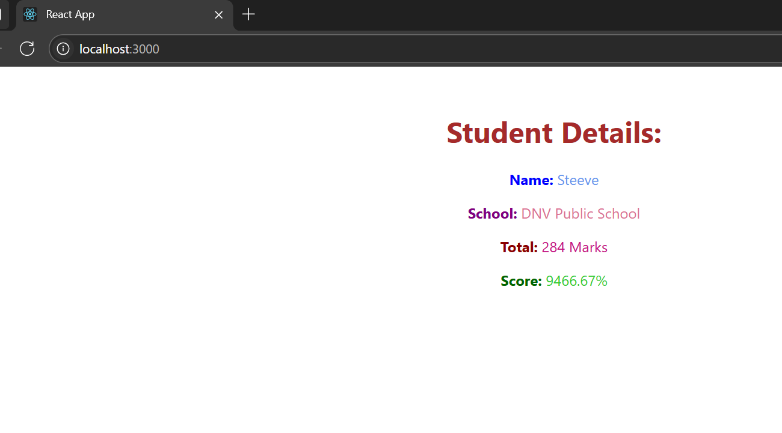

1. **ReactJS-HOL:**

**Post.js:**

import React from 'react';

class Post extends React.Component {

render() {

const { title, body } = this.props;

return (

<div style={{ border: '1px solid #ccc', padding: '10px', marginBottom: '10px' }}>

<h2>{title}</h2>

<p>{body}</p>

</div>

);

}

}

export default Post;

**Posts.js:**

import React from 'react';

import Post from './Post';

class Posts extends React.Component {

constructor(props) {

super(props);

this.state = {

posts: [],

hasError: false

};

}

loadPosts() {

fetch('https://jsonplaceholder.typicode.com/posts')

.then((response) => response.json())

.then((data) => this.setState({ posts: data }))

.catch((error) => {

console.error("Error fetching posts:", error);

this.setState({ hasError: true });

});

}

componentDidMount() {

this.loadPosts();

}

componentDidCatch(error, info) {

alert("An error occurred while rendering the Posts component.");

console.error("componentDidCatch:", error, info);

}

render() {

if (this.state.hasError) {

return <p>Something went wrong while loading posts.</p>;

}

return (

<div>

<h1>Blog Posts</h1>

{this.state.posts.map((post) => (

<Post key={post.id} title={post.title} body={post.body} />

))}

</div>

);

}

}

export default Posts;

**App.js:**

import React from 'react';

import Posts from './Posts';

function App() {

return (

<div className="App">

<Posts />

</div>

);

}

export default App;

**OUTPUT:**

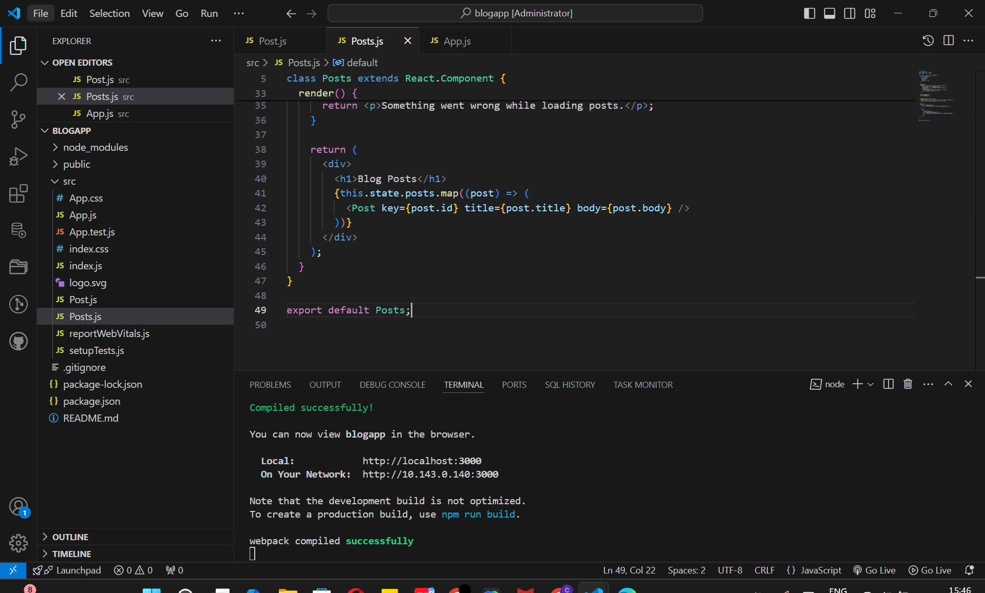

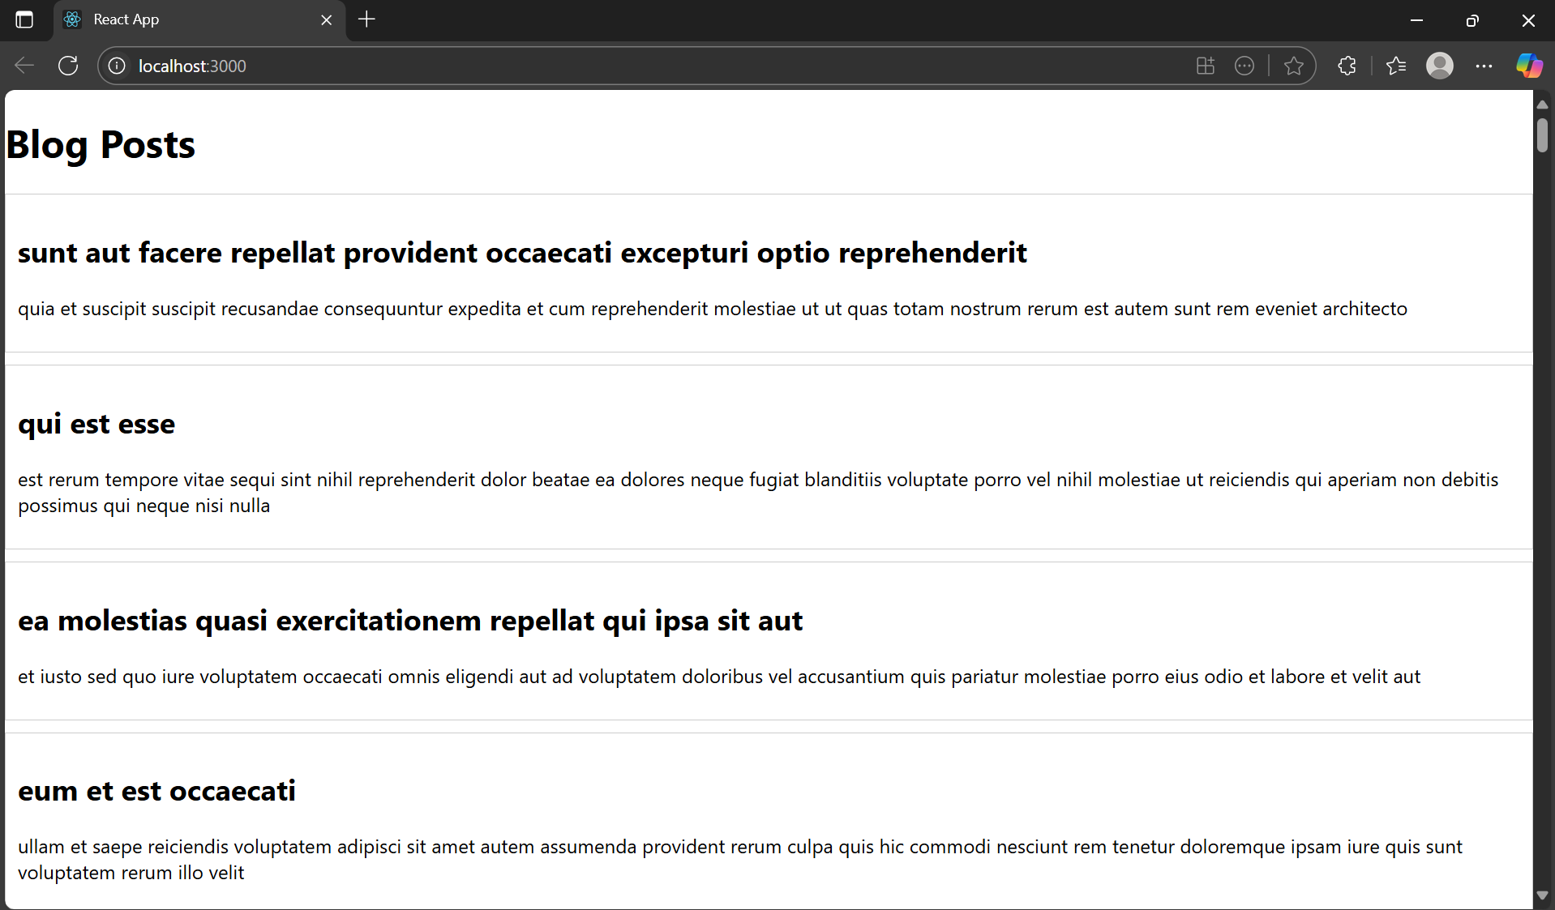

1. **ReactJS-HOL:**

**App.js:**

import React from 'react';

import CohortDetails from './CohortDetails';

function App() {

const cohorts = [

{

name: "INTADMDF10 - .NET FSD",

status: "Scheduled",

startDate: "22-Feb-2022",

coach: "Aathma",

trainer: "Jojo Jose"

},

{

name: "ADM21JF014 - Java FSD",

status: "Ongoing",

startDate: "10-Sep-2021",

coach: "Apoorv",

trainer: "Elisa Smith"

},

{

name: "CDBJF21025 - Java FSD",

status: "Ongoing",

startDate: "24-Dec-2021",

coach: "Aathma",

trainer: "John Doe"

}

];

return (

<div className="App">

<h1>Cohorts Details</h1>

{cohorts.map((cohort, index) => (

<CohortDetails key={index} cohort={cohort} />

))}

</div>

);

}

export default App;

**CohortDetails.js:**

import React from 'react';

import styles from './CohortDetails.module.css';

function CohortDetails({ cohort }) {

let titleColor = 'blue';

if (cohort.status.toLowerCase() === 'ongoing') {

titleColor = 'green';

}

const titleStyle = {

color: titleColor,

fontWeight: 'bold'

};

return (

<div className={styles.box}>

<h3 style={titleStyle}>{cohort.name}</h3>

<dl>

<dt>Started On</dt>

<dd>{cohort.startDate}</dd>

<dt>Current Status</dt>

<dd>{cohort.status}</dd>

<dt>Coach</dt>

<dd>{cohort.coach}</dd>

<dt>Trainer</dt>

<dd>{cohort.trainer}</dd>

</dl>

</div>

);

}

export default CohortDetails;

**CohortDetails.module.css:**

.box {

width: 300px;

display: inline-block;

margin: 10px;

padding: 10px 20px;

border: 1px solid black;

border-radius: 10px;

vertical-align: top;

}

dt {

font-weight: bold;

}

**OUTPUT:**

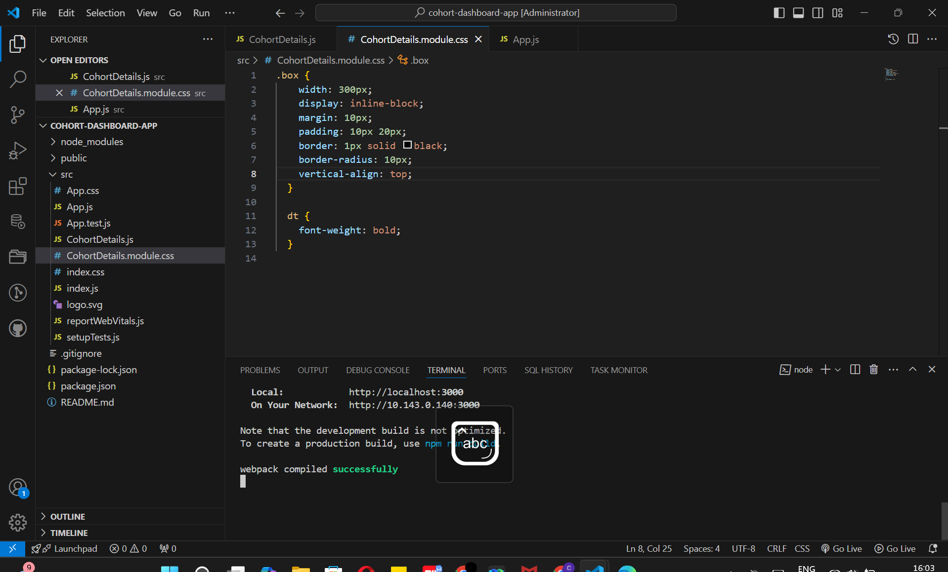

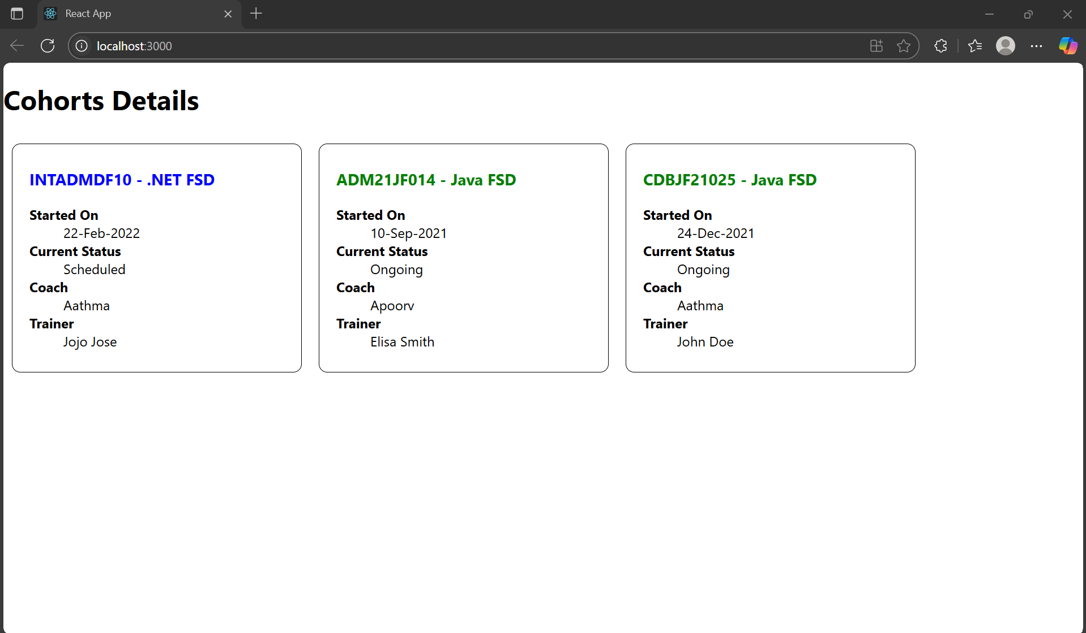

1. **ReactJS-HOL:**

**App.js:**

import React from 'react';

import { BrowserRouter as Router, Routes, Route, Link } from 'react-router-dom';

import Home from './Home';

import TrainerList from './TrainerList';

import TrainerDetails from './TrainerDetails';

import trainers from './TrainersMock';

function App() {

return (

<Router>

<nav>

<Link to="/">Home</Link> |{' '}

<Link to="/trainers">Trainers</Link>

</nav>

<hr />

<Routes>

<Route path="/" element={<Home />} />

<Route path="/trainers" element={<TrainerList trainers={trainers} />} />

<Route path="/trainers/:id" element={<TrainerDetails />} />

</Routes>

</Router>

);

}

export default App;

**Home.js:**

function Home() {

return (

<div>

<h2>Welcome to TrainersApp</h2>

<p>Explore our trainers and their technical skills!</p>

</div>

);

}

export default Home;

**Trainer.js:**

class Trainer {

constructor(trainerId, name, email, phone, technology, skills) {

this.trainerId = trainerId;

this.name = name;

this.email = email;

this.phone = phone;

this.technology = technology;

this.skills = skills;

}

}

export default Trainer;

**TrainerDetails.js**

import React from 'react';

import { useParams } from 'react-router-dom';

import trainers from './TrainersMock';

function TrainerDetails() {

const { id } = useParams();

const trainer = trainers.find(t => t.trainerId === parseInt(id));

return (

<div>

{trainer ? (

<>

<h2>{trainer.name} - {trainer.technology}</h2>

<p>Email: {trainer.email}</p>

<p>Phone: {trainer.phone}</p>

<p>Skills: {trainer.skills}</p>

</>

) : (

<p>Trainer not found.</p>

)}

</div>

);

}

export default TrainerDetails;

**TrainerList.js:**

import React from 'react';

import { Link } from 'react-router-dom';

function TrainerList({ trainers }) {

return (

<div>

<h2>Trainers List</h2>

<ul>

{trainers.map(trainer => (

<li key={trainer.trainerId}>

<Link to={`/trainers/${trainer.trainerId}`}>{trainer.name}</Link>

</li>

))}

</ul>

</div>

);

}

export default TrainerList;

**TrainersMock.js**

import Trainer from './Trainer';

const trainers = [

new Trainer(1, "Aathma", "aathma@cognizant.com", "9876543210", "Java", "Spring, Hibernate"),

new Trainer(2, "Elisa", "elisa@cognizant.com", "9876512345", "React", "Hooks, Redux"),

new Trainer(3, "John", "john@cognizant.com", "9876509876", "Python", "Flask, Django"),

];

export default trainers;

**OUTPUT:**

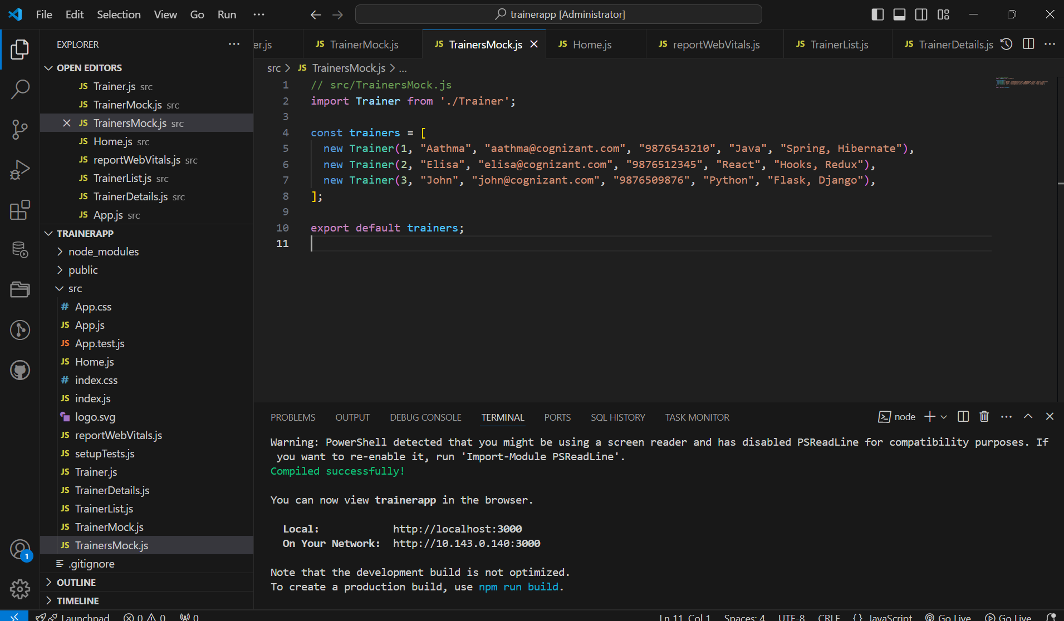

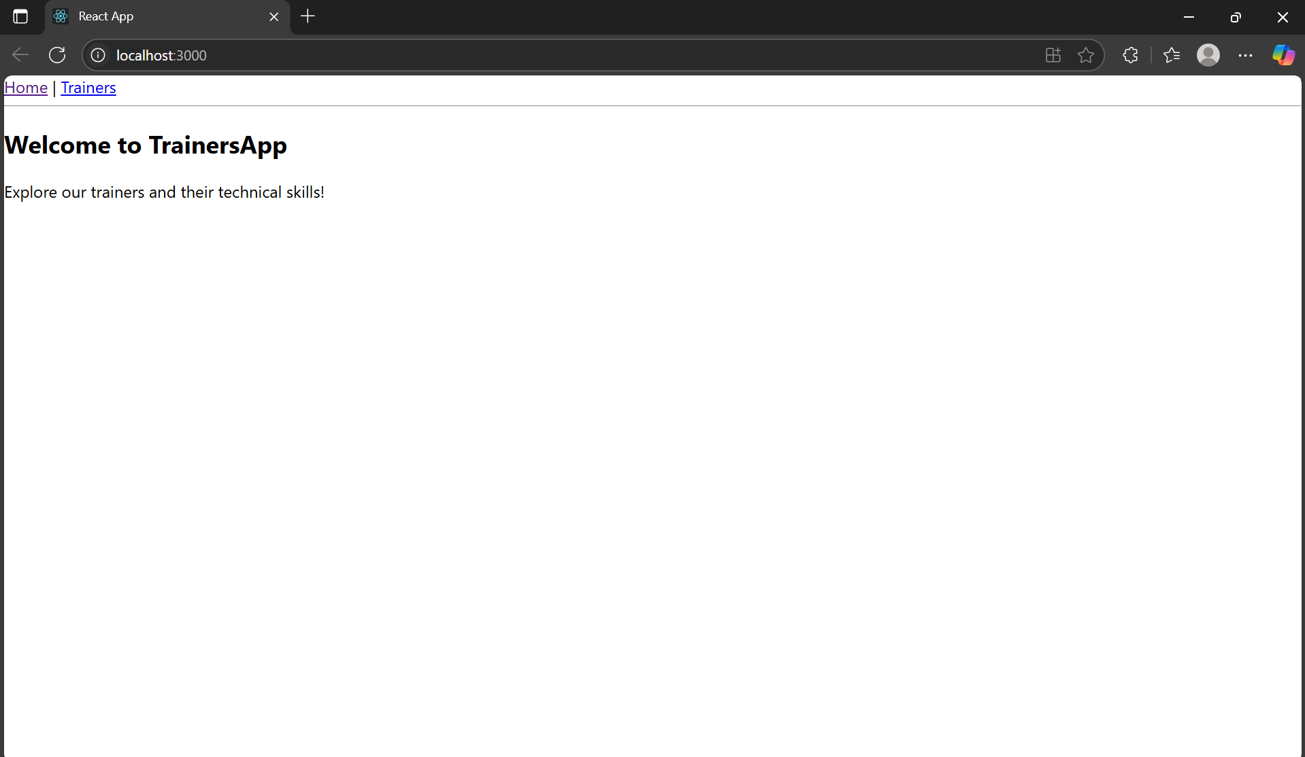

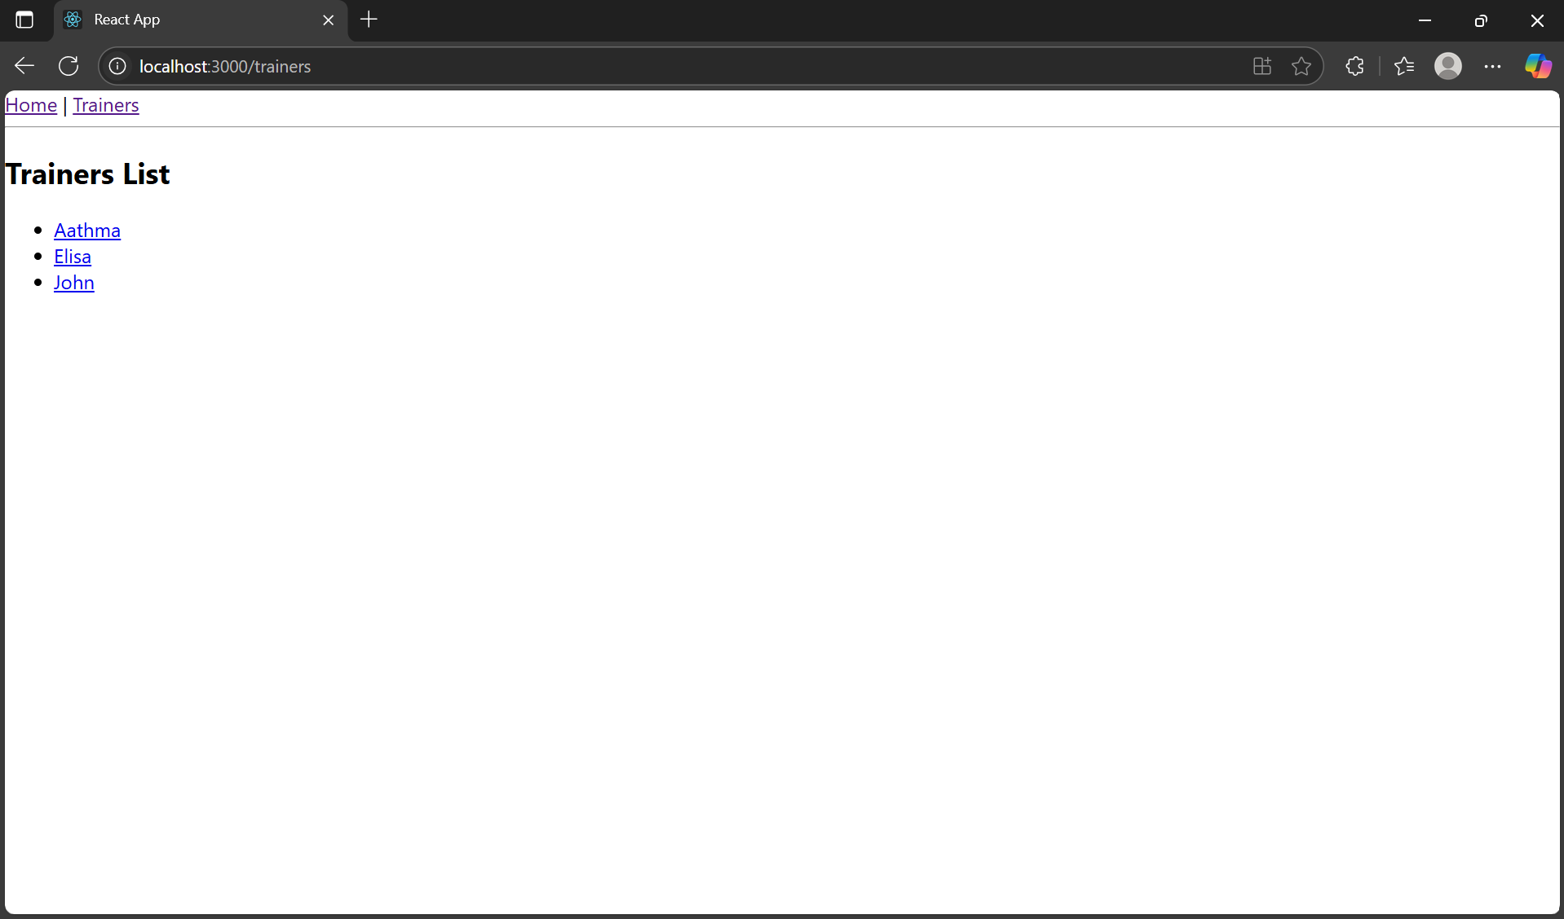

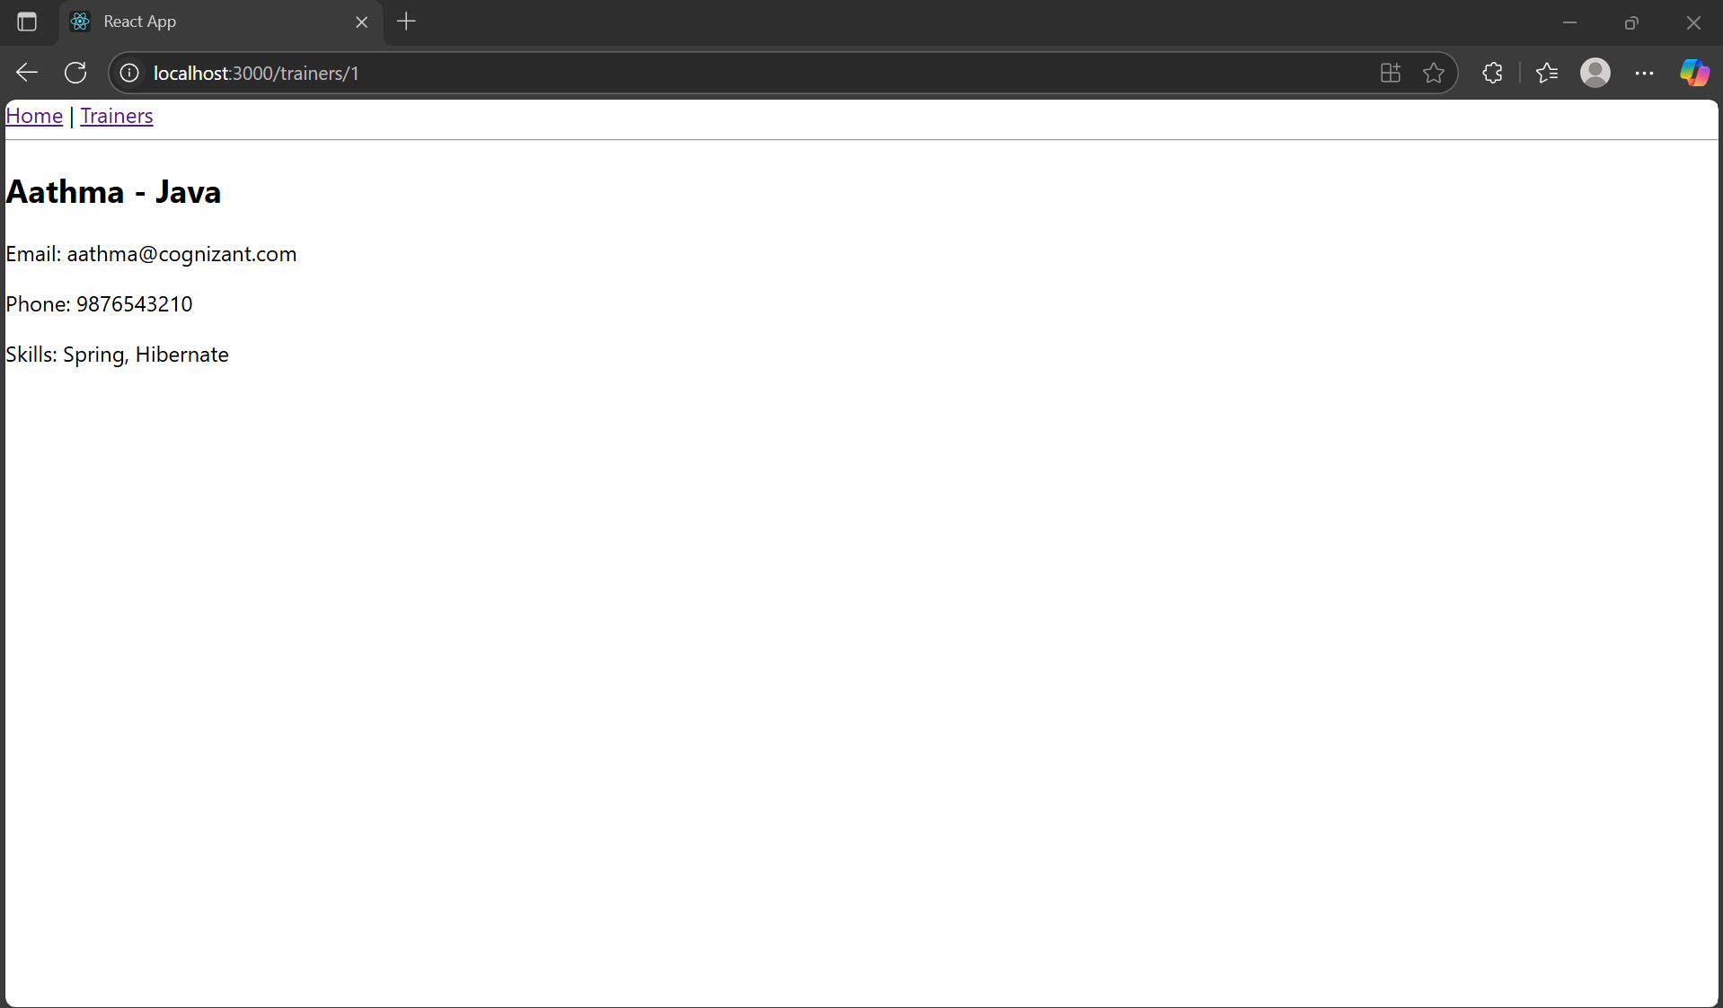

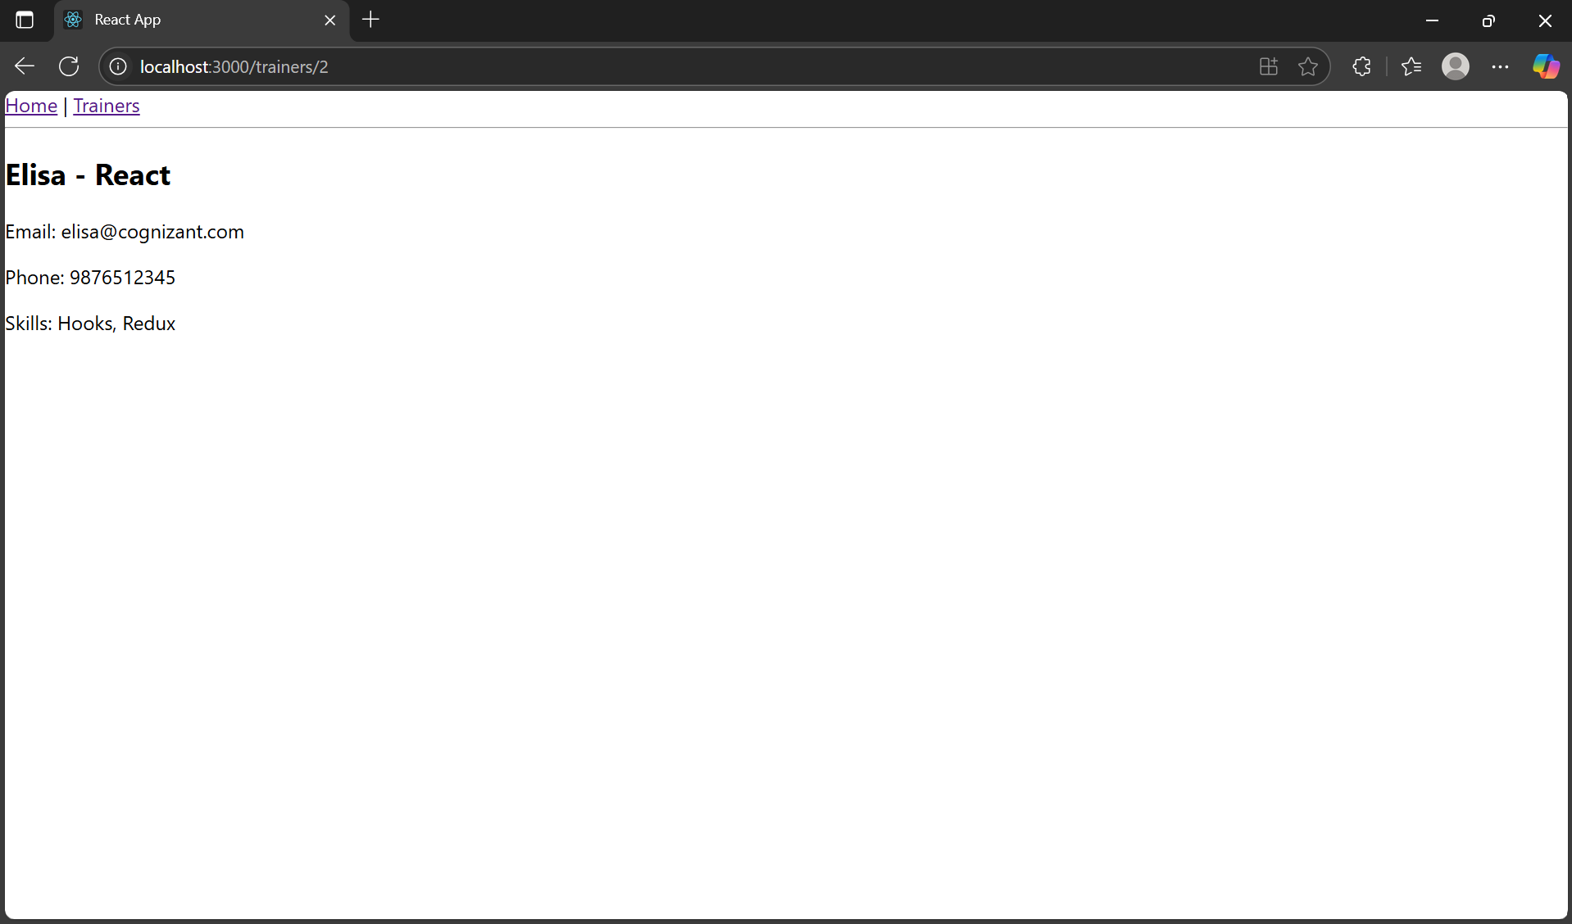

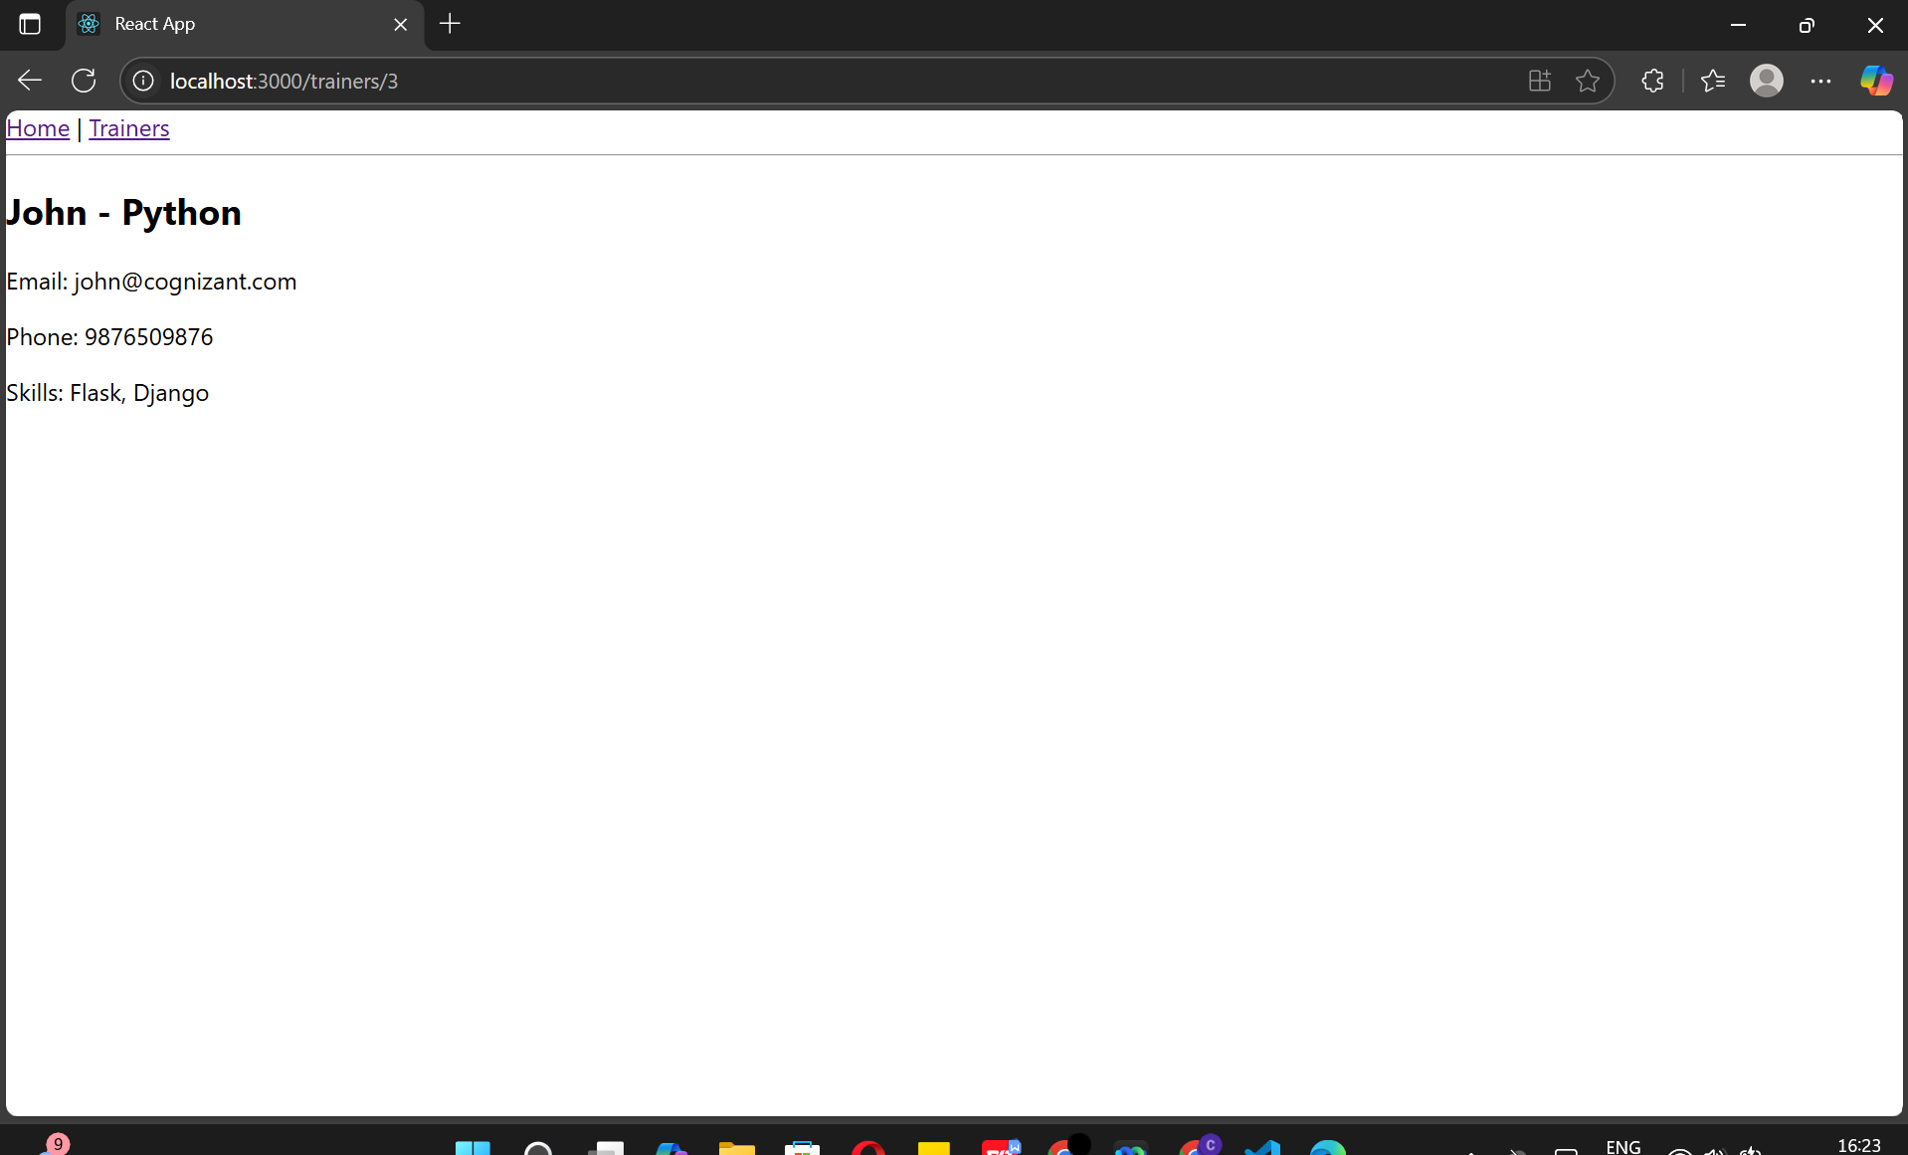

1. **ReactJS-HOL:**

**App.js:**

import React from 'react';

import OnlineShopping from './OnlineShopping';

function App() {

return (

<div className="App">

<OnlineShopping />

</div>

);

}export default App;

**index.js:**

import React from 'react';

import ReactDOM from 'react-dom/client';

import App from './App';

const root = ReactDOM.createRoot(document.getElementById('root'));

root.render(<App />);

**OnlineShopping.js:**

import React from 'react';

import Cart from './Cart';

class OnlineShopping extends React.Component {

constructor(props) {

super(props);

this.state = {

items: [

{ itemname: 'Laptop', price: 50000 },

{ itemname: 'Smartphone', price: 20000 },

{ itemname: 'Headphones', price: 1500 },

{ itemname: 'Shoes', price: 3000 },

{ itemname: 'Watch', price: 2500 }

]

};

}render() {

return ( <div>

<h2>🛒 Online Shopping Cart</h2>

{this.state.items.map((item, index) => (

<Cart key={index} itemname={item.itemname} price={item.price} />

))}

</div>

);

}

}

export default OnlineShopping;

**Cart.js:**

import React from 'react';

class Cart extends React.Component {

render() {

return (<div>

<h4>Item: {this.props.itemname}</h4>

<p>Price: ₹{this.props.price}</p>

<hr />

</div>

);

}

}Cart.defaultProps = {

itemname: 'Unknown Item',

price: '0'

};export default Cart;

**OUTPUT:**

