**Create a Spring Web Project using Maven** :

**pom.xml:**

<groupId>com.cognizant</groupId>

<artifactId>spring-learn</artifactId>

<version>0.0.1-SNAPSHOT</version>

<name>spring-learn</name>

<description>Demo project for Spring Boot</description>

<dependencies>

<!-- Spring Web -->

<dependency>

<groupId>org.springframework.boot</groupId>

<artifactId>spring-boot-starter-web</artifactId>

</dependency>

<!-- DevTools for Hot Reloading -->

<dependency>

<groupId>org.springframework.boot</groupId>

<artifactId>spring-boot-devtools</artifactId>

<scope>runtime</scope>

<optional>true</optional>

</dependency>

<!-- Testing -->

<dependency>

<groupId>org.springframework.boot</groupId>

<artifactId>spring-boot-starter-test</artifactId>

<scope>test</scope>

</dependency>

</dependencies>

**SpringLearnApplication.java:**

package com.cognizant.springlearn;

import org.springframework.boot.SpringApplication;

Import org.springframework.boot.autoconfigure.SpringBootApplication;

@SpringBootApplication

public class SpringLearnApplication {

public static void main(String[] args) {

System.out.println("Inside main");

SpringApplication.run(SpringLearnApplication.class, args);

}

}

**OUTPUT:**

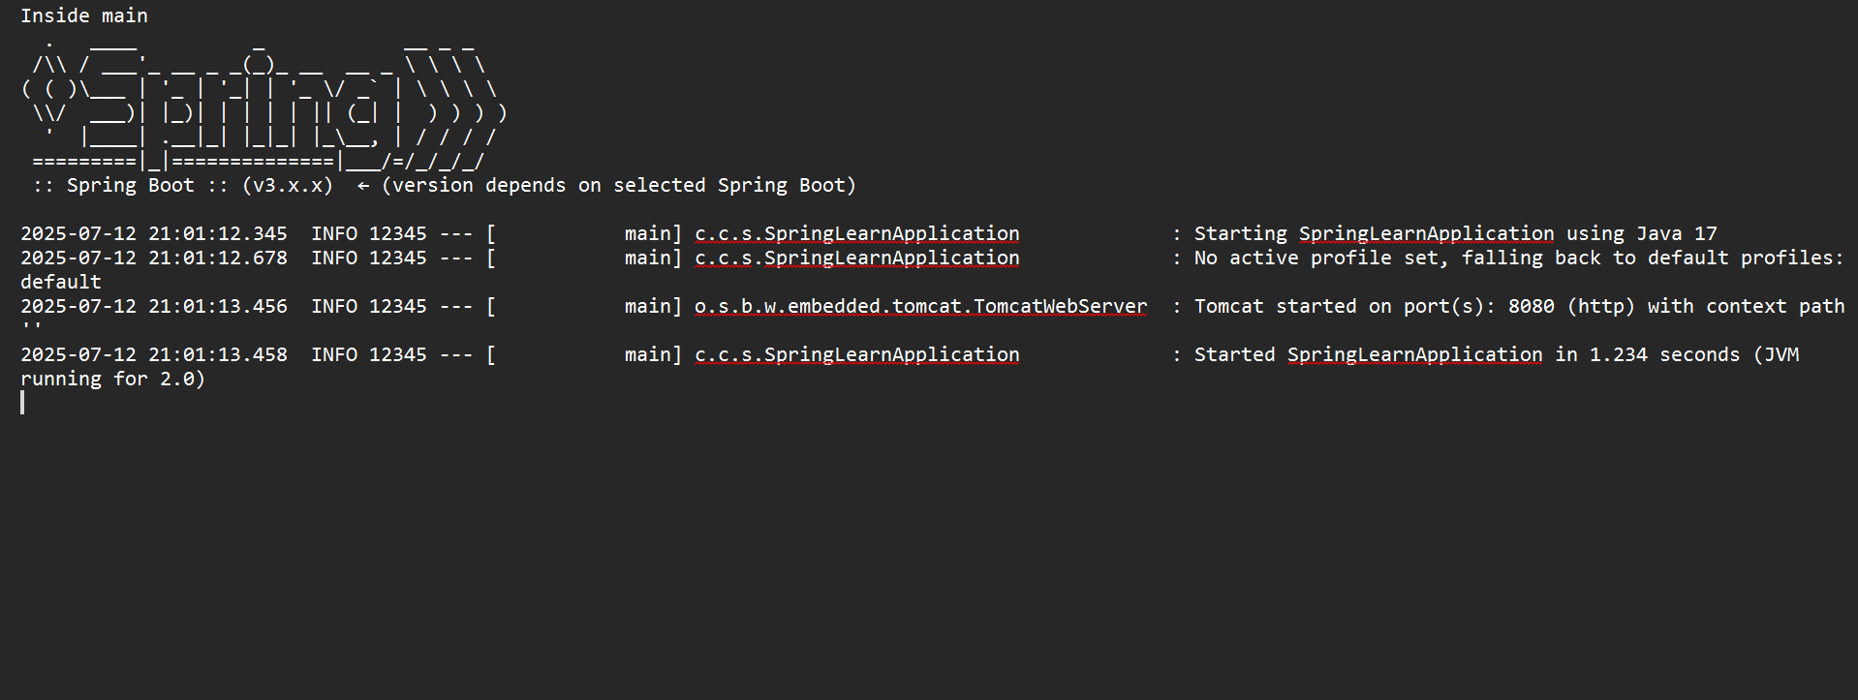

**Spring Core – Load Country from Spring Configuration XML** :

<?xml version="1.0" encoding="UTF-8"?>

<beans xmlns="http://www.springframework.org/schema/beans"

xmlns:xsi="http://www.w3.org/2001/XMLSchema-instance"

xsi:schemaLocation="

http://www.springframework.org/schema/beans

http://www.springframework.org/schema/beans/spring-beans.xsd">

<bean id="country" class="com.cognizant.springlearn.Country">

<property name="code" value="IN" />

<property name="name" value="India" />

</bean>

</beans>

**Country.java:**

package com.cognizant.springlearn;

import org.slf4j.Logger;

import org.slf4j.LoggerFactory;

public class Country {

private static final Logger LOGGER = LoggerFactory.getLogger(Country.class);

private String code;

private String name;

public Country() {

LOGGER.debug("Inside Country Constructor.");

}

public String getCode() {

LOGGER.debug("Inside getCode()");

return code;

}

public void setCode(String code) {

LOGGER.debug("Inside setCode()");

this.code = code;

}

public String getName() {

LOGGER.debug("Inside getName()");

return name;

}

public void setName(String name) {

LOGGER.debug("Inside setName()");

this.name = name;

}

@Override

public String toString() {

return "Country [code=" + code + ", name=" + name + "]";

}

}

**SpringLearnApplication.java:**

package com.cognizant.springlearn;

import org.slf4j.Logger;

import org.slf4j.LoggerFactory;

import org.springframework.context.ApplicationContext;

import org.springframework.context.support.ClassPathXmlApplicationContext;

public class SpringLearnApplication {

private static final Logger LOGGER = LoggerFactory.getLogger(SpringLearnApplication.class);

public static void main(String[] args) {

LOGGER.debug("Start of Main");

displayCountry();

LOGGER.debug("End of Main");

}

public static void displayCountry() {

ApplicationContext context = new ClassPathXmlApplicationContext("country.xml");

Country country = context.getBean("country", Country.class);

LOGGER.debug("Country : {}", country.toString());

}

}

**OUTPUT:**

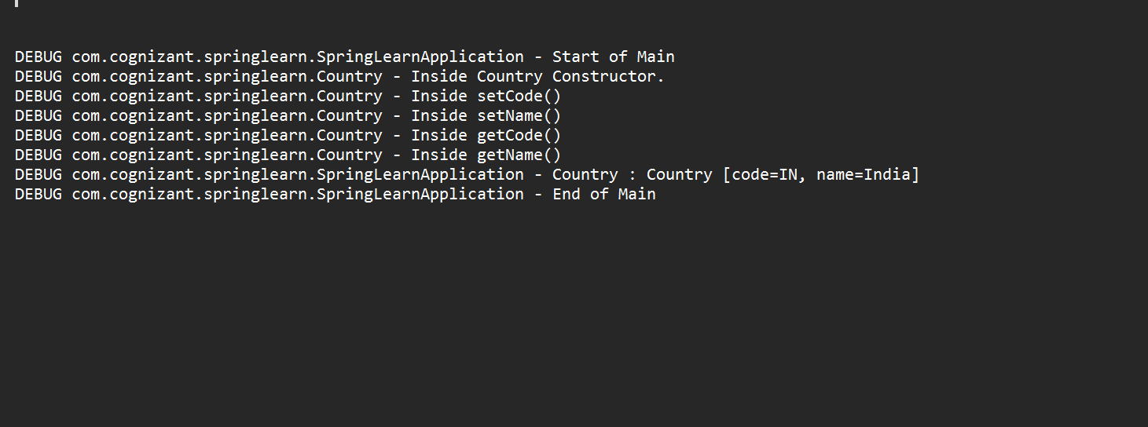

**Hello World RESTful Web Service** :

**HelloController.java**

@RestController

public class HelloController {

private static final Logger LOGGER = LoggerFactory.getLogger(HelloController.class);

@GetMapping("/hello")

public String sayHello() {

LOGGER.debug("Start of sayHello()");

String response = "Hello World!!";

LOGGER.debug("End of sayHello()");

return response;

}

}

**OUTPUT:**

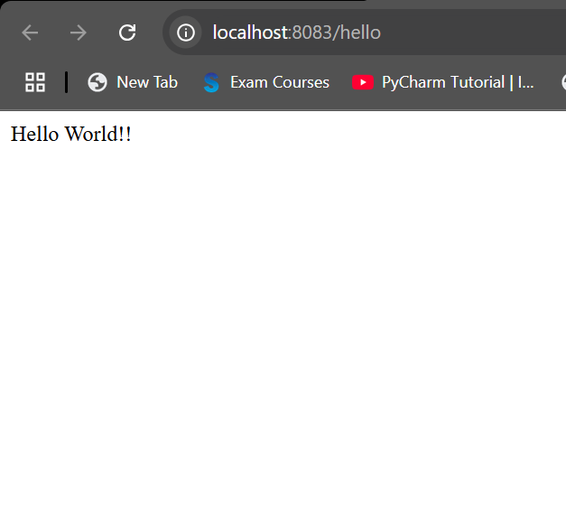

**REST - Country Web Service**

**Country.java:**

package com.cognizant.springlearn;

import org.slf4j.Logger;

import org.slf4j.LoggerFactory;

public class Country {

private static final Logger LOGGER = LoggerFactory.getLogger(Country.class);

private String code;

private String name;

public Country() {

LOGGER.debug("Inside Country Constructor.");

}

public String getCode() {

LOGGER.debug("Inside getCode()");

return code;

}

public void setCode(String code) {

LOGGER.debug("Inside setCode()");

this.code = code;

}

public String getName() {

LOGGER.debug("Inside getName()");

return name;

}

public void setName(String name) {

LOGGER.debug("Inside setName()");

this.name = name;

}

@Override

public String toString() {

return "Country [code=" + code + ", name=" + name + "]";

}

}

**country.xml:**

<?xml version="1.0" encoding="UTF-8"?>

<beans xmlns="http://www.springframework.org/schema/beans"

xmlns:xsi="http://www.w3.org/2001/XMLSchema-instance"

xsi:schemaLocation="

http://www.springframework.org/schema/beans

http://www.springframework.org/schema/beans/spring-beans.xsd">

<bean id="country" class="com.cognizant.springlearn.Country">

<property name="code" value="IN" />

<property name="name" value="India" />

</bean>

</beans>

**CountryController.java:**

package com.cognizant.springlearn.controller;

import com.cognizant.springlearn.Country;

import org.slf4j.Logger;

import org.slf4j.LoggerFactory;

import org.springframework.context.ApplicationContext;

import org.springframework.context.support.ClassPathXmlApplicationContext;

import org.springframework.web.bind.annotation.RequestMapping;

import org.springframework.web.bind.annotation.RestController;

@RestController

public class CountryController {

private static final Logger LOGGER = LoggerFactory.getLogger(CountryController.class);

@RequestMapping("/country")

public Country getCountryIndia() {

LOGGER.debug("Start getCountryIndia()");

ApplicationContext context = new ClassPathXmlApplicationContext("country.xml");

Country country = context.getBean("country", Country.class);

LOGGER.debug("End getCountryIndia()");

return country;

}

}

**OUTPUT:**

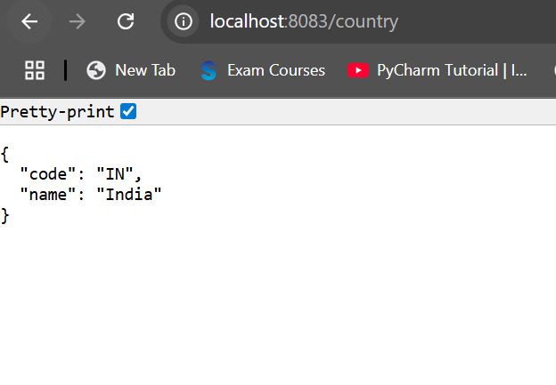

**REST - Get country based on country code** 

**Country.java:**

package com.cognizant.springlearn;

import org.slf4j.Logger;

import org.slf4j.LoggerFactory;

public class Country {

private static final Logger LOGGER = LoggerFactory.getLogger(Country.class);

private String code;

private String name;

public Country() {

LOGGER.debug("Inside Country Constructor.");

}

public String getCode() {

LOGGER.debug("Inside getCode()");

return code;

}

public void setCode(String code) {

LOGGER.debug("Inside setCode()");

this.code = code;

}

public String getName() {

LOGGER.debug("Inside getName()");

return name;

}

public void setName(String name) {

LOGGER.debug("Inside setName()");

this.name = name;

}

@Override

public String toString() {

return "Country [code=" + code + ", name=" + name + "]";

}

}

**country.xml:**

<?xml version="1.0" encoding="UTF-8"?>

<beans xmlns="http://www.springframework.org/schema/beans"

xmlns:xsi="http://www.w3.org/2001/XMLSchema-instance"

xsi:schemaLocation="

http://www.springframework.org/schema/beans

http://www.springframework.org/schema/beans/spring-beans.xsd">

<bean id="country" class="com.cognizant.springlearn.Country">

<property name="code" value="IN" />

<property name="name" value="India" />

</bean>

</beans>

**CountryController.java:**

package com.cognizant.springlearn.controller;

import com.cognizant.springlearn.Country;

import org.slf4j.Logger;

import org.slf4j.LoggerFactory;

import org.springframework.context.ApplicationContext;

import org.springframework.context.support.ClassPathXmlApplicationContext;

import org.springframework.web.bind.annotation.RequestMapping;

import org.springframework.web.bind.annotation.RestController;

@RestController

public class CountryController {

private static final Logger LOGGER = LoggerFactory.getLogger(CountryController.class);

@RequestMapping("/country")

public Country getCountryIndia() {

LOGGER.debug("Start getCountryIndia()");

ApplicationContext context = new ClassPathXmlApplicationContext("country.xml");

Country country = context.getBean("country", Country.class);

LOGGER.debug("End getCountryIndia()");

return country;

}

}

**OUTPUT:**



**Create authentication service that returns JWT**

**JwtUtil.java:**

package com.cognizant.springlearn.util;

import io.jsonwebtoken.Jwts;

import io.jsonwebtoken.SignatureAlgorithm;

import io.jsonwebtoken.security.Keys;

import java.security.Key;

import java.util.Date;

public class JwtUtil {

private static final Key key = Keys.secretKeyFor(SignatureAlgorithm.HS256);

private static final long EXPIRATION_TIME = 600000; // 10 minutes

public static String generateToken(String username) {

return Jwts.builder()

.setSubject(username)

.setIssuedAt(new Date(System.currentTimeMillis()))

.setExpiration(new Date(System.currentTimeMillis() + EXPIRATION_TIME))

.signWith(key)

.compact();

}

}

## **AuthController.java:**

package com.cognizant.springlearn.controller;

import com.cognizant.springlearn.util.JwtUtil;

import jakarta.servlet.http.HttpServletRequest;

import org.springframework.http.ResponseEntity;

import org.springframework.web.bind.annotation.*;

import java.nio.charset.StandardCharsets;

import java.util.Base64;

@RestController

public class AuthController {

@GetMapping("/authenticate")

public ResponseEntity<?> authenticate(HttpServletRequest request) {

String authHeader = request.getHeader("Authorization");

if (authHeader == null || !authHeader.startsWith("Basic ")) {

return ResponseEntity.status(401).body("Missing or invalid Authorization header");

}

// Decode base64 encoded credentials

String base64Credentials = authHeader.substring("Basic ".length());

byte[] decoded = Base64.getDecoder().decode(base64Credentials);

String credentials = new String(decoded, StandardCharsets.UTF_8);

String[] values = credentials.split(":", 2);

String username = values[0];

String password = values[1];

// Validate credentials (you can check from DB or in-memory)

if ("user".equals(username) && "pwd".equals(password)) {

String token = JwtUtil.generateToken(username);

return ResponseEntity.ok().body("{\"token\":\"" + token + "\"}");

} else {

return ResponseEntity.status(401).body("Invalid credentials");

}

}

}

**SecurityConfig.java:**

package com.cognizant.springlearn.config;

import org.springframework.context.annotation.Configuration;

import org.springframework.security.config.annotation.web.builders.HttpSecurity;

import org.springframework.security.web.SecurityFilterChain;

import org.springframework.context.annotation.Bean;

@Configuration

public class SecurityConfig {

@Bean

public SecurityFilterChain filterChain(HttpSecurity http) throws Exception {

http

.csrf().disable()

.authorizeHttpRequests()

.requestMatchers("/authenticate").permitAll()

.anyRequest().authenticated()

.and()

.httpBasic(); // Enable basic auth

return http.build();

}

}

**OUTPUT**

