**9.ReactJS-HOL:**

**App.js:**

import React from 'react';

import ListofPlayers from './ListofPlayers';

import IndianPlayers from './IndianPlayers'; // another component to show merged players etc.

function App() {

const flag = false; // change to false to switch component

return (

<div className="App">

<h1>🏏 Cricket App</h1>

{flag ? <ListofPlayers /> : <IndianPlayers />}

</div>

);

}

export default App;

**IndianPlayers.js:**

import React from 'react';

function IndianPlayers() {

const T20 = ['Rohit', 'Virat', 'Hardik', 'Pant'];

const Ranji = ['Shaw', 'Jurel', 'Mavi'];

const allPlayers = [...T20, ...Ranji];

const oddTeam = allPlayers.filter((_, index) => index % 2 === 1);

const evenTeam = allPlayers.filter((_, index) => index % 2 === 0);

return (

<div>

<h2>Merged Players</h2>

<p>{allPlayers.join(', ')}</p>

<h3>Odd Team Players</h3>

<p>{oddTeam.join(', ')}</p>

<h3>Even Team Players</h3>

<p>{evenTeam.join(', ')}</p>

</div>

);

}

export default IndianPlayers;

**ListofPlayers.js:**

import React from 'react';

function ListofPlayers() {

const players = [

{ name: 'Mr. Jack', score: 50 },

{ name: 'Mr. Michael', score: 70 },

{ name: 'Mr. John', score: 40 },

{ name: 'Mr. Ann', score: 61 },

{ name: 'Mr. Elisabeth', score: 61 },

{ name: 'Mr. Sachin', score: 95 },

{ name: 'Mr. Dhoni', score: 100 },

{ name: 'Mr. Virat', score: 84 },

{ name: 'Mr. Jadeja', score: 64 },

{ name: 'Mr. Raina', score: 75 },

{ name: 'Mr. Rohit', score: 80 }

];

const below70 = players.filter(player => player.score < 70);

return (

<div>

<h2>List of Players</h2>

{players.map((player, index) => (

<p key={index}>{player.name} {player.score}</p>

))}

<hr />

<h2>List of Players having Scores Less than 70</h2>

{below70.map((player, index) => (

<p key={index}>{player.name} {player.score}</p>

))}

</div>

);

}

export default ListofPlayers;

**OUTPUT:**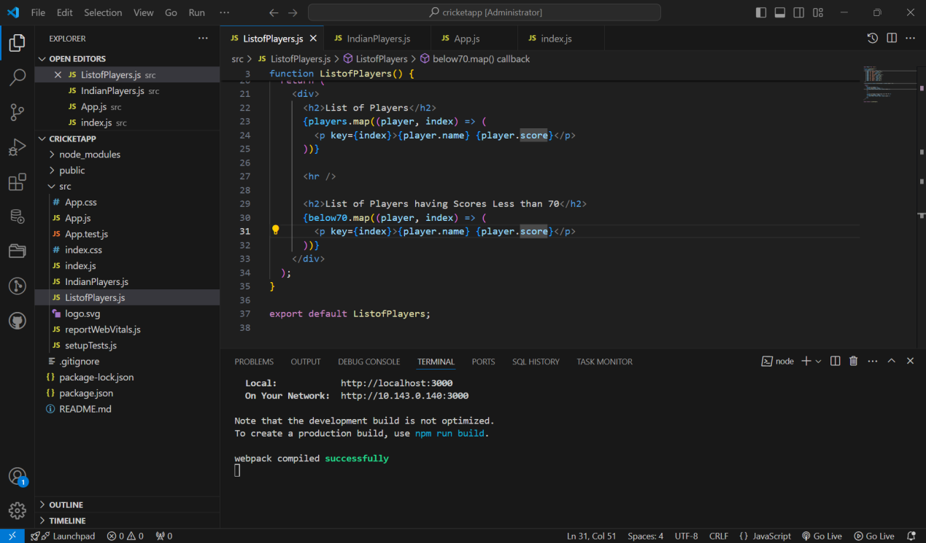

False:

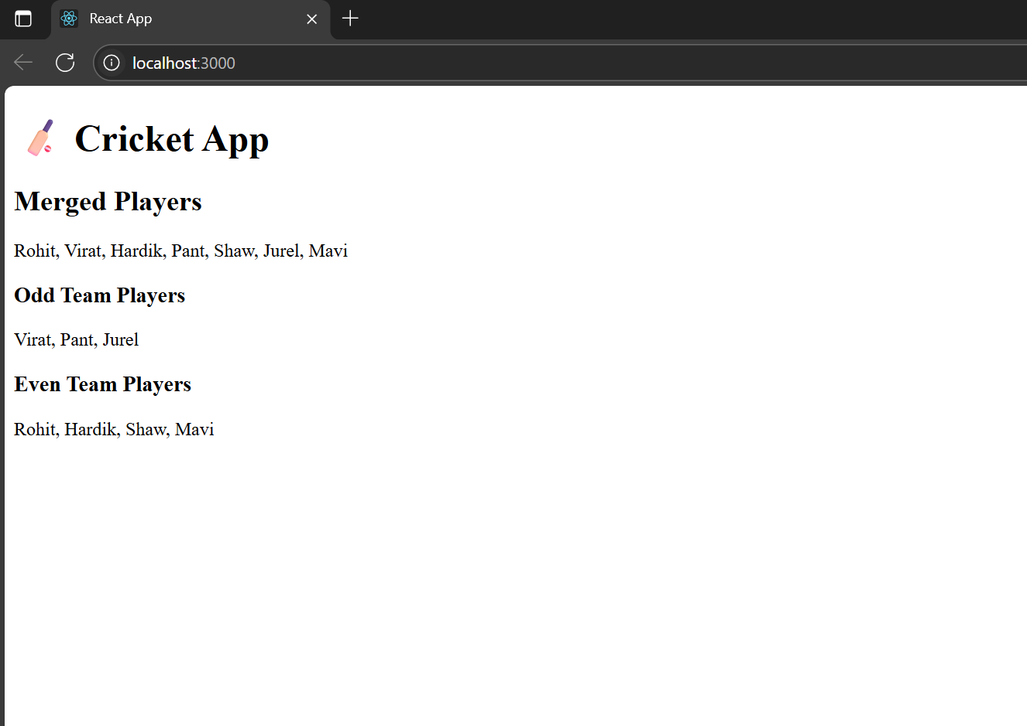

1. **ReactJS-HOL:**

**App.js:**

import React from 'react';

import './App.css';

function App() {

const offices = [

{

name: 'Alpha Towers',

rent: 55000,

address: 'MG Road, Bangalore',

image: 'https://images.unsplash.com/photo-1570129477492-45c003edd2be?auto=format&fit=crop&w=600&q=80'

},

{

name: 'Beta Blocks',

rent: 65000,

address: 'HiTech City, Hyderabad',

image: 'https://images.unsplash.com/photo-1568605114967-8130f3a36994?auto=format&fit=crop&w=600&q=80'

},

{

name: 'Gamma Spaces',

rent: 58000,

address: 'Indira Nagar, Chennai',

image: 'https://images.unsplash.com/photo-1570129477492-45c003edd2be?auto=format&fit=crop&w=600&q=80'

}

];

return (

<div className="App">

<h1>🏢 Office Space Rental</h1>

{offices.map((office, index) => (

<div

key={index}

style={{

border: '1px solid #ccc',

borderRadius: '10px',

padding: '15px',

margin: '15px auto',

width: '300px',

backgroundColor: '#fff',

boxShadow: '0px 0px 10px rgba(0,0,0,0.1)'

}}

>

<img

src={office.image}

alt={office.name}

style={{ width: '100%', height: '180px', borderRadius: '8px', objectFit: 'cover' }}

/>

<h2>{office.name}</h2>

<p><strong>Address:</strong> {office.address}</p>

<p style={{ color: office.rent < 60000 ? 'red' : 'green' }}>

<strong>Rent:</strong> ₹{office.rent}

</p>

</div>

))}

</div>

);

}

export default App;

**App.css:**

.App {

text-align: center;

font-family: 'Segoe UI', Tahoma, Geneva, Verdana, sans-serif;

background-color: #f8f8f8;

padding: 20px;

}

**OUTPUT:**

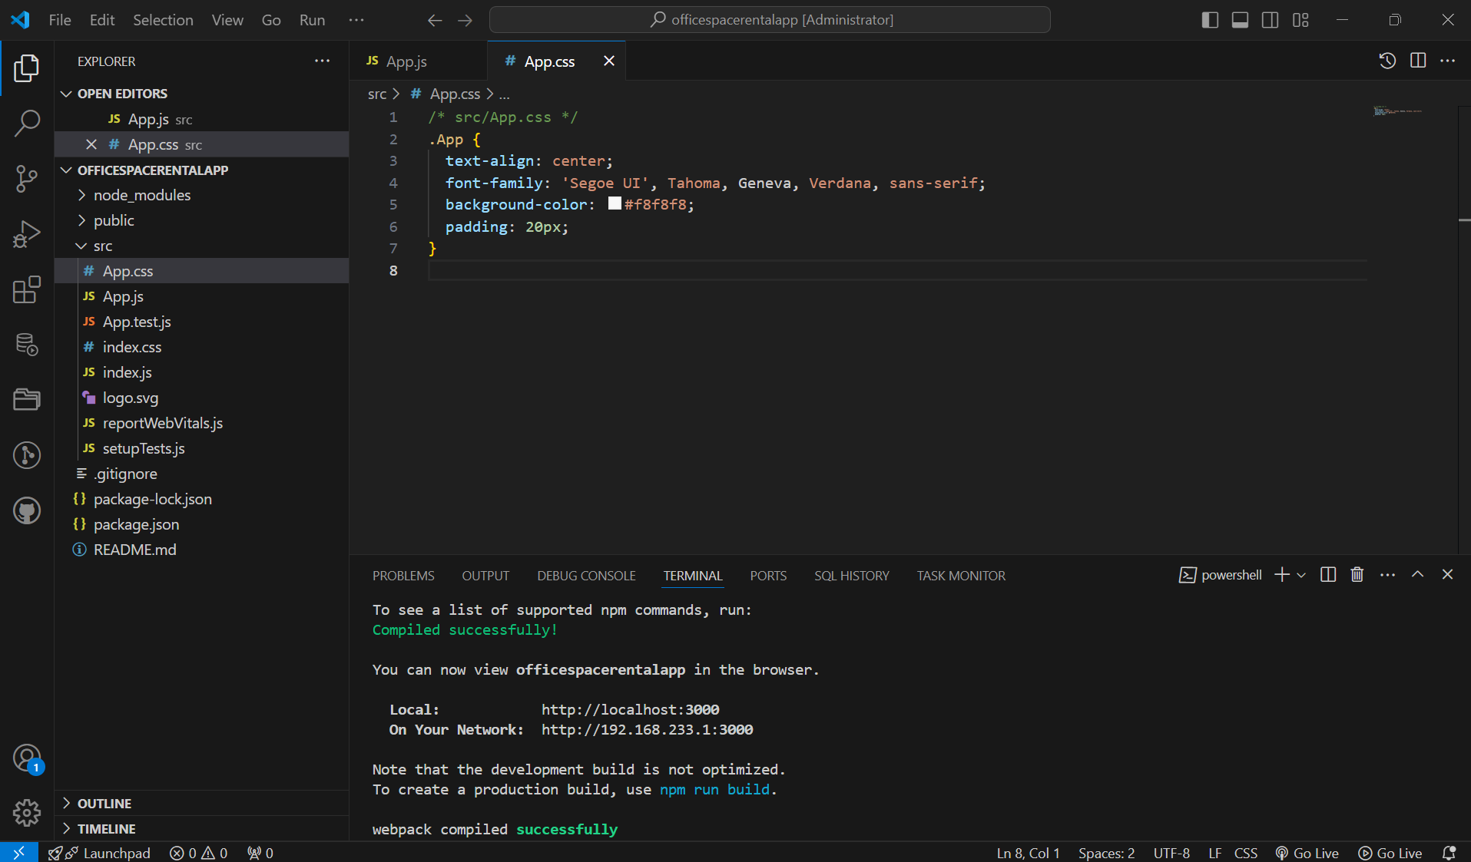

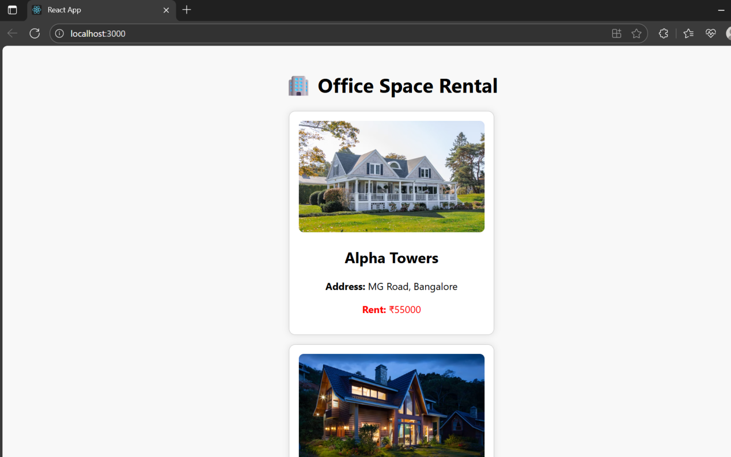

1. **ReactJS-HOL:**

**App.js:**

import React, { Component } from 'react';

import './App.css';

import CurrencyConverter from './CurrencyConverter';

class App extends Component {

constructor(props) {

super(props);

this.state = {

count: 0

};

this.handleSyntheticEvent = this.handleSyntheticEvent.bind(this);

}

increment = () => {

this.setState({ count: this.state.count + 1 });

};

sayHello = () => {

alert('Hello! This is a static message.');

};

handleIncrement = () => {

this.increment();

this.sayHello();

};

decrement = () => {

this.setState({ count: this.state.count - 1 });

};

sayWelcome = (msg) => {

alert(msg);

};

handleSyntheticEvent(e) {

alert('I was clicked');

}

render() {

return (

<div className="App">

<p>{this.state.count}</p>

<button onClick={this.handleIncrement}>Increment</button>

<button onClick={this.decrement}>Decrement</button>

<br />

<button onClick={() => this.sayWelcome('Welcome!')}>Say welcome</button>

<br />

<button onClick={this.handleSyntheticEvent}>Click on me</button>

<CurrencyConverter />

</div>

);

}

}

export default App;

**CurrencyConvetor.js:**

import React, { Component } from 'react';

class CurrencyConverter extends Component {

constructor(props) {

super(props);

this.state = {

rupees: '',

euro: ''

};

}

handleChange = (e) => {

this.setState({ rupees: e.target.value });

};

handleSubmit = (e) => {

e.preventDefault();

const euro = (this.state.rupees / 90).toFixed(2); // 1 Euro = ₹90

this.setState({ euro });

};

render() {

return (

<div style={{ marginTop: '30px' }}>

<h1 style={{ color: 'green', textAlign: 'left' }}>Currency Convertor!!!</h1>

<form onSubmit={this.handleSubmit}>

<div>

<label>Amount: </label>

<input

type="number"

placeholder="Enter amount in ₹"

value={this.state.rupees}

onChange={this.handleChange}

/>

</div>

<div>

<label>Currency: </label>

<textarea

value={this.state.euro ? `€${this.state.euro}` : ''}

readOnly

/>

</div>

<button type="submit">Submit</button>

</form>

</div>

);

}

}

export default CurrencyConverter;

**App.css:**

.App {

font-family: Arial, sans-serif;

padding: 20px;

}

h1 {

color: green;

font-size: 30px;

text-align: left;

margin-top: 40px;

}

button {

margin: 5px;

padding: 5px 10px;

}

input {

margin: 5px;

padding: 5px;

}

**OUTPUT:**

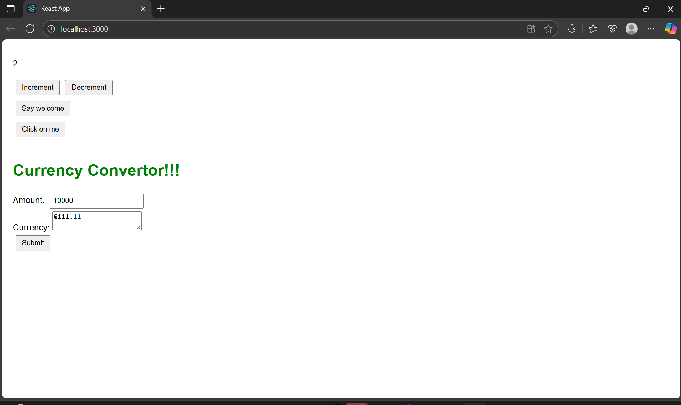

1. **ReactJS-HOL:**

**App.js:**

import React, { useState } from 'react';

import GuestPage from './GuestPage';

import UserPage from './UserPage';

function App() {

const [isLoggedIn, setIsLoggedIn] = useState(false);

// Toggle functions

const login = () => setIsLoggedIn(true);

const logout = () => setIsLoggedIn(false);

// Conditional element

let pageContent = isLoggedIn ? <UserPage /> : <GuestPage />;

return (

<div className="App">

<h1>✈️ Ticket Booking App</h1>

{isLoggedIn ? (

<button onClick={logout}>Logout</button>

) : (

<button onClick={login}>Login</button>

)}

{/* Conditional rendering */}

{pageContent}

</div>

);

}

export default App;

**GuestPage.js:**

import React from 'react';

function GuestPage() {

return (

<div>

<h2>👤 Guest View</h2>

<p>You can browse available flights, but need to log in to book tickets.</p>

</div>

);

}

export default GuestPage;

**UserPage.js:**

import React from 'react';

function UserPage() {

return (

<div>

<h2>✅ User View</h2>

<p>You are logged in! You can now book flight tickets.</p>

</div>

);

}

export default UserPage;

**OUTPUT:**

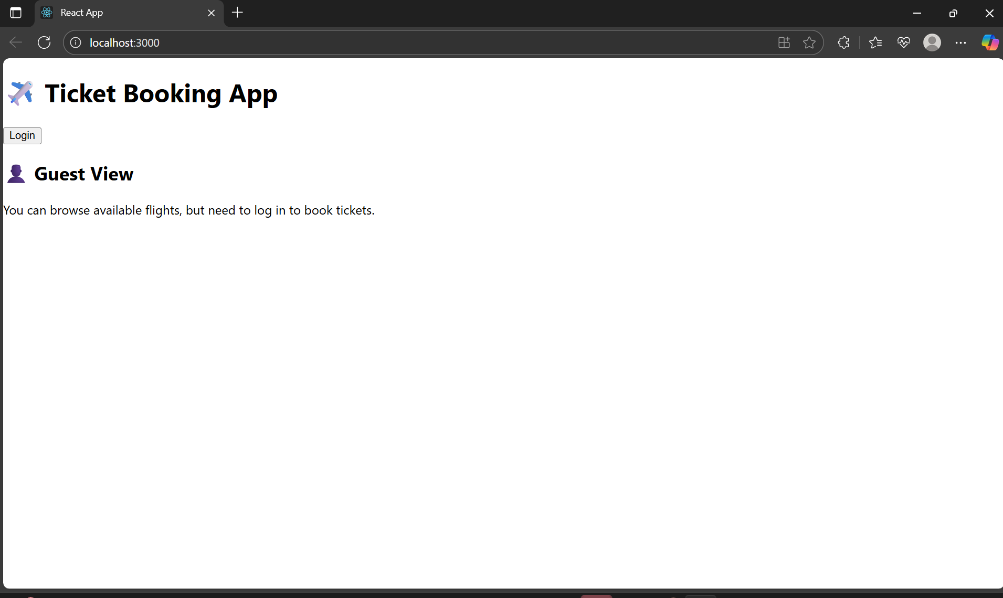

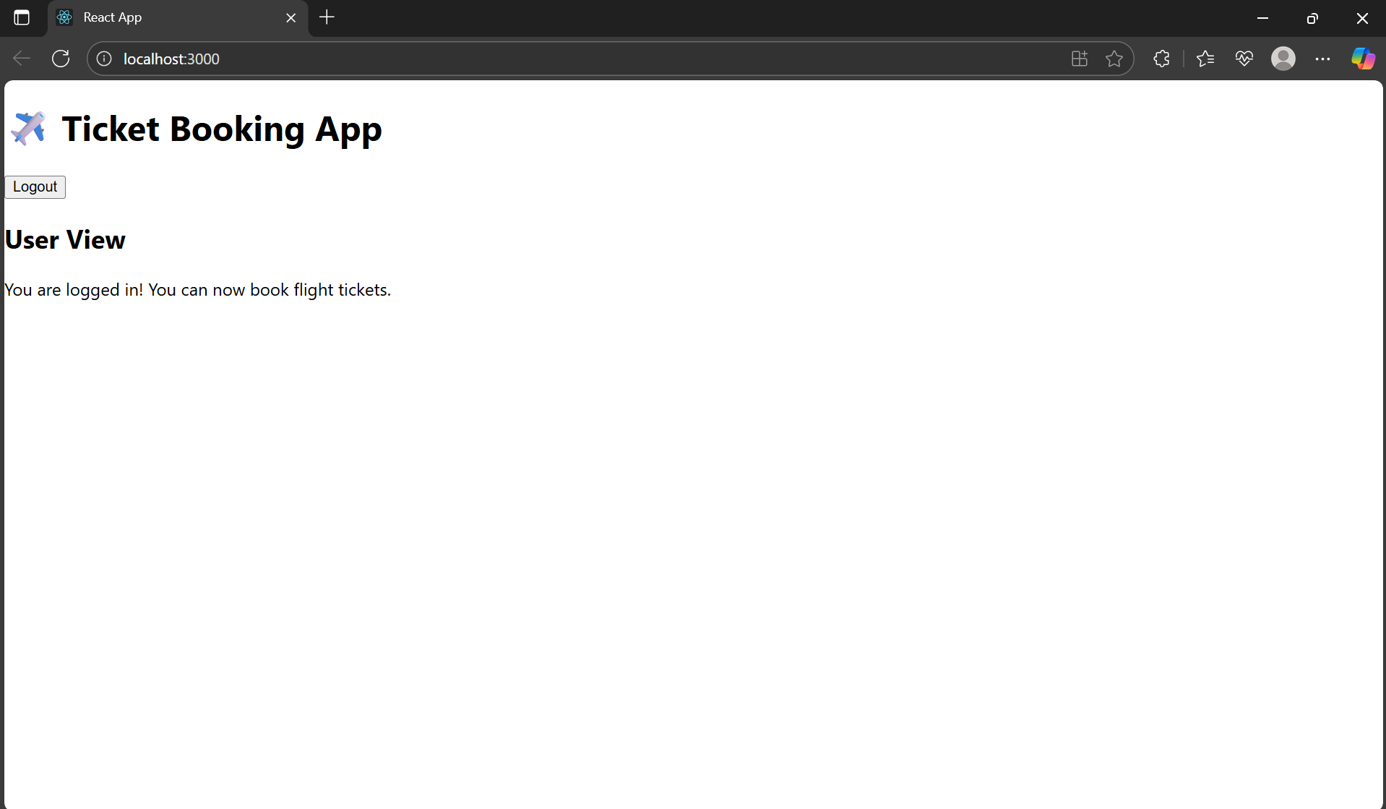

1. **ReactJS-HOL:**

**App.js:**

import React from 'react';

import './App.css';

import CourseDetails from './CourseDetails';

import BookDetails from './BookDetails';

import BlogDetails from './BlogDetails';

function App() {

return (

<div className="container">

<CourseDetails />

<div className="divider" />

<BookDetails />

<div className="divider" />

<BlogDetails />

</div>

);

}

export default App;

**App.css:**

.container {

display: flex;

justify-content: space-around;

padding: 20px;

font-family: Arial, sans-serif;

}

.section {

width: 30%;

}

.divider {

border-left: 3px solid green;

height: auto;

}

**BookDetails.js:**

import React from 'react';

const books = [

{ title: "Master React", price: 670 },

{ title: "Deep Dive into Angular 11", price: 800 },

{ title: "Mongo Essentials", price: 450 }

];

function BookDetails() {

return (

<div className="section">

<h2>Book Details</h2>

{books.map((book, index) => (

<div key={index}>

<strong>{book.title}</strong><br />

<span>{book.price}</span>

<br /><br />

</div>

))}

</div>

);

}

export default BookDetails;

**BlogDetails.js:**

import React from 'react';

const blogs = [

{

title: "React Learning",

author: "Stephen Biz",

content: "Welcome to learning React!"

},

{

title: "Installation",

author: "Schewzdenier",

content: "You can install React from npm."

}

];

function BlogDetails() {

return (

<div className="section">

<h2>Blog Details</h2>

{blogs.map((blog, index) => (

<div key={index}>

<strong>{blog.title}</strong><br />

<em>{blog.author}</em><br />

<span>{blog.content}</span>

<br /><br />

</div>

))}

</div>

);

}

export default BlogDetails;

**CourseDetails.js:**

import React from 'react';

const courses = [

{ name: "Angular", date: "4/5/2021" },

{ name: "React", date: "6/3/2021" }

];

function CourseDetails() {

return (

<div className="section">

<h2>Course Details</h2>

{courses.map((course, index) => (

<div key={index}>

<strong>{course.name}</strong><br />

<span>{course.date}</span>

<br /><br />

</div>

))}

</div>

);

}

export default CourseDetails;

**OUTPUT:**

