Demanding topics to be covered by the Widhya Platform

Apoorv Dwivedi, Suhit Kumar

**Abstract**—We present analysis of several topics to be covered in the missions of Widhya’s platform from the data collected from the students such as Flutter, Cloud Computing and many more. The analysis is supported by the visualizations of the data and includes various plots. Moreover, we have also presented the satisfaction ratings of the students by the Widhya’s Learning platform including various aspects such as effective learning through missions, UI/UX design of the platform etc.

✦

1. **INTRODUCTION**

Over 60% of the students are nowadays engaged in self learning through various online platforms such as Udacity, Dataquest etc. In this situation, every learning platform has to look forward to the demand of the students to learn the new technologies, so that they can include those technologies in their platform.

Moreover, they have to take feedbacks from their students about the platform on which they are learning which includes many parameters. Some of those are ‘Design of the platform’, ‘Cost’, ‘Accessibility’ etc.

Following the similar patterns, Widhya has taken feedback from its students regarding some of their parameters and they look forward to add some more technologies on their platform.

This analysis suggests Widhya to include some of the technologies based on the demand of the students and it also provide the feedback to Widhya that how their platform is being liked by the students.

Widhya has conducted a survey and concluded the data in the form of a csv file. The data includes many parameters. Some of them are numerical like ratings etc. and others are textual like suggestions.

We have analyzed the meaningful data from the datafile. We have used various suggestions regarding what topics should be included in the platform from the data file to suggest Widhya the topics they should include in their platform.

We have used the various ratings on the scale of 10 by the students for providing the feedback to Widhya’s platform.

All the analysis is supported by the visualizations of the data.

1. **APPROACH**

To know about the technologies in which the students are most interested, we extracted the data regarding the technologies they want to learn in the coming future from the datafile.

Then we looked the name of the technologies mentioned in their responses and then counted the number of occurrences of each technology in the responses.

We get the following graph if we visualize the number of occurrences of each technology mentioned in the student’s response:

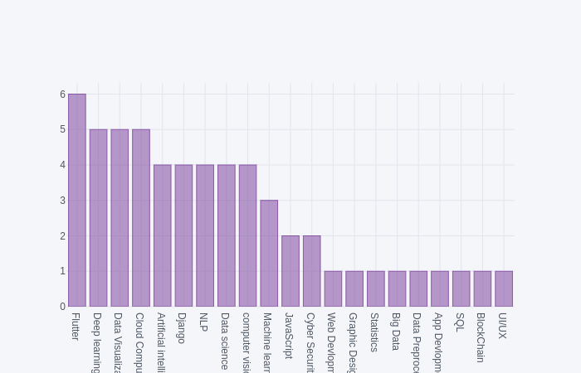

We have also plotted the tree map related to the same data as below:

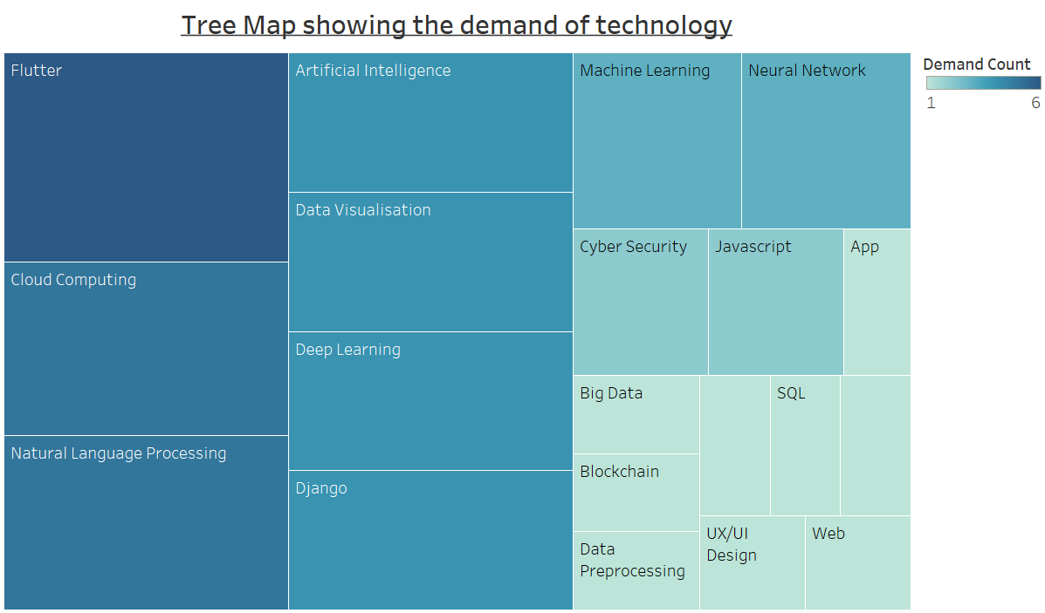

From the above visualized data we recommend Widhya to include the following technologies (arranged as per their demand):

1. Flutter
2. Cloud Computing
3. Natural Language Processing
4. Artificial Intelligence
5. Data Visualization
6. Django

In their platform.

Moreover, we have also analyzed the data regarding the skills the students have and plotted the following graph:

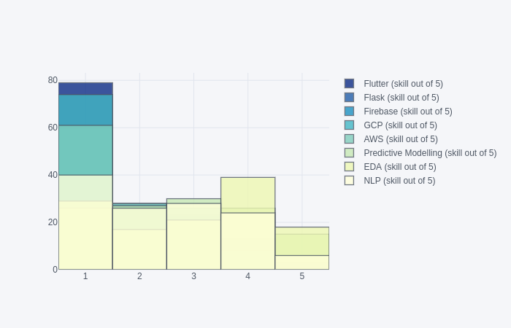

The above graph also shows that there is a need to include the following topics:

1. Flutter
2. Flask
3. Firebase
4. GCP
5. AWS

Because the ratings of the students in these skills was found to be very low.

To know about the feedback regarding the Widhya’s platform we have analyzed their ratings corresponding to the various indicated parameters and plotted as below:

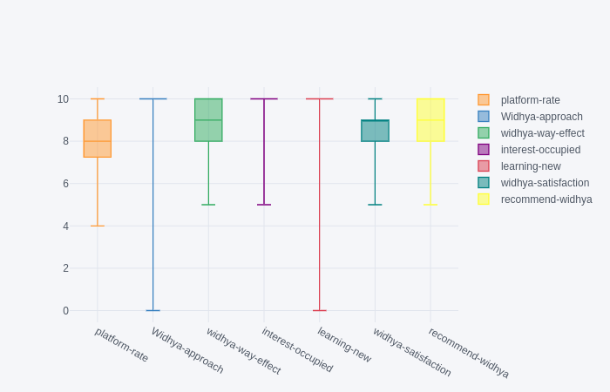

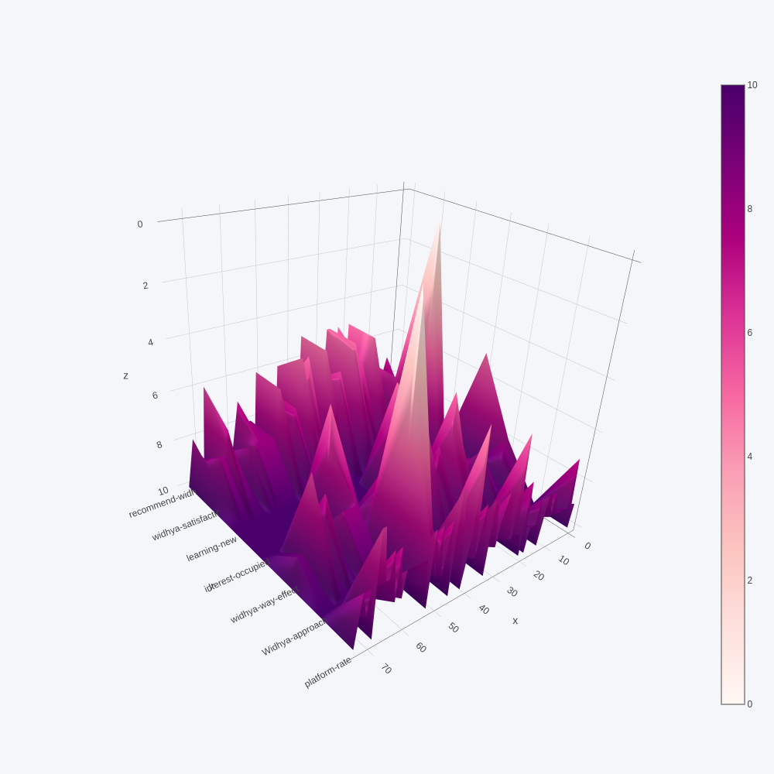

1. **CONCLUSION**

After performing the above analysis, we conclude the findings as below:

1. We recommend Widhya to include the following topics in their platform:
   * 1. Flutter
     2. Cloud Computing
     3. Natural Language Processing
     4. Artificial Intelligence
     5. Data Visualization
     6. Django
     7. Flask
     8. Firebase
     9. GCP
     10. AWS
2. Overall, we have found that the students were satisfied with the Widhya’s platform.