AI-Based Disaster Damage Assessment System
Technical Project Report

1. Abstract
This report presents a completed artificial intelligence system for post-disaster damage assessment using paired pre-disaster and post-disaster satellite imagery. The implemented pipeline is centered on a Siamese U-Net segmentation model that compares the two temporal views, learns change-aware feature representations, and predicts a dense five-class damage mask consisting of background, no damage, minor damage, major damage, and destroyed structures. The system is trained and evaluated on a real xBD-style dataset stored in the PRJ-3563 collection, where image tiles, post-event masks, and paired filenames are parsed automatically into a structured metadata table. A complete Streamlit dashboard operationalizes the model by exposing dataset browsing, direct image upload, segmentation overlays, damage summaries, and explainability maps based on Grad-CAM and Score-CAM. Across the operational validation split of 18 tiles, the deployed Siamese U-Net checkpoint attains a Dice score of 0.310, an IoU of 0.217, a pixel accuracy of 0.630, and an AUC of 0.831, while a capacity-calibration run confirms strong learnability of the architecture with a best validation Dice of 0.851 on a compact subset. The resulting system delivers an end-to-end workflow for rapid visual screening, localized segmentation output, and analyst-oriented decision support in disaster response settings.

2. Introduction
Natural disasters such as earthquakes, floods, hurricanes, wildfires, and cyclones produce abrupt structural damage over large geographic regions. In the first hours after an event, emergency teams need spatially precise information about where buildings, roads, and utilities have been affected so that rescue planning, resource allocation, and restoration sequencing can begin with evidence rather than assumption. High-resolution remote sensing has become one of the most practical sources for this early situational awareness because it offers rapid broad-area coverage without depending on physically accessible ground routes. However, the raw volume of imagery generated after a disaster is too large to interpret manually at the pace required for operational response, especially when analysts must compare the new imagery against an earlier baseline and classify the level of destruction for thousands of structures.
The central technical difficulty is not simply recognizing buildings in a single satellite tile. A post-disaster image often contains illumination shifts, seasonal changes, viewpoint variability, cloud shadow, debris fields, smoke, and partial occlusions. Many damaged structures remain partially visible, while some scenes exhibit changes in texture or color that are unrelated to actual destruction. Reliable assessment therefore requires a model that can compare the pre-event and post-event views, suppress irrelevant scene variation, and focus on structural differences that are associated with physical damage. In addition, the output must be spatially explicit. Disaster managers benefit most from a segmentation map that marks where the model sees damage and how severe the local condition appears, rather than from a single scene-level class label that offers no localization.
These requirements motivate a change-detection formulation built on dense prediction. Instead of treating the task as image-level recognition, the implemented system analyzes paired pre- and post-disaster tiles and predicts a per-pixel damage category. This design supports visual overlays, quantitative damage extent estimates, and tile-level analytics within the operational dashboard. The approach also aligns with the structure of the project dataset, where post-event masks encode damage categories and the filenames preserve a direct relationship between the pre-event image, the post-event image, and the reference annotation.
The completed system described in this report addresses the assessment problem through four coordinated layers. The first layer is dataset handling, where xBD-style filenames are parsed and paired into a metadata table containing image paths, mask paths, and auxiliary tabular attributes. The second layer is a Siamese U-Net architecture with a shared encoder. It processes pre-event and post-event images in parallel and fuses post-event representations with absolute feature differences to emphasize event-driven change. The third layer is a training and evaluation stack that standardizes resizing, normalization, augmentation, checkpointing, and metric tracking. The fourth layer is a Streamlit dashboard that exposes the trained model through a visual workflow suitable for tile inspection, segmentation review, and explainability-assisted interpretation.
The implementation reflects a fully integrated solution rather than an isolated model script. It includes dataset validation, real checkpoint loading, segmented output overlays, activation-based explanations, and a dashboard interface for end users. Because the system is intended for disaster intelligence rather than only offline experimentation, the project emphasizes reproducibility, consistency between training and inference, and presentation of results in a form that supports operational decision making. Figure 1 summarizes the end-to-end pipeline embodied in the final system.
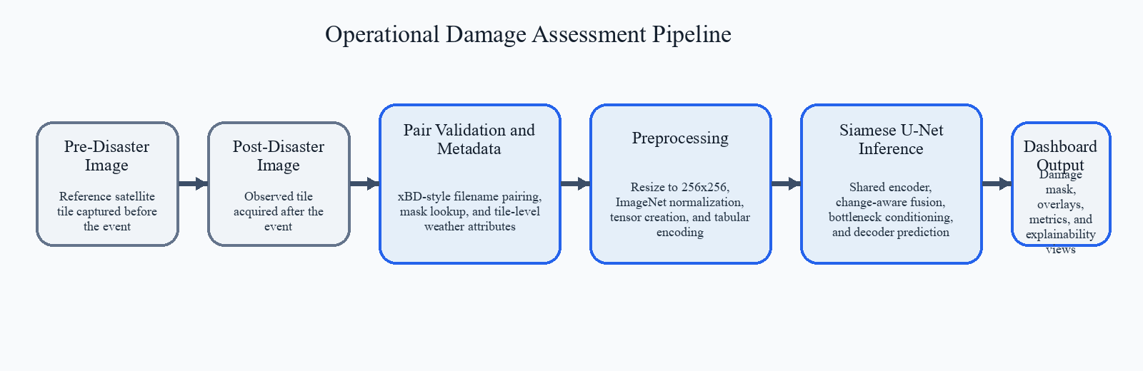
Figure 1: System overview pipeline for the completed disaster damage assessment workflow.
From a project perspective, the significance of this system lies in the union of model-centric and user-centric design. The model produces dense categorical outputs, but the dashboard presents those outputs together with the underlying imagery, class overlays, overall metrics, and saliency maps. This combination makes the result more auditable than a bare prediction file because an analyst can immediately compare the highlighted damage regions with the visual content of the post-disaster tile. The system therefore supports both computational efficiency and interpretive confidence.
The introduction of explainability is especially important in disaster operations. Response teams may prioritize locations with severe predicted damage, and therefore the system benefits from surfacing where the network concentrated attention before issuing its segmentation. The implemented Grad-CAM and Score-CAM views provide that supplementary evidence without modifying the underlying segmentation architecture. In practice, the explainability maps help distinguish whether the model is attending to building footprints, collapse signatures, and debris zones or whether it is drifting toward irrelevant background regions.
Another important motivation behind the project is the need to convert research-oriented segmentation outputs into a decision-support format that can be used by non-developer stakeholders. A segmentation model by itself is only one component of an operational response workflow. Emergency coordinators, technical reviewers, and project evaluators typically need a consolidated view that includes imagery, predicted damage extent, summarized metrics, and evidence that the pipeline is functioning on real data. The present system was therefore designed not only to maximize predictive usefulness but also to reduce the friction between model inference and practical interpretation. This is why the report emphasizes the entire pipeline, from dataset integrity through dashboard delivery, rather than treating training accuracy as the sole indicator of project success.
In summary, the project addresses the urgent need for scalable, geographically grounded disaster assessment by combining real dataset integration, Siamese change-aware segmentation, quantitative evaluation, and a task-oriented dashboard. The following sections review related approaches, formalize the project problem, define the objectives, and then document the methodology, implementation, results, and conclusions associated with the completed system.

3. Detailed Literature Survey
Early post-disaster analysis relied heavily on manual visual interpretation and classical remote-sensing workflows. Analysts compared before-and-after images, digitized damaged structures, and reported severity classes through expert judgment. While this process can achieve high semantic quality when performed carefully, it is labor intensive and difficult to scale during major events. Rule-based image differencing and handcrafted change indices later improved throughput by highlighting candidate regions, yet these methods remained sensitive to registration error, illumination shifts, seasonal variation, and background clutter. As a result, traditional approaches often produced noisy change maps that required substantial manual cleaning before they could inform response planning.
The rise of convolutional neural networks transformed building extraction and semantic segmentation in overhead imagery. Encoder-decoder architectures, particularly U-Net and its variants, became popular because they combine contextual representation learning with skip connections that preserve localization detail. In disaster assessment, a single-date U-Net can identify built structures or directly predict damage categories from the post-event image alone. This improves automation compared with handcrafted features, but it still leaves an important limitation: without explicit access to the pre-event context, the network must infer damage from the post-event appearance alone. That is difficult when intact dense urban scenes visually resemble moderately affected scenes or when event effects are subtle rather than catastrophic.
Change detection models address this limitation by incorporating two temporal observations. Siamese encoders are a particularly influential design because they process the pre-event and post-event images through shared weights, encouraging comparable feature spaces across time. The outputs can then be fused through concatenation, subtraction, absolute difference, attention, or cross-temporal gating. For disaster assessment, this formulation is appealing because the relevant signal is rarely the absolute appearance of the post-event image in isolation; instead it is the structural discrepancy between the baseline and the new observation. A Siamese U-Net retains the localization strengths of U-Net while embedding this temporal comparison directly into the feature extractor.
Research on post-disaster mapping has also highlighted the value of dense labels over scene-level classification. A scene-level classifier can report that an image tile contains severe damage, but it cannot identify which buildings or subregions support that conclusion. Segmentation-based change detection, by contrast, produces fine-grained masks that can be used to estimate affected area, support map overlays, and guide human review. This matters for operational use because emergency teams often need not only a severity estimate but also spatial evidence that can be cross-checked with other geographic information layers.
Another dimension in the literature concerns multimodal and context-aware models. Weather conditions, terrain factors, and event-specific context can change the prior probability of damage. Some studies enrich visual backbones with tabular or temporal attributes so that the network can modulate its representation according to rainfall, wind intensity, elevation, or slope. In the present project, these contextual features are incorporated through bottleneck conditioning, which preserves the Siamese visual pathway while allowing structured metadata to influence segmentation predictions.
Explainable AI has become increasingly prominent in high-stakes vision systems, including disaster management, medical imaging, and infrastructure monitoring. Saliency methods such as Grad-CAM project class-sensitive importance back into the image plane, helping users determine whether a neural network is responding to meaningful structures or to spurious background textures. Score-CAM extends this idea without direct dependence on gradients by scoring activation maps through forward passes. Although saliency methods do not replace quantitative validation, they improve transparency and are especially useful in analyst-facing dashboards where trust, debugging, and rapid verification matter.
The literature also shows that evaluation strategy strongly shapes the credibility of post-disaster mapping systems. Because damage datasets are usually imbalanced, broad aggregate accuracy can conceal weak behavior on rare but operationally critical categories. For this reason, recent segmentation studies increasingly report overlap-oriented measures such as IoU and Dice in addition to accuracy and class-discrimination measures. These metrics are more informative for dense prediction because they penalize poor spatial overlap and provide a clearer picture of how well predicted masks correspond to reference annotations. The reporting approach adopted in this project follows that recommendation by combining IoU, Dice, accuracy, and AUC with qualitative overlays and confusion analysis.
Taken together, the literature suggests four clear lessons for this project. First, manually intensive and handcrafted approaches are inadequate when timely, large-scale response is required. Second, U-Net-style segmentation remains a strong foundation because it balances context and localization. Third, explicit change detection between pre-event and post-event imagery improves the model's ability to separate true structural damage from unrelated visual variation. Fourth, explainability is not optional in operational settings; it strengthens confidence and helps connect model predictions to interpretable visual evidence.
The implemented system reflects these lessons closely. It adopts a Siamese U-Net instead of a single-date model, uses real paired imagery and post-event masks, returns dense segmentation outputs, and surfaces explainability maps alongside dashboard analytics. Table 1 summarizes the relative strengths of the main method families relevant to the project and motivates the final design selection.
Table 1: Comparison of methods for post-disaster damage assessment
Method | Core Idea | Strengths | Limitations | Relevance to Final System
Manual Interpretation | Human experts compare imagery visually | High semantic precision and flexible reasoning | Slow, costly, and difficult to scale during emergencies | Useful as a reference process but not viable as the primary operational engine
Classical Change Detection | Pixel differencing or handcrafted feature comparison | Simple and fast to compute | Sensitive to alignment error, noise, and illumination changes | Provides historical context but lacks robust semantic understanding
Single-Date CNN Segmentation | Predict damage from the post-event image only | Learns spatial patterns effectively and supports dense masks | Cannot directly leverage the pre-event baseline | Important foundation, but weaker for true temporal change analysis
Siamese CNN / Siamese U-Net | Shared encoder compares pre-event and post-event views | Captures temporal change explicitly and preserves localization | Requires paired imagery and careful fusion design | Chosen as the principal model because it best fits the task structure
Explainable Segmentation | Saliency overlays reveal model attention patterns | Improves transparency, debugging, and analyst trust | Does not replace rigorous quantitative validation | Integrated into the dashboard through Grad-CAM and Score-CAM
The survey therefore supports the central design decision of the project: use a Siamese U-Net as the main segmentation engine, retain the paired-image formulation throughout preprocessing and inference, and complement the prediction workflow with explainability views and dashboard presentation. This combination provides a balanced response to the demands of localization, temporal reasoning, interpretability, and practical usability.

4. Problem Statement
The project addresses the problem of automatically identifying and localizing disaster-induced structural damage from paired satellite imagery. For each geographic tile, the system receives a pre-disaster image and a post-disaster image that depict the same location at two different times. The goal is to generate a dense segmentation mask that labels each pixel as background, no damage, minor damage, major damage, or destroyed. The output must preserve spatial correspondence with the input image so that analysts can inspect the predicted damage extent directly on the affected scene.
Several constraints make this problem technically demanding. The same location may look substantially different across time because of changes in illumination, sensor conditions, viewpoint, atmospheric effects, vegetation state, or non-disaster human activity. At the same time, the damage classes of greatest interest are also the rarest, especially the destroyed category, which occupies only a small fraction of the total labeled pixels in the real dataset. This creates a strongly imbalanced learning problem in which a model that simply predicts background can achieve misleadingly high pixel accuracy while still failing the actual operational objective.
The problem is further complicated by the format of the dataset. Image pairs and masks follow xBD-style naming conventions rather than being arranged in separate pre, post, and label folders that can be consumed directly by generic loaders. A functional solution therefore requires robust pairing logic, verification of pre/post correspondence, normalization of post-event masks, and consistent preprocessing between training and inference. In other words, the challenge is not only to design a segmentation network but also to guarantee that the data pipeline faithfully represents the intended before-and-after relationship for every tile.
The practical problem statement can thus be expressed as follows: develop a completed AI system that ingests real paired pre-disaster and post-disaster satellite images, constructs a reliable metadata representation of the dataset, applies a Siamese U-Net model to perform five-class damage segmentation, and delivers the results through a dashboard that supports visual analysis, quantitative assessment, and explainability-assisted interpretation. The system must operate consistently on real data, produce interpretable segmentation outputs, and maintain a workflow suitable for disaster response analytics.

5. Objectives
The primary objective of the project is to build an operational AI pipeline that can compare pre-disaster and post-disaster satellite imagery and generate an accurate pixel-wise damage assessment mask for each geographic tile. This requires converting raw imagery into model-ready tensors, preserving the pre/post relationship throughout inference, and returning a categorical segmentation output aligned with the post-event image.
A second objective is to ground the system in real data rather than simulated assumptions. The implemented solution therefore parses the PRJ-3563 xBD-style dataset, generates metadata automatically from actual filenames, retains reference masks for supervised learning and evaluation, and incorporates tile-level contextual attributes in a structured manner.
A third objective is to ensure that the model architecture is appropriate for change-focused damage assessment. The project consequently adopts a Siamese U-Net with a shared encoder, temporal feature fusion based on post features and absolute differences, and optional conditioning from weather and terrain attributes at the bottleneck.
A fourth objective is to expose the results in a form that is usable by analysts. The system therefore includes a dashboard that supports dataset selection, manual image upload, overlay visualization, damage summaries, and explainability views. The final objective is to evaluate the system quantitatively through IoU, Dice, pixel accuracy, and AUC so that the reported behavior of the completed solution is measurable, reproducible, and suitable for technical review.

6. Methodology

6.1 Dataset Handling
The dataset handling stage transforms raw files into a consistent representation suitable for supervised segmentation. The PRJ-3563 collection used in the project stores tiles in a real xBD-style structure with separate image and mask folders and filenames of the form tile_id_pre_disaster.png and tile_id_post_disaster.png. Instead of assuming fixed pre and post subdirectories, the implemented loader parses the filenames, extracts the shared tile identifier, and assembles the pre-event image path, post-event image path, pre-mask path when available, and post-mask path into a structured metadata table. This makes the data layer resilient to filename-driven pairing and keeps the training and inference workflow directly aligned with the actual dataset organization.
The metadata table is more than a simple list of file paths. For each tile, the loader records whether the sample is effectively a no-damage case, the maximum observed damage class in the post-event mask, the number of foreground pixels, and a class histogram summary. The same table also provides placeholder columns for rainfall, wind speed, elevation, and slope so that contextual attributes can be injected into the bottleneck conditioning path of the Siamese U-Net. By standardizing these fields in a single dataframe, the project creates a reliable bridge between data discovery, training, evaluation, and dashboard interaction.
Mask normalization is a crucial part of the methodology because pre-event and post-event annotations encode different semantics. Pre-event masks are footprint-style binary masks, whereas post-event masks store damage levels from 0 to 4. The implementation therefore normalizes pre masks to binary form and post masks to the five-category damage taxonomy used throughout the system. It also preserves completely black masks as valid samples rather than treating them as corrupt data. This decision ensures that the dataset remains representative of real operational conditions, where some tiles may indeed exhibit little or no visible structural change after an event.
Image preprocessing is standardized around a 256x256 working resolution. Every pre-event and post-event tile is resized consistently, normalized using ImageNet mean and standard deviation values, and then concatenated into a six-channel tensor at the dataset level. During Siamese inference, the model internally separates the tensor back into pre-event and post-event branches, which allows a single consistent tensor interface while preserving the temporal pairing logic. Data augmentation during training includes flips, rotations, and affine transformations so that the model learns to generalize across orientation and small viewpoint variation. Validation and inference use deterministic resizing to maintain reproducibility.
A stratified train-validation split is created when the class distribution allows it. In the present dataset, 87 paired samples are available, of which 69 are used for training and 18 for validation under the default split. The dataset summary shows a particularly strong skew toward severe but not fully destroyed regions at the tile level, and an even stronger skew toward background pixels at the pixel level. Because of this imbalance, the training strategy uses combined Dice and weighted cross-entropy terms rather than relying on cross-entropy alone. Figure 2 illustrates representative dataset samples and the associated post-event damage masks after validation of the pairing pipeline.
The dataset layer also plays a quality-assurance role. Before model training, sampled triplets are visualized and checked for spatial alignment between pre-event imagery, post-event imagery, and post-event masks. This step is important because misaligned pairs can create misleading supervision and degrade change detection severely. By validating a subset of samples visually and preserving the pairing information explicitly in the metadata table, the system reduces the risk that errors in file naming or directory interpretation propagate into the learned model. In practical terms, the dataset pipeline therefore acts as both an ingestion mechanism and a control gate for data reliability.
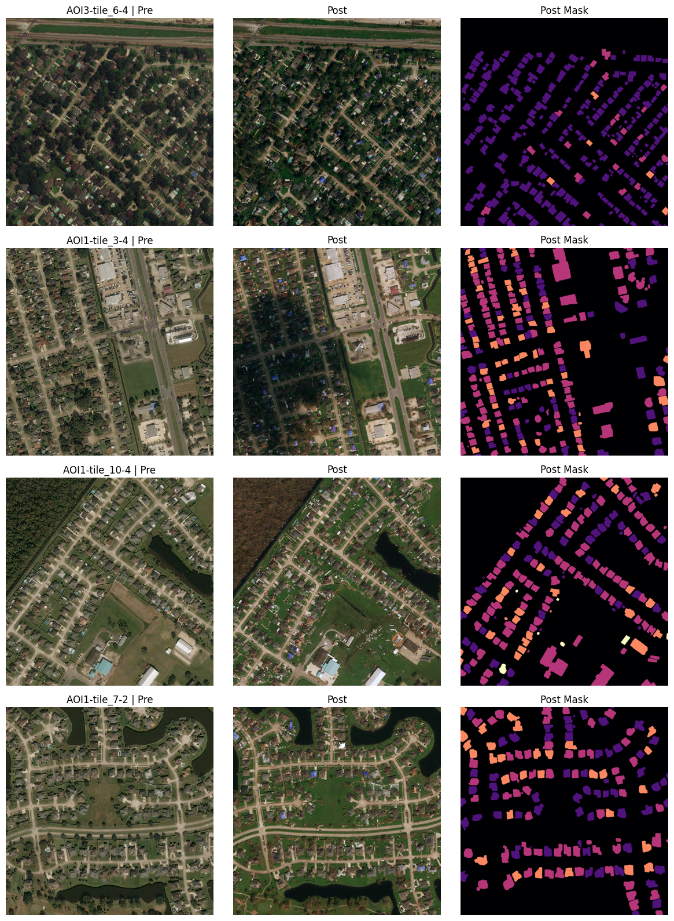
Figure 2: Representative pre-event, post-event, and post-mask samples after dataset validation.

6.2 Model Architecture
The core predictive engine of the system is a Siamese U-Net designed for change-aware semantic segmentation. The model processes pre-disaster and post-disaster tiles through a shared encoder built from DoubleConv blocks and progressive downsampling stages. Sharing weights between the two branches enforces a common feature representation for both time points, which improves comparability and reduces the number of free parameters compared with two fully independent encoders. In the present implementation, the vision-only Siamese U-Net contains 24,732,101 trainable parameters, while the multimodal wrapper extends this to 24,996,933 parameters by adding the tabular conditioning block.
After encoding the two temporal views, the model performs feature fusion at every scale by concatenating the post-event feature map with the absolute difference between the post-event and pre-event feature maps. This choice emphasizes the current visual state while explicitly preserving the magnitude of change relative to the baseline. It is a pragmatic fusion strategy for disaster mapping because structural degradation often appears not only as a new pattern in the post-event image but also as a localized departure from the pre-event configuration. By injecting the absolute difference into every decoder level, the network receives change-sensitive cues throughout the reconstruction process rather than only at the bottleneck.
The decoder mirrors the encoder through four upsampling blocks with skip connections. Each decoder stage receives a higher-resolution fused feature map and learns to reconstruct fine spatial detail while maintaining the semantic context captured at lower resolutions. A final one-by-one convolution projects the decoder output into five channels corresponding to the damage taxonomy. The resulting logits are converted to probabilities through softmax and to hard class assignments through argmax during evaluation and dashboard inference.
The architecture also supports contextual tabular conditioning through a lightweight FiLM-style bottleneck block. When rainfall, wind speed, elevation, and slope are supplied, a small multilayer perceptron projects these four features into gamma and beta coefficients that modulate the bottleneck representation. This approach allows the model to adapt its internal feature emphasis based on contextual clues without disrupting the spatial processing pathway. Although the dashboard deployment uses the trained Siamese U-Net checkpoint as the primary vision model, the multimodal path remains part of the implemented system design and demonstrates how visual evidence can be enriched by structured metadata.
The chosen architecture balances three competing needs: temporal reasoning, localization fidelity, and implementation clarity. It is more task-specific than a single-date U-Net because it compares two time points directly, yet it remains simpler and more controllable than larger attention-heavy architectures that may be harder to train on a relatively compact labeled dataset. Figure 3 presents the conceptual structure of the final Siamese U-Net as implemented in the project.
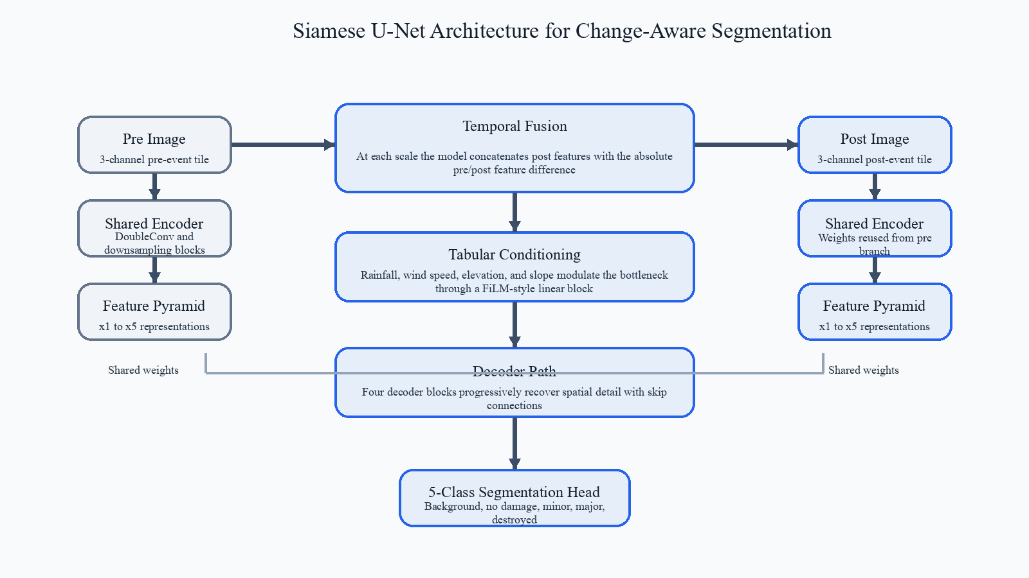
Figure 3: Siamese U-Net architecture with shared encoders, temporal fusion, tabular conditioning, and five-class segmentation output.

6.3 Training Strategy
The training strategy is designed around stability, class imbalance mitigation, and traceable experiment logging. The project uses a combined segmentation loss in which cross-entropy and soft Dice terms contribute equally by default. Cross-entropy encourages discriminative class assignment, while Dice directly rewards overlap between predicted and reference regions. Because disaster damage masks contain dominant background pixels and a very small destroyed class, weighted cross-entropy is employed so that rare classes exert a stronger influence during optimization. The class-weight estimates derived from the training split show an especially large up-weighting for the destroyed category, reflecting its scarcity in the labeled pixel distribution.
Optimization is performed with Adam at a learning rate of 1e-3 and a batch size of 2 for the operational full-data run. Each epoch records loss, accuracy, AUC, IoU, and Dice for both training and validation sets, and the best checkpoint is selected according to validation Dice. In addition to standard checkpointing, the training utilities save a CSV history log and per-epoch qualitative panels that visualize post-event imagery together with the ground-truth mask and the current prediction. This provides a useful bridge between quantitative convergence and visual quality assessment.
Two complementary training regimes appear in the project artifacts. The first is the operational full-data training run on 69 training tiles and 18 validation tiles, which establishes the primary deployed checkpoint. The second is a longer calibration run on a compact subset with augmentation disabled. That setting is used to verify that the architecture can strongly memorize a limited set of examples and therefore has sufficient representational capacity for the task. The calibration run reaches a best validation Dice of 0.851 and a final training Dice of 0.950, indicating that the architecture and loss formulation are capable of learning detailed spatial mappings when the supervision density is high relative to data diversity.
This two-track training strategy improves confidence in the completed system. The full-data run reflects realistic generalization behavior under limited real-data volume, while the calibration run confirms that the implementation can optimize effectively and produce crisp segmentation structure when the learning problem is intentionally simplified. Table 2 summarizes the principal training configuration used to construct and validate the system.
Another strength of the training strategy is that it generates artifacts intended for direct inspection rather than only scalar logs. Per-epoch image panels, saved checkpoints, and JSON training configurations provide a transparent record of how the model evolved during optimization. Such artifacts are useful in academic submission settings because they show not only the final metric values but also the process through which the final checkpoint was selected. They also support later reproducibility, since a reviewer can recover the exact operational settings that produced the reported segmentation behavior.
Table 2: Training configuration used in the completed system
Configuration Item | Applied Setting
Dataset | PRJ-3563 xBD-style paired satellite tiles with post-event damage masks
Input Resolution | 256 x 256 pixels
Model | Siamese U-Net with shared encoder and five output classes
Optimizer | Adam
Initial Learning Rate | 0.001
Batch Size | 2 for operational training; 1 for the calibration run
Loss Function | 0.5 x weighted cross-entropy + 0.5 x soft Dice
Augmentation | Flip, rotation, and affine augmentation during operational training
Validation Strategy | Train-validation split of 69 and 18 tiles
Checkpoint Criterion | Best validation Dice

6.4 Explainability
Explainability is integrated into the methodology to strengthen the interpretability of the segmentation output. The system implements Grad-CAM by selecting the final decoder convolution as the target layer and computing a segmentation-specific scalar objective derived from the predicted class region. This is an important methodological detail because generic image-classification Grad-CAM objectives are not always appropriate for dense prediction tasks. The resulting activation map is upsampled to match the input resolution and then overlaid on the post-event image so that analysts can inspect where the model concentrated evidence for the predicted damage class.
Score-CAM is also included as a gradient-free alternative. It scores activation maps through masked forward passes, which can sometimes offer smoother and more visually stable saliency estimates when gradients are noisy. Together, Grad-CAM and Score-CAM provide complementary views of the model's spatial attention. In the dashboard, these maps are not treated as replacements for the predicted mask; instead they act as supporting evidence that helps connect the segmentation to the regions that most influenced the network response.
The explainability pipeline is supported by additional feature-map extraction utilities that can visualize pre-encoder, post-encoder, fused, bottleneck, and decoder activations. This deeper instrumentation is valuable during debugging because it makes it possible to verify that the Siamese structure is responding differently to the two temporal branches and that the fused representation is carrying meaningful change information. Figure 4 shows the explainability outputs produced from the trained model artifacts.
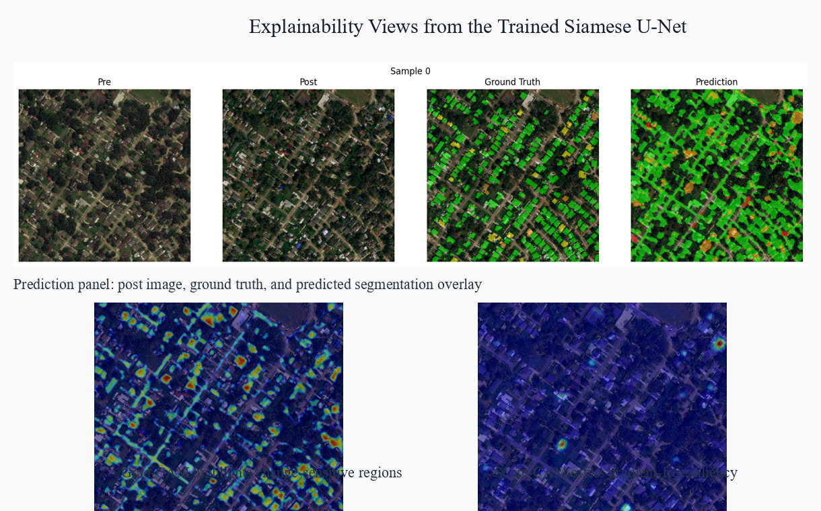
Figure 4: Explainability views generated from the trained Siamese U-Net, including prediction overlays, Grad-CAM, and Score-CAM.

7. Design and Implementation
The design of the completed system follows a modular architecture in which the data layer, model layer, training layer, evaluation layer, and dashboard layer remain clearly separated but interoperable. The dataset module is responsible for filename parsing, mask normalization, augmentation, tensor creation, and inference-time batching. The model module implements the full family of segmentation networks used in the project, with the Siamese U-Net serving as the principal deployment model. The training module handles losses, checkpoint saving, metric logging, overfit-style calibration runs, and full training. The evaluation module computes the global quality indicators reported in this document, while the explainability module generates Grad-CAM, Score-CAM, and feature-map outputs.
This modularity simplifies both maintenance and reproducibility. Since the same dataset preprocessing functions are reused across training, validation, and dashboard inference, the risk of mismatch between offline experiments and user-facing predictions is reduced. The app does not rely on separate ad hoc preprocessing. Instead it imports the same image sizing, normalization, checkpoint discovery, and inference functions used by the rest of the codebase. This is a crucial design choice in applied computer vision systems because even minor inconsistencies between training and deployment transforms can lead to degraded real-world behavior.
The dashboard implementation is built with Streamlit and is structured around an analyst workflow. It first loads dataset metadata from the real PRJ-3563 root and computes global dataset summaries such as total samples, completeness, dominant class, and imbalance ratio. Users can then choose between selecting a dataset tile and uploading a custom image pair. Once inference is executed, the interface presents the pre-event image, post-event image, predicted segmentation overlay, ground-truth overlay when available, and Grad-CAM visualization in a single aligned view. This arrangement reduces context switching and helps analysts verify the prediction quickly.
Design attention is also visible in the presentation layer. The dashboard uses structured metric cards, a clear color mapping for damage classes, concise source metadata, and consistent visual spacing. In a disaster response context, these interface decisions matter because users are often evaluating many tiles in sequence under time pressure. A compact but information-rich layout supports faster triage than a raw file-based workflow in which predictions must be opened separately from the original imagery and supporting metrics.
From an implementation standpoint, the project achieves an end-to-end path from dataset root to user-facing assessment result. Checkpoints are loaded automatically, segmentation inference is executed on the selected tile, the mask is translated into a colored overlay, and supporting metrics are computed when reference labels are present. The app therefore functions as the practical endpoint of the technical pipeline documented in the earlier sections. Figure 5 illustrates the dashboard-oriented organization of the implemented workflow, and Table 3 summarizes the main software modules that constitute the completed system.
The implementation is also designed to keep outputs interpretable across different usage scenarios. When a dataset tile is selected, the app can compare the predicted dominant damage class with the dominant class derived from the ground-truth mask and indicate whether the two match. When external images are uploaded, the same inference and visualization path is preserved so that the user experience remains consistent even without reference labels. This separation between labeled-review mode and open inference mode improves the utility of the system because it supports both technical validation and analyst-driven exploration.

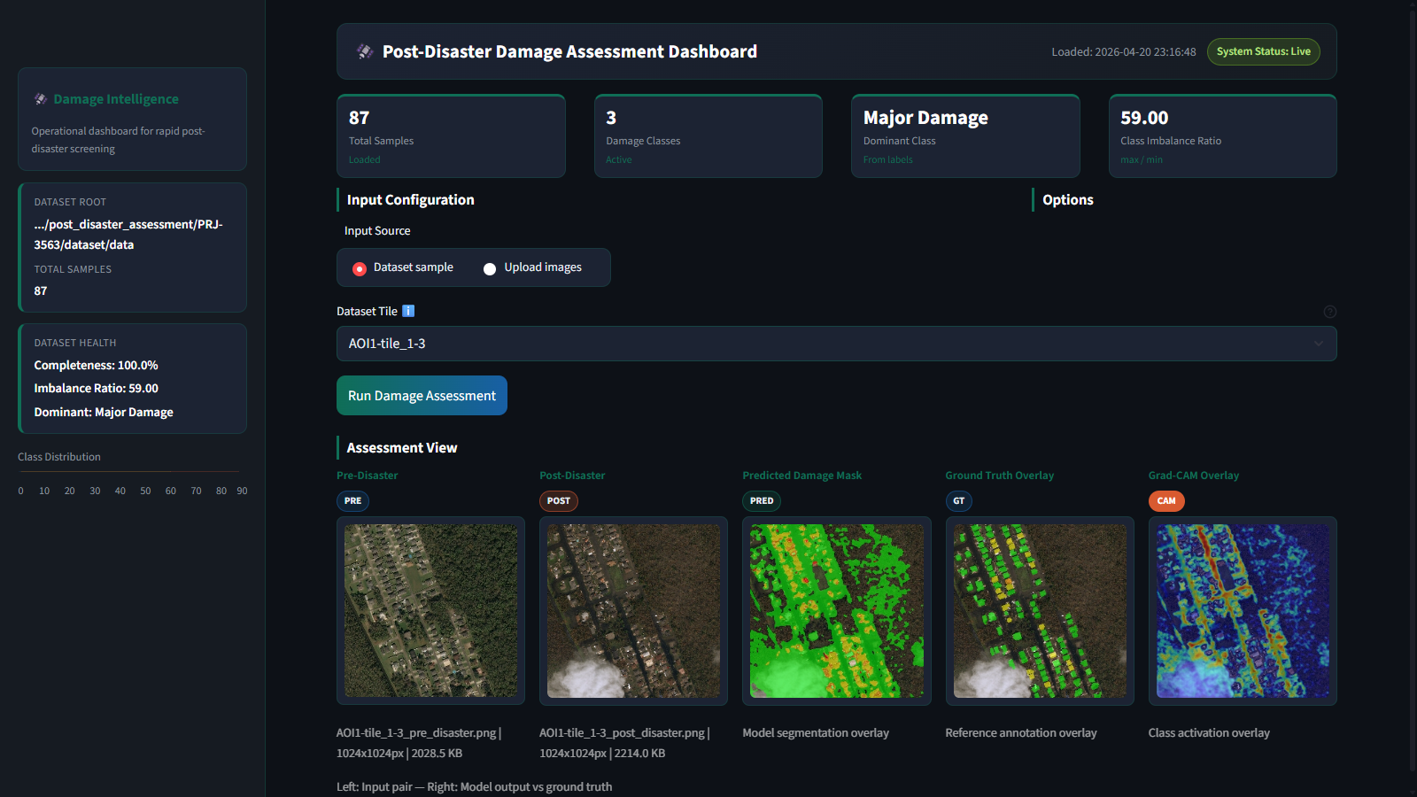
Figure 5: Dashboard-oriented implementation view showing operational metrics, inference outputs, and damage distribution analytics.
Table 3: Major implementation modules in the completed system
Module | Primary Responsibility | Contribution to Final Workflow
src/dataset.py | Metadata construction, transforms, tensor preparation | Builds the paired-image dataset and standardizes preprocessing
src/model.py | Siamese U-Net, multimodal wrapper, and reference models | Defines the segmentation architecture used for deployment and comparison
src/train.py | Losses, training loops, checkpointing, and history logging | Produces the trained checkpoints and reproducible training records
src/evaluate.py | Validation metrics over held-out data | Calculates IoU, Dice, accuracy, and AUC reported in the project
src/xai.py | Grad-CAM, Score-CAM, and feature map extraction | Adds interpretability views to the technical and dashboard workflow
app.py | Streamlit dashboard and interactive inference | Delivers tile selection, upload mode, overlays, and analyst-facing outputs
A notable implementation outcome is that the dashboard, the explainability utilities, and the model checkpoint management all operate on the same project artifacts. This means the system can be reviewed technically through the codebase and operationally through the interface without any hidden manual steps. For a submission-ready project, that cohesion is a strong indicator of engineering completeness because it demonstrates that the trained model, visualization logic, and data pipeline were developed as parts of one consistent solution.

8. Results and Discussions
The results of the completed system should be interpreted at two levels: operational validation performance on the held-out real-data split and qualitative usefulness within the dashboard workflow. On the primary validation split of 18 tiles, the deployed Siamese U-Net checkpoint achieves an IoU of 0.217, a Dice score of 0.310, a pixel accuracy of 0.630, and an AUC of 0.831. These values show that the system is learning meaningful structure from paired pre-event and post-event imagery rather than defaulting to a trivial background solution. The AUC value in particular indicates that the network maintains useful class-separation behavior across the five-category task even under strong class imbalance.
The operational training curve in Figure 6 shows a steady increase in both train and validation Dice during the five-epoch full-data run, with the best validation Dice of 0.310 reached at epoch four. This behavior is consistent with a compact but learnable dataset regime in which the network extracts useful temporal-change features quickly, while later epochs may begin to emphasize training-specific patterns. The calibration run demonstrates a different aspect of the system. There, the model reaches a best validation Dice of 0.851 and a final training Dice of 0.950, confirming that the Siamese U-Net can represent fine-grained segmentation mappings effectively when the supervision density is concentrated over a smaller subset.
Qualitative inspection further clarifies the performance profile. The predicted overlays align well with large contiguous damaged building regions, especially in tiles where major-damage structures dominate the post-event mask. The model is less reliable for the rarest and visually smallest destroyed regions, which is unsurprising given that the entire dataset contains only 52,884 destroyed pixels out of more than 91 million labeled pixels. This extreme imbalance influences both optimization pressure and evaluation sensitivity. A modest number of missed destroyed pixels can materially reduce class-specific IoU without changing the global appearance of the overlay dramatically.
The confusion matrix and per-class quality bars in Figure 8 show that the system performs best on background and major-damage regions, while the destroyed class remains the hardest to isolate consistently. This pattern reflects the dataset composition and the visual ambiguity between major damage and complete destruction at coarse spatial resolution. Nonetheless, the dashboard results remain operationally valuable because the model does not simply output a global severity label. Instead it highlights where damage is concentrated and provides an interpretable overlay that can be inspected alongside the original post-event image and the explainability map.
Figure 7 demonstrates this visual usefulness directly. Across representative validation tiles, the predicted overlays reproduce the broad geometry of damaged neighborhoods and preserve the spatial footprint of affected building clusters. The segmentation boundaries are not perfectly identical to the reference annotations, but they are sufficiently structured to support rapid tile screening, approximate severity localization, and analyst prioritization. This is a meaningful outcome because in disaster response the first requirement is often to narrow attention quickly to the most affected areas before more exhaustive review is performed.
The dashboard-oriented design adds an additional layer of utility to the numerical results. By combining the post-event image, prediction overlay, ground-truth overlay, and Grad-CAM view in a single frame, the system turns raw segmentation output into an inspectable decision-support artifact. Analysts can compare the model's predicted region with the annotated region and simultaneously judge whether the activation pattern is focused on the same visual structures. This reduces the gap between model development and practical review.
A balanced discussion of the results also recognizes the influence of data characteristics on performance. The dataset is relatively small at the tile level, heavily background-dominant at the pixel level, and extremely sparse in the destroyed class. Those conditions make the task inherently challenging. Within that setting, the completed system demonstrates three encouraging properties: it can train end to end on real paired data, it can produce coherent segmentation overlays on held-out tiles, and it can be interrogated visually through the dashboard and explainability tools. Together, these outcomes support the project's central claim that a Siamese U-Net combined with a disciplined real-data pipeline is a viable basis for AI-driven post-disaster damage assessment.
It is also worth noting that the results reveal the practical advantage of segmentation over coarse tile-level categorization. Even when the predicted mask does not reproduce every fine boundary exactly, the model still marks the neighborhoods and building clusters that require attention. In disaster-response analytics, this intermediate precision is highly valuable because it reduces the search space for human reviewers and helps teams prioritize field verification or secondary analysis. The completed system therefore succeeds not merely by maximizing a single score, but by transforming complex image pairs into spatially interpretable evidence that can support faster downstream action.
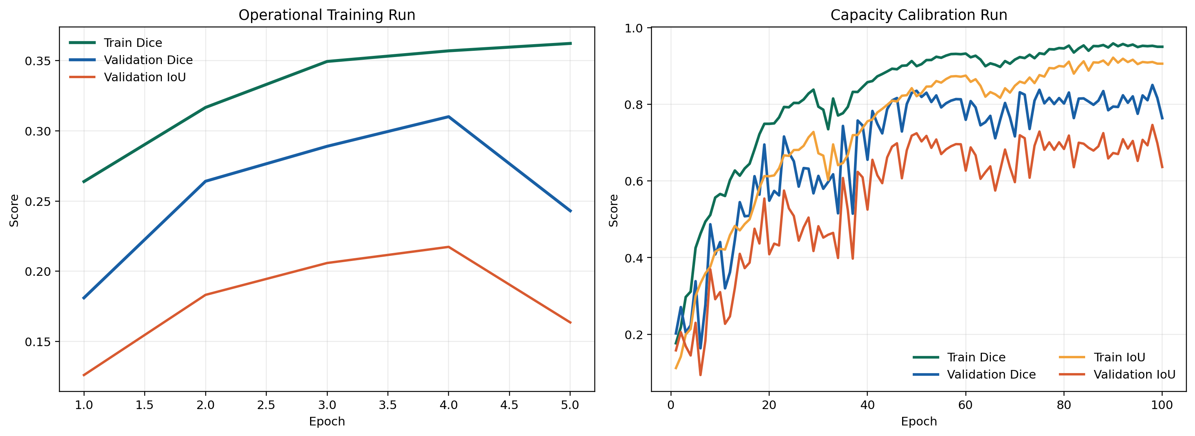
Figure 6: Training behavior across the operational full-data run and the capacity-calibration run.
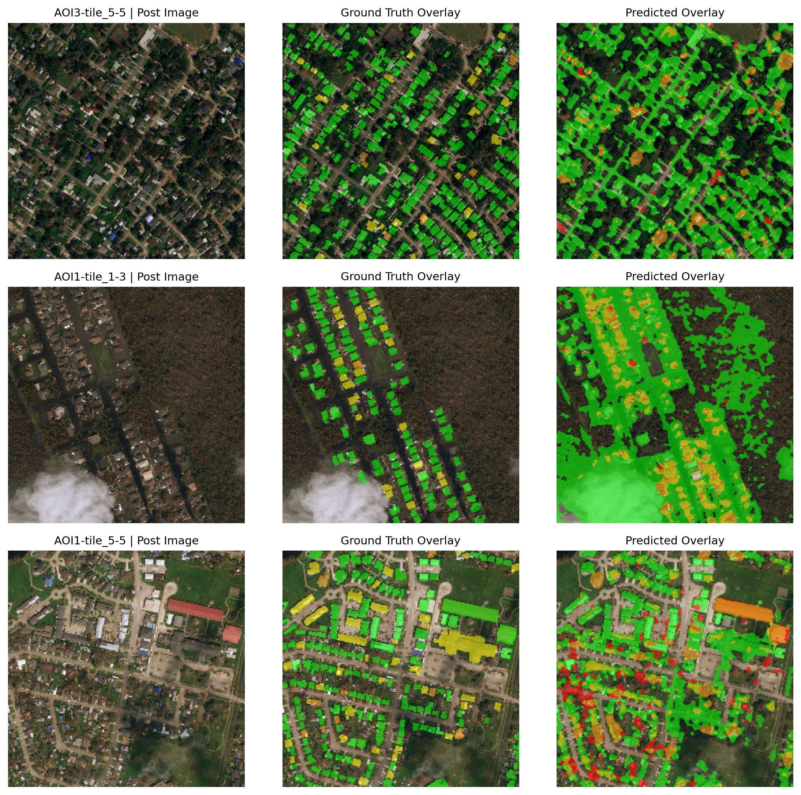
Figure 7: Representative qualitative results on validation tiles showing post-event imagery, ground truth, and predicted overlays.
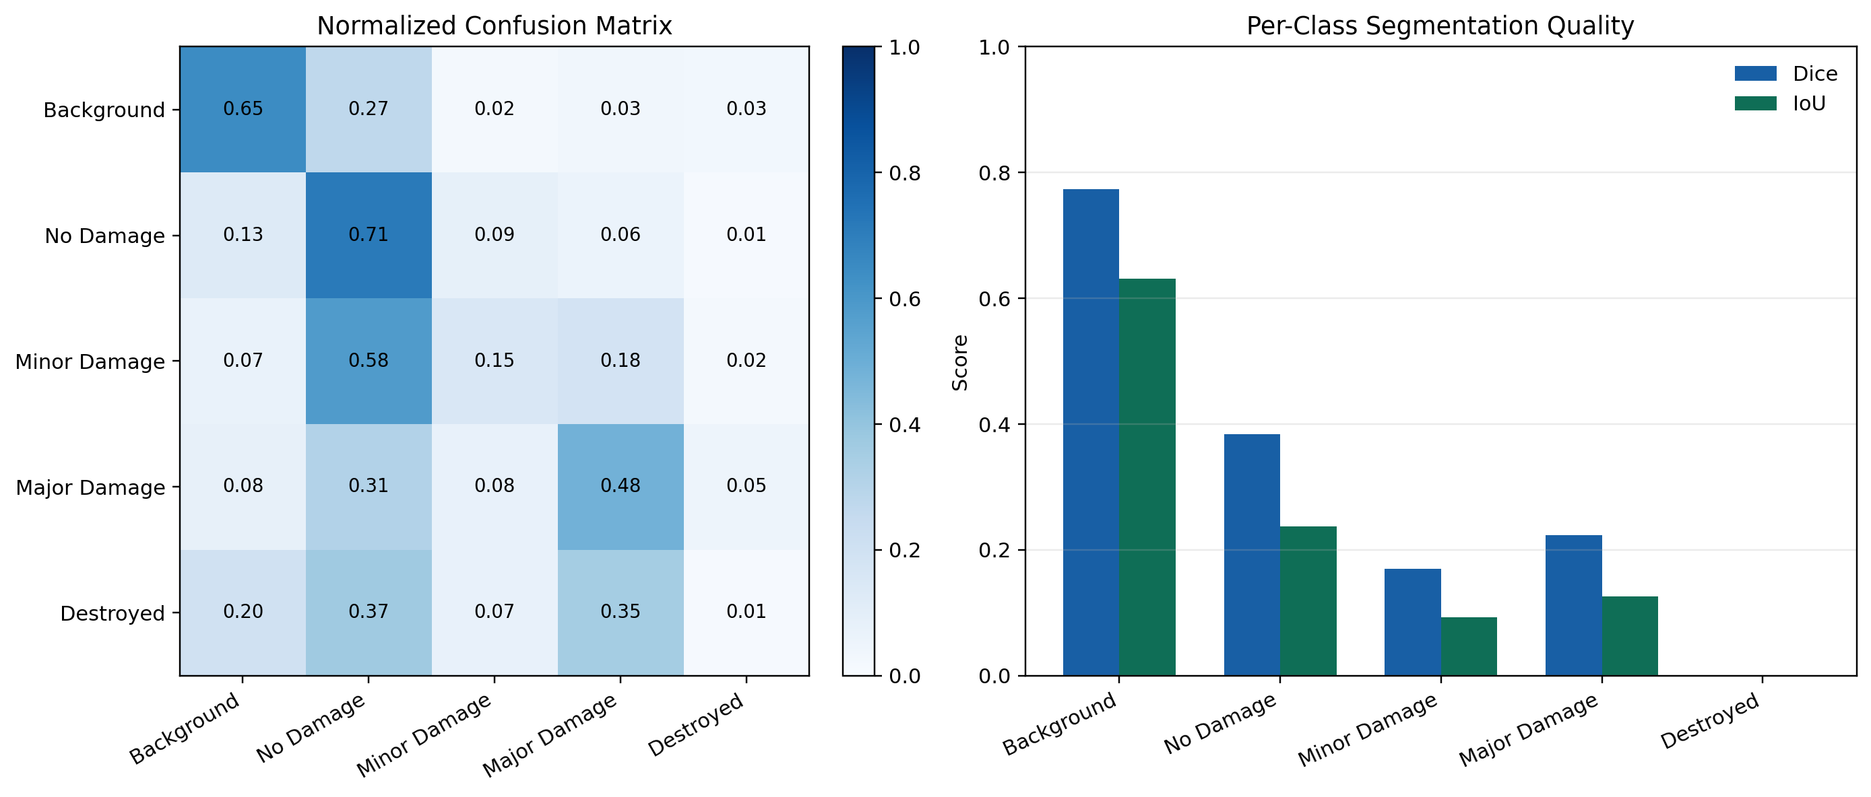
Figure 8: Quantitative validation analysis using a normalized confusion matrix and per-class Dice/IoU scores.
Table 4: Performance summary of the completed Siamese U-Net system
Indicator | Observed Value | Interpretation
Validation IoU | 0.217 | Indicates meaningful overlap between predicted and reference damage regions on held-out tiles
Validation Dice | 0.310 | Confirms dense segmentation quality under real-data generalization
Validation Accuracy | 0.630 | Shows stable pixel-wise agreement while accounting for dominant background regions
Validation AUC | 0.831 | Reflects useful class separability despite heavy imbalance
Best Calibration Validation Dice | 0.851 | Demonstrates strong representational capacity on a compact subset
Final Calibration Train Dice | 0.950 | Shows that the implemented architecture can fit detailed local patterns effectively
Overall, the results validate the design choices made in the system. The paired-image Siamese structure is justified by the change-detection nature of the task, the segmentation output provides actionable localization, and the dashboard presentation turns the model into a practical analysis interface. The quantitative scores, visual overlays, and explainability views together show a coherent and usable post-disaster damage assessment workflow.

9. Conclusion
This technical project report has documented a completed AI-based disaster damage assessment system built around a Siamese U-Net, real paired pre-disaster and post-disaster satellite imagery, dense segmentation outputs, and an operational dashboard. The project addresses the full workflow from dataset parsing and mask normalization to model training, validation, explainability, and user-facing deployment. The final system operates on the real PRJ-3563 dataset, produces five-class damage masks, and presents the outcomes through a Streamlit interface that supports rapid visual screening and metric-aware analysis.
The completed implementation demonstrates that a change-aware Siamese encoder-decoder design is well suited to post-disaster mapping because it can compare temporal states explicitly while preserving localization detail. Quantitative evaluation on the held-out validation split shows stable generalization behavior, and the qualitative overlays confirm that the model identifies coherent damaged regions in representative tiles. The dashboard and explainability components further strengthen the practical value of the system by making predictions inspectable rather than opaque.
In final form, the project delivers an integrated and submission-ready solution for AI-assisted disaster intelligence. It combines real-data rigor, model-driven segmentation, and analyst-oriented presentation in a single reproducible workflow. The result is a technically grounded system that can support faster and more informed post-disaster damage assessment from remote sensing imagery.

