**People’s Attitudes Towards Artificial Intelligence**

**Author:**

**张悦（ZY1804225）**

**苏怀星（ZY1804622）**

**张云（SY1804418）**

**2018-12-21**

**Abstract**

At present, artificial intelligence is widely used in our lives and make our life more convenient, which leads to different attitudes towards the development of artificial intelligence. This paper aims to learn about what people think of AI indeed and which opinion most of people hold. A questionnaire with 10 questions has been designed and 86 respondents filled out it through the Internet. Based on the analyzation of survey result, most interviewees tend to except that artificial will just be qualified for physical work and a part of design work but not outplay human beings. Besides, the report shows that the answerers’ choices have some relationship with their jobs, ages, education backgrounds, subjects and sexualities.

**Key words**: artificial intelligence; human; development; physical/creative work

**Ⅰ Introduction**

Nowadays, with the development of technology, artificial intelligence (AI) increases significantly in our daily life. For instance, Virtual assistants like Siri, Cortana are able to interpret human speech respond via synthesized voices. Industrial and commercial robots are in widespread use performing jobs more cheaply or with greater accuracy and reliability than humans. In a word, AI makes our life more comfortable and easier.

However, some people begin to worry about AI has developed so fast and it may affect our life and even do harm to us. These people argue that AI may be uncontrollable in the future. But other people think that the worry is unnecessary and they hope AI can be a part of our life.

In this condition, the researching team does this research to find out what people think of AI indeed and which opinion most of people hold.

**Ⅱ Methodology and Procedure**

The authors of this paper use the form of questionnaire. In this questionnaire, we design ten questions. The first part has five questions which is designed to learn about the basic information about the interviewees because the team think the answer of this questionnaire may highly depend on the answerers’ age, educational background and so on. In addition, the second part has other five questions to find the interviewees’ attitude towards AI. In this part, the authors want to learn about how the answerers think of AI and which kind of job they except it can do.

The team accomplished this questionnaire and gathered the data form the internet. There were 86 people involved in the research, which was enough to achieve reliable results. The data and analysis will be showed in the next chapter.

**Ⅲ Presentation and Discussion of Results**

In the first part of the questionnaire, the questionnaire is designed to learn about the background of interviewees, because the attitude towards AI may be influenced by the jobs, ages, education backgrounds, subjects and sexualities. As a result, the answers of this part will be used in the process of analyzing data in the second part.

In the second part of the questionnaire, the five questions are designed to learn about what the answerers think about AI.

Firstly, the authors want to learn the answerers’ attitude towards the development, so the authors take the Alpha Go, Master and Zero as an example. The result shows that 55.81% of participants think it is very exciting and hopeful, 38.37% of participants do not care about it and only 5.81% of participants are afraid of the development of artificial and oppose the development. And for more details, those 5.81% who hold the negative attitude are graduate students majoring in science, who learn more about the technology and think more about it. In this condition, this paper think most of people hold the positive attitude towards AI so its continuous development will be excepted by most of people.

Secondly, this paper wants to talk about the physical labor that AI for us, so we point out the question that if AI can do amount of physical labor in 20 years, most of which is uncreative, what the world will be. The result has showed that 47.67% of participants didn’t worry about it and they excepted people can do many creative jobs, which could avoid the waste of manpower resource. Meantime, 44.19% of answerers were worried about it a little but they thought the situation could be improved with the father development of our society. However, there were still 8.14% of interviewees worried about the social disruption caused by the development. In addition, all of three doctor hoped AI could make people do more creative job. In conclusion, most of people have positive opinion and they hope AI can do most of physical labor to make people do most of creative work.

Thirdly, the researchers suppose that AI will be developed farther in 40 years so that it can do many creative jobs, such as coding, drawing and writing, and ask the interviewees’ attitude. The result is much different from the last one. 40.70% of the answerers were terrified and afraid that our human would be dominated by AI. However, 38.37% of the participants were excited about it and they excepted the life would be more interesting and comfortable. In the same time, still 20.93% of answerers thought that it is no concerned about them. In addition, the research can find that the answer of this question has some relationship with that of first question. All of answerers that were worried about the Alpha Go also felt afraid in this question. In conclusion, most of answerers didn’t except AI become more advanced so that it might control human beings.

Fourthly, the authors give AI more advanced ability, that in more than 100 years, AI has really developed beyond human ability to complete many tasks that humans cannot complete, such as completing novels in a short time and completing scientific research. This research wants to figure out if the answerers have the confidence that our human being will not be controlled by AI. The result shows that 45.35% of them thought that human would be dominated by AI, while 54.65% of them argued that human would liberate and realize their own ideal. In this condition, interviewees didn’t make sure if AI would change the human’s status in the world.

Finally, the research wants to figure out what the answerers except the AI to do. The result shows that 27.91% of the answerers hoped that AI could complete the mechanical work, 38.37% excepted AI to have the ability to think and learn, 13.95% wished it to have same ability as human beings and 19.77% prospected it might surpass human beings. In addition, the interviewees whose ages are more than 40 did not except AI to have the ability that human could not achieve. What’s more, the proportion of male interviewees who excepted AI would have the ability beyond human beings is larger than that of female interviewees. Also a large proportion of male answers hoped AI could have the ability to think and learn, while most of female answers just wished AI would just be qualified for physical work.

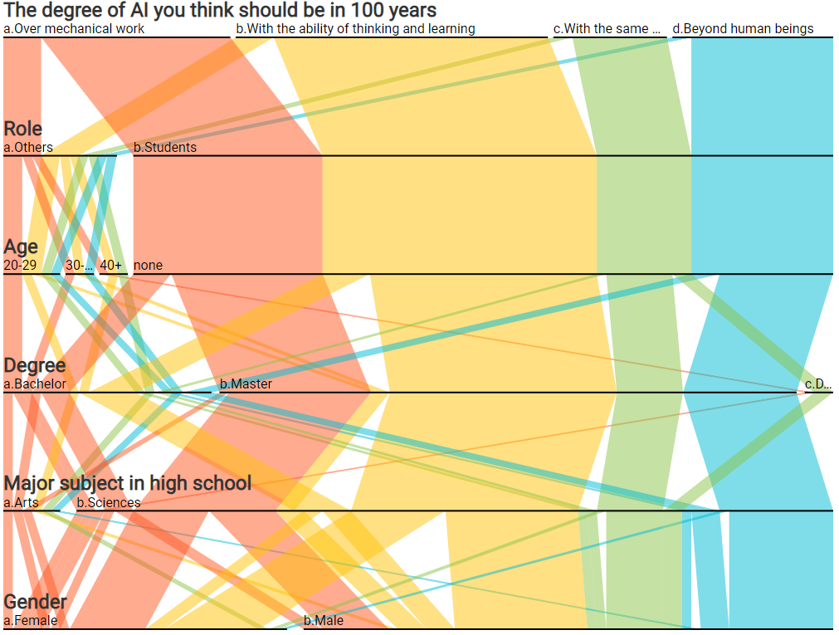

Chart 1

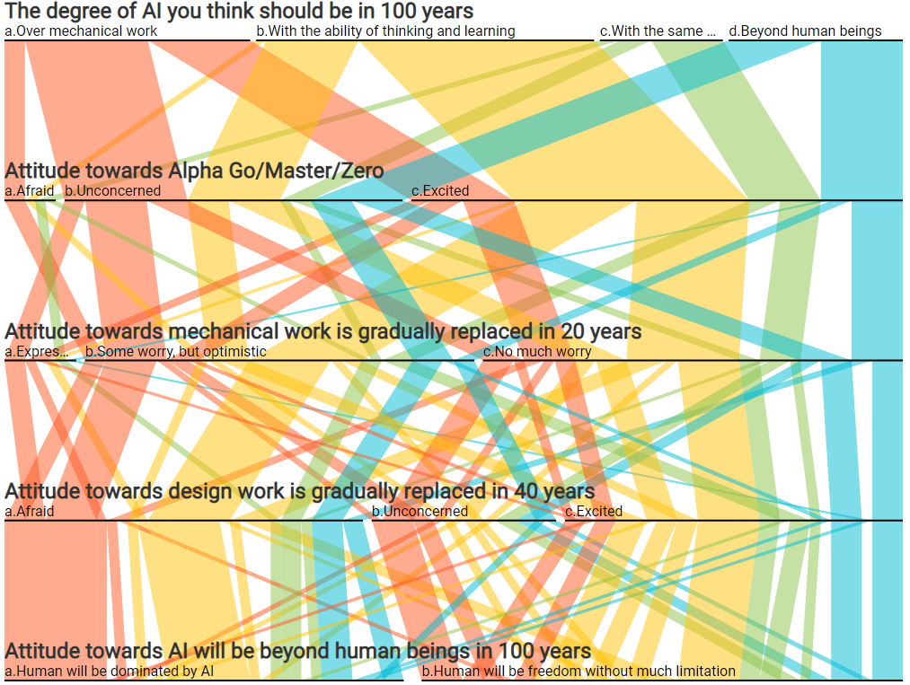

Chart 2

**Ⅳ Conclusions and Discussion**

**Conclusion:**

From the results which have been analyzed in detail above, we can conclude that most of people have positive attitude towards AI and they hope AI could do most of mechanical work and some of creative work. What is more, some of people are afraid that AI might surpass human beings and even dominate human beings. In conclusion, people hope that AI could be improved but they don’ t want it uncontrollable

**Discussion:**

In spite of the fact that some analysis and conclusions have been attained successfully, there are still some efforts to achieve that could make the results more reliable. Maybe more details of the data can be figure out from the results of the questionnaire. More questions can be involved so that more details can be obtained. And considering that most of interviewees are students, which may have a huge influence in the results, the research needs to interview more people in other occupations. Even so, the authors have tried their best in such short time.