Assignment #1

# A Letter to yourself!

Write a program that displays your name and address on the screen as if it were a letter. Your output should look something like that below.

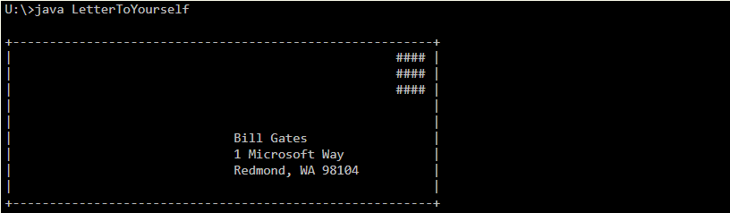

## Frequently-Asked Questions

**Does my letter have to look exactly like yours?**

No, but it does have to look roughly like a letter, including the box around the outside and the stamp.

**Do I have to use my real address?**

Of course not. But make sure your fake address takes up three lines.

**How to I get a | to show up on the screen?**

The | character is called a "pipe". Assuming you are using a normal US keyboard, it is Shift + backslash (\). The backslash key is usually located between the Backspace and Enter keys.