Assignment #3

### Numbers and Math

# Numbers and Math

Every programming language has some kind of way of doing numbers and math. Don't worry, programmers lie frequently about being math geniuses when they really aren't. If they were math geniuses, they would be doing math, not writing ads and social network games to steal people's money.

This exercise has lots of math symbols so let's name them right away so you know what they're called. As you type this one in, say the names. When saying them feels boring you can stop saying them. Here are the names:

* + plus
* - minus
* / slash
* * asterisk
* % percent
* < less-than
* > greater-than
* <= less-than-or-equal
* >= greater-than-or-equal

Notice how the operations are missing? After you type in the code for this exercise you are to go back and figure out what each of these does and complete the table. For example, + does addition.

public class NumbersAndMath

{

public static void main( String[] args )

{

System.out.println( "I will now count my chickens:" );

System.out.println( "Hens " + ( 25 + 30 / 6 ) );

System.out.println( "Roosters " + ( 100 - 25 * 3 % 4 ) );

System.out.println( "Now I will count the eggs:" );

System.out.println( 3 + 2 + 1 - 5 + 4 % 2 - 1 / 4 + 6 );

System.out.println( "Is it true that 3 + 2 < 5 - 7?" );

System.out.println( 3 + 2 < 5 - 7 );

System.out.println( "What is 3 + 2? " + ( 3 + 2 ) );

System.out.println( "What is 5 - 7? " + ( 5 - 7 ) );

System.out.println( "Oh, that's why it's false." );

System.out.println( "How about some more." );

System.out.println( "Is it greater? " + ( 5 > -2 ) );

System.out.println( "Is it greater or equal? " + ( 5 >= -2 ) );

System.out.println( "Is it less or equal? " + ( 5 <= -2 ) );

}

}

## What You Should See

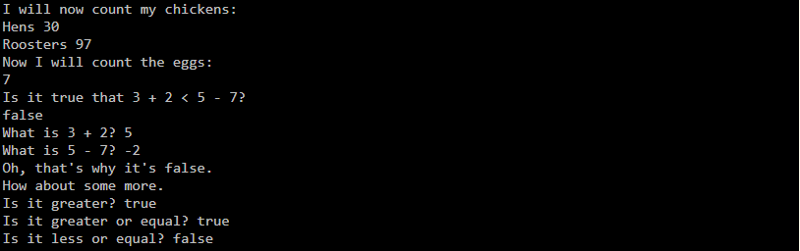

## What You Should Do on Your Own

1. Above each line, use two slashes // to write a comment to yourself explaining what the line does.
2. Notice the math seems "wrong"? There are no fractions, only whole numbers. Find out why by researching what a "floating point" number is.
3. Rewrite NumbersAndMath.java to use floating point numbers so it's more accurate (hint: 20.0 is floating point).
4. Why the % character is called "modulus" instead of "percent"?
5. How does modulus (%) work?
6. What is the order of operations?
7. Why does / (divide) round down?

### Your Initials