Car Pooling System - Requirement 1

You are a very active member of a Nature Club in your organization. In one of the meetings, it was discussed to build a car pooling system to help cut down the pollution. Being very active and tech savvy, you wish to contribute towards the development of system. One of the members being an architect has understood the requirement and would be sharing you with smaller requirements.

The complete data model designed by the architect is given below.  
 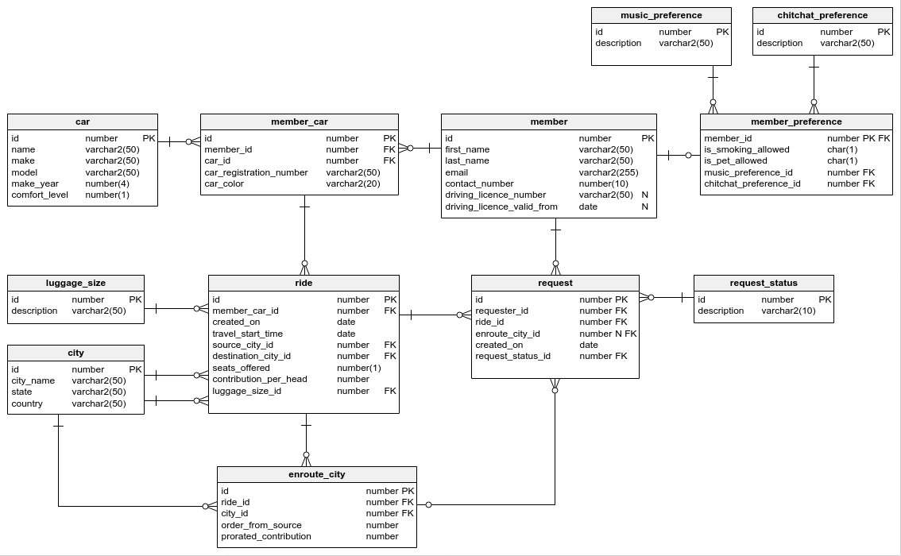

Since you are an object-oriented specialist and you want to build a part of the system initially, you choose to create the basic classes like **cars**, **members** their relationships and few small functionalities. The overall model that you will be implementing today is given below.

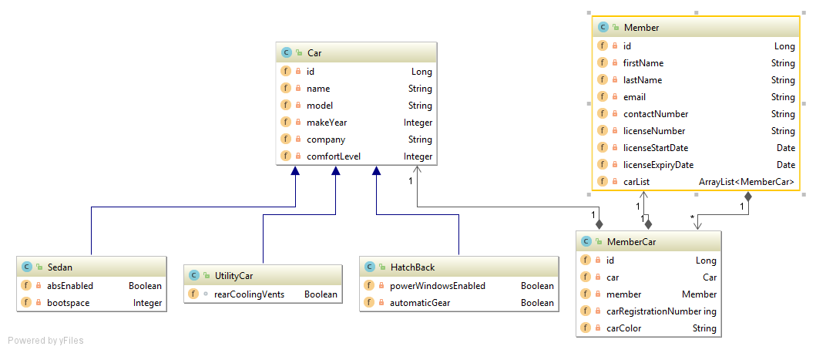

# Requirement 1:

The users of the system are going to be general public who own cars. They are classified as members in our system.

1. Create a **Member** Class with the following attributes:

|  |  |
| --- | --- |
| Member Field name | Type |
| id | Long |
| firstName | String |
| lastName | String |
| email | String |
| contactNumber | String |
| licenseNumber | String |
| licenseStartDate | Date (java.util) |
| licenseExpiryDate | Date (java.util) |

1. Mark all the attributes as private
2. Create / Generate appropriate Getters & Setters
3. Add a default constructor and a parameterized constructor to take in all attributes.
4. When the “member” object is printed, it should display the following details:

* Member: firstname, lastname
* Member contact details: contactNumber, email

1. Two members are considered same if they have same email and contactNumber. Implement the logic in the appropriate function. (Case – Insensitive)

The Input to your program would be details of two members, You need to display their details as given in "e" and use the function to compare the two members and display if the members are same or unique. Refer to Sample IO.

Sample Input and Output 1:  
[All text in bold corresponds to input and the rest corresponds to output.]

Member1 :  
id:  
1  
first name:  
Arun  
last name:  
Kumar  
email:  
arun123@gmail.com  
contact number:  
9878767655  
license number:  
TN38QW1232343  
license start date:  
12-12-2010  
license expiry date:  
13-12-2020

Member2 :  
id:  
2  
first name:  
Mohamed  
last name:  
Safiq  
email:  
safiq1243@gmail.com  
contact number:  
9667826601  
license number:  
TN33VA1238743  
license start date:  
01-05-2013  
license expiry date:  
01-04-2125  
  
Member 1  
Name: Arun , Kumar  
Member contact details: 9878767655 , arun123@gmail.com  
  
Member 2  
Name: Mohamed , Safiq  
Member contact details: 9667826601 , safiq1243@gmail.com

Member 1 and Member 2 are different  
  
Sample Input and Output 2:  
[All text in bold corresponds to input and the rest corresponds to output.]  
  
Member1 :  
id:  
1  
first name:  
Sam  
last name:  
Nath  
email:  
Sam123@gmail.com  
contact number:  
9456738498  
license number:  
TN45AS123456  
license start date:  
12-12-2010  
license expiry date:  
13-12-2021  
Member2 :  
id:  
2  
first name:  
Swamy  
last name:  
Nathan  
email:  
Sam123@gmail.com  
contact number:  
9456738498  
license number:  
TN54DF321456  
license start date:  
01-05-2012  
license expiry date:  
01-05-2123  
  
Member 1  
Name: Sam , Nath  
Member contact details: 9456738498 , Sam123@gmail.com  
  
Member 2  
Name: Swamy , Nathan  
Member contact details: 9456738498 , Sam123@gmail.com  
Member 1 is same as Member 2