Question 1: 12456
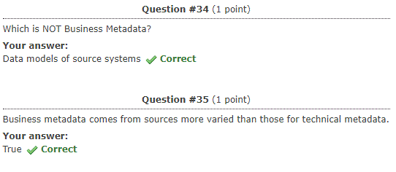
Question 2: 12456
Question 3: 12456
Question 4: 12456
Question 5: 12456

