# neutron_fwaas学习

## 简介

Neutron_fwaas是从neutron中独立出来的一个项目，提供Firewall-as-a-Service的功能，引用官方的介绍：

The Firewall-as-a-Service (FWaaS) plug-in adds perimeter firewall management to Networking. FWaaS uses iptables to apply firewall policy to all Networking routers within a project. FWaaS supports one firewall policy and logical firewall instance per project.

Whereas security groups operate at the instance-level, FWaaS operates at the perimeter to filter traffic at the neutron router.

可以理解，同样是iptables规则，security group是在计算节点上虚拟机的外部生效，而fwaas是在router上生效，官方文档的图上看得很清楚：

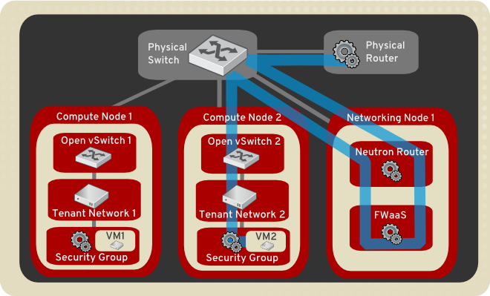

## 安装配置

这里简单介绍一下在centos7上的安装过程。

要使用fwaas，首先需要在网络节点安装fwaas的包：

yum install openstack-neutron-fwaas

安装完后需要修改一些配置项：

vi /etc/neutron/neutron.conf

service_plugins = router,neutron_fwaas.services.firewall.fwaas_plugin.FirewallPlugin

[fwaas]

driver = neutron_fwaas.services.firewall.drivers.linux.iptables_fwaas.IptablesFwaasDriver

enabled = True

升级数据库：

neutron-db-manage --service fwaas upgrade head

修改horizon的配置文件local_settings.py：

OPENSTACK_NEUTRON_NETWORK = {

...

'enable_firewall' = True,

...

}

重启apache

systemctl restart httpd

重启neutron-server和l3-agent

systemctl restart neutron-l3-agent

systemctl restart neutron-server

## 用户操作过程

可以选择从horizon界面或者CLI创建防火墙，这里展示界面创建的过程：

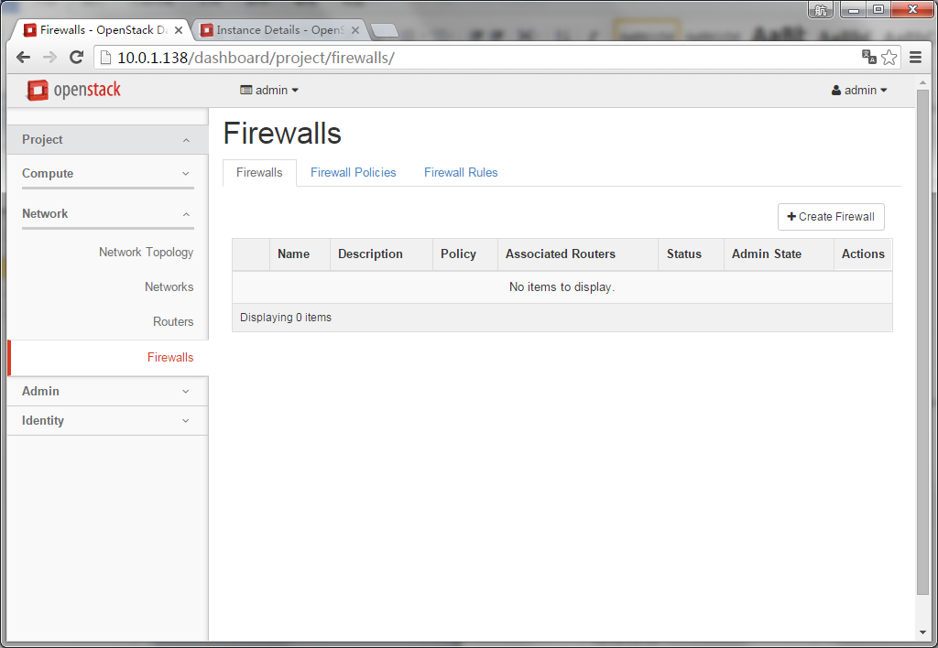

首先创建一条防火墙规则：

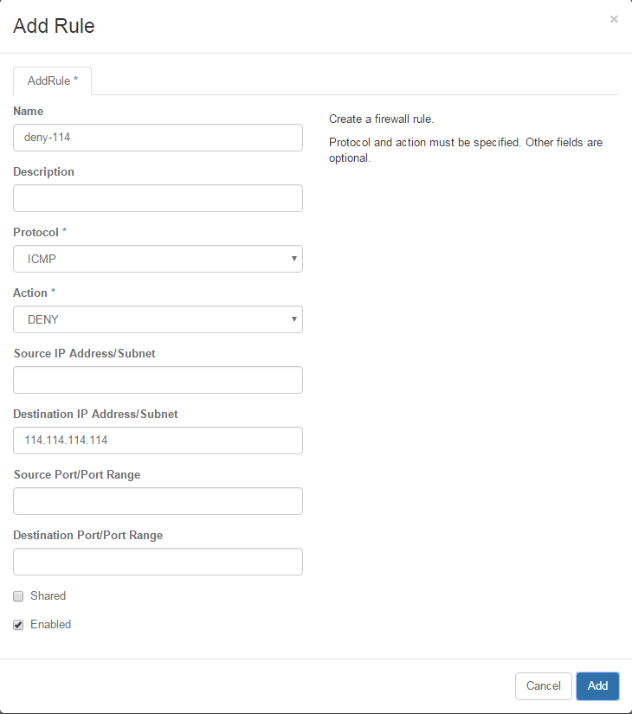

然后创建一个防火墙策略并插入刚才创建的规则：

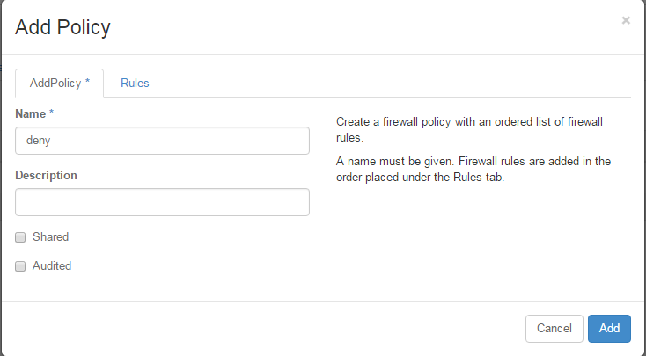

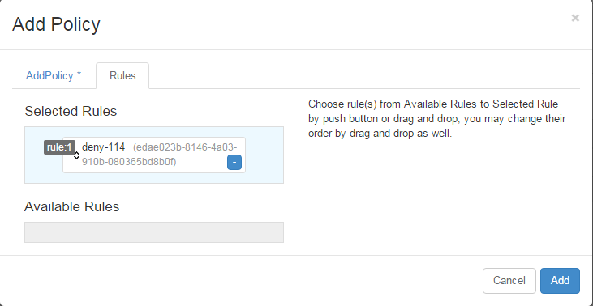

最后创建防火墙，并选择要关联的路由器：

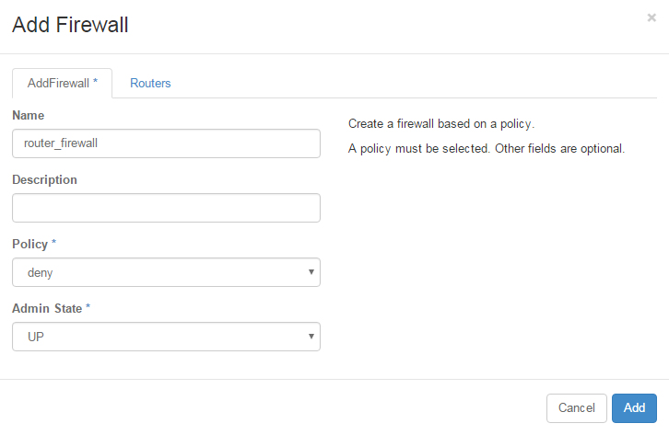

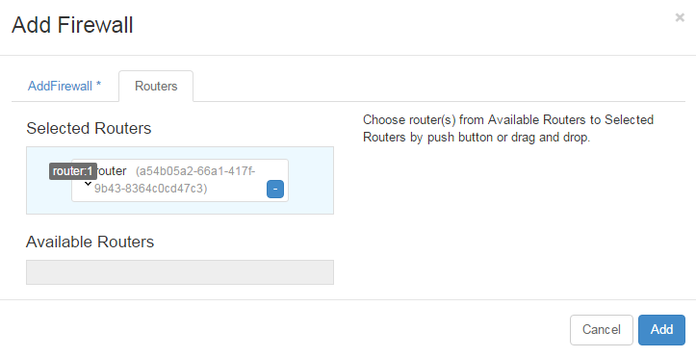

## 功能验证

防火墙未关联路由器时ping 114可以通：

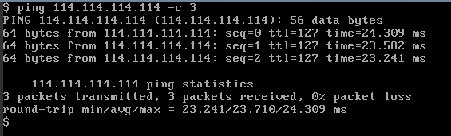

防火墙关联路由器后，ping 114不通：

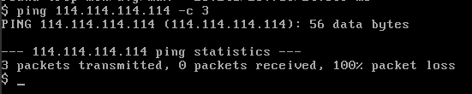

## 代码逻辑简介

用一句话来概括Fwaas的架构：**plugin接收请求，先在数据库创建对象的记录，然后通过rpc调用agent，agent接收rpc请求后在driver上执行请求中对应的方法完成实际操作，并通过rpc将执行后的status返回给plugin，plugin更新数据库中的status。**引用一张lbaas wiki上的图，他们是类似的，虽然是三年前的，但架构没什么变化，清楚地描述了这个过程。

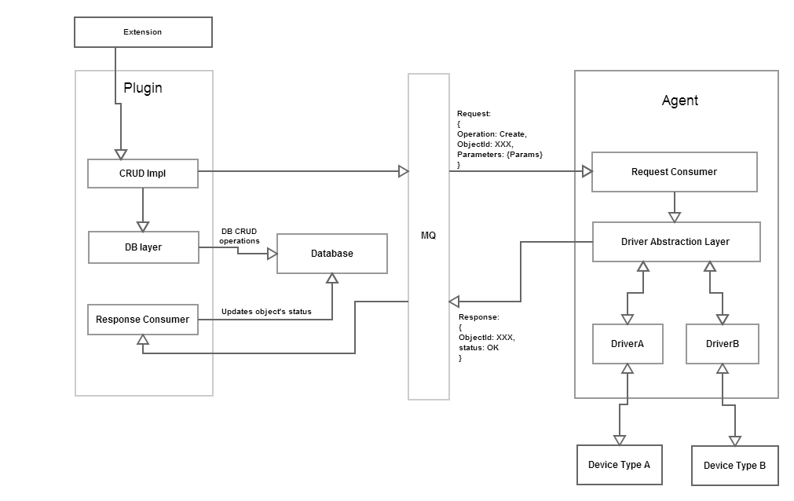

看过了大的框架，我们知道fwaas分为三部分**plugin,agent,driver**。

在plugin和agent之间的队列有两个：**l3_agent**和**q-firewall-plugin。**

可以用rabbitmqctl list_queues看到：

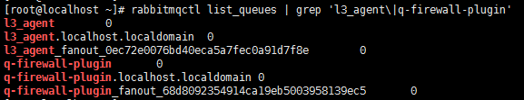

下面我们分别看一下这三部分关键的代码。

### plugin

Fwaas的API和lbaas，vpnaas一样，是作为neutron api的extension，neutron-server会在启动的时候根据service_plugins的配置来加载extension，这部分的代码主要在neutron/api/extensions.py中。

先看一下这个配置项的内容：

service_plugins = router,neutron_fwaas.services.firewall.fwaas_plugin.FirewallPlugin

也就是neutron_fwaas/services/firewall/fwaas_plugin.py中的FirewallPlugin类

这个FirewallPlugin类的对象会在neutron server启动的时候被创建

这个对象在创建时第一步会调用**start_rpc_listeners**，这个方法如其名，启动了plugin的RPC server，topic是**q-firewall-plugin**。

第二步创建一个rpc client对象， topic是**l3_agent**。

当plugin接收到用户的请求时会发送rpc请求到**l3_agent**这个队列里，监听这个队列的RPCserver就是neutron l3 agent。

class **FirewallPlugin**(

firewall_db.Firewall_db_mixin,

firewall_router_insertion_db.FirewallRouterInsertionDbMixin):

*"""Implementation of the Neutron Firewall Service Plugin.*

*This class manages the workflow of FWaaS request/response.*

*Most DB related works are implemented in class*

*firewall_db.Firewall_db_mixin.*

*"""*

supported_extension_aliases = [*"fwaas"*, *"fwaasrouterinsertion"*]

path_prefix = fw_ext.FIREWALL_PREFIX

def **__init__**(*self*):

*"""Do the initialization for the firewall service plugin here."""*

***self*.start_rpc_listeners()**

*self*.agent_rpc = FirewallAgentApi(

f_const.L3_AGENT,

cfg.CONF.host

)

firewall_db.subscribe()

def **start_rpc_listeners**(*self*):

***self*.endpoints = [FirewallCallbacks(*self*)]**

***self*.conn = n_rpc.create_connection()**

***self*.conn.create_consumer(**

**f_const.FIREWALL_PLUGIN, *self*.endpoints, fanout=False)**

return *self*.conn.consume_in_threads()

class **FirewallCallbacks** (object):

target = oslo_messaging.Target(version=*'1.0'*)

def **__init__**(*self*, plugin):

super(FirewallCallbacks, *self*).__init__()

*self*.plugin = plugin

def **set_firewall_status**(*self*, context, firewall_id, status, **kwargs):

*"""Agent uses this to set a firewall's status."""*

LOG.debug(*"Setting firewall %s to status: %s"* % (firewall_id, status))

# Sanitize status first

if status in (n_const.ACTIVE, n_const.DOWN, n_const.INACTIVE):

to_update = status

else:

to_update = n_const.ERROR

# ignore changing status if firewall expects to be deleted

# That case means that while some pending operation has been

# performed on the backend, neutron server received delete request

# and changed firewall status to PENDING_DELETE

updated = *self*.plugin.update_firewall_status(

context, firewall_id, to_update, not_in=(n_const.PENDING_DELETE,))

if updated:

LOG.debug(*"firewall %s status set: %s"* % (firewall_id, to_update))

return updated and to_update != n_const.ERROR

def **firewall_deleted**(*self*, context, firewall_id, **kwargs):

*"""Agent uses this to indicate firewall is deleted."""*

LOG.debug(*"firewall_deleted() called"*)

with context.session.begin(subtransactions=True):

fw_db = *self*.plugin._get_firewall(context, firewall_id)

# allow to delete firewalls in ERROR state

if fw_db.status in (n_const.PENDING_DELETE, n_const.ERROR):

*self*.plugin.delete_db_firewall_object(context, firewall_id)

return True

else:

LOG.warning(_LW(*'Firewall %(fw)s unexpectedly deleted by '*

*'agent, status was %(status)s'*),

{*'fw'*: firewall_id, *'status'*: fw_db.status})

fw_db.update({*"status"*: n_const.ERROR})

return False

### agent

l3 agent 在启动的时候，会创建一个neutron.service.Service对象，它继承了neutron.common.rpc. Service，调用**create_consumer**，topic是**l3_agent**。

class **Service**(service.Service):

*"""Service object for binaries running on hosts.*

*A service enables rpc by listening to queues based on topic and host.*

*"""*

def **__init__**(*self*, host, topic, manager=None, serializer=None):

super(Service, *self*).__init__()

*self*.host = host

*self*.topic = topic

*self*.serializer = serializer

if manager is None:

*self*.manager = *self*

else:

*self*.manager = manager

def **start**(*self*):

super(Service, *self*).start()

*self*.conn = create_connection(new=True)

LOG.debug(*"Creating Consumer connection for Service %s"*,

*self*.topic)

endpoints = [*self*.manager]

*self*.conn.create_consumer(*self*.topic, endpoints)

# Hook to allow the manager to do other initializations after

# the rpc connection is created.

if callable(getattr(*self*.manager, *'initialize_service_hook'*, None)):

*self*.manager.initialize_service_hook(*self*)

# Consume from all consumers in threads

*self*.conn.consume_in_threads()

与此同时，l3_agent创建时，默认的manager如下：

def **main**(manager=*'neutron.agent.l3.agent.L3NATAgentWithStateReport'*):

register_opts(cfg.CONF)

common_config.init(sys.argv[1:])

config.setup_logging()

server = neutron_service.Service.create(

binary=*'neutron-l3-agent'*,

topic=topics.L3_AGENT,

report_interval=cfg.CONF.AGENT.report_interval,

manager=manager)

service.launch(cfg.CONF, server).wait()

下面的代码片段可以看到它的继承关系：

class **L3NATAgentWithStateReport**(L3NATAgent):

class **L3NATAgent**(firewall_l3_agent.FWaaSL3AgentRpcCallback,

ha.AgentMixin,

dvr.AgentMixin,

manager.Manager):

下方代码中的**红色**部分读取了安装时配置文件中的这两个参数：

**[fwaas]**

**driver = neutron_fwaas.services.firewall.drivers.linux.iptables_fwaas.IptablesFwaasDriver**

**enabled = True**

这部分的逻辑基本就是读取配置文件中fwaas的driver并创建driver的对象，l3 agent接收到plugin的RPC请求后会调用实际driver对象中对应的**create_firewall，update_firewall，delete_firewall**方法，然后设置firewall的status并发送RPC请求到plugin在监听的**q-firewall-plugin**队列，这部分逻辑是下方代码中**绿色**的部分。

plugin收到请求后就会执行**set_firewall_status** 或者**firewall_deleted**更新数据库中firewall的status。

这两个方法的代码在前文的plugin部分。

class **FWaaSL3AgentRpcCallback**(api.FWaaSAgentRpcCallbackMixin):

*"""FWaaS Agent support to be used by Neutron L3 agent."""*

def **__init__**(*self*, conf):

LOG.debug(*"Initializing firewall agent"*)

*self*.conf = conf

**fwaas_driver_class_path = provconf.get_provider_driver_class(**

**cfg.CONF.fwaas.driver)**

***self*.fwaas_enabled = cfg.CONF.fwaas.enabled**

# None means l3-agent has no information on the server

# configuration due to the lack of RPC support.

if *self*.neutron_service_plugins is not None:

fwaas_plugin_configured = (constants.FIREWALL

in *self*.neutron_service_plugins)

if fwaas_plugin_configured and not *self*.fwaas_enabled:

msg = _(*"FWaaS plugin is configured in the server side, but "*

*"FWaaS is disabled in L3-agent."*)

LOG.error(msg)

raise SystemExit(1)

*self*.fwaas_enabled = *self*.fwaas_enabled and fwaas_plugin_configured

if *self*.fwaas_enabled:

try:

*self*.fwaas_driver = importutils.import_object(

fwaas_driver_class_path)

LOG.debug(*"FWaaS Driver Loaded: '%s'"*, fwaas_driver_class_path)

except ImportError:

msg = _(*'Error importing FWaaS device driver: %s'*)

raise ImportError(msg % fwaas_driver_class_path)

*self*.services_sync = False

# setup RPC to msg fwaas plugin

***self*.fwplugin_rpc = FWaaSL3PluginApi(topics.FIREWALL_PLUGIN,**

**conf.host)**

super(FWaaSL3AgentRpcCallback, *self*).__init__(host=conf.host)

.........

def **_invoke_driver_for_plugin_api**(*self*, context, fw, func_name):

*"""Invoke driver method for plugin API and provide status back."""*

LOG.debug(*"%(func_name)s from agent for fw: %(fwid)s"*,

{*'func_name'*: func_name, *'fwid'*: fw[*'id'*]})

try:

routers = *self*.plugin_rpc.get_routers(context)

router_info_list = *self*._get_router_info_list_for_tenant(

routers,

fw[*'tenant_id'*])

if not router_info_list:

LOG.debug(*'No Routers on tenant: %s'*, fw[*'tenant_id'*])

# fw was created before any routers were added, and if a

# delete is sent then we need to ack so that plugin can

# cleanup.

if func_name == *'delete_firewall'*:

*self*.fwplugin_rpc.firewall_deleted(context, fw[*'id'*])

return

LOG.debug(*"Apply fw on Router List: '%s'"*,

[ri.router[*'id'*] for ri in router_info_list])

# call into the driver

try:

*self*.fwaas_driver.__getattribute__(func_name)(

*self*.conf.agent_mode,

router_info_list,

fw)

if fw[*'admin_state_up'*]:

status = constants.ACTIVE

else:

status = constants.DOWN

except nexception.FirewallInternalDriverError:

LOG.error(_LE(*"Firewall Driver Error for %(func_name)s "*

*"for fw: %(fwid)s"*),

{*'func_name'*: func_name, *'fwid'*: fw[*'id'*]})

status = constants.ERROR

# delete needs different handling

**if func_name == *'delete_firewall'*:**

**if status in [constants.ACTIVE, constants.DOWN]:**

***self*.fwplugin_rpc.firewall_deleted(context, fw[*'id'*])**

**else:**

***self*.fwplugin_rpc.set_firewall_status(**

**context,**

**fw[*'id'*],**

**status)**

except Exception:

LOG.exception(

_LE(*"FWaaS RPC failure in %(func_name)s for fw: %(fwid)s"*),

{*'func_name'*: func_name, *'fwid'*: fw[*'id'*]})

*self*.services_sync = True

return

.........

def **create_firewall**(*self*, context, firewall, host):

*"""Handle Rpc from plugin to create a firewall."""*

return *self*._invoke_driver_for_plugin_api(

context,

firewall,

*'create_firewall'*)

def **update_firewall**(*self*, context, firewall, host):

*"""Handle Rpc from plugin to update a firewall."""*

return *self*._invoke_driver_for_plugin_api(

context,

firewall,

*'update_firewall'*)

def **delete_firewall**(*self*, context, firewall, host):

*"""Handle Rpc from plugin to delete a firewall."""*

return *self*._invoke_driver_for_plugin_api(

context,

firewall,

*'delete_firewall'*)

### driver

从上面的配置文件可以看到driver配置如下

[fwaas]

driver = neutron_fwaas.services.firewall.drivers.linux.iptables_fwaas.IptablesFwaasDriver

这是社区默认的iptables的driver

如果要使用vyatta firewall的话这里要配成

driver = neutron_fwaas.services.firewall.drivers.vyatta.vyatta_fwaas.VyattaFirewallDriver

社区的iptables driver实现了三个方法**create_firewall，update_firewall，delete_firewall。**

接收的参数是agent_mode, apply_list, firewall

agent_mode是router的模式，可以在l3_agent.ini中配置，默认router的是legacy

apply_list是防火墙关联的router的列表，每个router元素都有属性iptables_manager，用来在相应的router namespace中执行iptables命令

firewall是防火墙的对象，其中包含了防火墙的规则等各种信息

这里主要逻辑就是根据传入参数的防火墙规则，生成需要的iptables命令，然后通过iptables_manager调用iptables_table对象的各种方法，如add_chain, remove_chain, add_rule, remove_rule等，在相应的router namespace中执行相应的iptables命令，实现防火墙的功能。

class **IptablesFwaasDriver**(fwaas_base.FwaasDriverBase):

*"""IPTables driver for Firewall As A Service."""*

def **__init__**(*self*):

LOG.debug(*"Initializing fwaas iptables driver"*)

def **create_firewall**(*self*, agent_mode, apply_list, firewall):

LOG.debug(*'Creating firewall %(fw_id)s for tenant %(tid)s'*,

{*'fw_id'*: firewall[*'id'*], *'tid'*: firewall[*'tenant_id'*]})

try:

if firewall[*'admin_state_up'*]:

*self*._setup_firewall(agent_mode, apply_list, firewall)

else:

*self*.apply_default_policy(agent_mode, apply_list, firewall)

except (LookupError, RuntimeError):

# catch known library exceptions and raise Fwaas generic exception

LOG.exception(_LE(*"Failed to create firewall: %s"*), firewall[*'id'*])

raise fw_ext.FirewallInternalDriverError(driver=FWAAS_DRIVER_NAME)

def **delete_firewall**(*self*, agent_mode, apply_list, firewall):

LOG.debug(*'Deleting firewall %(fw_id)s for tenant %(tid)s'*,

{*'fw_id'*: firewall[*'id'*], *'tid'*: firewall[*'tenant_id'*]})

fwid = firewall[*'id'*]

try:

for router_info in apply_list:

ipt_if_prefix_list = *self*._get_ipt_mgrs_with_if_prefix(

agent_mode, router_info)

for ipt_if_prefix in ipt_if_prefix_list:

ipt_mgr = ipt_if_prefix[*'ipt'*]

*self*._remove_chains(fwid, ipt_mgr)

*self*._remove_default_chains(ipt_mgr)

# apply the changes immediately (no defer in firewall path)

ipt_mgr.defer_apply_off()

except (LookupError, RuntimeError):

# catch known library exceptions and raise Fwaas generic exception

LOG.exception(_LE(*"Failed to delete firewall: %s"*), fwid)

raise fw_ext.FirewallInternalDriverError(driver=FWAAS_DRIVER_NAME)

def **update_firewall**(*self*, agent_mode, apply_list, firewall):

LOG.debug(*'Updating firewall %(fw_id)s for tenant %(tid)s'*,

{*'fw_id'*: firewall[*'id'*], *'tid'*: firewall[*'tenant_id'*]})

try:

if firewall[*'admin_state_up'*]:

*self*._setup_firewall(agent_mode, apply_list, firewall)

else:

*self*.apply_default_policy(agent_mode, apply_list, firewall)

except (LookupError, RuntimeError):

# catch known library exceptions and raise Fwaas generic exception

LOG.exception(_LE(*"Failed to update firewall: %s"*), firewall[*'id'*])

raise fw_ext.FirewallInternalDriverError(driver=FWAAS_DRIVER_NAME)