

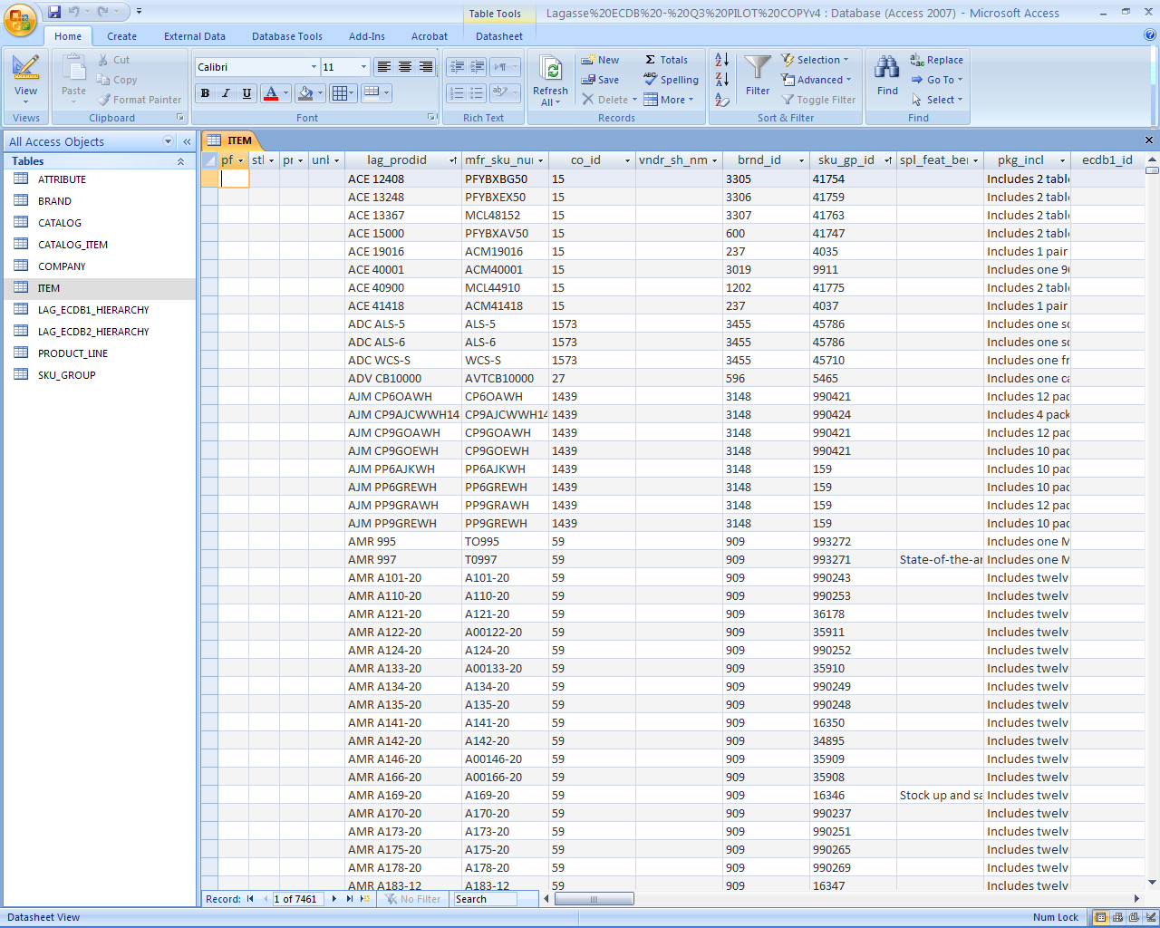

ECDB 2.0 Sample Database

General Information

Welcome:

Welcome to LagasseSweet’s new Electronic Content Database version 2.0 (ECDB 2.0)! The ECDB 2.0 was designed to provide you, our valued customer, the rich product information and media to meet the needs of even your most demanding online customer. It represents an ongoing initiative and investment that LagasseSweet has chosen to make in order to enable you to more effectively reach and sell successfully to your online customers.

Getting Started with this Sample ECDB 2.0:

The CD contains the primary database of product information along with accompanying images, logos, and MSDS sheets.

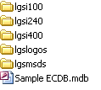

The sample ECDB data can be found in the main directory in a file titled Sample ECDB.mdb. You will need Microsoft Access 2002 or higher to open and access this data. Microsoft Access is available as part of the standard MS Office software suite. MS Access was necessary because of the wealth of information and relationships that are now provided in the ECDB 2.0

Supporting images can be found in the “lgsi” folders. Images (both primary and alternate) with a size of 100x100 can be found in lgsi100, 240x240 found in lgsi240, and 400x400 images found in lgsi400. They are saved as .jpg files and should be easily opened by any image viewing application.

Brand logos can be found in the “lgslogos” folder. Logos are also saved as .jpg files and can be easily opened by any image viewing application.

Material Safety Data Sheets (MSDS) can be found in the “lgsmsds” folder. Material Safety Data Sheets have been saved as .pdf files. PDF files can be opened a PDF reader (freeware) available on Adobe software’s site.

Navigating the Sample ECDB 2.0:

The ECDB 2.0 exists (in its most basic form) as a series of 10 tables. Some familiarity with MS Access will help you to extract the information.
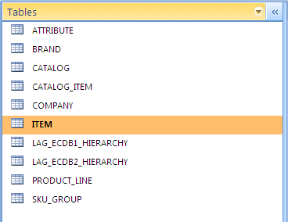

The key table for the database is the ITEM table. It contains the product descriptions, operational data, image & MSDS file references, green information, and relationships to the other tables in the database. Our product SKU can be found in the lag_prodid field.

The ATTRIBUTE table contains descriptive information about each item found on the ITEM table. On this table, you can find a myriad of information for each item including dimensions, color, scents, materials, etc., that can be used to compare items with each other or allow users to filter search results.

The BRAND table contains branding information for each item found on the ITEM table. It contains both a text version of the brand name along with a reference to a brand logo that can be found in the “lgslogos” folder.

The CATALOG AND CATALOG_ITEM tables are provided in order to allow you to identify what products found on the ITEM table belong to The Works catalog, are non-cataloged items, or can be considered “nationally stocked” items.

The COMPANY table contains the manufacturer information associated to each item found on the ITEM table.

The LAG_ECDB1_HIERARCHY table contains the categorization of each item found on the ITEM table. It is the structure that has been traditionally provided in the ECDB 1.0.

The LAG_ECDB2_HIERARCHY table represents an ecommerce optimized categorization of each item found on the ITEM table. Where the ECDB 1.0 hierarchy allowed an item to appear in only 1 category, the new ECDB 2.0 hierarchy allows for an item to appear in multiple categories.

The PRODUCT _LINE table is currently not used and is being reserved for future expansion.

The SKU_GROUP table contains all of the product selling points and marketing copy for each item found on the ITEM table.

ECDB 1.0 TO ECDB 2.0 Transition Guide

Many of you are already an ECDB 1.0 customer. The following guide is provided to help you map the fields that are now available in the ECDB 2.0 in order to speed your transition to our new product.

ECDB 1.0  Field Name | Description | ECDB 2.0 Database Field Name | Table | Description
Item Number | This is the combination of the three letter manufacturer prefix and the item number which typically corresponds to the item number used by the manufacturer. | LAG_PRODID | ITEM | LagasseSweet Item code which represents a complete item number.
Short Description | This is an abbreviated product description. | PROD_DSC | ITEM | Abbreviated 25-character non consumer-friendly description of the item intended for a dealer’s legacy system and/or packing list documents. This field is not recommended for consumer viewing.
UOM | Unit of Measure. This is how the item is sold. Move your mouse over this description to see an explanation of the codes. | INV_UN_CDE | ITEM | LagasseSweet’s inventory selling unit of measure.
Ctn Pk/Un | Quantity and unit of the master carton. This is generally the reshipable container. | PKG_INCL | ITEM | Describes the content of the package itself.
List Price | Suggested list price at time of publication. Some items may not have a List Price due to price differences throughout the country. | LIST_AMT | ITEM | The list price of the item.  Also See: CAT_LIST_AMT for the current catalog list price.
Dist Net Price | Distributor Net Price. This is the price distributors pay for the product. Some items may not have a Dist Net Price due to price differences throughout the country and is reflected by 'Call for Pricing'. | N/A | N/A | N/A
Promo Price | Promotion Price. This is the price in the Quarterly Promotions Flyer. | N/A | N/A | N/A
Pallet Price | Quarterly price based on buying in full pallet quantities as identified in the Pallet Quantity column. | N/A | N/A | N/A
Pallet Qty | Number of cases per pallet. | N/A | N/A | N/A
Unit Weight | Weight per unit of sale. | ITEM_WGT | ITEM | The item weight based on the selling unit of measure. Weight values are reflected in single numbers in pounds with 3 decimal places to the right (x.xxx).
Unit Cube | Cube per unit of sale. (cubic inches) | N/A | Calculate using fields:  ITEM_DEPTH, ITEM_ WDT, ITEM_HGT X’s 12 (values are cubic inches – omit times 12 if you need cubic feet)
Prefix | Three letter code identifying the Manufacturer. | N/A | N/A | N/A
Manufacturer | Original producer of product. | CO_ID | BRAND | The brand name of the product
Manufacturer Website | Shows the Website Address of the Manufacturer. | BRND_WEB | BRAND | URL address of the Brand web site as maintained by the Supplier.
New Description | Shows if a new Extended Description was added since last quarter. | N/A
Extended Description 1 | This is the first part of the extended description that describes the product in detail. | CON_ITEM_COP | ITEM | Detailed item - level selling copy suitable for display in paragraph format.  Also see fields: SMRY_SLLNG_STM: Summary Selling Copy  Also see: LG_SLLNG_COP: Long Selling Copy
Extended Description 2 | If the Extended Description 1 is longer than 256 characters, the Extended Description will continue here. | CON_ITEM_COP | ITEM
Extended Description 3 | If the Extended Description 2 is longer than 256 characters, the Extended Description will continue here. | CON_ITEM_COP | ITEM
Extended Description 4 | If the Extended Description 3 is longer than 256 characters, the Extended Description will continue here. | CON_ITEM_COP | ITEM
Breakout Header | This is some additional product information found in the Product Catalog. | SKU_GP_NM | SKU_GROUP | Not exact match. A descriptive heading, which describes a common group of items within a given SKU Group.  Also see fields: SMRY_SLLNG_STM: Summary Selling Copy  Also see: SH_SLLNG_COP: Short Selling Copy
Breakout Text | This is some additional product information found in the Product Catalog. | SKU_GP_NM | SKU_GROUP
SKU Description 1 | This is some additional unit of measure information found in the Product Catalog. | SKU_GP_NM | SKU_GROUP
SKU Description 2 | This is some additional unit of measure information found in the Product Catalog. | SKU_GP_NM | SKU_GROUP
SKU Group Description | This is the general group description found in the Product Catalog. | SKU_GP_NM | SKU_GROUP
Previous Quarters Product Category Code | If the Product Category Code has changed since previous quarter, this will show what the old Product Category Code was. | N/A | N/A | N/A
Product Category Code | This is the LagasseSweet Code for the Product Category. A spreadsheet showing the list of the codes is available on the E-Commerce Database CD. | Refer to Hierarchy Tables
Product Category Full Description | This is the full length Product Category showing all levels separated by a ">". | Refer to Hierarchy Tables
Product Subcategory 1 | This is the top level of the Product Category.
Product Subcategory 2 | This is the second level of the Product Category.
Product Subcategory 3 | This is the third level of the Product Category. Not all items have a third level.
Product Subcategory 4 | Lagasse has re-categorized its product categories and there are no longer fourth levels. The column remains so that setups/data-pulls are not affected.
Catalog Page | This is the page in the 2010 LagasseSweet "Works" Product Catalog where you can find the item. There is a PDF copy of each catalog page on the E-Commerce Database CD; these are available in priced and non-priced. | CAT_PG_NUM | CATALOG_ITEM | The item’s page number, which corresponds to the assigned catalog.
UPS | An "N" in this column shows which items cannot be sent via UPS. | SML_PKG_IND | ITEM | Used to indicate whether the Master Carton will be accepted for shipment by UPS or FedEx.  Small Package Codes are as follows:  Y - Yes, small package  N - No, not a small package  Null - Not a small package
AVL | Availability. Identified if certain products have restrictions as to where an item can be sold. NC=Not available in California. CO=Only available in California. | N/A | N/A | N/A
CHG | Change. Identified a change in product price or item number or if a product has been discontinued. P=Product Price Change. N=Product Number Change. D=Discontinued Product. | N/A | N/A | N/A
Image Name | This shows what the image name is in the image folders. | SGL_IMG  Also see: ALT_IMG | ITEM | Filename of the main image graphically representing an item.
Manufacturer Logo Name | This shows what the Manufacturer's Logo Image Name is in the Manufacturer Logo folder. | BRND_LOGO |  | Filename of image graphically representing the Brand's logo.
MSDS Name | This shows the name of the MSDS file in the MSDS folder. | MSDS_IND | ITEM | An indicator indicating whether or not the product has an associated MSDS sheet.
Enviro Conscious Logo | A "Y" indicates if this item is designates as Envrio-Conscious | GRN_IND | ITEM | Yes or null value indicating if the item is considered "Green". An item is considered Green based on criteria including: Contains Recycled Content, Helps to Recycle, Energy Saver, Renewable Source/ Rechargeable, Biodegradable/Compostable, Non-toxic, "Greener" Alternative/ Reusable, Low VOC's, CFC's, etc., and other Green criteria.
Must Purchase in Quantities of | This indicates items that must be purchases in multiple case packs and not as individual eaches | MUST_ORDER_  QTY | ITEM | Minimum quantity to be purchased to place order
Country of Origin | The country of origin information is provided to us by our suppliers. We do not independently verify the COO information and do not represent or warrant as to its accuracy or completeness. | CTRY_ORIG_CDE | ITEM | Used for export only. Indicates the country where this product was manufactured. This code will conform to the Harmonized Tariff Schedule for the LagasseSweet States, Listing of International Standard Country Codes (ISO). Two alpha digits are used.
Stock Item | This column indicates items that are stocked by Lagasse. | Refer to Catalog and Catalog Item Tables
Unit Height | Height per unit of sale | ITEM_HGT | ITEM | Item's Weight With Packaging
Unit Length | Length per unit of sale | ITEM_ WDT | ITEM | Item's Width With Packaging
Unit Width | Width per unit of sale | ITEM_ WDT | ITEM | Item's Width With Packaging
Case UPC Code | Carton UPC; the Universal Product Code (UPC) is a barcode that is widely used in the United States for tracking trade items in stores. | UPC_CTN | ITEM | Assigned UPC Code. 14 digit UPC Code
Individual Sell UPC | The Universal Product Code (UPC) is a barcode that is widely used in the United States for tracking trade items in stores. Typically referred to as the Retail UPC | UPC_RTL | ITEM | Assigned UPC Code. 12 digit UPC Code
MFG_Item | Manufacturer Item Number | MFR_SKU_NUM | ITEM | The product number provided and used by the manufacturer of the product

How to learn more or subscribe to the LagasseSweet ECDB 2.0:

If you are interested in learning more or subscribing to LagasseSweet’s new ECDB 2.0, please contact your customer sales representative or send an email to ecdbsupport@lagasseinc.com.

Check http://www.lagassesweet.com/static/ecdb2/ecdb2.html for more details and up to date information.

