Name: Suihin Wong

SU email: swong18@syr.edu

1.

CREATE STREAM WEBLOGS (timestamp bigint, Browser varchar, OS varchar, Uri varchar, user varchar) with (kafka_topic='weblogs', value_format ='json',timestamp='timestamp');

select * from weblogs;

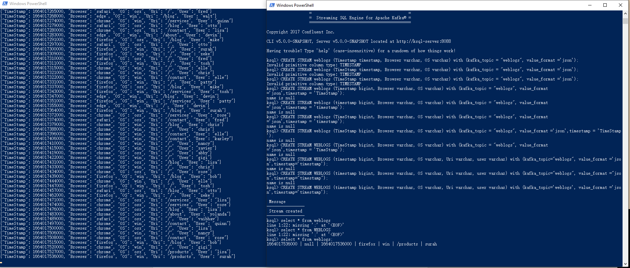

2.

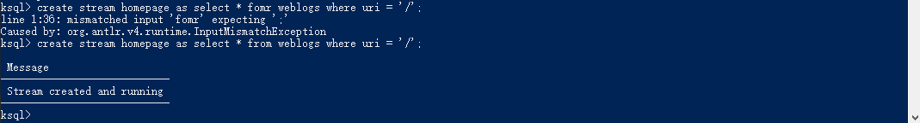

3.

select os, count(*) from weblogs window session (60 seconds) group by os;



4.

create table user_activity as select os, count(*) from weblogs window session (60 seconds) group by os;

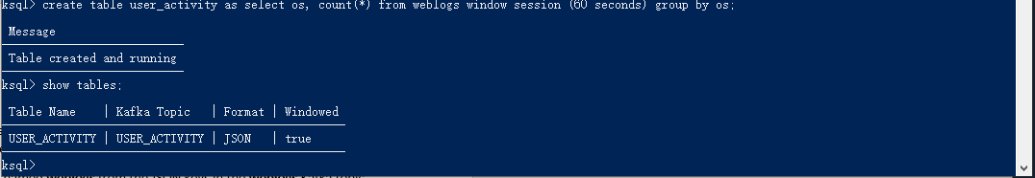

5.

select user,os, count(*) as actitvity_count from weblogs window session (60 seconds) group by user, os having count(*) > 1;

