**Basic Information**

**Your Name: Suihin Wong(Henry)**

**Your SUID: swong18**

**Your Email: swong18@syr.edu**

**Date Due: 7/19/2022**

**Homework #: 2**

# **Exercises**

Complete each of the following exercises. If you are unsure how to accomplish the task, please consult the coursework videos where there are explanations and demos.

1. Use built in SQL functions to write an SQL Select statement on **fudgemart_products** which derives a **product_category** column by extracting the last word in the product name. For example

a. for a product named ‘Leather Jacket’ the product category would be ‘Jacket’

b. for a product named ‘Straight Claw Hammer’ the category would be ‘Hammer’

Your select statement should include product id, product name, product category and product department.

2. Write a user defined function called **f_total_vendor_sales** which calculates the sum of the wholesale price * quantity of all products sold for that vendor. There should be one number associated with each vendor id, which is the input into the function. Demonstrate the function works by executing an SQL select statement over all vendors calling the function.

3. Write a stored procedure called **p_write_vendor** which when given a required vendor name, phone and optional website, will look up the vendor by name first. If the vendor exists, it will update the phone and website. If the vendor does not exist, it will add the info to the table. Write code to demonstrate the procedure works by executing the procedure twice so that it adds a new vendor and then updates that vendor’s information.

**Insert**

**Update**

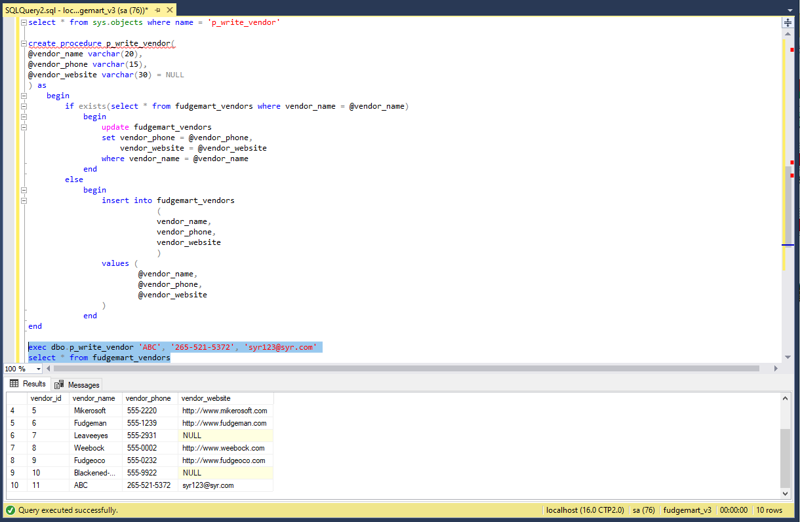

4. Create a view based on the logic you completed in question 1 or 2. Your SQL script should be programmed so that the entire script works every time, dropping the view if it exists, and then re-creating it.

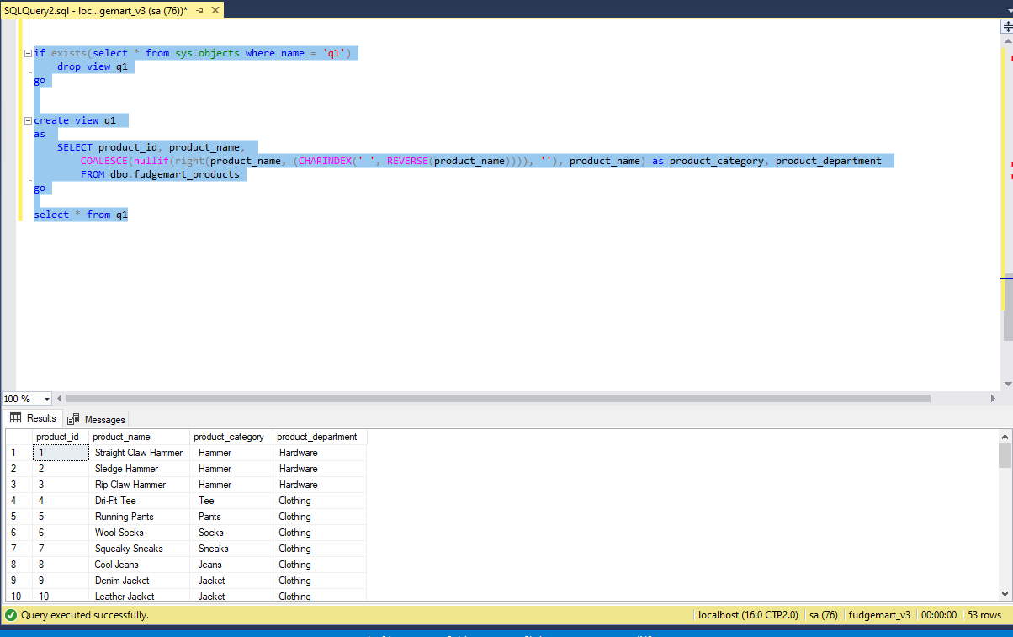

5. Write a table valued function **f_employee_timesheets** which when provided an employee_id will output the employee id, name, department, payroll date, hourly rate on the timesheet, hours worked, and gross pay (hourly rate times hours worked).

