1. Create a non-clustered index on the **timesheets** table in the **demo** database. The index you create should be designed to improve the following query:

select employee_id, employee_firstname, employee_lastname, sum(timesheet_hourlyrate*timesheet_hours)

from timesheets

group by employee_id, employee_firstname, employee_lastname;

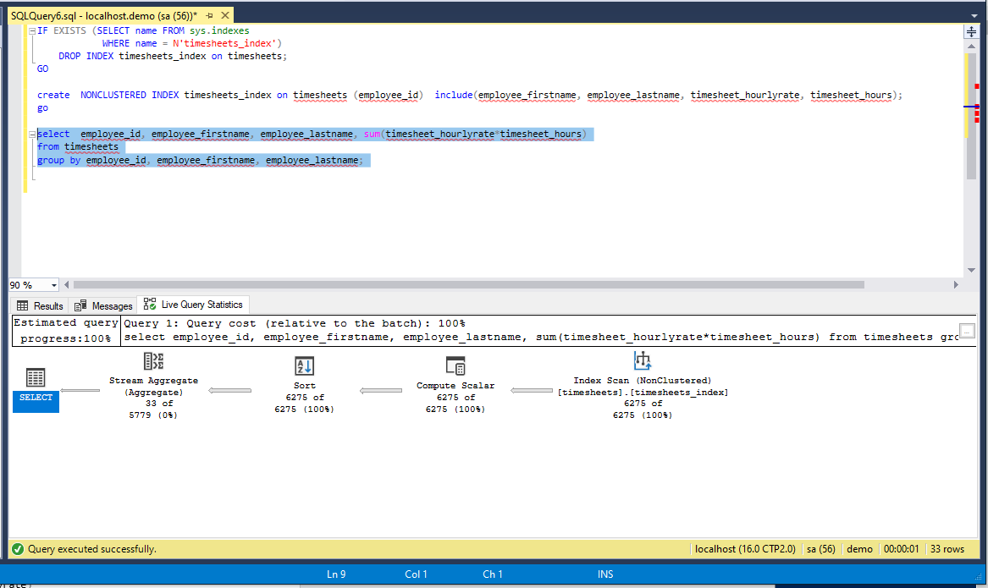

1. Write an SQL Select query which uses the index you created in the first question but does an index seek instead of an index scan.

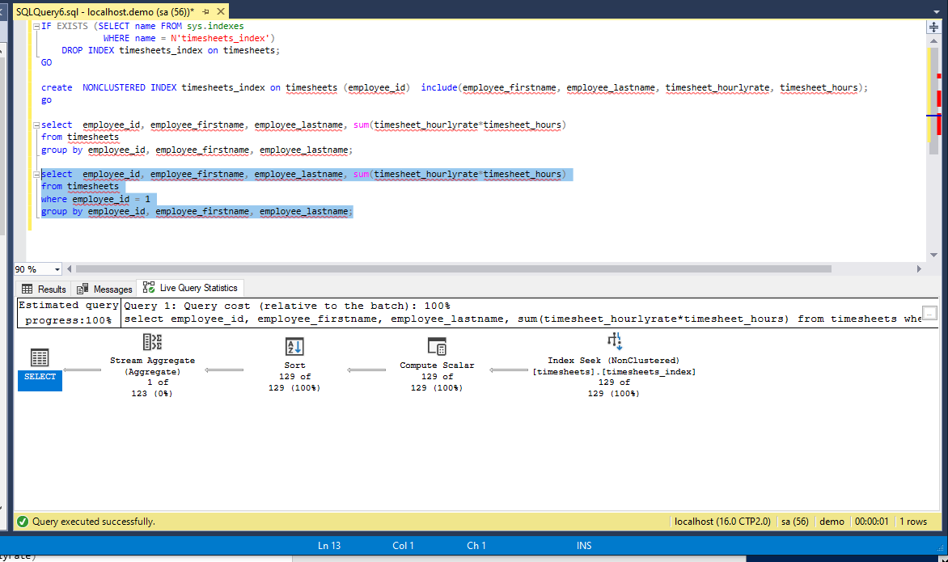

1. Create a single columnstore index on the **timesheets** table in the **demo** database which will improve the following queries:

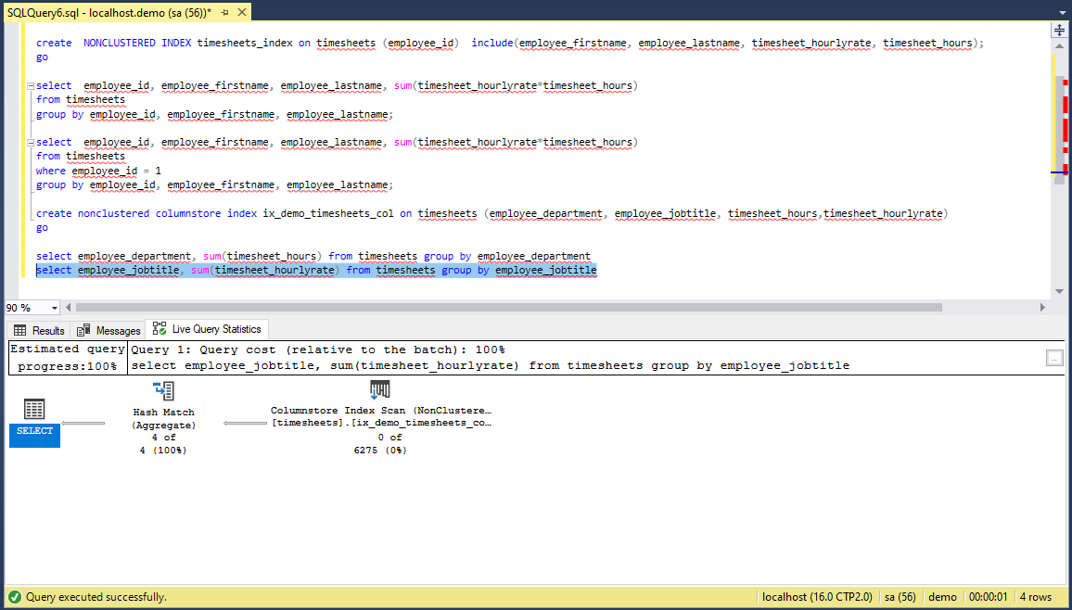

1. Create an indexed view named **v_employees** on the **timesheets** table in the **demo** database which lists the employee id, first name, last name, job title, and department columns values and one row per employee (essentially re-building the employee table). Then set a unique clustered index on the view and finish by writing an SQL Select query which uses the indexed view.

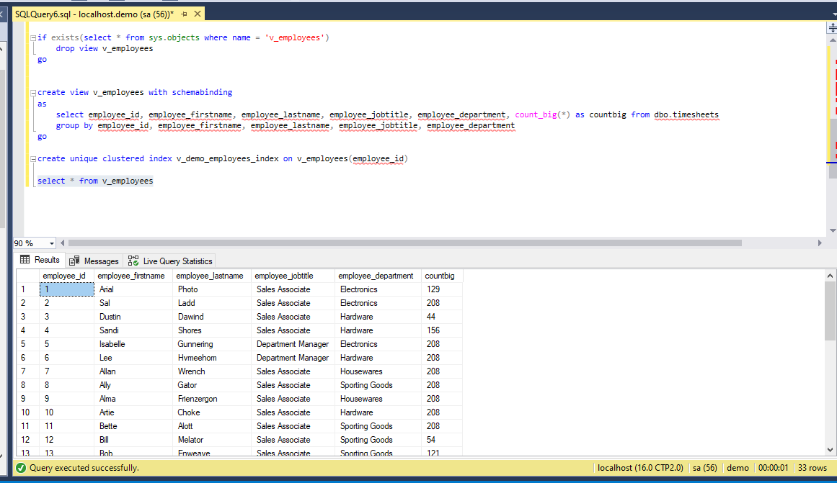

1. Output the following query in JSON format: Display the employee id, first name, last name, count of timesheets, total hours worked, and average timesheet hourly rate.

