Name: Suihin Wong

SU email: swong18@syr.edu

1,















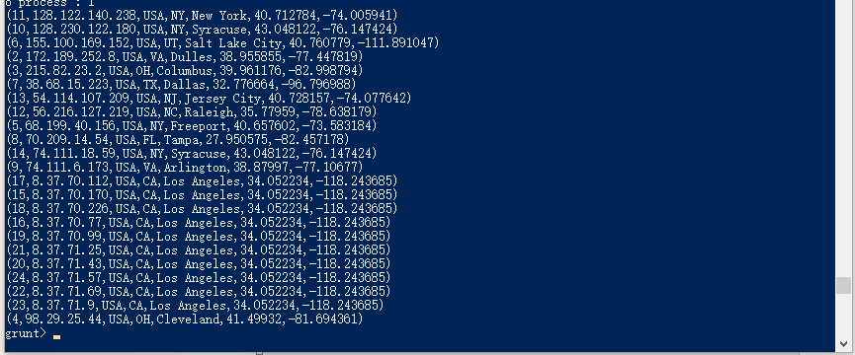

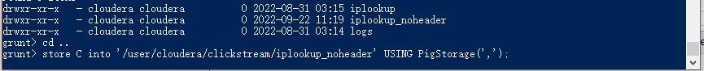

2.







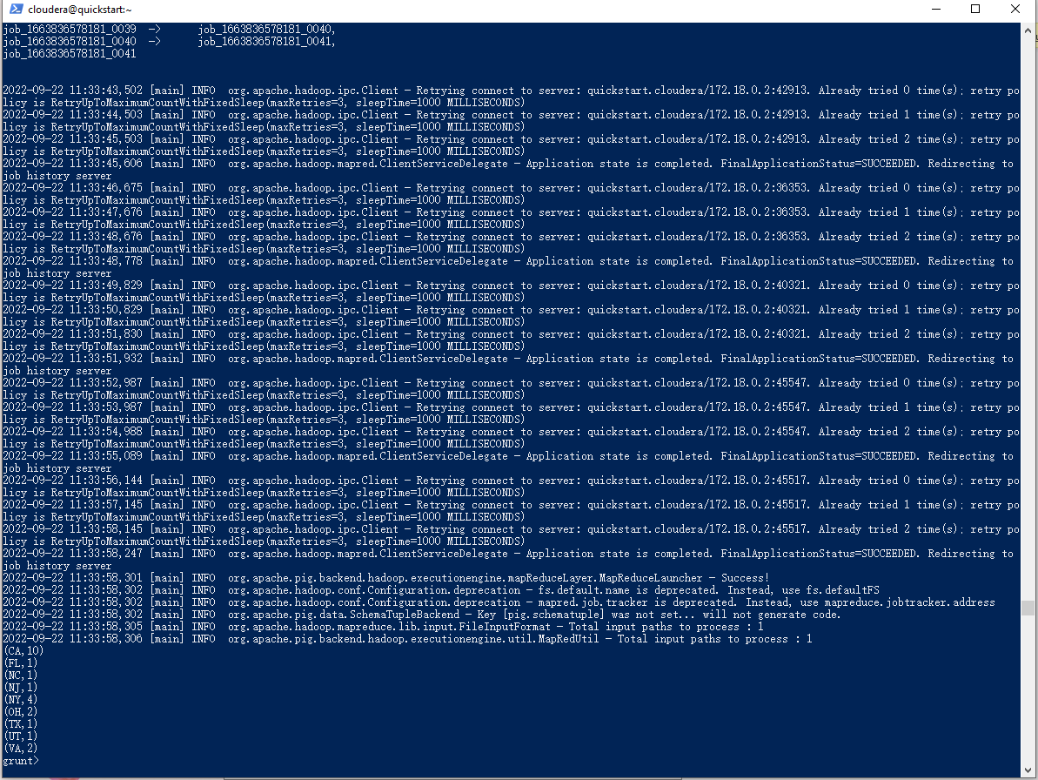

3.







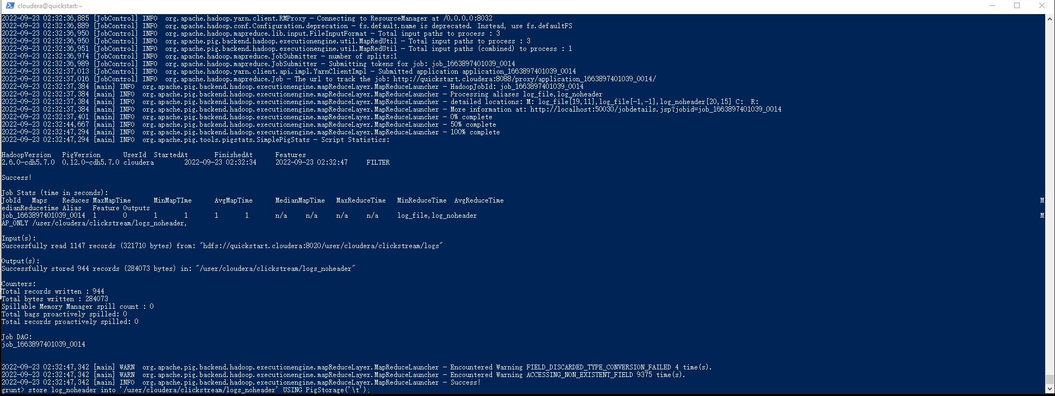



4.

CREATE EXTERNAL TABLE **weblogs** (  
reqdate:string,

Reqtime:string,

X1 int,

Method string,

Uri string,

X2 int ,

X3 int,

X4 int ,

ipaddress:string,

useragent:chararray  
) ROW FORMAT DELIMITED

FIELDS TERMINATED BY “\t”

LOCATION ‘/path/to/hdfs/’;

CREATE EXTERNAL TABLE **iplookup**(  
IP string,

Country string,

State string,

City string,

ApproxLat string,

ApproxLng string,  
) ROW FORMAT DELIMITED

FIELDS TERMINATED BY “,”

LOCATION ‘/path/to/hdfs/’;

Cant be able to connect to hive due to technical issue.

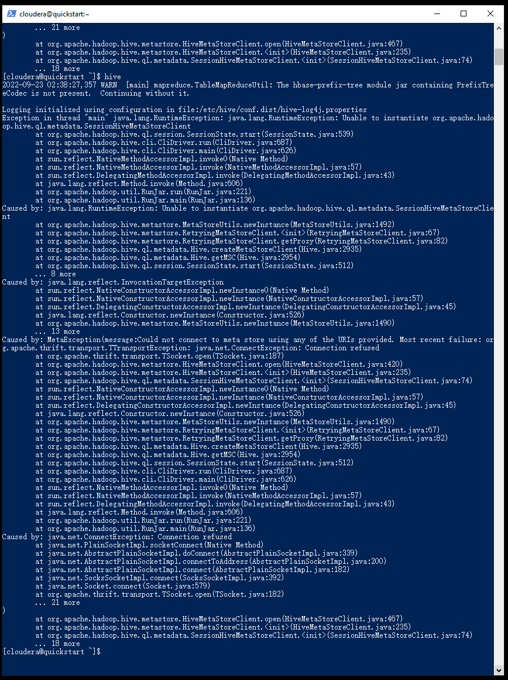

5

SELECT iplookup.city, count(*)

FROM weblogs

JOIN iplookup on

(weblogs.ipaddress = iplookup.ipaddress)

Group by iplookup.city;

Hive not working on my local device

