Name: Suihin Wong

SU email: swong18@syr.edu

1.

Showed that created two external (iplookup and weblogs)table using hive

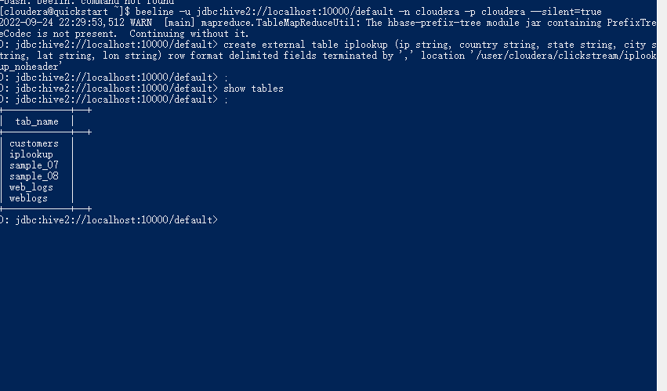

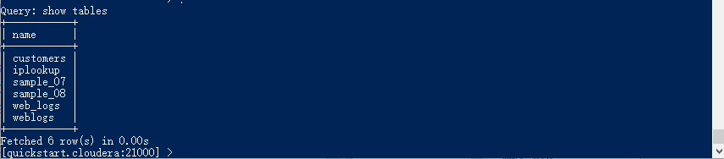

1a



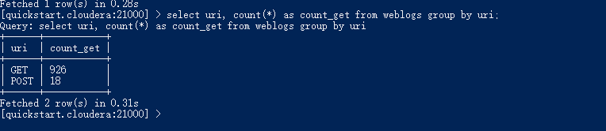

1b

Select count(*) from weblogs where useragent = “Mac”

1c

Select ipaddress, count(*) where useragent = ‘Mac’ group by ipaddress

2a.



2b.

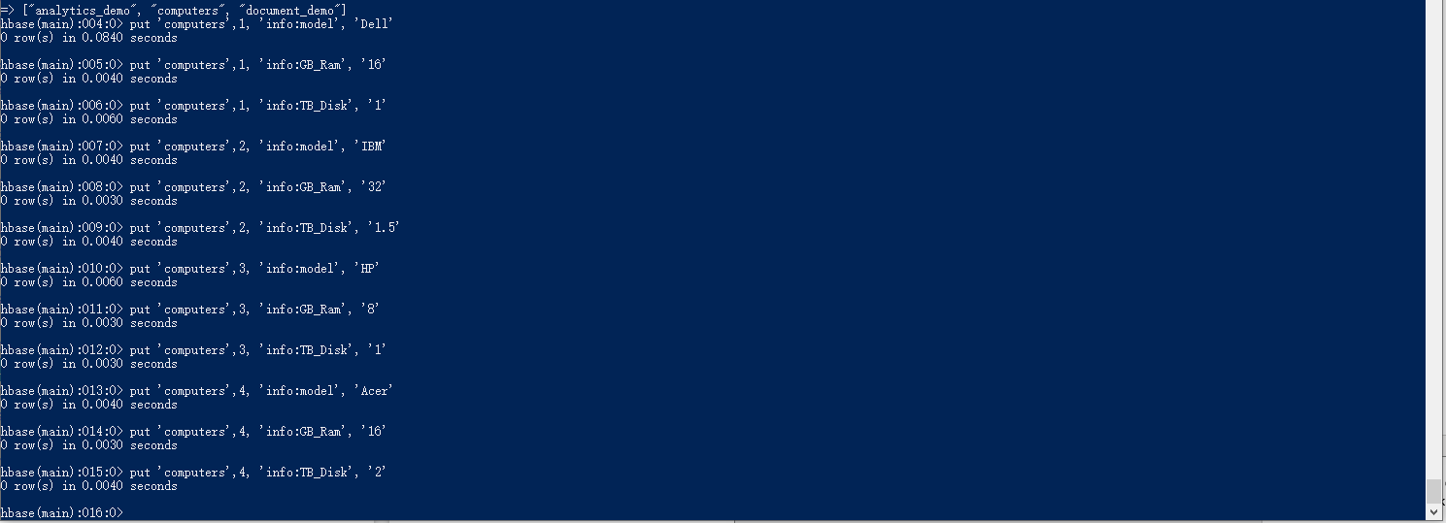

3.

create external table computers (computer_id int, model string, GB_Ram int, TB_Disk int) stored by 'org.apache.hadoop.hive.hbase.HBaseStorageHandler' WITH SERDEPROPERTIES("hbase.columns.mapping" = "info:model,info:GB_Ram,info:TB_Disk") TBLPROPERTIES("hbase.table.name"="computers");

select sum(gb_ram), sum(tb_disk) from computers;

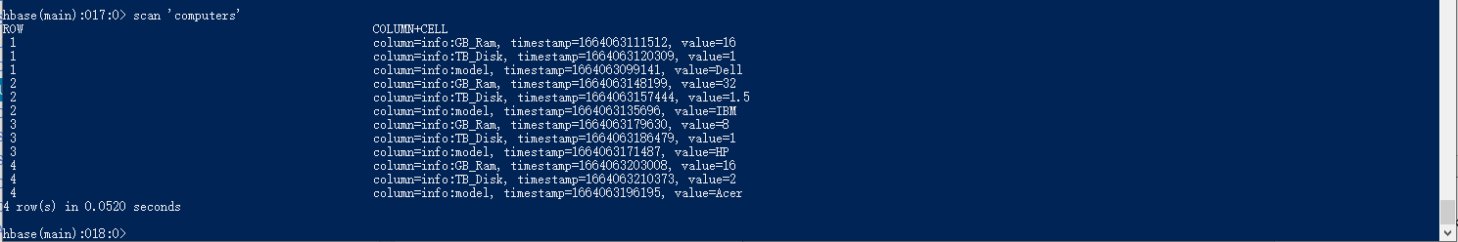

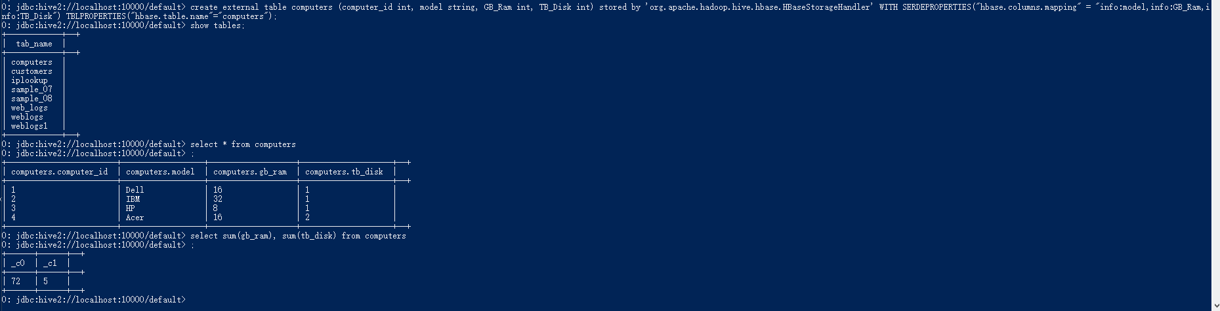

4.

create table iplookup_hbase (ip_key string, country string, state string, city string, lat string, lon string) stored by 'org.apache.hadoop.hive.hbase.HBaseStorageHandler' WITH SERDEPROPERTIES ("hbase.columns.mapping"=":key, ip:country, ip:state, ip:city, ip:lat, ip:lon") TBLPROPERTIES("hbase.table.name"="iplookup_hbase");

insert into iplookup_hbase select ip, country, state, city, lat, lon from iplookup;

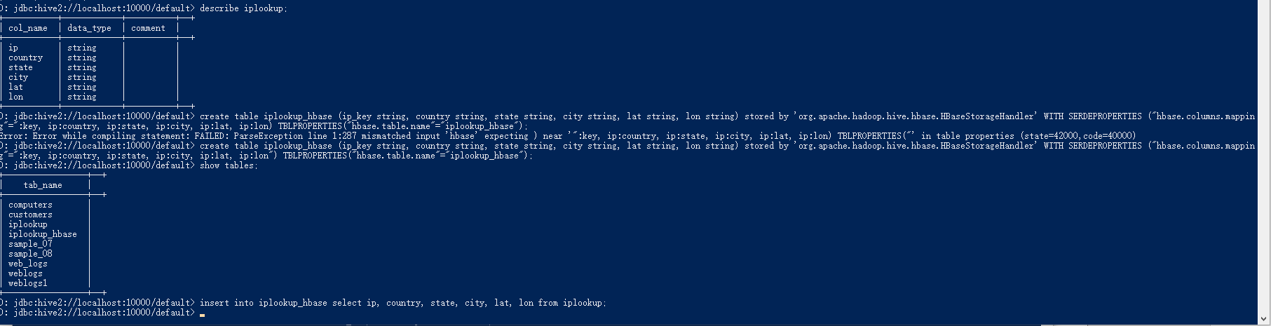

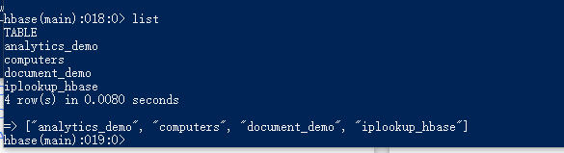

5.

scan 'iplookup_hbase', {COLUMNS => ['ip:city','ip:state']}

