Name: Suihin Wong

SU email: swong18@syr.edu

1.

I think product transactions would be a good fit in Cassandra. Columns would include product name, customer, transaction time, price. Cluster by time, and partition by product name.

2.





3.

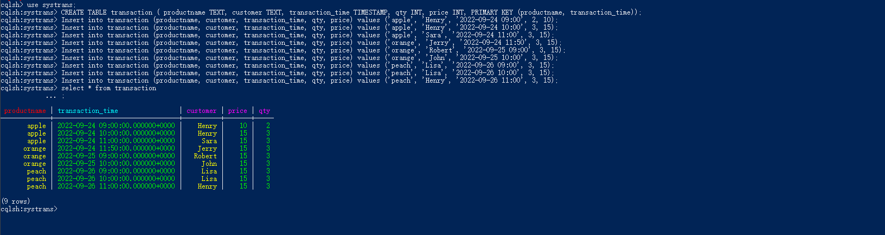

4.

Create index for customer (partition key) and this is the select statement

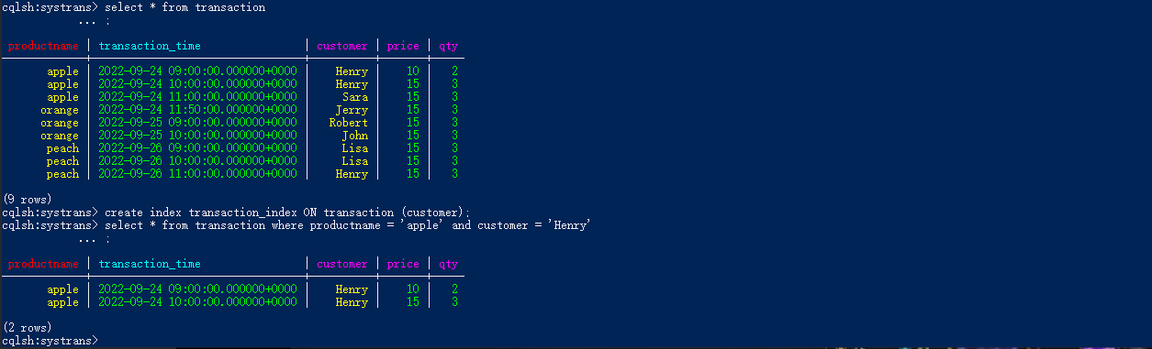

5.

Create index for qty (cluster key) and this is the select statement





