Gnoblins & Dwagons: Temple of the Book of Lost Knowledge

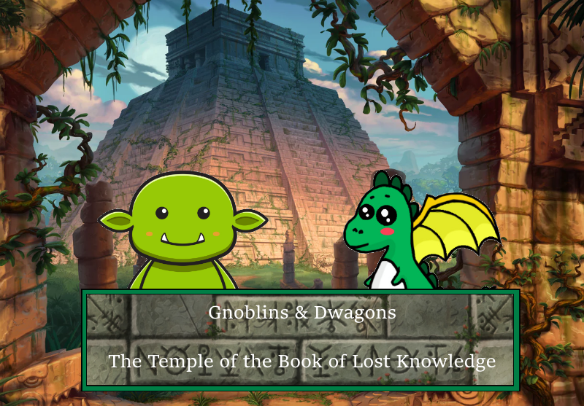

In the second game of the riveting and critically unacclaimed Gnoblins & Dwagons game-series, is the Temple of the Book of Lost Knowledge coming for PC this Christmas.

|  |  |
| --- | --- |
| Sune Andreas Dyrbye | 201205948 |
| Anders Hundahl | 202007859 |
| Lukas Mandrup | 201804423 |
| Luyen Nhu Vu | 202007393 |

# Outline

The main character is a hero from one of the races: ogres, elves, humans, or dwarves. The hero has been given a quest from their leader to retrieve the Book of Lost Knowledge from a temple in unknown lands far away. Rumours has it that others are trying to retrieve the book as well, so the hero must hurry to acquire the Book.

The Book contains divine powers and old scriptures that will result in great prosperity and wisdom to whomever possesses it. The leader of the players’ chosen race has told the hero to retrieve the Book with any means necessary. If the book falls into wrong hands, it will result in their races demise. After a long journey, the hero stumbles upon a temple which has been abandoned for centuries.

Treasure seekers and merchants have arrived to gain finances from the adventurers who dare enter the unknown depths of the temple. The hero enters the temple with his/its mighty bravery. The temple has been prepared with mystic powers and traps to fend off intruders. The hero must fight mystical creatures, other adventurers and solve puzzle rooms to proceed through the dungeon. They must gather helpful resources like weapons and armour to overcome increasingly deadlier challenges.

A mysterious figure outside hands quests to the hero, which will reward him with items which might become useful later. After progressing through the temple in what seems like ages, the hero arrives at the treasure room where he/it can see the Book upon a pedestal. As the hero approaches the Book, the mysterious figure appears. It turns out it’s he is an evil demonic overlord who seeks to unleash demonic energy into world and end all life of what we know. The hero defeats the demonic overlord and retrieves The Book of Lost Knowledge and returns home as a hero. The race lives in prosperity until a new evil emerges.

# Character

The game lets the player choose which main character they would like to play as. The characters are four heroes from four different factions or races. They have the same objective to retrieve The Book of Lost Knowledge and are equally motivated to retrieve it to stop evildoers from retrieving it first. The characters have different stats which will influence the style of play for the player. Below are the concept arts for each main character:

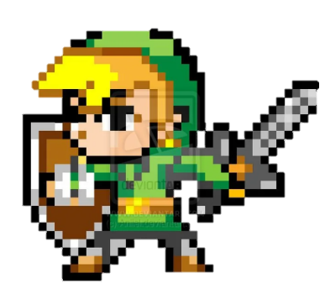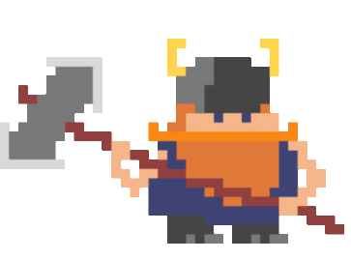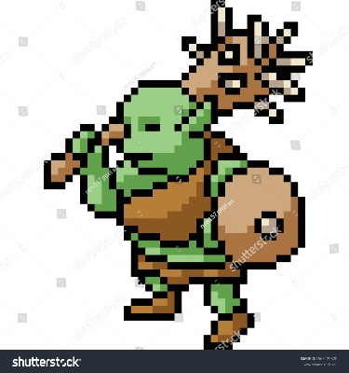

Character - Ogre

Character - Dwarf

Character - Human

Character - Elf

Having returned from the quest for the Sword of Destiny, the mighty hero must once more venture into the fray of battle.

The other characters are nearly irrelevant since they are NPCs. Their only purpose is to aid the player in exchange for financial benefits. Their background is that they are treasure seekers and have set up camp to up their financial status to new heights by bargaining with the brave souls who goes dungeon delving.

The last character is the Mysterious Figure who gives side-quests to the hero. He is also an NPC most of the game until the final encounter. He is the main antagonist but is only revealed as the Demonic Overlord at the end of the game.

# Gameplay

The gameplay has two distinct phases: Dungeon phase and camp phase. In the Dungeon phase the player character explores the dungeon, fighting monsters and getting loot (such as gold). In the camp phase the player spends the gold to buy new equipment (weapons, armour, and consumable potions).

**Dungeon:**

The dungeon is procedurally generated, providing new unique levels each time the player enters. In the dungeon, the player will encounter enemies that get progressively stronger, and more difficult to beat as they delve deeper.

If the player dies, they lose their progress and must start from the beginning without the resources they gathered however the player gets to keep the equipment that they have equipped. The player can always choose to retreat out of the dungeon, taking with them all their loot. This will reset the dungeon, and the player still has to start from the beginning again, but this time they will have extra resources, that they bought with the loot they found in the last attempt. This will force the player to weigh risk of dying by continuing versus the additional reward of extra loot.

**Camp:**

In the camp the player can interact with vendors and other NPCs. They can sell the loot they acquired in the dungeon and buy new equipment. This is also where the player can get quests and missions, that can be completed in the dungeon. The quests provide rewards in the form of gold and story progression.

# Game World

* The camp outside the ancient glooming looking temple will be a cheerful place where the player can relax before venturing into the temple again. This camp is where friendly NPCs will be greeting the player and a certain shady one also will be offering the player quests. The player can from this point spent his gold on equipment before his next run.
* The Map of the dungeon will be procedurally generated, however it will consist of different sized rooms with different events, such as enemies, puzzles, or chests.
* The overall theme of the tower is ominous and dark, where danger may await the player around every corner, with some elements of humour to lighten the mood.

As for the general mood of the game it is meant to be humoristic yet fitting, this may mean that certain objects or entities will be named or misspelled on purpose e.g., the title “gnoblins”. The in-game music will be fitting to the thing the player is doing, this some banging dungeon delving music for when it is in the dungeon, peaceful quiet music when the player is in the camp and fitting combat music to get the blood running.

# Gestalt

The player first sees the camp with the NPCs ready to help the player, for a price of course. Aside from this the player will be introduced to the temple, the predicament of the temple and the mechanics of the dungeon delving/roguelike elements of the dungeon in a tutorial style fashion that will help the player get their first coins and gear to delve further into the temple on the next run.

The aim of the game is to keep the player entertained and engaged at one time, by combining excitement with a dazzle of humour to not make the entire game too dark. As mentioned earlier the music will be fitted to what the player is doing at the moment and some sound effects will be added that entertains the player as well.

As the game at the very start offers a choice of races, every playthrough will be different and the equipment you get can force you to go in a direction you might not have anticipated. This allows for great replay ability.

# Gameplay Mechanics

Gnoblins & Dwagons is a 2D, top-down action-adventure roguelike, in the style of the Legend of Zelda and the early Final Fantasy games. The player controls a character that moves in a two-dimensional map of a dungeon.

**Combat**

* The player will encounter enemies in the dungeon and need to fight them to progress. The combat shifts the game from real-time to a turn-based, on a separate combat screen, similar to how the early Pokémon games handled battles. The combat will be based on d20 systems (like D&D). There will be three stats:
  + Strength: determines how much damage your attacks deal
  + Toughness: determines how much damage you can take before dying
  + Dexterity: determines how hard the entity is to hit in combat.
  + Agility: determines who strikes first in combat.
* Additionally, a skill-based mechanic will be added to each attack that determines whether the hero succeeds or misses their attacks. This will be either easier or harder based on the skill of the hero, and the attack that they’ve used.

**Exploration**

* The game contains a large element of exploration. The dungeon levels are generated when the player enters and are therefore always new. The layout will not be revealed to the player, and they must therefore explore the environment to discover how to progress.
* There will also be several puzzles in some levels of the dungeon. These will be solvable by exploring the rest of the level.

**Progression**

* To complete the game, the player must progress through several levels of the dungeon.
* The players will be able to spend the loot they acquired in the dungeon in the camp to buy new and better equipment.

**Character stats**

* The different starting characters will have different stats and starting equipment, which allows for different playstyles, aside from this they will have their own special modifiers.

# Enemies

The enemies are the denizens of the Temple. It ranges from the common dungeon rat to the kleptomaniacal thieves that roam the tight halls of the Temple. The walls crawl with dangerous traps and monsters that are ready to pounce on unsuspecting intruders.

Each enemy has different fighting capabilities with their own sources of power. Some are magical, some are pure brutes, and some might just be deceivers of the mind.

The hero must wander the suffocating corridors of the Temple and fight off the potential enemies. Some enemies might be weak to quick and nimble attacks but strong against hard-hitting slow attacks.

Each floor of the Temple has new enemies and challenges that they need to overcome. On the upper floors, the Gnoblins have overrun, seeking out riches. The further down the Temple the hero gets, the more demonic power flows into the inhabitants, increasing their threat.

Should the hero make it to the bottom of the dungeon, the evil demonic overlord that has turned the once peaceful Temple into a lair of despotic chaos, guards the Book of Lost Knowledge. Only total victory may save the hero's people.

# Bonus

The game will feature multiple aspects that all incentivize replayability this includes:

**Races:**

As mentioned earlier the game will feature 4 different races that can be chosen at the start of the game. This choice will heavily aid the player in utilizing certain builds, however it will not stop the player in playing with other builds, only make it more challenging.

**Items & Builds:**

The items in the shop will be randomly generated within certain thresholds. They might increase your chance to hit or make you harder to hit. And the better the item the higher the stats. However better items only show up when you progress further in the game.

**Procedurally generated dungeon:**

Every dive is a new experience as the dungeon gets generated from scratch every time you start a new dive. This means the location of enemies, what enemies and their drops get randomized. The rooms’ location and their connections get randomized. And of course, the location of the boss, the staircases and the puzzle rooms get randomized.

# Monetisation

The full game will be provided for free, for everyone. Theoretically if the game draws a lot of attention from the public and they demand more from the producers of the game, there can be donation system, where fans can contribute to the developers. The money can afterwards be used for further development of the game like bug fixing and add more items for the player. The money could also be used for expanding the team and secure further development of the products in the future.

The game could include expansions and DLCs for the community, but since we hate microtransactions and greedy companies, we choose not to scam our community.

Since it is free, it would boost the amount of players and fans as the roadblock of money won’t be in our way. It would boost our image and will let more players try our game.