**Hosting a Persistent Apache Web Application Using NFS and ConfigMap in Kubernetes**

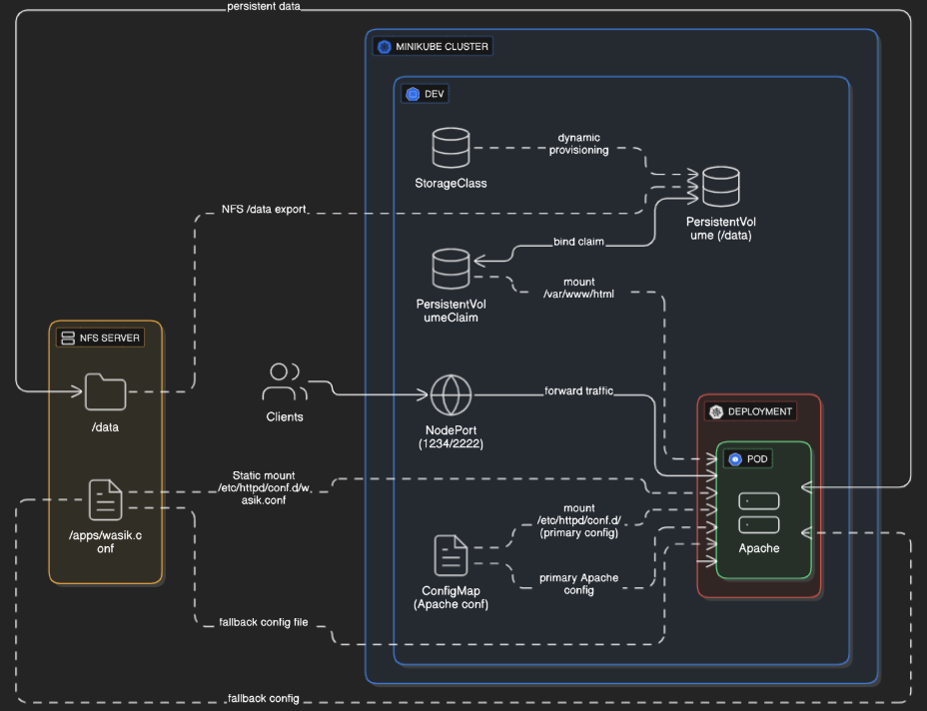

• **Apache + NFS Deployment in Kubernetes (Dev Namespace)**

• **K8s Apache Server Setup with NFS Storage**

• **Kubernetes Apache Deployment with ConfigMap and Persistent Volume**

* Namespace: Isolate resources in dev
* PV & PVC: Persistent via NFS
* ConfigMap: Apache config with port 1234/2222
* Deployment: Apache container with volumes
* NodePort Service: External access to web sever
* NFS Server: Backend file store

**Prerequisite**

* NFS srver ( VM)
* Minikube Cluster
* Proper connectivity with nfs server & cluster node
* First we create nfs server export two directory   
    
  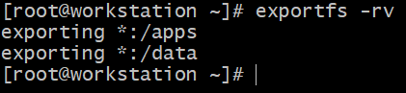

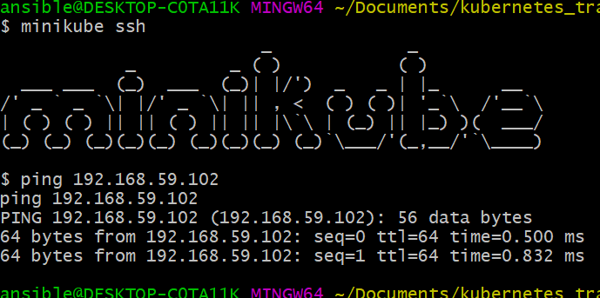

**Create namespace**

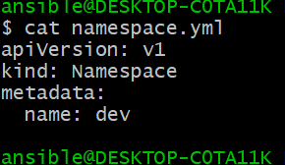

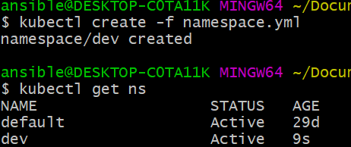

**Create Roll base Access Control**.

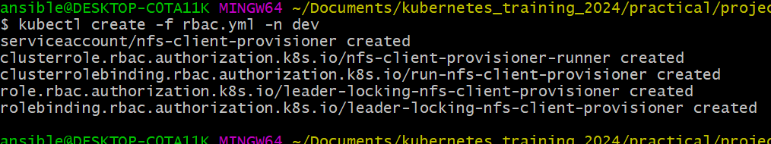

**Service account create**

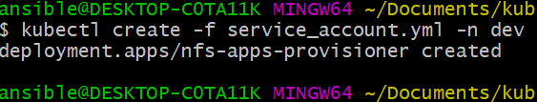

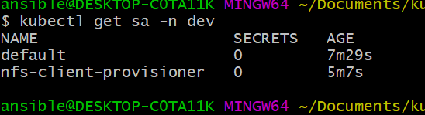

**Shared Storage (RWX)**>>> NFS allows multiple pods across different nodes to read/write simultaneously to the same files.

This is crucial for web servers, shared logs, or collaborative file editing.

**Centralized Data**>>> Documents (e.g., HTML, PHP, config files) are stored in one place (NFS server) and accessible from multiple pods or deployments.

**Persistent Volumes**>>> Kubernetes can mount NFS as a PersistentVolume (PV), ensuring data is retained even if the pod dies or restarts.

**Dynamic & Static Provisioning**>>NFS supports both manual PV/PVC setups (static) and automatic PVC-based provisioning (dynamic) via provisioners.

**Ease of Backup**>>> Backing up files is easy because all documents are stored centrally on the NFS server.

NFS

NFS Server IP: **192.168.59.102**

NFS Export Path: **/data**

StorageClass: **nfs-data**

PVC Name: **data-pvc**

Mount Path: **/var/www/html/**

Pod IP: **10.244.1.187**

Web Port: **1234 (custom Apache)**

NodePort: **32504**

NFS Server IP **192.168.59.102**

NFS Export Path **/apps**

Shared File **/apps/wasik.conf**

Export Type **Static**

Create storage class  
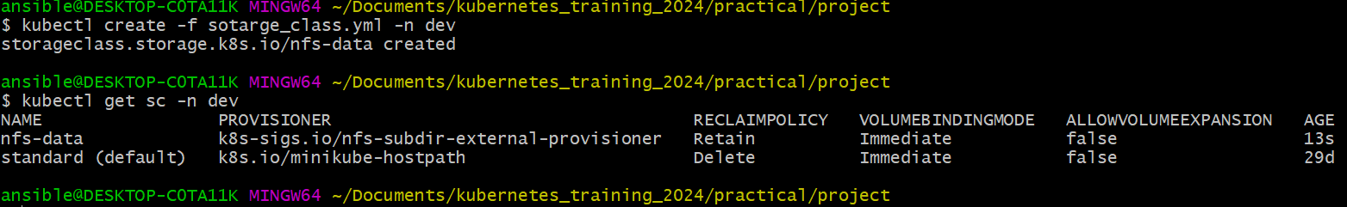

Create PVC  
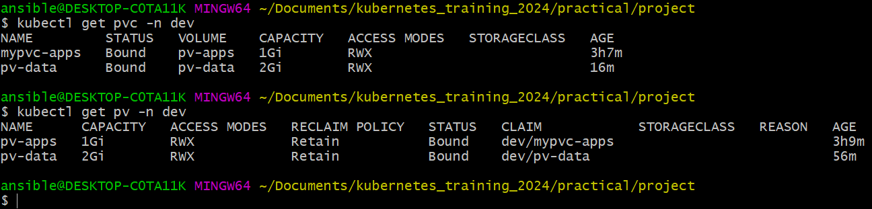

Create PV

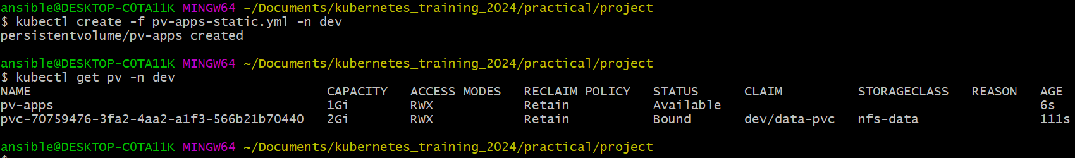

;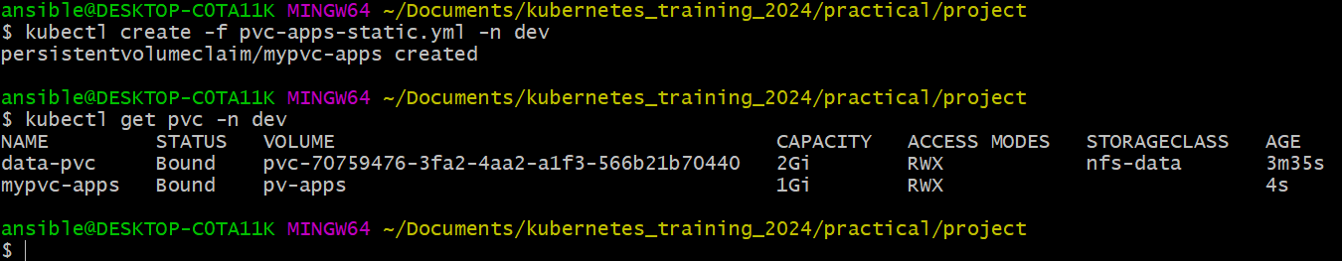



|  |  |
| --- | --- |
| NFS path: /data  Use Case: Website data  Type: Dynamic  Mountpath in Pod: /var/www/html/  PVC-Name: data-pvc  Notes: Provisioned via StorageClass [nfs-data] | NFS path: /apps/wasik.conf  Use case: apche conf  Type: static  Mountpath in Pod: /etc/httpd/conf.d/wasik.conf  PVC name: mypvc-apps  Notes: Manually created PV[pv-apps] |

Create deployment

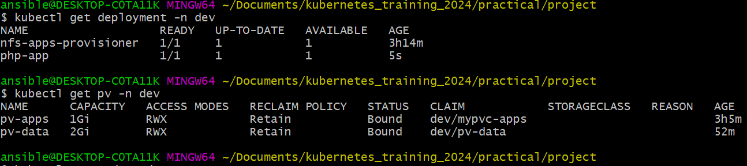

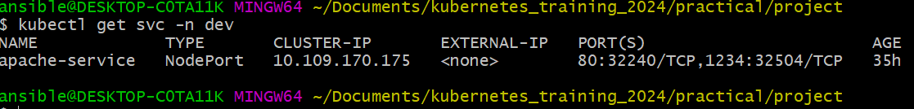

Minikube IP: **192.168.59.100**

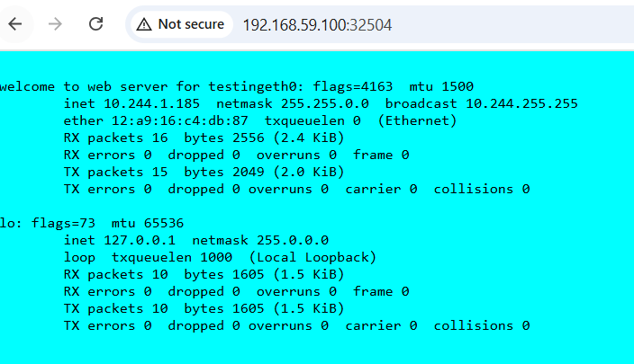

NFS sever Persistent volume:

**/data**

**/apps**

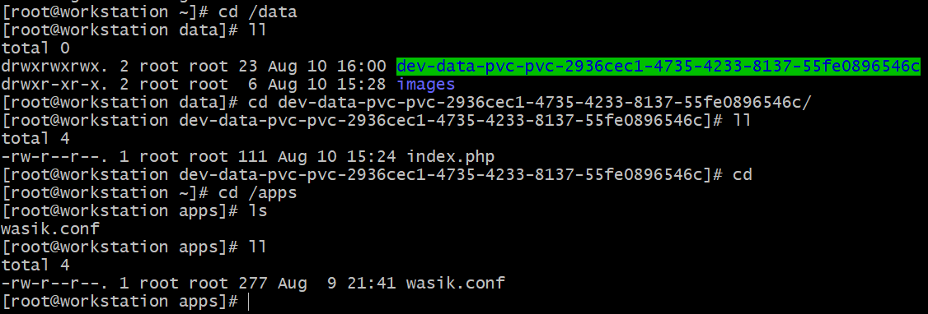

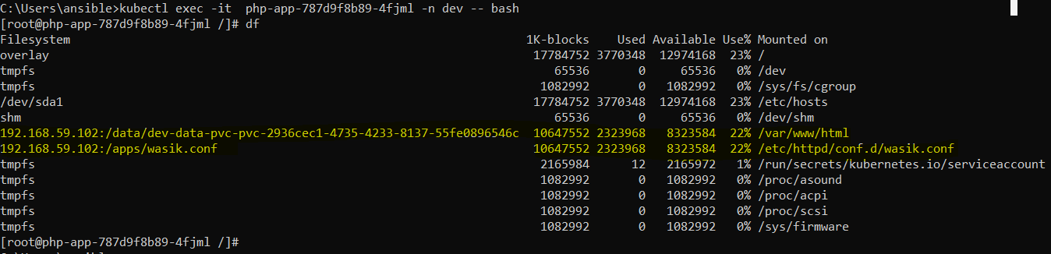

Download repository:

<https://github.com/suja-sk/Web_application_hosting_with_persistent_volume_ConfigMap_on_kubernates.git>

Thanks