* Create name space ----dev-space.yml
* Create rbac policy------rbac.yml
* Then create serviceAccount---nfs-provisioner-deploy.yml
* Create storageClass-----class.yml
* Create pvc ----pvc.yml

nfs share dynamically attached with one share point …  
for that /data is mounted

but /apps not mounted .. no PV created .. by default both are create on /data directory

for this reason we only create one manual static nfs share point

pv-apps-static.yml—

first create pv … Then create PVC

PV is showing status: available state.. then go for pvc-apps-static.yml

PVC status: Pending state.

When we check pv pv-apps

Status showing : released

kubectl patch pv pv-apps --type=json -p='[{"op": "remove", "path": "/spec/claimRef"}]'

persistentvolume/pv-apps patched

after that pvc status bound & PV bound

then relunch the deployment with static configure wasik.conf

from nfs shared

its working properly

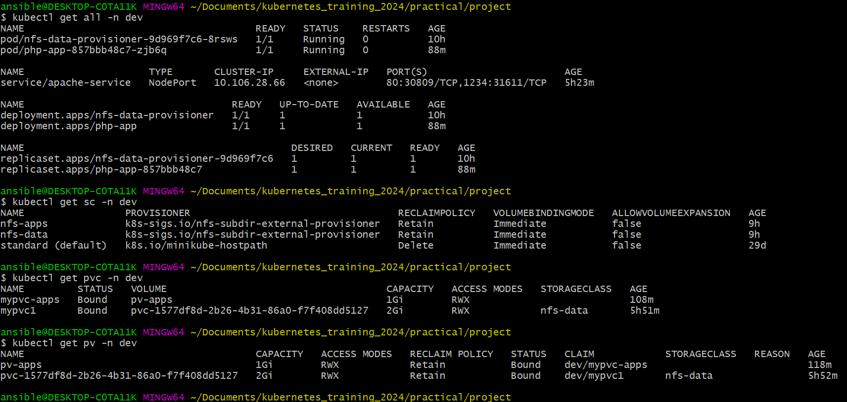

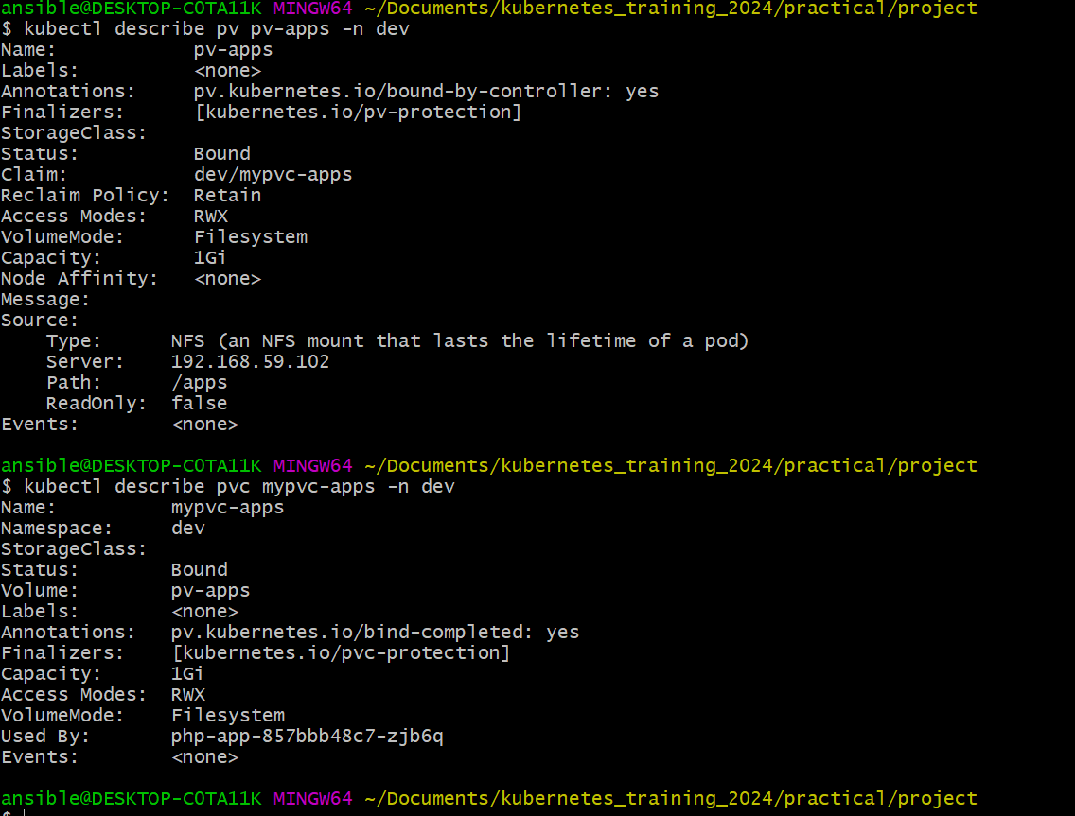

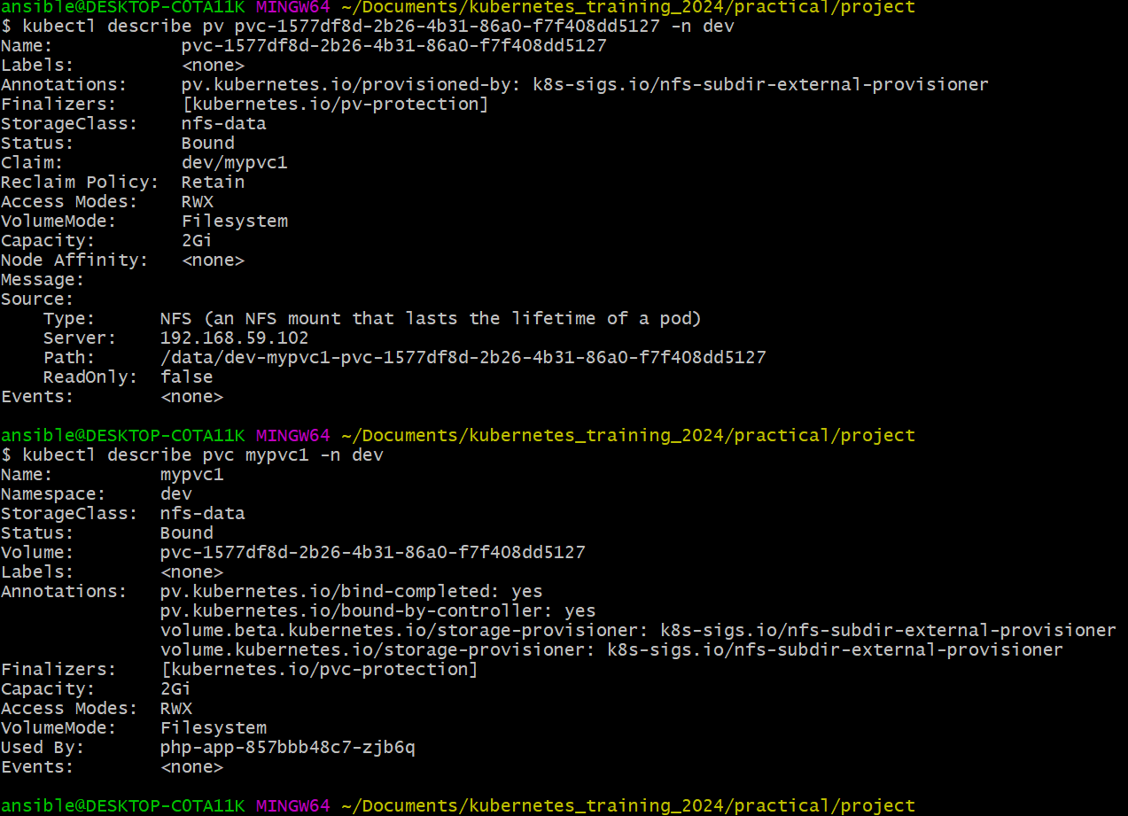

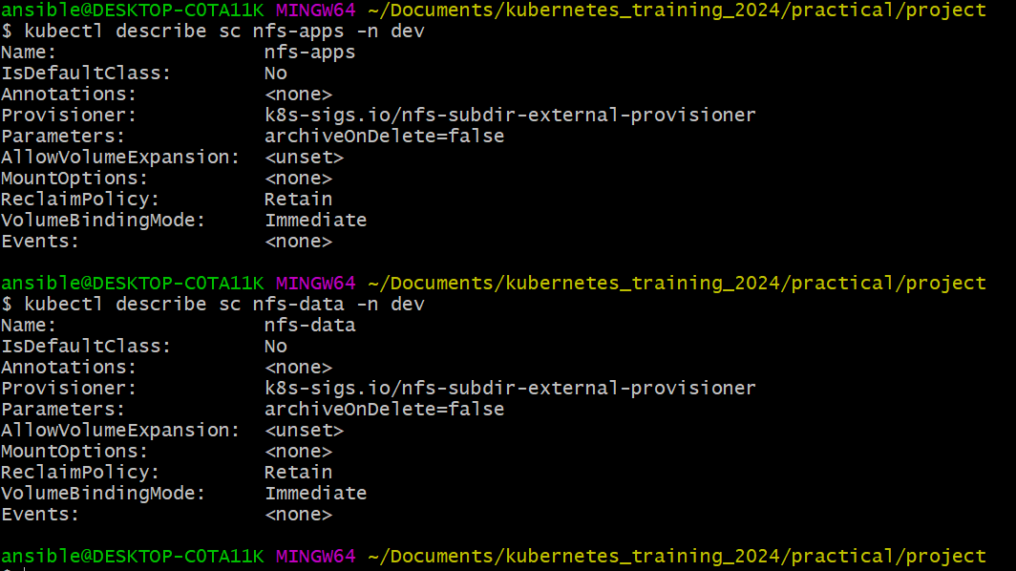

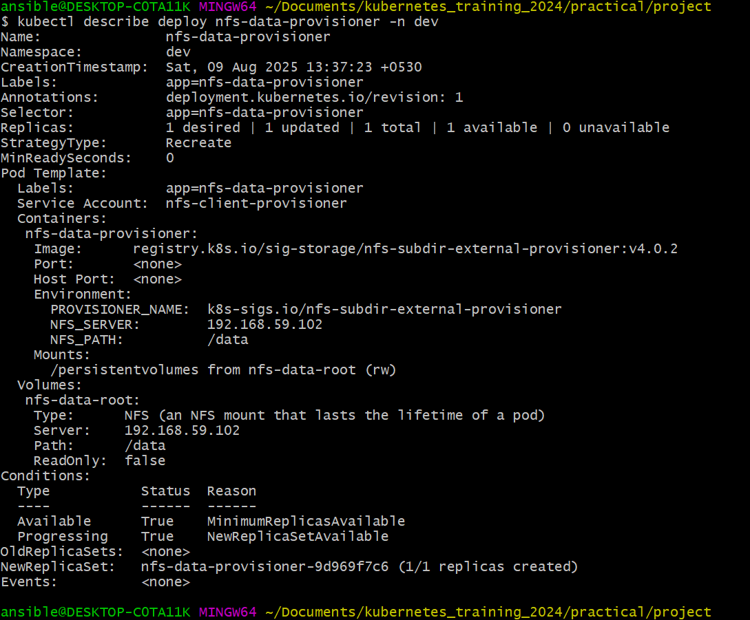

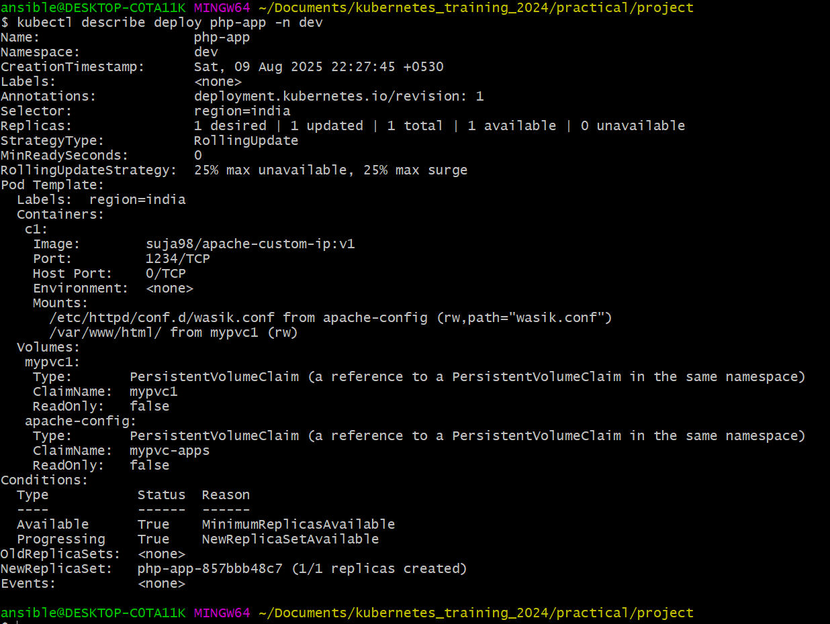

Step :

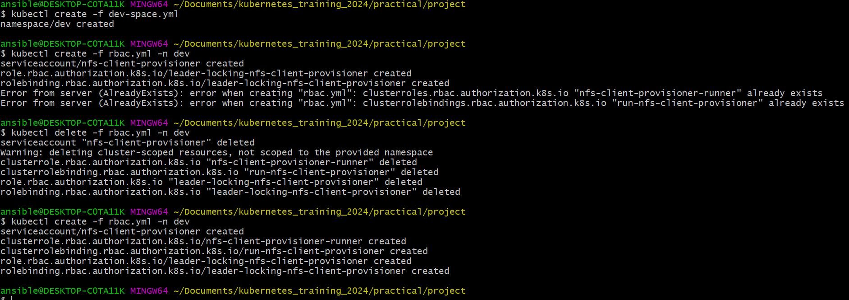

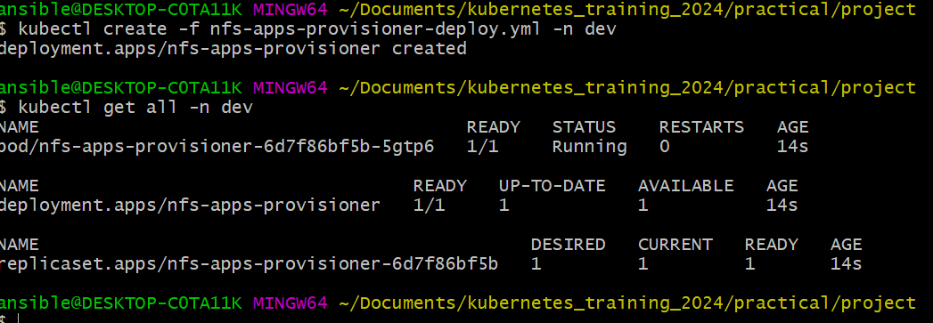

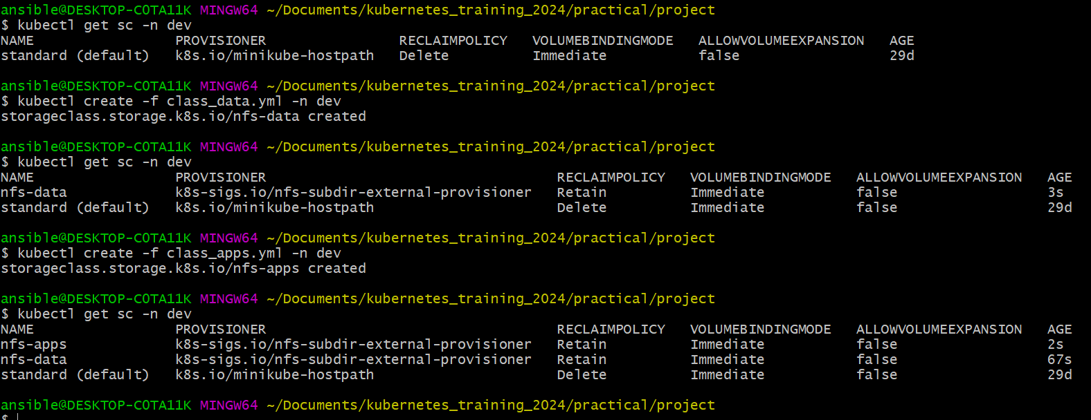

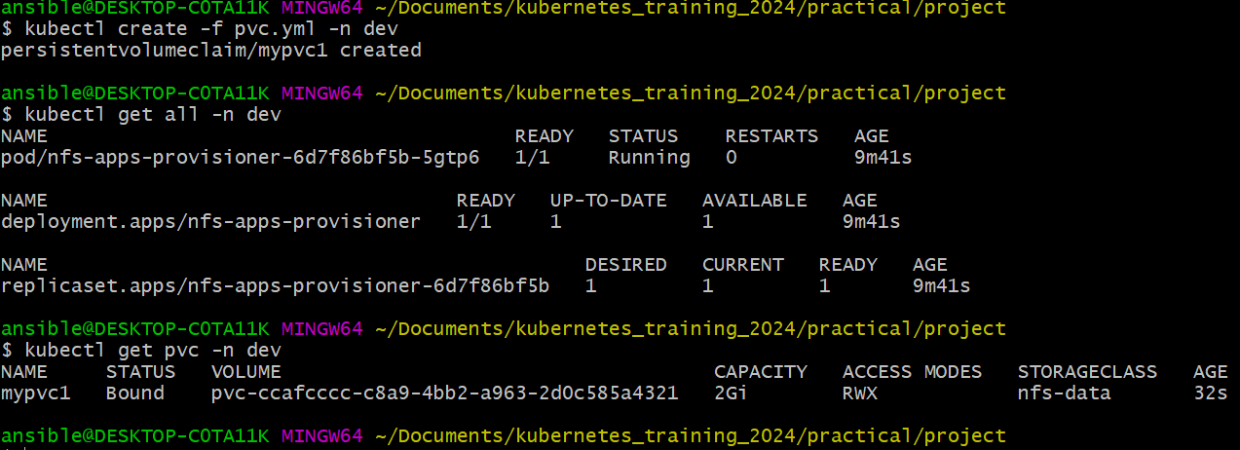

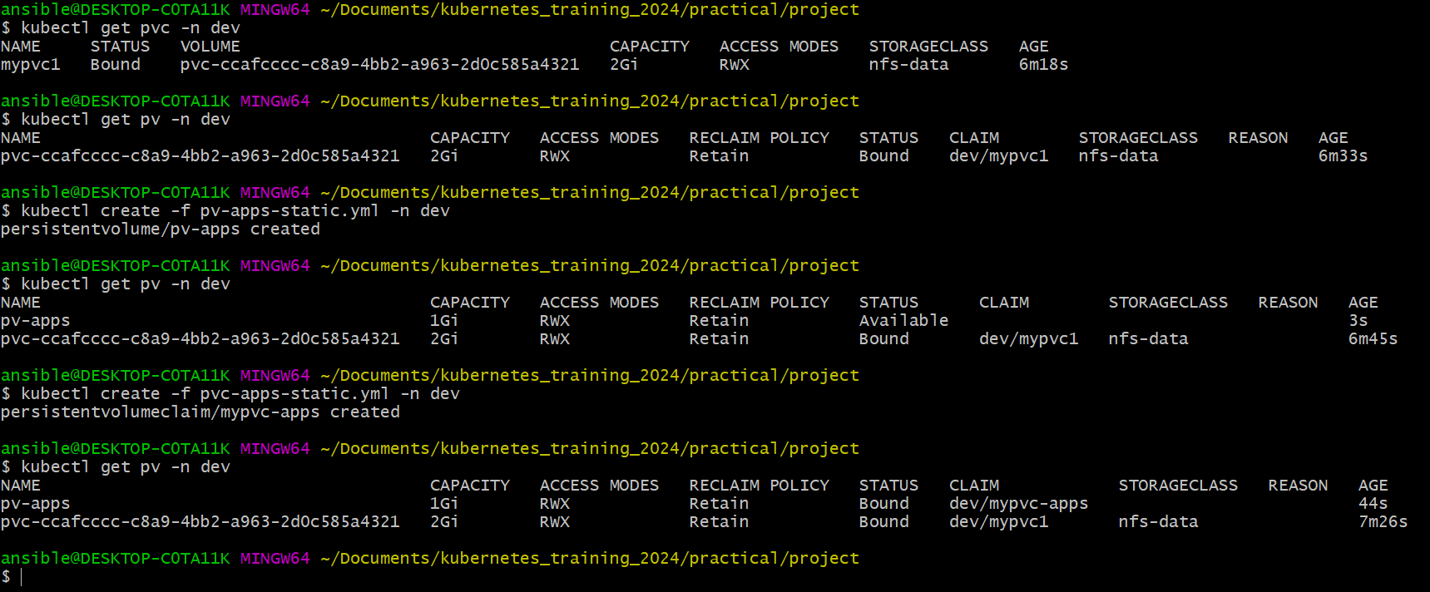

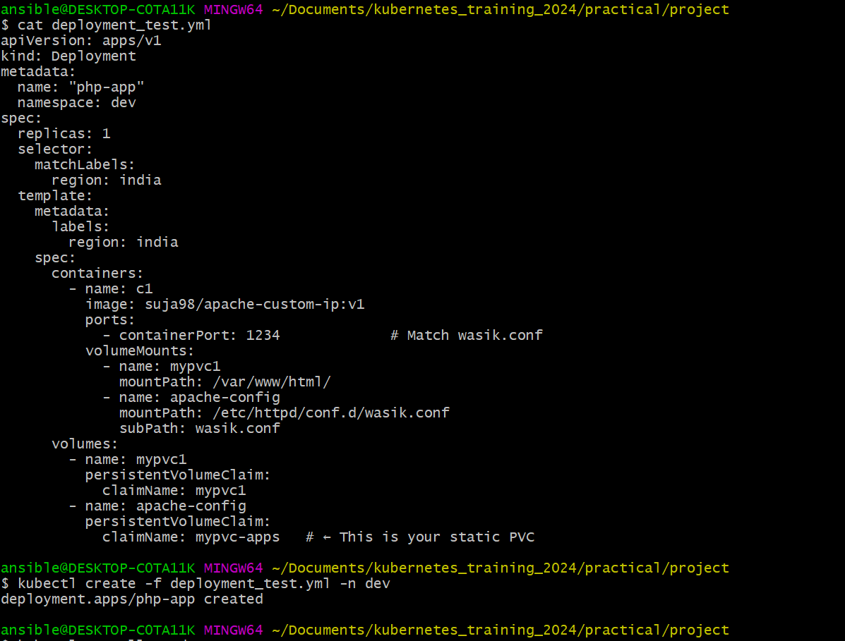

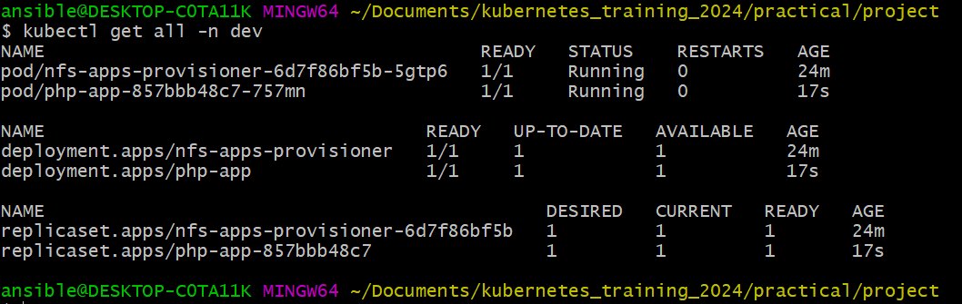

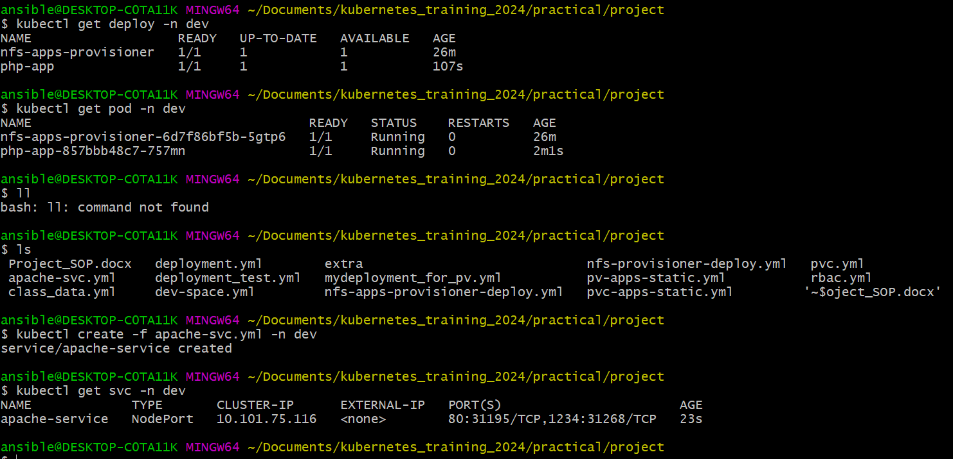

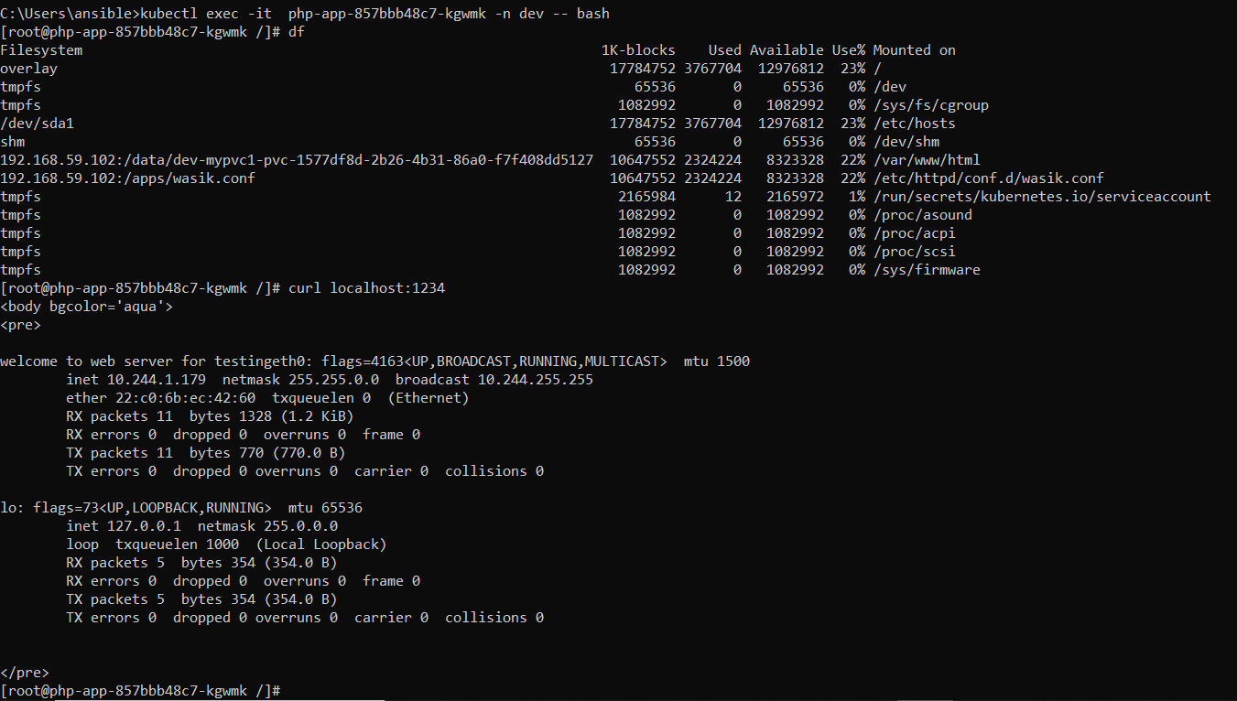

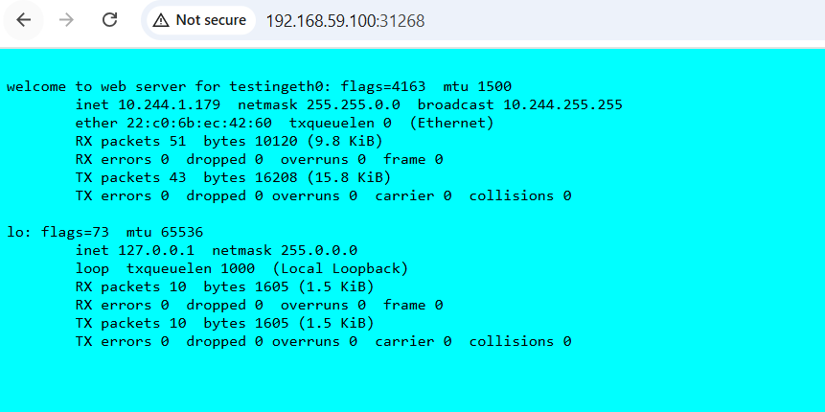

|  |  |
| --- | --- |
| Namespace | Isolate resources in dev |

|  |  |
| --- | --- |
| PV & PVC | Persistent storage via NFS |

|  |  |
| --- | --- |
| ConfigMap | Apache config with port 1234 |

|  |  |
| --- | --- |
| Deployment | Apache container with volumes |

|  |  |
| --- | --- |
| NodePort Service | External access to web server |

|  |  |
| --- | --- |
| NFS Server | Backend file store |