PROJECT DOCUMENTATION

- Title:- Netflix Content Analysis Dashboard.
Using Power BI.
Submitted By :- Sujal Sudhakar Salvi.
Course :- Data Analytics.
Submitted To :- Prajakta Tayde.

- Introduction :-
This project focuses on analyzing Netflix’s content library using Power BI.
The dashboard provides insights into the distribution of movies and TV shows, content growth over time, genre popularity, and country-wise content production.
The goal of this dashboard is to present Netflix data in a visually interactive and easy-to-understand format for better decision-making.

- Objective of the Dashboard :-
          - To analyze the total number of titles available on Netflix
          - To compare Movies and TV Shows
          - To understand Netflix content growth over time
          - To identify top genres and top countries producing content
          - To present insights using interactive visualizations

- Dataset Description :-
The dataset used in this project contains information about Netflix movies and TV shows.
It includes details such as title type, country, release year, date added, genre, rating, and duration.

- Column Description :-

  - show_id :- A unique identifier assigned to each Netflix movie or TV show.

  - Type :- Indicates whether the content is a Movie or a TV Show.

  - Title :- The official name of the movie or TV show available on Netflix.

  - Director :- Name of the director associated with the content.

  - Cast :- List of main actors and actresses featured in the title.

  - Country :- Country where the content was primarily produced.

  - date_added :- The date when the title was added to the Netflix platform.

  - release_year :- The year in which the content was originally released.

  - Rating :- Audience age rating assigned to the content.

  - Duration :- Length of the movie in minutes or number of seasons for TV shows.

  - listed_in :- Genre or category under which the content is classified.

  - Description :- Brief summary describing the storyline or theme of the content.
- Dashboard Design & Visualizations :-

  - Cards :-

- Total Titles Card :-

Explanation:-
The Total Titles card displays the complete count of Netflix content entries available in the dataset. Each title in the dataset represents a unique movie or TV show, identified using a distinct show _id. By counting these unique identifiers, the card provides an accurate measure of how many titles are analyzed in the dashboard.

Purpose :-
This card serves as a foundation metric for the dashboard.
It helps users understand the size of the dataset and gives context to other visualizations such as movies, TV shows, and genre distribution.

- Total Movies Card :-

Explanation :-

The Total Movies card shows the number of titles that are classified specifically as Movies. This value is calculated by filtering the dataset where the content type is marked as “Movie” and then counting the corresponding records. Only full-length movies are included in this count.

Purpose :-

This card helps in identifying how much of Netflix’s content library is focused on movies. It allows users to compare movie availability against TV shows and understand Netflix’s content strategy.

- Total TV Shows Card :-

Explanation :-

The Total TV Shows card represents the total number of entries categorized as TV Shows in the dataset. This includes all series-based content such as single-season and multi-season shows. The value is obtained by filtering the dataset for “TV Show” content type and counting the number of records.

Purpose :-

This card highlights Netflix’s presence in episodic and series-based entertainment. When viewed alongside the Movies card, it provides a clear comparison between different content formats. This card highlights Netflix’s presence in episodic and series-based entertainment. When viewed alongside the Movies card, it provides a clear comparison between different content formats.

- Total Genres Card :-

Explanation :-

The Total Genres card displays the number of distinct content categories available in the dataset. Genres are derived from the listed _in column, which classifies titles into categories such as Drama, Comedy, Action, and Documentary. A distinct count is applied to ensure that repeated genres are counted only once.

Purpose :-

This card indicates the diversity of Netflix content. A higher genre count reflects a wider range of content options, catering to different audience preferences.

  - Donut Chart – Movies vs TV Shows:-
Explanation :-
The donut chart is used to show how Netflix content is divided between Movies and TV Shows. Each section of the donut represents one content type, and the size of each section depends on how many titles belong to that category. The data is grouped using the Type column, and the total number of titles is calculated using the Show ID count. By looking at the donut chart, users can immediately understand which type of content is more common on Netflix. The chart provides a clear visual comparison rather than just numbers, making it easier to interpret the data at a glance.

Purpose :-
The main purpose of the donut chart is to compare the proportion of Movies and TV Shows in Netflix’s content library. It helps users quickly see where Netflix places more emphasis—whether on movies or on series-based content. This visualization also supports decision-making by showing the overall content balance without requiring deep analysis.

  - Line Chart – Content Growth Over Time :-
Explanation :-
The line chart is used to show how Netflix content has changed over time.
In this chart, the horizontal axis represents the release year, while the vertical axis shows the number of titles released in each year. Each point on the line represents how many movies and TV shows were released during that specific year. As the line moves upward or downward, it shows whether Netflix content production increased or decreased over time.
This makes it easy to notice growth patterns, sudden rises, or periods where fewer titles were released.

Purpose :-
The purpose of the line chart is to analyze trends over the years.
It helps users understand how Netflix’s content library has expanded and how its focus on content creation has evolved. By observing this chart, users can identify peak years of content release and understand long-term growth in Netflix’s offerings.

  - Stacked Column Chart – Country-wise Content :-
Explanation :-
The stacked column chart is used to compare Netflix content across different countries while also showing the type of content within each country. In this chart, the horizontal axis represents countries, and the vertical axis shows the total number of titles available from each country. Each column is divided into segments based on content type, such as Movies and TV Shows. This stacking allows the chart to display not only the overall content count for a country but also how that content is split between movies and TV shows. As a result, users can clearly see both the total contribution of each country and the internal distribution of content types.

Purpose :-
The purpose of the stacked column chart is to analyze geographical distribution of Netflix content. It helps users understand which countries contribute the most content and whether those contributions are mainly movies, TV shows, or a mix of both. This visualization makes it easier to compare countries side by side while still preserving detailed information about content type.

  - Bar Chart – Top Genres :-
Explanation :-
The bar chart is used to compare Netflix content across different categories, such as genres or ratings. Each bar represents one category, and the length of the bar shows the number of titles that fall under that category. The data is grouped using the selected field (for example, genre or rating), and the total count of titles is calculated using the show _id. This visual makes it easy to identify which categories are more common and which ones have fewer titles.
Longer bars indicate categories with more content, while shorter bars show less representation.

- Dashboard View:-
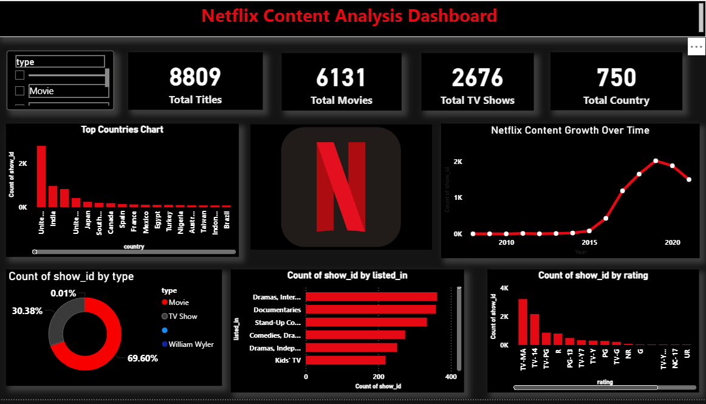
- Conclusion :-
This project successfully demonstrates how Power BI can be used to analyze and visualize Netflix content data in an effective and meaningful way. By using cards, charts, and a well-structured layout, the dashboard presents important information such as total titles, content type distribution, release trends, and country-wise contributions in a clear and easy-to-understand format. The use of different visualizations helps in understanding Netflix’s content strategy, showing how movies and TV shows are distributed across genres, countries, and time periods. Data cleaning and proper formatting ensured that the analysis was accurate and reliable. The inclusion of a consistent color theme, title, and logo improved the overall appearance and professionalism of the dashboard. Overall, this dashboard provides a comprehensive overview of Netflix’s content library and highlights how data visualization can support better insights and decision-making. The project also helped in gaining hands-on experience with data preparation, visualization design, and storytelling using Power BI.

