**Product Design**

TEAM 26 (RESOLVE)

**Gopendra Singh: 2022101003**

**Sujal Keshri: 2022101004**

**Neel Amrutia: 2022101117**

**Kevin Thakkar: 2022101064**

# **Design Model :**

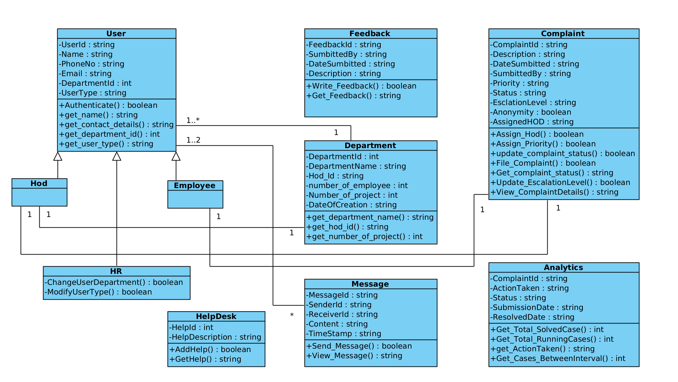

**Table for Class Description:**

| 1. User | Class state   * Maintains user information such as UserId, name, email, phone number, and department. UserId is unique to each user.   Class behavior   * Implements methods for user authentication, getting name, email id, phone number and department of user on providing user id. |
| --- | --- |
| 1. Employee | Class state   * Inherits states from User class where each user is an Employee.   Class behavior   * Inherits all the behavior of the User class. * Additionally, it implements a method for providing feedback of the platform. |
| 1. HOD | Class state   * Inherits states from User class where each user is an HOD.   Class behavior   * Inherits all the behavior of the User class. |
| 1. HR | Class state   * Inherits states from User class where each user is an HOD.   Class behavior   * Inherits all the behavior of the User class. * Additionally, it implements methods for changing department of users and modifying type of user (for eg. HR can change the type of user from Employee to HOD). |
| 1. Department | Class state   * Maintains the information such as department id, name, its date of creation and user id of the HOD of the department. * Maintains the information of the number of employees working in a department and number of projects going on under a department.   Class behavior   * It implements methods to get department name, get the name of HOD and get number of projects going on under a department on providing department id. |
| 1. Complaint | Class state   * Maintains the information such as complaint id, its description, date of submission of complaint and user id of the user submitting the complaint. * It maintains the information of the HOD assigned for the complaint and whether the user is anonymous or non-anonymous. * It also contains information of priority (HIGH, MEDIUM, LOW) assigned to the complaint, its status (OPEN or CLOSED), escalating level (Stage of complaint resolution).   Class behavior   * It implements methods for filing complaints, getting complaint status and its details. * It implements methods for assigning HOD and priority to a complaint. * It also implements methods for updating complaint status and its escalation level. |
| 1. Message | Class state   * Maintains information such as message id which uniquely identifies a message and user id of the sender and receiver. * It contains the message content and timestamp at which the message is sent.   Class behavior   * It implements methods for sending and viewing messages. |
| 1. Feedback | Class state   * It contains information such as feedback id which uniquely identifies a feedback. * It also contains information such as the user id of the user giving the feedback. * It maintains the feedback description and the timestamp at which feedback is submitted.   Class behavior   * It implements methods for writing feedback and getting the feedback on giving feedback id. |
| 1. Helpdesk | Class state   * It maintains information such as help id and description of the help.   Class behavior   * It implements for adding help and getting help. |
| 1. Analytics | Class state   * It maintains information such as case id and its status (OPEN or CLOSED). * It also maintains the information of all the actions taken for the case. * It contains the information of the date of submission and resolved date of the case for better analysis of the cases.   Class behavior   * It implements the methods of getting the total number of cases solved till date and total number of running cases. * It implements a method of getting the number of cases which are filed between specific dates provided as arguments. |

.

# **Sequence Diagram(s)**

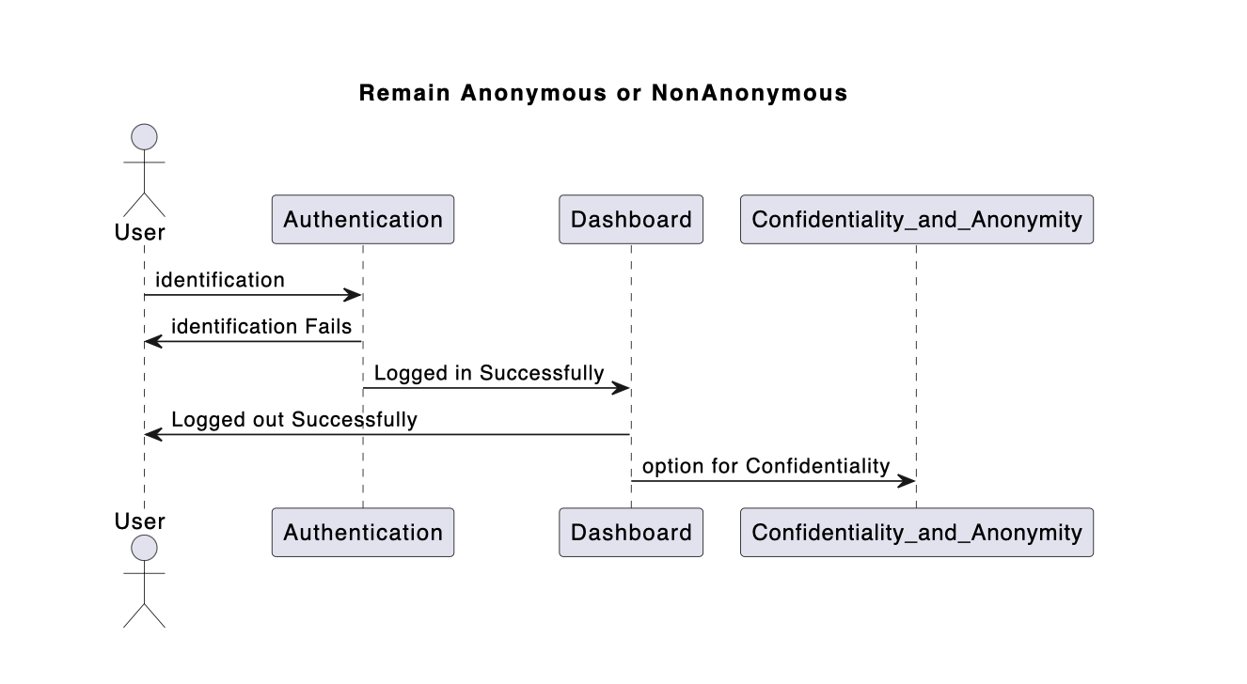

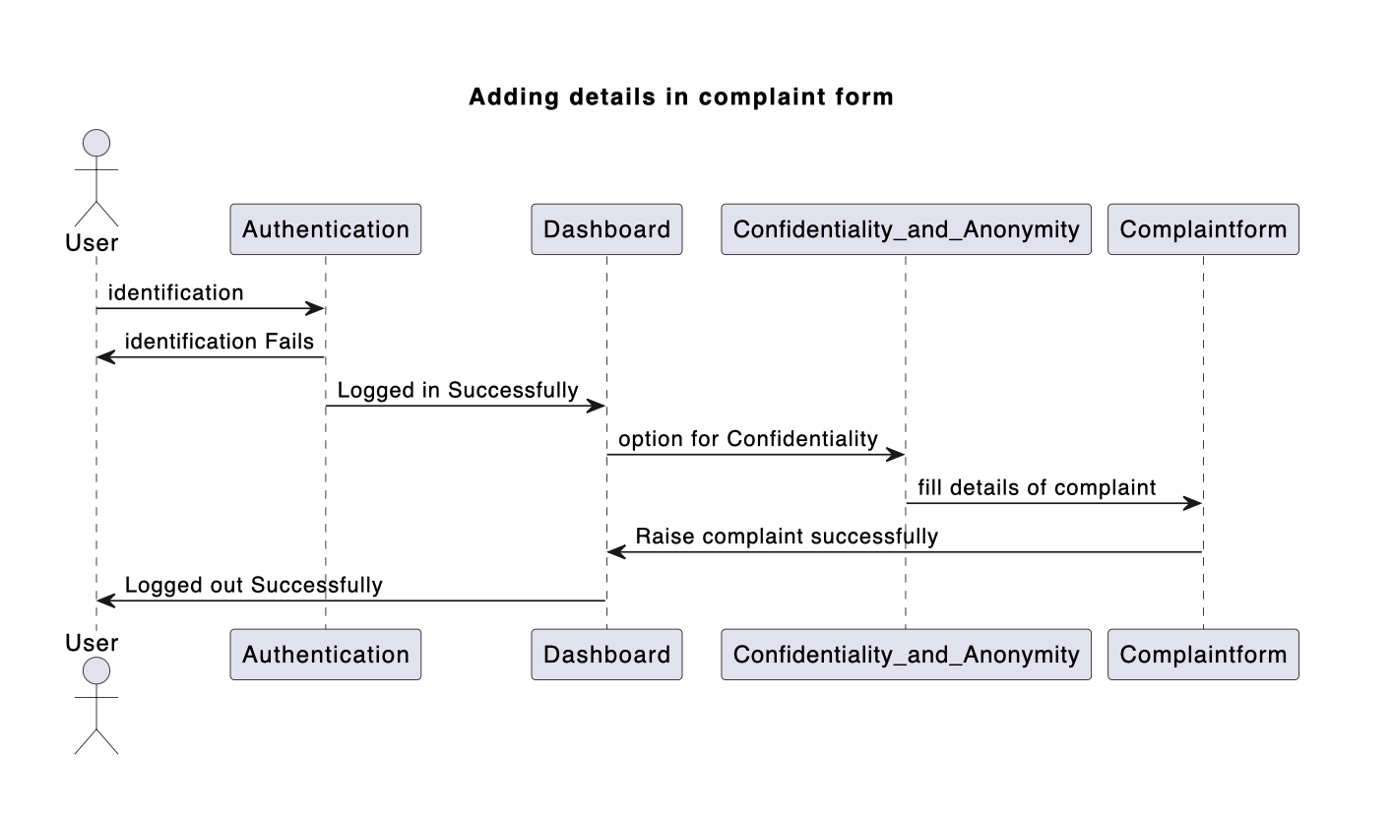

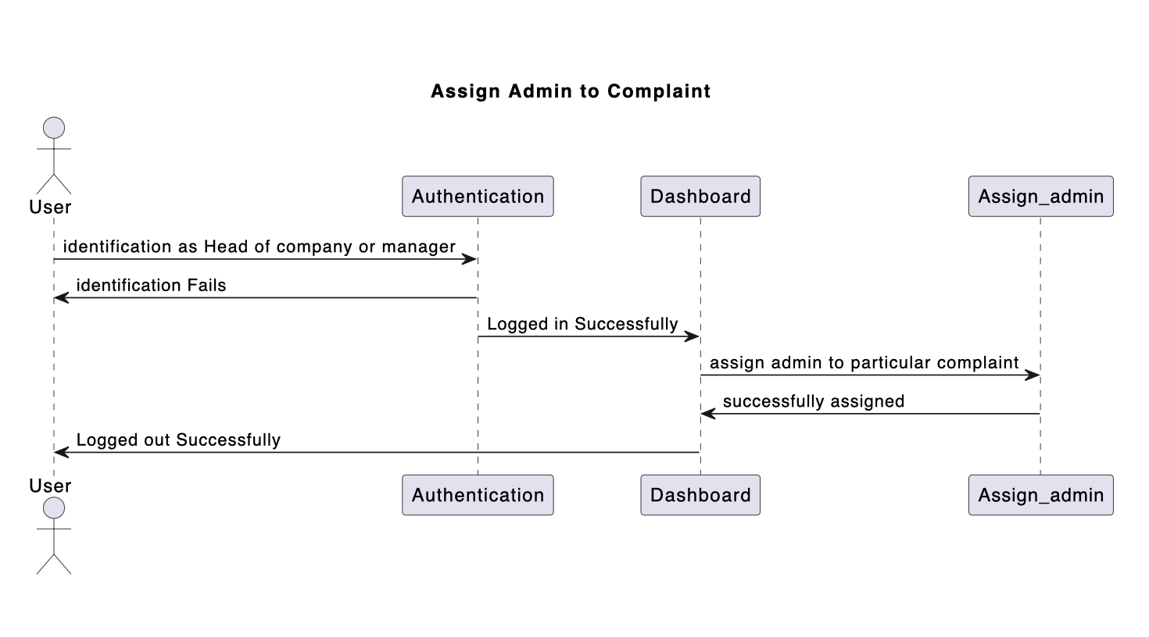

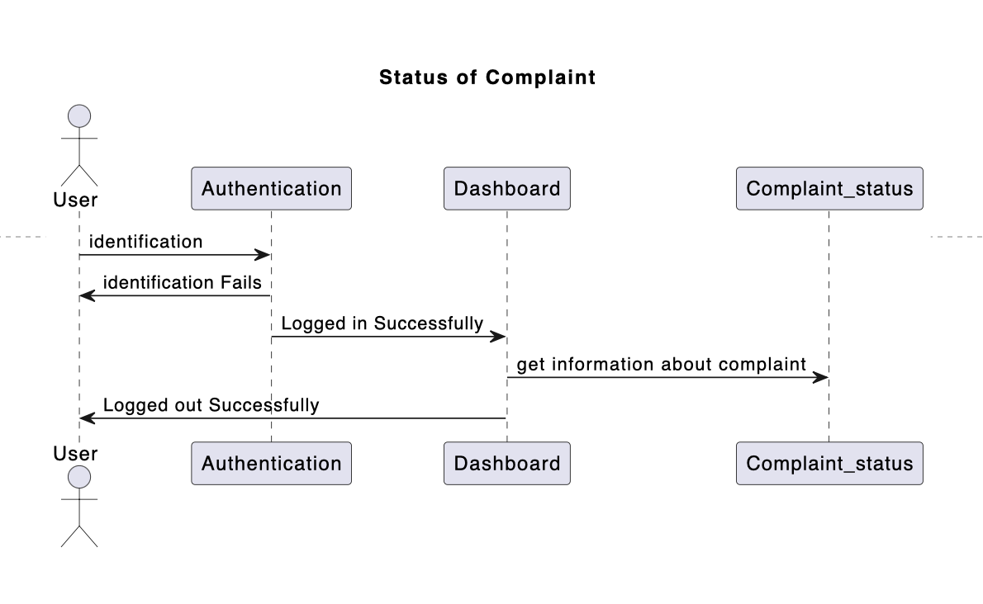

# **Design Rationale**

**1) Anonymous Reporting with Escalation Levels:**

* **Purpose- T**o allow anonymous reporting stems from the understanding that individuals might fear retaliation or repercussions for reporting complaints openly.

* **Consideration 1**: Allow users to submit complaints anonymously to encourage reporting without fear of retaliation, promoting transparency and trust within the organization.
* **Rejected Solutions**: One alternative considered was to require users to disclose their identities. However, this approach could deter individuals from reporting due to concerns about confidentiality and potential backlash.

* **Alternatives Thought Of:** Implement a multi-level escalation system based on the severity of the issue, ensuring that critical complaints receive prompt attention from higher authorities.
* **Rationale Chosen for this approach:**

I) Anonymous reporting allows individuals to feel safe voicing concerns, encouraging participation and capturing a wider range of experiences.

II) Escalation levels ensure appropriate action is taken based on severity, with anonymity potentially lifted only at higher levels and with user consent.

* **Strengths:** Anonymity encourages transparency and increases the likelihood of receiving honest feedback from individuals who may otherwise remain silent.
* **Deficiencies:** This also makes it challenging to follow up or gather additional information for certain cases.

**2) Real Time Case Updates:**

* **Purpose-** Providing real-time updates on case statuses enhances transparency and keeps complainants informed throughout the resolution process.

* **Consideration 1**: Keep complainants informed throughout the resolution process, fostering transparency and building trust in the system.
* **Rejected Solutions**: An alternative considered was to provide periodic updates at set intervals. However, this approach could lead to complaints feeling neglected or overlooked, resulting in decreased confidence in the system.
* **Alternatives Thought Of:** Implement a secure and efficient notification system that updates complainants in real-time without compromising anonymity or sensitive information.
* **Rationale Chosen for this approach:**

I) Real-time updates keep complainants informed and invested in the process, fostering trust and transparency.

II) This can be achieved through a secure notification system within the platform.

* **Strengths:** Real-time updates demonstrate the organization's commitment to addressing concerns promptly and efficiently. It empowers complainants by keeping them engaged and informed, ultimately enhancing their overall experience.
* **Deficiencies:** Implementing real-time updates may require significant resources and infrastructure to ensure seamless communication and timely responses.

**3) AI- DRIVEN Trend Analysis:**

* **Purpose-** Leveraging AI for trend analysis enables organizations to identify patterns and systemic issues within complaint data, facilitating proactive interventions to improve DEI efforts continuously.

* **Consideration 1**: Implement robust data anonymization and privacy measures to ensure that sensitive information is not compromised during the analysis process.
* **Rejected Solutions**: Manual analysis of complaint data was considered as an alternative. However, this approach is time-consuming, prone to human error, and may not effectively capture complex patterns or trends.
* **Alternatives Thought Of:** Utilize AI and machine learning techniques to analyze complaint data and identify patterns or systemic issues related to DEI within the organization.
* **Rationale Chosen for this approach:**

I) AI analysis can detect recurring themes and identify areas where systemic issues may exist.

II) This allows for proactive measures to address the root causes of discrimination or bias.

* **Strengths:** AI-driven analysis offers speed, accuracy, and scalability, enabling organizations to efficiently identify emerging issues and implement targeted solutions.
* **Deficiencies:** AI-driven analysis may require ongoing refinement and fine-tuning to ensure accurate results.

**4) Secure Data Encryption:**

* **Purpose-** Prioritizing secure data encryption is essential for protecting user privacy and maintaining confidentiality throughout the complaint resolution process.

* **Consideration-1**: Implement industry-standard data encryption techniques to protect sensitive information shared during the complaint resolution process.
* **Rejected Solutions**: Storing data without encryption was considered, but it posed significant risks in terms of data security and compliance with privacy regulations.
* **Alternatives Thought Of:** Ensure that encryption measures do not hinder the usability or performance of the platform, maintaining a seamless user experience.

* **Rationale Chosen for this approach:**

I) Robust data encryption safeguards user privacy and builds trust within the platform.

II) It demonstrates the organization's commitment to protecting sensitive information.

* **Strengths:** Robust data encryption measures enhance trust and credibility in the platform, fostering a positive user experience.
* **Deficiencies:** Implementing strong encryption measures may introduce complexities in data management and access controls.

**5) TECH STACK WE USED**: The decision to utilize a web-based platform with React as the front-end framework and Firebase as the back-end database was driven by the need for flexibility, scalability, and real-time updates. React's component-based architecture enables rapid development and seamless integration of features, making it well-suited for dynamic user interfaces. Firebase's real-time database capabilities align with the requirement for immediate updates and notifications, ensuring timely escalation and resolution of complaints.

* **Rejected Solutions**: Alternatives such as Angular or Vue.js were considered for front-end development. However, react was chosen due to its large developer community, extensive ecosystem of libraries and components, and compatibility with Firebase. Other backend solutions like MongoDB or SQL databases were also evaluated, but Firebase's real-time syncing and authentication features were deemed essential for maintaining data integrity and security.
* **Strengths**: Leveraging React and Firebase offers a modern, scalable, and cost-effective solution for building a responsive and interactive platform. It enables seamless integration of anonymous reporting features with real-time updates and escalation workflows, enhancing user experience and operational efficiency.
* **Deficiencies**: While React and Firebase provide numerous advantages, there may be a learning curve for us unfamiliar with these technologies. Additionally, Firebase's pricing model based on usage requires careful monitoring and optimization to manage costs effectively.

Therefore, Throughout the design process, it was crucial to maintain a balance between user privacy, data security, and usability. The rationale behind each design decision was to consider the potential trade-offs and strive to create a platform that is both secure and user-friendly, fostering trust and encouraging active participation in the DEI complaint resolution process.