**Software Requirements Specification (SRS) Document**

|  |  |
| --- | --- |
|  | Resolve  Team: 26  Gopendra Singh, Sujal Keshri, Kevin Thakkar, Neel Amrutia |

# Brief problem statement

The current workplace faces challenges in communication and efficient resolution of complaints. Employees encounter difficulties in expressing concerns due to a lack of a dedicated platform, compromising privacy. The absence of real-time updates and a structured resolution process further delays conflict resolution. Additionally, the lack of an anonymous reporting option hinders candid feedback, impacting the creation of a positive and inclusive work environment. There is a need for a cutting-edge Employee Platform to address these issues by improving communication, ensuring privacy, streamlining conflict resolution, and encouraging open feedback.

# System requirements

1. Technology Stack.

* **React**: For the development of the frontend user interface, ensuring a dynamic and responsive experience.
* **Firebase**: Firebase provides real-time database, authentication, and cloud storage services, complementing React's frontend development with seamless data management, user authentication, and file storage capabilities.
* **Tailwind CSS**: Tailwind CSS is used for styling the frontend components of the application. Its utility-first approach allows for rapid development and customization of UI elements by applying pre-defined classes directly to HTML elements, enabling a more streamlined and efficient styling process.
* **Material-UI**: For several inbuilt UI components and basically to improve user experience in terms of frontend of the website.

1. Data Encryption:

* Integrate ‘crypto-js’ library in React to handle data encryption and decryption.
* Use encryption algorithms such as DES for securing sensitive data during transmission and storage.

1. AI/ML(Future scope):

* AI algorithms for analyzing and predicting patterns in workplace complaints.
* Natural Language Processing (NLP) for sentiment analysis in employee communications.
* Machine learning for continuous improvement in issue resolution strategies.

# Users Profile

1. Employees:

* Role: End-users, employees across various departments.
* Responsibilities: Submit complaints, provide feedback, and seek conflict resolution.
* Computer Familiarity: Varied, from basic to intermediate.
* Training/Support: Provide user-friendly guides for submitting complaints and providing feedback.

1. Admins:

* Role: System Administrators for conflict resolution.
* Responsibilities: Manage and resolve complaints, ensure privacy.
* Computer Familiarity: Proficient in the Employee Platform tools.
* Training/Support: Specialized training for conflict resolution features.

1. HR Manager:

* Role: Oversight of the Employee Platform.
* Responsibilities: Monitor complaint resolution, ensure the system's effectiveness.
* Computer Familiarity: Basic to intermediate.
* Training/Support: General training on monitoring and system oversight.

# Feature requirements (described using use cases)

| **No.** | **User Case Name** | **Description** | **Release** |
| --- | --- | --- | --- |
|  | User Authentication | The users authenticate themselves through phone number and otp. On successful login, the page redirects to the dashboard. | R1 |
|  | Confidentiality and Anonymity | The user is provided with the feature to either remain anonymous or non-anonymous. If the non-anonymous option is selected then the users need to provide name, email and department. | R1 |
|  | Adding details in complaint form | A dedicated complaint form is filled by the user describing the issue and providing all the necessary details asked in the complaint form. | R1 |
|  | Case Manager | HR can access the case manager, featuring a list of all cases filed within the organization. By clicking on a specific case from the list, the HR can view all case details and take actions, such as assigning an admin to the case. | R1 |
|  | Assigning admin | The HR assigns admin for a case by looking at availability and other parameters like case type, department and location. | R1 |
|  | Assigning priority | The HR assigns priority to a case as (HIGH, MEDIUM, LOW) based on its severity level. | R1 |
|  | Complaint tracking | The user can track the current status of the complaint resolution process, which includes graphs depicting escalation levels and actions taken up to that point. | R1 |
|  | Complaint status updation | The assigned admin of the case can update the status of the complaint and report the actions taken up to that point. | R1 |
|  | Analytics and Reporting | This outlines the functionalities related to analytics and reporting within the organization, offering data-driven insights into common workplace concerns and providing customizable reports for management analysis. Admins view analytics for their assigned cases, while HR sees analytics for all organization-wide cases. | R2 |
|  | Direct Messaging | Employees, HR, and assigned admins can engage in direct messaging regarding the case, facilitating direct communication among them. | R2 |
|  | Helpdesk | It provides the help module to employees for using the platform. It provides information about the escalation levels based on severity of the case. | R2 |
|  | Platform Feedback | The Employee can give anonymous or non-anonymous feedback about the platform experience. The HR can see these feedbacks. | R2 |

**Use case diagram**

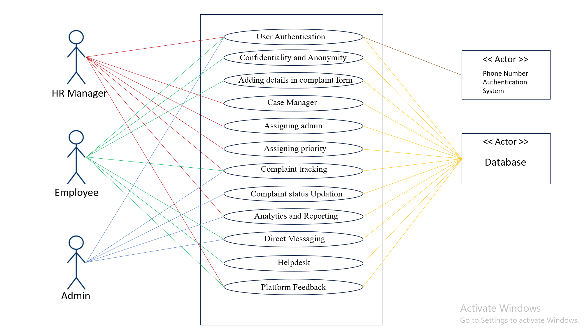

**Use case description**

|  |  |
| --- | --- |
| **Use Case Number:** | UC-01 |
| **Use Case Name:** | User Authentication |
| **Overview:** | The users authenticate themselves through phone number and otp. On successful login, the page redirects to the dashboard. |
| **Actors:** | Employee, Admin, HR Manager, Database |
| **Pre condition:** | No pre condition only fill mobile number and fill right otp |
| **Flow:** | Main (success) Flow:   1. The user enters a phone number. 2. OTP is sent to the given phone number. 3. User enters the OTP. 4. Login successful. |
|  | Alternate Flows:   1. If authentication fails, user is asked to fill in the details again. |
| **Post Condition:** | Number should be in database of company and user must be logged in to dashboard. |

|  |  |
| --- | --- |
| **Use Case Number:** | UC-02 |
| **Use Case Name:** | Confidentiality and Anonymity |
| **Overview:** | The user is provided with the feature to either remain anonymous or non-anonymous. If the non-anonymous option is selected then the users need to provide name, email and department. |
| **Actors:** | Employee, Database |
| **Pre condition:** | Employees must be authenticated before raising any complaint. |
| **Flow:** | Main (success) Flow:   1. The user is asked to choose to remain anonymous or non-anonymous. 2. If non-anonymous is chosen, the user is asked to enter name, email-id and department. Then the user needs to click on the next button. 3. If anonymous is chosen then the user just needs to click on the next button. |
|  | Alternate Flows:   1. If non-anonymous is chosen and required fields are not filled the page gets refreshed and the process starts again. |
| **Post Condition:** | The employee will be redirected to the complaint form page to fill the required details. |

|  |  |
| --- | --- |
| **Use Case Number:** | UC-03 |
| **Use Case Name:** | Adding details in complaint form |
| **Overview:** | A dedicated complaint form is filled by the user describing the issue and providing all the necessary details asked in the complaint form. |
| **Actors:** | Employee, Database |
| **Pre condition:** | Employees must be authenticated and have chosen to file a complaint by filling the choice of being anonymous or non-anonymous. |
| **Flow:** | Main (success) Flow:   1. The user fills all the details asked in the complaint form in their respective blocks. 2. The user hits the submit button. |
|  | Alternate Flows: No alternate flow.   1. If any mandatory field is left unfilled, the user is asked to fill that detail. |
| **Post Condition:** | The employee gets a case id and a confirmation that the case has been filed. |

|  |  |
| --- | --- |
| **Use Case Number:** | UC-04 |
| **Use Case Name:** | Case Manager |
| **Overview:** | HR can access the case manager, featuring a list of all cases filed within the organization. By clicking on a specific case from the list, the HR can view all case details and take actions, such as assigning an admin to the case. |
| **Actors:** | HR Manager, Database |
| **Pre condition:** | HR must be Authenticated and logged in to the dashboard. |
| **Flow:** | Main (success) Flow:   1. A page containing the list of all cases is displayed. 2. The HR can proceed with any case. |
|  | Alternate Flows: No alternate flow |
| **Post Condition:** | The HR will have a list of all filed cases and can opt to work further on any case. |

|  |  |
| --- | --- |
| **Use Case Number:** | UC-05 |
| **Use Case Name:** | Assigning admin |
| **Overview:** | The HR assigns admin for a case by looking at availability and other parameters like case type, department and location. |
| **Actors:** | HR Manager, Database |
| **Pre condition:** | Only HR can access this feature so HR must be authenticated and have chosen a case through the case manager. |
| **Flow:** | Main (success) Flow:   1. The HR chooses from a list of available admins and to assign it to the required case. 2. The HR hits the assign button to update the change. |
|  | Alternate Flows:   1. If no admin is chosen and the assign button is clicked, the HR is notified to choose an admin. |
| **Post Condition:** | Admin is assigned to that particular case. |

|  |  |
| --- | --- |
| **Use Case Number:** | UC-06 |
| **Use Case Name:** | Assigning priority |
| **Overview:** | The HR assigns priority to a case as (HIGH, MEDIUM, LOW) based on its severity level. |
| **Actors:** | HR Manager, Database |
| **Pre condition:** | Only HR can access this feature so HR must be authenticated and have chosen a case through the case manager. |
| **Flow:** | Main (success) Flow:   1. The HR chooses a priority (HIGH, MEDIUM, LOW). 2. The HR hits the submit button to update the change. |
|  | Alternate Flows:   1. If priority is not chosen and the submit button is clicked, the HR is notified to choose a priority. |
| **Post Condition:** | Priority is assigned to that particular case. |

|  |  |
| --- | --- |
| **Use Case Number:** | UC-07 |
| **Use Case Name:** | Complaint tracking |
| **Overview:** | The user can track the current status of the complaint resolution process, which includes graphs depicting escalation levels and actions taken up to that point. |
| **Actors:** | Employee, Admin, HR Manager, Database |
| **Pre condition:** | The employee must be authenticated and logged in to the dashboard. |
| **Flow:** | Main (success) Flow:   1. The user can see the progress of the complaint and can take action based on progress. |
|  | Alternate Flows: No alternate flow |
| **Post Condition:** | The employee will be redirected to a page containing the current status of the case. |

|  |  |
| --- | --- |
| **Use Case Number:** | UC-08 |
| **Use Case Name:** | Complaint status updation |
| **Overview:** | The assigned admin of the case can update the status of the complaint and report the actions taken up to that point. |
| **Actors:** | Admin, Database |
| **Pre condition:** | Admin must be authenticated and have chosen to update a case through the dashboard. |
| **Flow:** | Main (success) Flow:   1. Admin updates the status of the complaint. |
|  | Alternate Flows: No alternate flow |
| **Post Condition:** | Status of the case is updated. |

|  |  |
| --- | --- |
| **Use Case Number:** | UC-09 |
| **Use Case Name:** | Analytics and Reporting |
| **Overview:** | This outlines the functionalities related to analytics and reporting within the organization, offering data-driven insights into common workplace concerns and providing customizable reports for management analysis. Admins view analytics for their assigned cases, while HR sees analytics for all organization-wide cases. |
| **Actors:** | Admin, HR Manager, Database |
| **Pre condition:** | HR or Admin must be authenticated and have chosen the analytics and report section from the dashboard. |
| **Flow:** | Main (success) Flow:   1. Admin and HR manager can see the data of complaint and can take inferences from it. |
|  | Alternate Flows: No alternate flow |
| **Post Condition:** | The user (HR or Admin) is redirected to a page containing the analytics and report of all cases of their concerns. |

|  |  |
| --- | --- |
| **Use Case Number:** | UC-10 |
| **Use Case Name:** | Direct Messaging |
| **Overview:** | Employees, HR, and assigned admins can engage in direct messaging regarding the case, facilitating direct communication among them. |
| **Actors:** | Employee, Admin, Database |
| **Pre condition:** | HR, admin or employees must be authenticated and logged in to the dashboard and have chosen messaging option from there. |
| **Flow:** | Main (success) Flow :   1. Employees, HR, and assigned admins can share information through Messaging. |
|  | Alternate Flows: No alternate flow |
| **Post Condition:** | A messaging window opens. |

|  |  |
| --- | --- |
| **Use Case Number:** | UC-11 |
| **Use Case Name:** | Helpdesk |
| **Overview:** | It provides the help module to employees for using the platform. It provides information about the escalation levels based on severity of the case. |
| **Actors:** | Employee, Database |
| **Pre condition:** | no pre-condition |
| **Flow:** | Main (success) Flow: Employees can ask for help and the platform will provide a help module for a particular issue.   1. A page containing all information about the platform usage and the escalation process used will be displayed. |
|  | Alternate Flows: No alternate flow |
| **Post Condition:** | A Helpdesk page containing required information will be displayed. |

|  |  |
| --- | --- |
| **Use Case Number:** | UC-12 |
| **Use Case Name:** | Platform Feedback |
| **Overview:** | The Employee can give anonymous or non-anonymous feedback about the platform experience. The HR can see these feedbacks. |
| **Actors:** | Employee, HR, Database |
| **Pre condition:** | The employee must be authenticated. |
| **Flow:** | Main (success) Flow:   1. The user writes its experience about the platform on a text box displayed on the page. 2. The user hits the submit button. |
|  | Alternate Flows:   1. If the user tries to submit an empty text box, then the page is refreshed and the process starts again. |
| **Post Condition:** | The feedback given will be successfully saved to the database. |