Queue Implementation Using Java Collections
Study Notes by Dr. Amar Panchal | Career Credentials

1. Introduction to Queue
A Queue is a linear data structure that follows the FIFO (First In, First Out) principle.
The element inserted first is removed first. It works like a queue of students waiting for their turn at the examination counter.
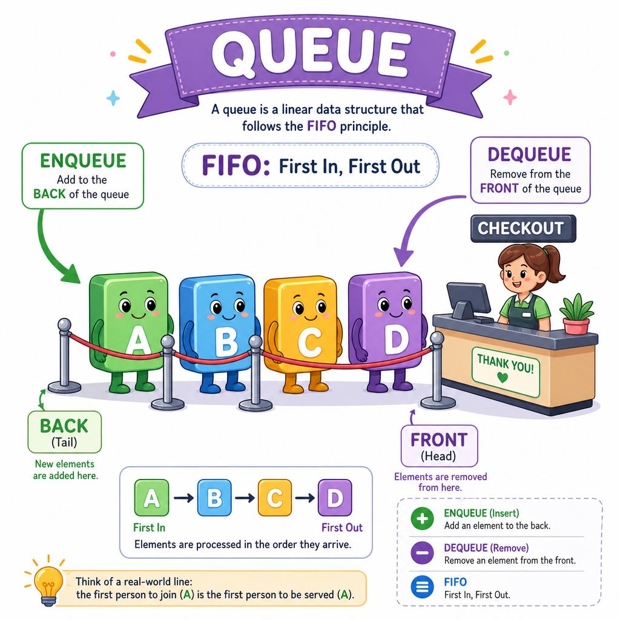
algodaily.com
Enqueue
Insert at the rear
Dequeue
Remove from the front

Example
Suppose we insert the elements 10, 20, 30 into a queue.
Front → Rear

10

20

30
After one dequeue operation:

20

30
The element 10 is removed because it entered the queue first.

2. Queue in Java Collections Framework
Java provides the Queue interface in the java.util package. It defines the standard operations for queue-based data structures.
Common implementations include:
- LinkedList
- ArrayDeque
- PriorityQueue
For ordinary FIFO queue problems, ArrayDeque is generally a good default choice. LinkedList is also useful for teaching queue implementation through Java Collections.

Basic syntax
import java.util.Queue;
import java.util.LinkedList;

Queue<Integer> queue = new LinkedList<>();
Explanation:
- Queue<Integer> — declares a queue that stores integer values.
- new LinkedList<>() — creates the queue implementation.
- Integer — specifies the type of elements stored in the queue.
You can also store String, Double, or custom objects such as Student.

3. Important Queue Methods
Method | Purpose | Example
add(e) | Inserts an element; throws an exception if insertion fails | queue.add(10);
offer(e) | Inserts an element; returns false if insertion fails | queue.offer(20);
remove() | Removes and returns the front element; throws an exception if empty | queue.remove();
poll() | Removes and returns the front element; returns null if empty | queue.poll();
element() | Returns the front element without removing it; throws an exception if empty | queue.element();
peek() | Returns the front element without removing it; returns null if empty | queue.peek();
size() | Returns the number of elements | queue.size();
isEmpty() | Checks whether the queue is empty | queue.isEmpty();
contains(e) | Checks whether an element exists | queue.contains(20);
clear() | Removes all elements | queue.clear();
Important distinction: Prefer offer(), poll() and peek() when you want to handle insertion failure or an empty queue without exceptions.
Note that Queue does not provide an indexed get() method. It is designed around queue operations, not random access.

4. Complete Example 1: Basic Queue Operations
import java.util.Queue;
import java.util.LinkedList;

public class QueueExample {
public static void main(String[] args) {

Queue<Integer> queue = new LinkedList<>();

// Insertion
queue.offer(10);
queue.offer(20);
queue.offer(30);

System.out.println("Queue: " + queue);

// View front element
System.out.println("Front: " + queue.peek());

// Remove front element
System.out.println("Removed: " + queue.poll());

// Display updated queue
System.out.println("Queue: " + queue);

// Size and empty check
System.out.println("Size: " + queue.size());
System.out.println("Is Empty: " + queue.isEmpty());
}
}

Output
Queue: [10, 20, 30]
Front: 10
Removed: 10
Queue: [20, 30]
Size: 2
Is Empty: false

Logic breakdown
- Three elements are inserted using offer().
- peek() reads 10 without removing it.
- poll() removes 10.
- The remaining elements are 20 and 30.
- size() returns 2.
Remember: peek() looks; poll() takes.

5. Complete Example 2: Process All Queue Elements
This example demonstrates how a queue can process elements until it becomes empty.
import java.util.Queue;
import java.util.LinkedList;

public class ProcessQueue {
public static void main(String[] args) {

Queue<Integer> queue = new LinkedList<>();

queue.offer(100);
queue.offer(200);
queue.offer(300);
queue.offer(400);

while (!queue.isEmpty()) {
int value = queue.poll();
System.out.println("Processing: " + value);
}

System.out.println("Queue is empty: " + queue.isEmpty());
}
}

Output
Processing: 100
Processing: 200
Processing: 300
Processing: 400
Queue is empty: true
Where is this useful?
- Processing customer requests
- Managing print jobs
- Handling tasks in order
- Breadth-First Search (BFS) in graphs and trees
- Processing messages in a system

6. Complete Example 3: Queue Using ArrayDeque
Java's ArrayDeque is an alternative implementation of the Queue interface. It is often preferred for standard FIFO queues because it avoids the per-node overhead of a linked list.
import java.util.Queue;
import java.util.ArrayDeque;

public class ArrayDequeQueue {
public static void main(String[] args) {

Queue<String> queue = new ArrayDeque<>();

queue.offer("Rahul");
queue.offer("Priya");
queue.offer("Amit");

System.out.println(queue);

System.out.println("Next person: " + queue.peek());

System.out.println("Served: " + queue.poll());

System.out.println("Waiting: " + queue);
}
}
Output:
[Rahul, Priya, Amit]
Next person: Rahul
Served: Rahul
Waiting: [Priya, Amit]
Important: ArrayDeque does not permit null elements. LinkedList permits them, although inserting null into a queue can make empty-queue results from peek() and poll() ambiguous.

7. Queue vs Stack
Feature | Queue | Stack
Principle | FIFO | LIFO
Insertion | Rear | Top
Removal | Front | Top
Common insertion method | offer() | push()
Common removal method | poll() | pop()
Read next element | peek() | peek()
Typical example | Ticket counter | Undo operation

8. Time Complexity
For a typical queue implementation using LinkedList or ArrayDeque:
Operation | Typical time complexity
offer() | $O(1)$
poll() | $O(1)$
peek() | $O(1)$
isEmpty() | $O(1)$
size() | $O(1)$
contains() | $O(n)$
clear() | $O(n)$
These are typical costs for the specified implementations. PriorityQueue has different insertion and removal costs because it maintains heap order.

9. Common Mistakes Students Should Avoid
- Calling remove() on an empty queue without checking it first.
- Confusing peek() with poll().
- Assuming a queue supports get(index).
- Assuming every queue implementation preserves FIFO order. PriorityQueue, for example, removes elements according to priority rather than insertion order.
- Using Stack when a queue is required.
- Forgetting that Queue is an interface and cannot be instantiated directly.
Incorrect:
Queue<Integer> q = new Queue<>(); // Compilation error
Correct:
Queue<Integer> q = new LinkedList<>();
Or:
Queue<Integer> q = new ArrayDeque<>();

Java Collections: PriorityQueue Class
Notes by Dr. Amar Panchal | Career Credentials

1. What is a PriorityQueue?
A PriorityQueue is a class in Java Collections Framework that stores elements according to their priority.
Unlike a normal queue, which follows FIFO (First In, First Out), a PriorityQueue processes elements according to their priority ordering.
By default, Java's PriorityQueue arranges elements in natural ascending order. Therefore, the smallest element is removed first for numbers.

Example: Insert elements in any order

40

10

30

20
Insertion order: 40, 10, 30, 20
Removal order

10

20

30

40
Elements are removed in ascending order.
Important: A PriorityQueue is generally implemented using a heap. Printing the queue does not necessarily display all elements in sorted order; the head element is the one with the highest priority according to the comparator.

2. Declaration and syntax
import java.util.PriorityQueue;

PriorityQueue<Integer> pq = new PriorityQueue<>();
Explanation:
- PriorityQueue is the collection class.
- Integer specifies the type of elements.
- new PriorityQueue<>() creates a min-priority queue by default.

3. Important methods
Method | Purpose | Example
offer(e) | Insert an element | pq.offer(30);
add(e) | Insert an element | pq.add(20);
peek() | Read the highest-priority element without removing it | pq.peek();
poll() | Remove and return the highest-priority element | pq.poll();
remove() | Remove the head; throws an exception if empty | pq.remove();
isEmpty() | Check whether the queue is empty | pq.isEmpty();
size() | Return the number of elements | pq.size();
contains(e) | Check whether an element exists | pq.contains(20);
clear() | Remove all elements | pq.clear();

4. Complete example: Min-Priority Queue
import java.util.PriorityQueue;

public class Main {
public static void main(String[] args) {

PriorityQueue<Integer> pq = new PriorityQueue<>();

// Insertion
pq.offer(40);
pq.offer(10);
pq.offer(30);
pq.offer(20);

// Read the highest-priority element
System.out.println("Top element: " + pq.peek());

// Remove elements according to priority
while (!pq.isEmpty()) {
System.out.println(pq.poll());
}
}
}
Output:
Top element: 10
10
20
30
40

How does it work?
- Insert all four elements.
- peek() returns 10, the smallest element.
- poll() removes 10.
- The next smallest element becomes the head.
- Continue until the queue is empty.

5. Max-Priority Queue
What if the largest element should be removed first?
Use a reverse-order comparator.
import java.util.PriorityQueue;
import java.util.Collections;

public class Main {
public static void main(String[] args) {

PriorityQueue<Integer> pq =
new PriorityQueue<>(Collections.reverseOrder());

pq.offer(40);
pq.offer(10);
pq.offer(30);
pq.offer(20);

while (!pq.isEmpty()) {
System.out.println(pq.poll());
}
}
}
Output:
40
30
20
10
Here, the largest element has the highest priority.

6. Min-Heap vs Max-Heap
Feature | Min-Heap | Max-Heap
Default in Java | Yes | No
First element removed | Smallest | Largest
Construction | new PriorityQueue<>() | new PriorityQueue<>(Collections.reverseOrder())
Typical use | Lowest-cost task | Highest-score task

7. Interactive example: Try a PriorityQueue
Insert numbers and remove them one by one to see how priority ordering works.

PriorityQueue simulator
This illustrates the removal order. It is not a Java runtime.
Min-HeapMax-Heap
Enter an integer
Offer
Elements to be removed first to last

10
Head

20

30

40
PollClear
Current size: 4

8. PriorityQueue of strings
Strings are ordered lexicographically by default.
import java.util.PriorityQueue;

public class Main {
public static void main(String[] args) {

PriorityQueue<String> pq = new PriorityQueue<>();

pq.offer("Mango");
pq.offer("Apple");
pq.offer("Banana");

while (!pq.isEmpty()) {
System.out.println(pq.poll());
}
}
}
Output:
Apple
Banana
Mango

