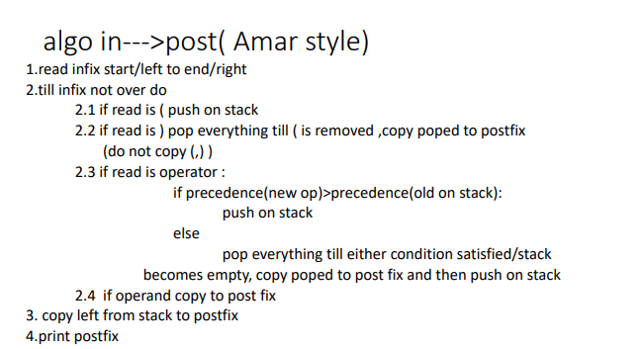
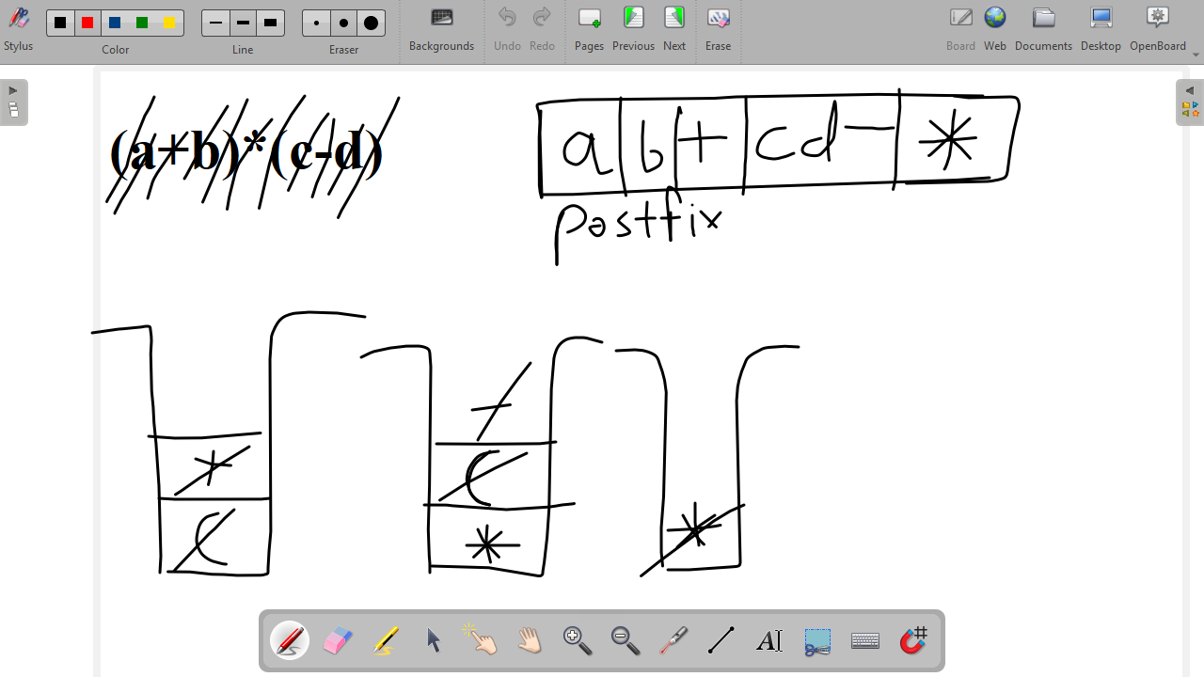
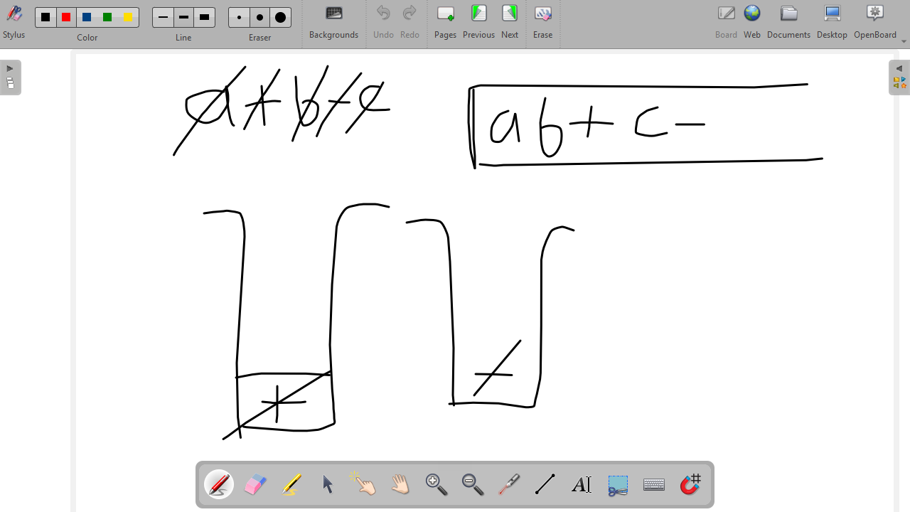
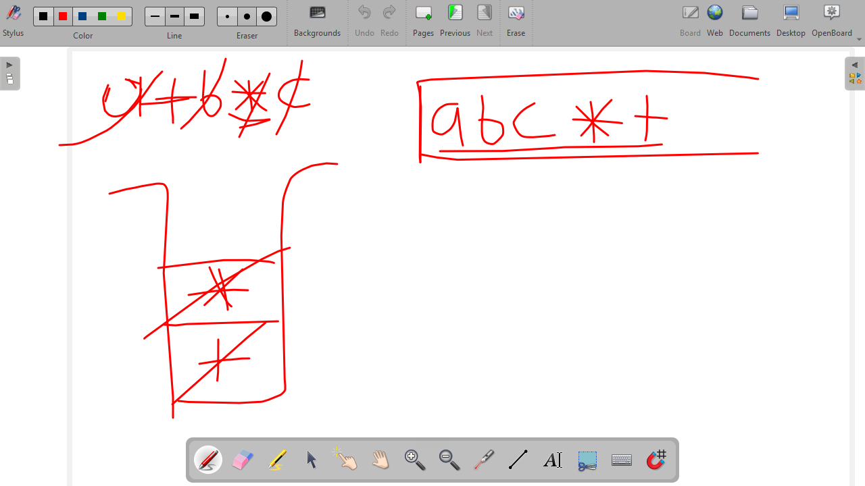
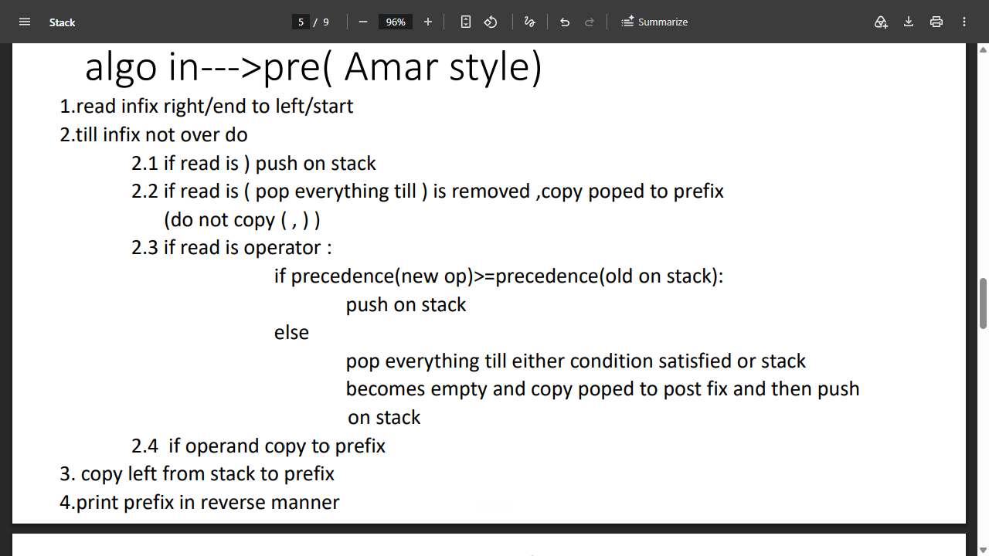
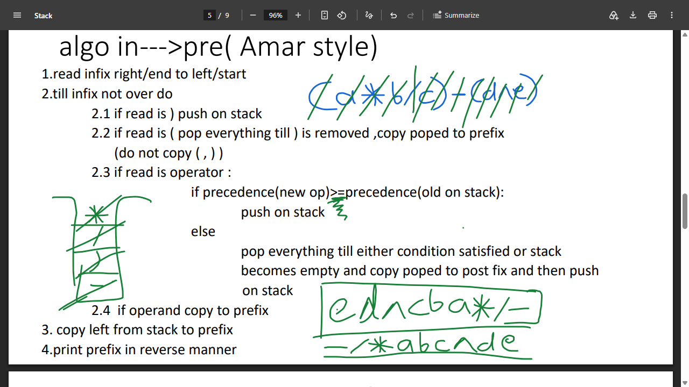
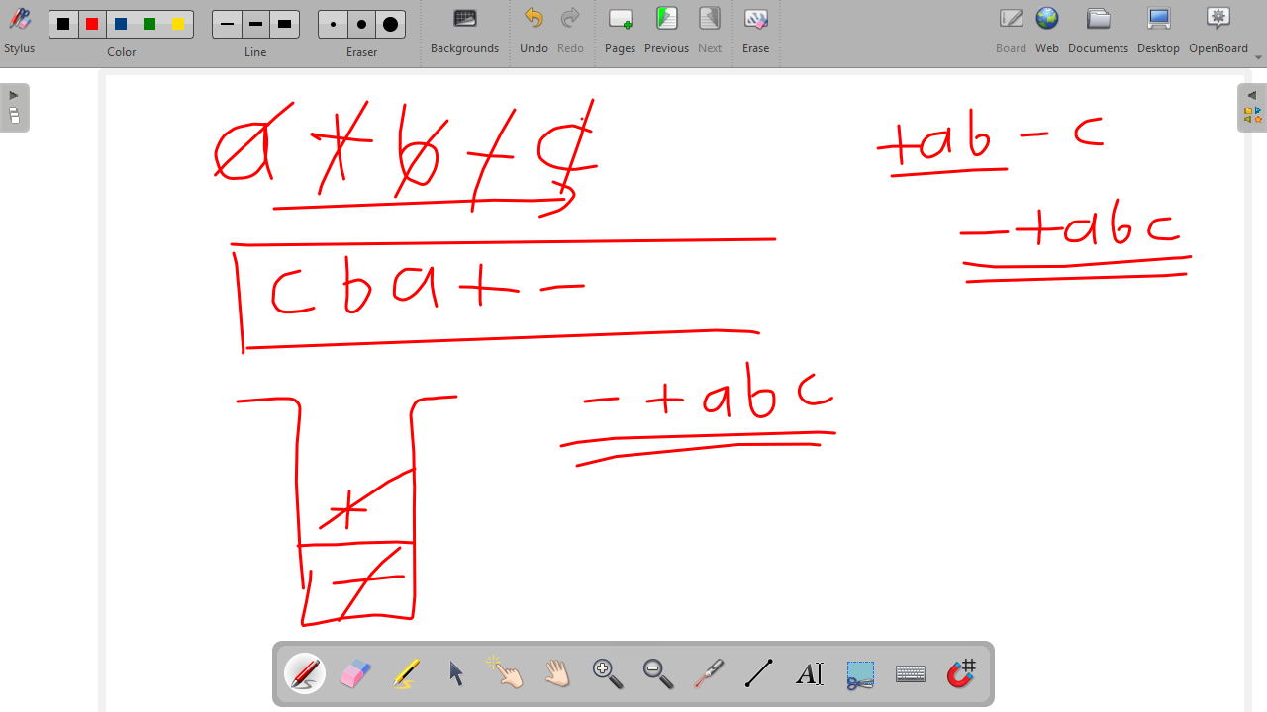
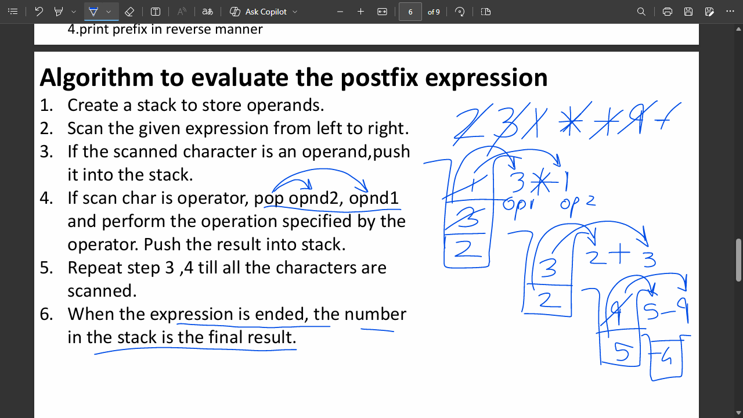
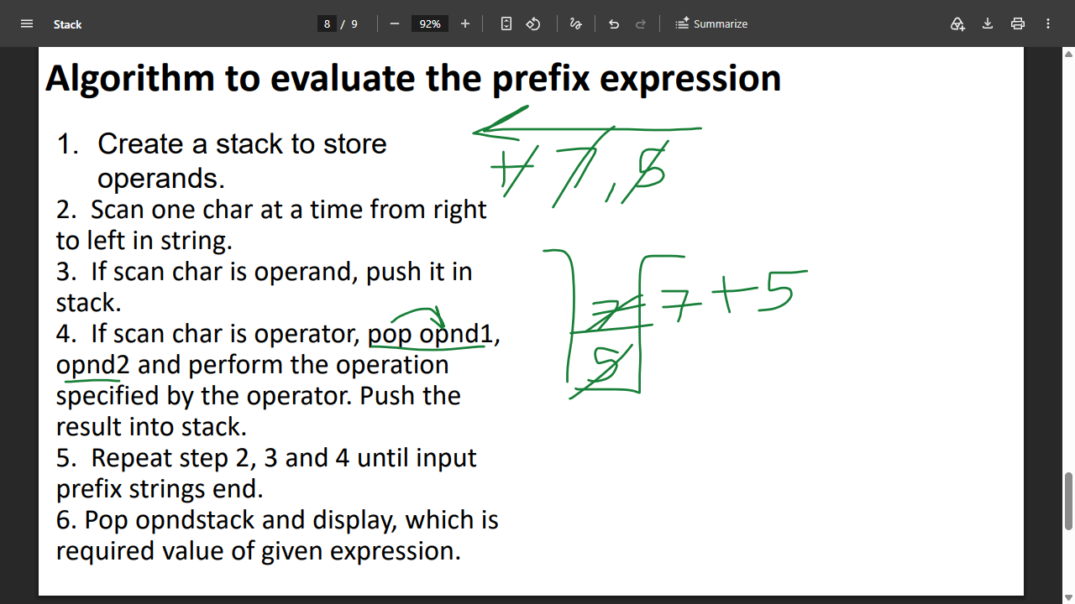
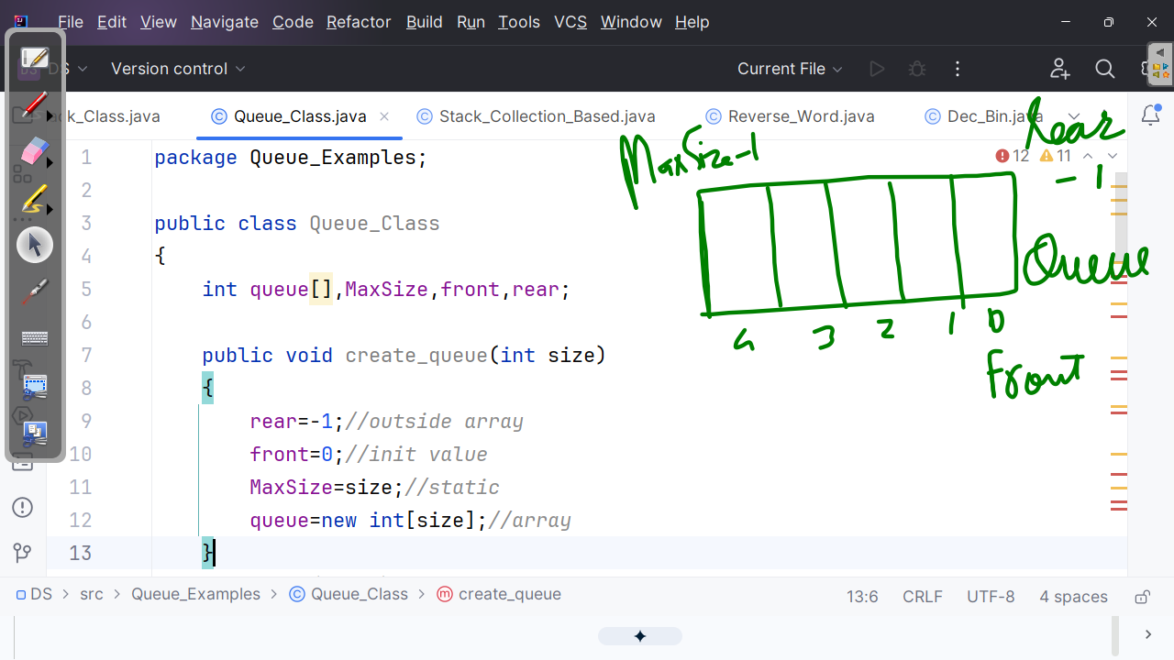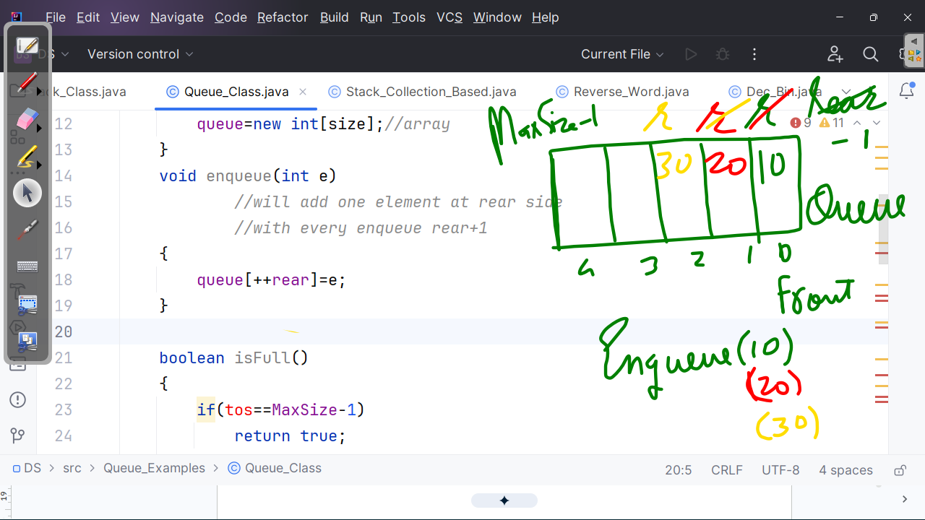
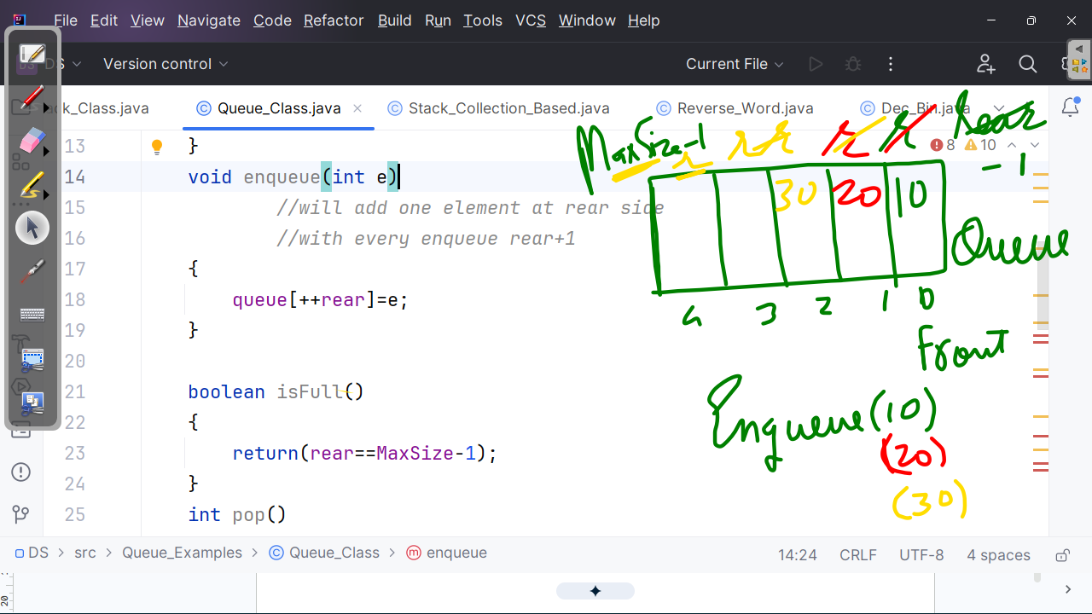
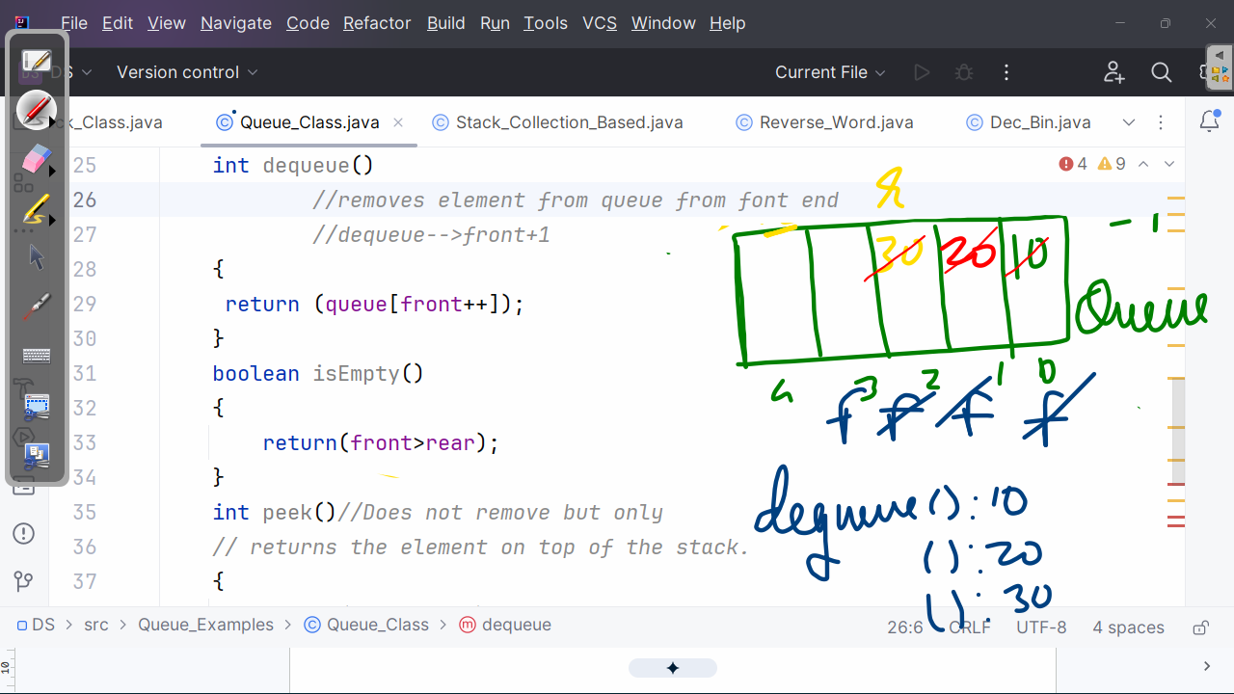
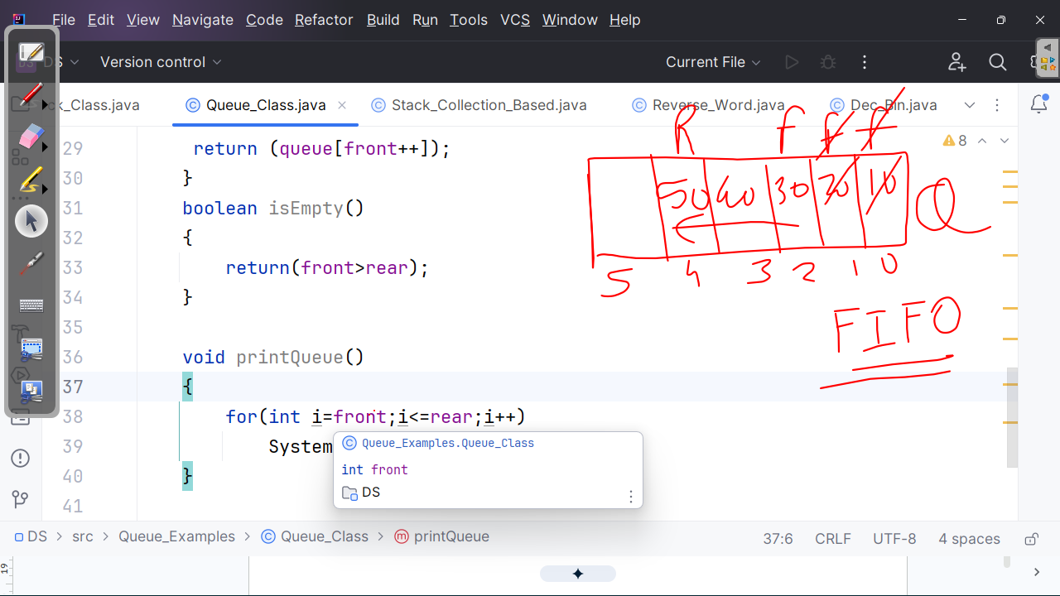
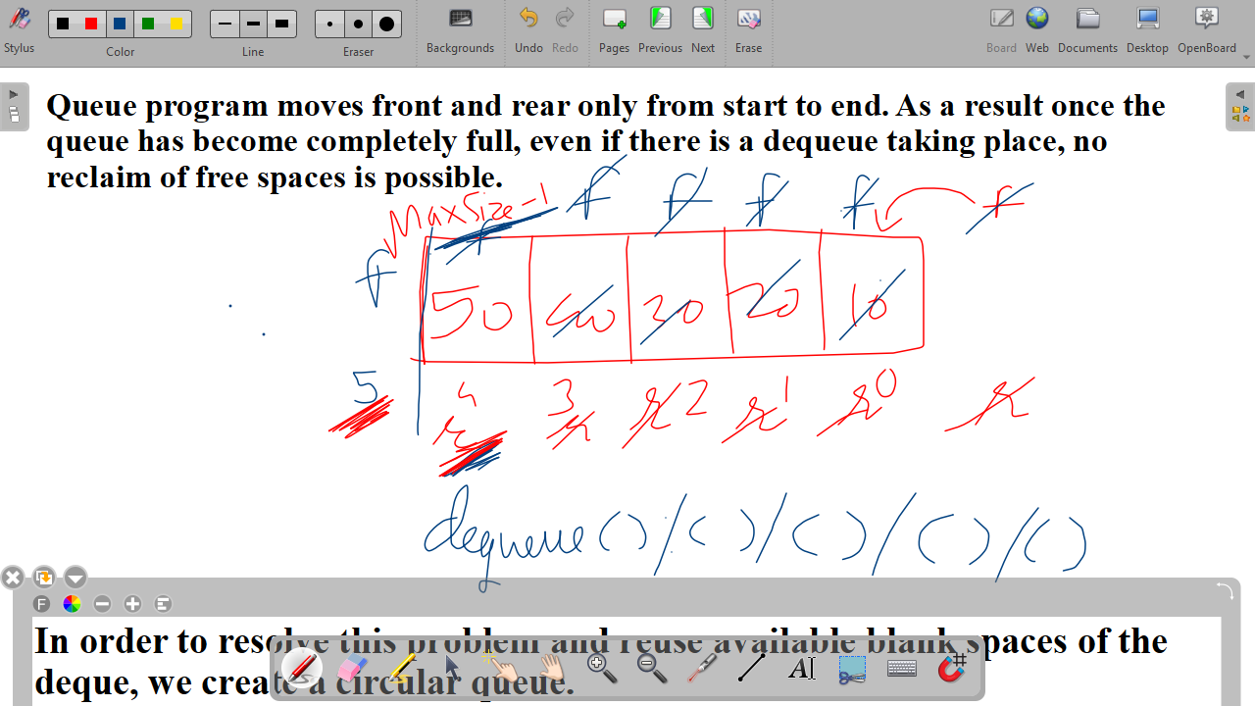

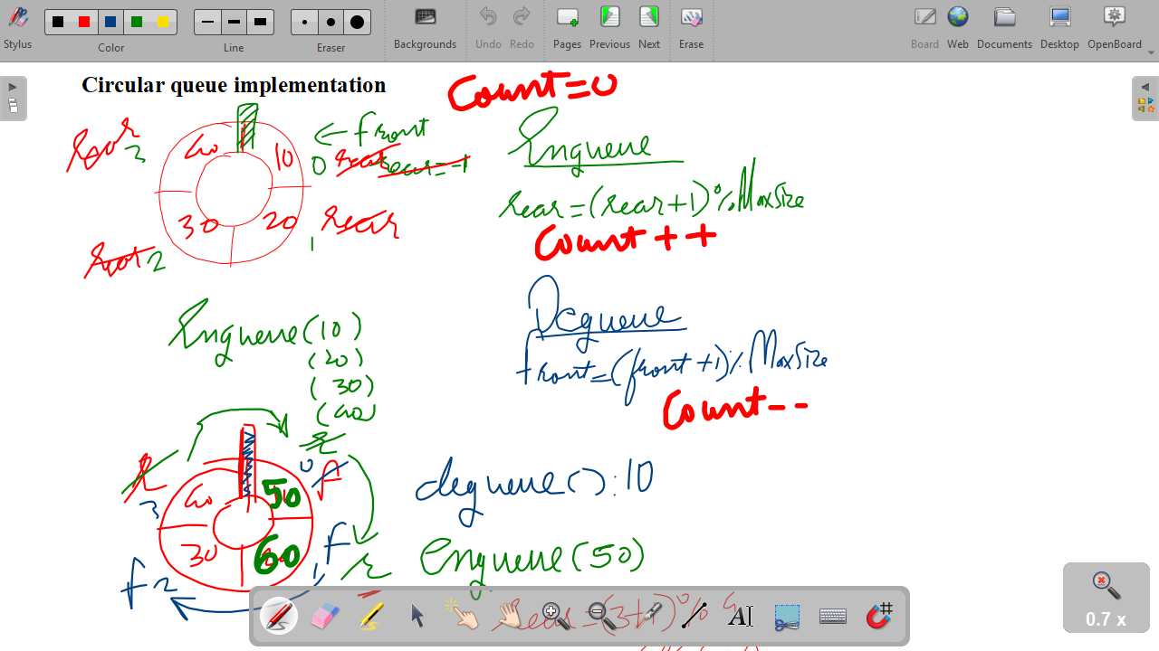
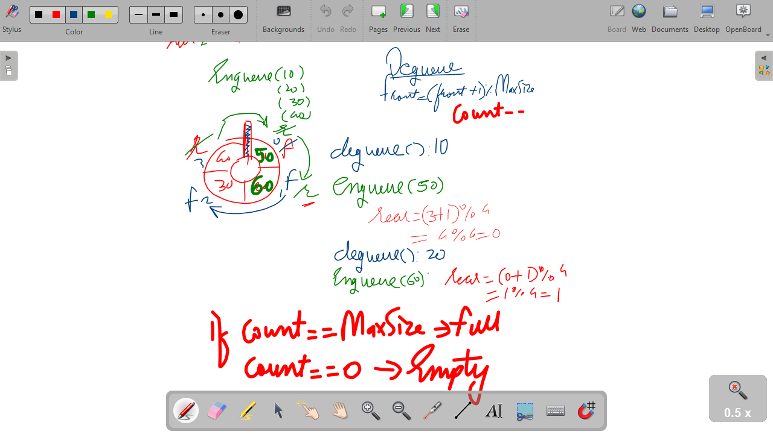
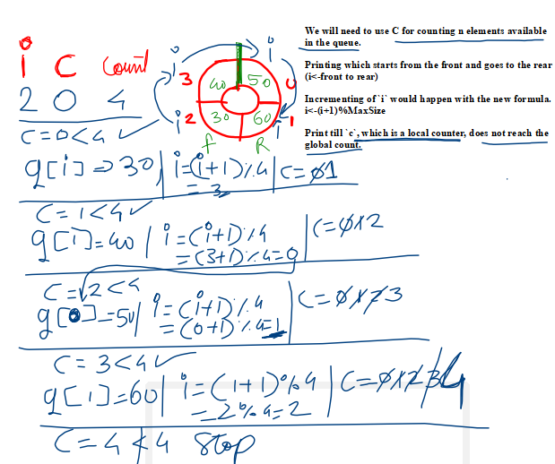

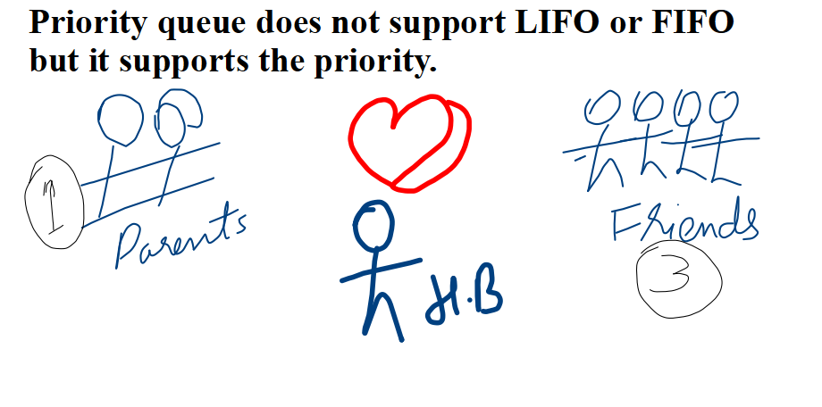
A priority queue can be an ascending priority queue or a descending priority queue.
In an ascending priority queue the highest weightage is given to the lowest priority, also known as a ranking system.

In a descending priority queue the highest weightage is given to the highest priority, also known as the total system.

example:enqueue: 55,11,88,2,9,15,6
Ascending :dequeue:2,6,9,11,15,55,88
Descending :dequeue:88,55,15,11,9,6,2

Priority queue is used most in a preemptive mechanism with RTOS, also known as priority-based preemptive scheduling. (A higher-priority task can stop any lower-priority task in between so that the higher-priority task can be executed immediately. )

example:mobile:You're listening to music. Your friend calls up. Music stops and the ringtone will go on. You talk. You keep the phone down. The music restarts.

If one has to use a linear queue in order to implement a priority queue, which functions will you change: Enqueue or Dequeue or both?
yes no
If we modify DQ to act on a priority, there will be cavities in between Qs.

We will modify NQ such that after every NQ data is re-sorted so that the front always stores the element with the highest priority in either case.

In an ascending priority queue the front will have the minimum. In a descending priority queue the front will have the maximum.

