package Stack_Examples;

import java.util.Scanner;
import java.util.Stack;

public class Infix_To_Postfix {

static int precedence(char ch) {

if (ch == '+' || ch == '-')
return 1;

if (ch == '*' || ch == '/' || ch == '%')
return 2;

return 0;
}

static String convert(String infix) {

Stack<Character> stack = new Stack<>();

String postfix = "";

for (int i = 0; i < infix.length(); i++)//till infix not over
{

char ch = infix.charAt(i);

if (ch == '(') {

stack.push(ch);

}
else if (ch == ')') {

while (!stack.isEmpty() && stack.peek() != '(') {
postfix = postfix + stack.pop();
}

if (!stack.isEmpty()) {
stack.pop();//removing (
}

}
else if (ch == '+' || ch == '-' ||
ch == '*' || ch == '/' || ch == '%') {

while (!stack.isEmpty() &&
stack.peek() != '(' &&
precedence(ch) <= precedence(stack.peek())) {

postfix = postfix + stack.pop();
}

stack.push(ch);

}
else {

postfix = postfix + ch;

}
}
//when done
while (!stack.isEmpty())
{
postfix = postfix + stack.pop();
}

return postfix;
}

public static void main(String[] args) {

Scanner sc = new Scanner(System.in);

System.out.print("Enter infix expression: ");
String infix = sc.next();

String postfix = convert(infix);

System.out.println("Postfix expression: " + postfix);

sc.close();
}
}

import java.util.Scanner;
import java.util.Stack;

public class Postfix_Evaluation {

static int evaluate(String postfix) {

Stack<Integer> stack = ____________________;

for (int i = 0; i < postfix.length(); i++) {

char c = postfix.charAt(i);

// If character is an operand
if (Character.isDigit(c)) {

int num = ____________________;

____________________;

}
// If character is an operator
else {

int opnd2 = ____________________;
int opnd1 = ____________________;

int result = 0;

switch (c) {

case '+':
result = ____________________;
break;

case '-':
result = ____________________;
break;

case '*':
result = ____________________;
break;

case '/':
result = ____________________;
break;

case '%':
result = ____________________;
break;
}

____________________;
}
}

return ____________________;
}

public static void main(String[] args) {

Scanner sc = new Scanner(System.in);

System.out.print("Enter postfix expression: ");
String postfix = sc.next();

int result = evaluate(postfix);

System.out.println("Result = " + result);

sc.close();
}
}

package Queue_Examples;

public class Queue_Class
{
int stack[],MaxSize,tos;

public void create_stack(int size)
{
tos=-1;//outside array
MaxSize=size;//static
stack=new int[size];//array
}
void push(int e)
{
tos++;
stack[tos]=e;
//stack[++tos]=e;
}
boolean isFull()
{
if(tos==MaxSize-1)
return true;
else
return false;
//return(tos==MaxSize-1)
}
int pop()
{
int temp=stack[tos];
tos--;
return(temp);
//return(stack[tos--]);
}
boolean isEmpty()
{if(tos==-1)
return true;
else
return false;
//return(tos==-1)
}
int peek()//Does not remove but only
// returns the element on top of the stack.
{
return(stack[tos]);
}
void printStack()
{
for(int i=tos;i>=0;i--)
System.out.print("\n"+stack[i]);
}

}

package Queue_Examples;

public class Queue_Class
{
int queue[],MaxSize,front,rear;

public void create_queue(int size)
{
rear=-1;//outside array
front=0;//init value
MaxSize=size;//static
queue=new int[size];//array
}
void enqueue(int e)
//will add one element at rear side
//with every enqueue rear+1
{
queue[++rear]=e;
}

boolean isFull()
{
return(rear==MaxSize-1);
}
int dequeue()
//removes element from queue from font end
//dequeue-->front+1
{
return (queue[front++]);
}
boolean isEmpty()
{
return(front>rear);
}

void printQueue()
{
for(int i=front;i<=rear;i++)
System.out.print("\n"+queue[i]);
}

}
//Above is the class definition for the ADT of a queue.
Write another `main.py` file which will have a menu-driven option that also handles error conditions and gives you four basic options to work with: Enqueue, Dequeue , print, and exit.

package Queue_Examples;

public class Circular_Queue_Class
{
int queue[],MaxSize,front,rear,count;

public void create_queue(int size)
{
rear=-1;//outside array
front=0;//init value
MaxSize=size;//static
queue=new int[size];//array
}
void enqueue(int e)
//will add one element at rear side
//with every enqueue rear+1
{
queue[++rear]=e;
}

boolean isFull()
{
return(rear==MaxSize-1);
}
int dequeue()
//removes element from queue from font end
//dequeue-->front+1
{
return (queue[front++]);
}
boolean isEmpty()
{
return(front>rear);
}

void printQueue()
{
for(int i=front;i<=rear;i++)
System.out.print("\n"+queue[i]);
}

}
package Queue_Examples;

import java.util.Scanner;

public class Queue_Main {

public static void main(String[] args) {

Scanner sc = new Scanner(System.in);
//Queue_Class q = new Queue_Class();//linear
Circular_Queue_Class q=new Circular_Queue_Class();//circular

System.out.print("Enter queue size: ");
int size = sc.nextInt();

q.create_queue(size);

int choice, element;

do {
System.out.println("\n----- QUEUE MENU -----");
System.out.println("1. Enqueue");
System.out.println("2. Dequeue");
System.out.println("3. Print Queue");
System.out.println("4. Exit");
System.out.print("Enter your choice: ");

choice = sc.nextInt();

switch (choice) {

case 1:
if (q.isFull())
{
System.out.println("Queue Overflow! Queue is full.");
}
else {
System.out.print("Enter element: ");
element = sc.nextInt();

q.enqueue(element);

System.out.println("Element inserted successfully.");
}
break;

case 2:
if (q.isEmpty()) {
System.out.println("Queue Underflow! Queue is empty.");
}
else {
element = q.dequeue();

System.out.println("Deleted element: " + element);
}
break;

case 3:
if (q.isEmpty()) {
System.out.println("Queue is empty.");
} else {
System.out.println("Queue elements:");
q.printQueue();
System.out.println();
}
break;

case 4:
System.out.println("Exiting program...");
break;

default:
System.out.println("Invalid choice! Please select 1 to 4.");
}

} while (choice != 4);

sc.close();
}
}
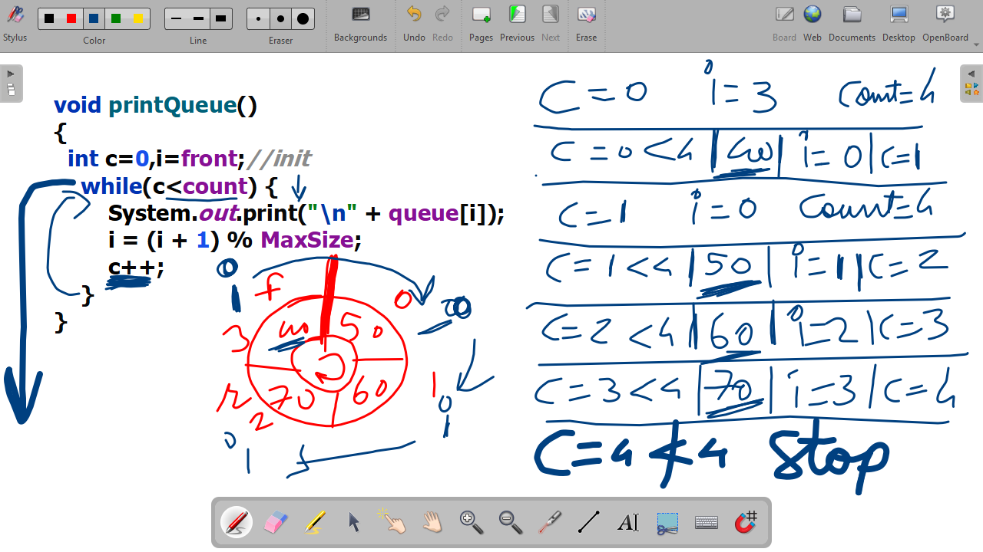

//collection queue
package Queue_Examples;
import java.util.Queue;
import java.util.LinkedList;
import java.util.Scanner;

public class Queue_Collection_Based
{
public static void main(String[] args) {

Scanner sc = new Scanner(System.in);
Queue<Integer> q=new LinkedList<>();
System.out.print("Enter queue size: ");
int choice, element;
do {
System.out.println("\n----- QUEUE MENU -----");
System.out.println("1. Enqueue");
System.out.println("2. Dequeue");
System.out.println("3. Print Queue");
System.out.println("4. Exit");
System.out.print("Enter your choice: ");

choice = sc.nextInt();

switch (choice) {

case 1:
System.out.print("Enter element: ");
element = sc.nextInt();
q.offer(element);
System.out.println("Element inserted successfully.");
break;

case 2:
if (q.isEmpty()) {
System.out.println("Queue Underflow! Queue is empty.");
}
else {
element = q.poll();
System.out.println("Deleted element: " + element);
}
break;

case 3:
if (q.isEmpty()) {
System.out.println("Queue is empty.");
} else {
System.out.println("Queue elements:");
for(int i:q)
System.out.print(i+" - ");
}
break;

case 4:
System.out.println("Exiting program...");
break;

default:
System.out.println("Invalid choice! Please select 1 to 4.");
}

} while (choice != 4);

sc.close();
}
}

import java.util.PriorityQueue;
import java.util.Scanner;
import java.util.Collections;

public class Main {

public static void main(String[] args) {

Scanner sc = new Scanner(System.in);

// Create a min-priority queue
PriorityQueue<Integer> pq = new PriorityQueue<>();

int choice;

do {
System.out.println("\n----- PRIORITY QUEUE MENU -----");
System.out.println("1. Insert Element");
System.out.println("2. Remove Highest Priority Element");
System.out.println("3. Peek Highest Priority Element");
System.out.println("4. Display Priority Queue");
System.out.println("5. Search Element");
System.out.println("6. Size of Priority Queue");
System.out.println("7. Check if Empty");
System.out.println("8. Clear Priority Queue");
System.out.println("9. Exit");
System.out.print("Enter your choice: ");

choice = sc.nextInt();

switch (choice) {

case 1:
System.out.print("Enter element: ");
int value = sc.nextInt();

pq.offer(value);

System.out.println("Element inserted successfully.");
break;

case 2:
if (pq.isEmpty()) {
System.out.println("Priority Queue is empty.");
} else {
System.out.println(
"Removed element: " + pq.poll()
);
}
break;

case 3:
if (pq.isEmpty()) {
System.out.println("Priority Queue is empty.");
} else {
System.out.println(
"Highest priority element: " + pq.peek()
);
}
break;

case 4:
if (pq.isEmpty()) {
System.out.println("Priority Queue is empty.");
} else {
System.out.println(
"Priority Queue: " + pq
);
System.out.println(
"Note: Display order is not necessarily sorted."
);
}
break;

case 5:
System.out.print("Enter element to search: ");
int search = sc.nextInt();

if (pq.contains(search)) {
System.out.println("Element found.");
} else {
System.out.println("Element not found.");
}
break;

case 6:
System.out.println(
"Size: " + pq.size()
);
break;

case 7:
if (pq.isEmpty()) {
System.out.println("Priority Queue is empty.");
} else {
System.out.println("Priority Queue is not empty.");
}
break;

case 8:
pq.clear();
System.out.println("Priority Queue cleared.");
break;

case 9:
System.out.println("Program terminated.");
break;

default:
System.out.println("Invalid choice. Try again.");
}

} while (choice != 9);

sc.close();
}
}

