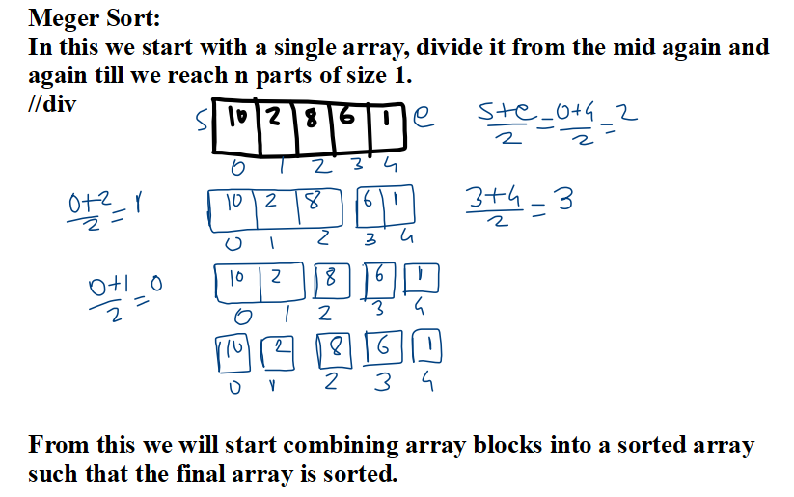
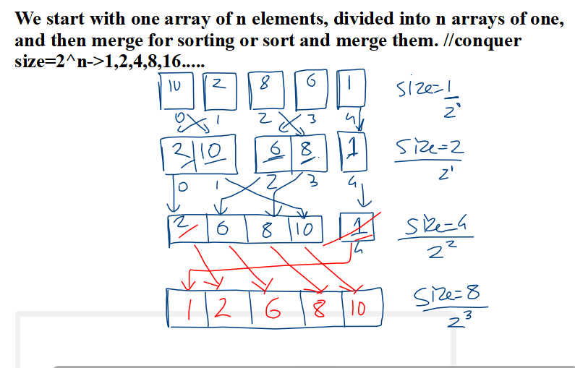

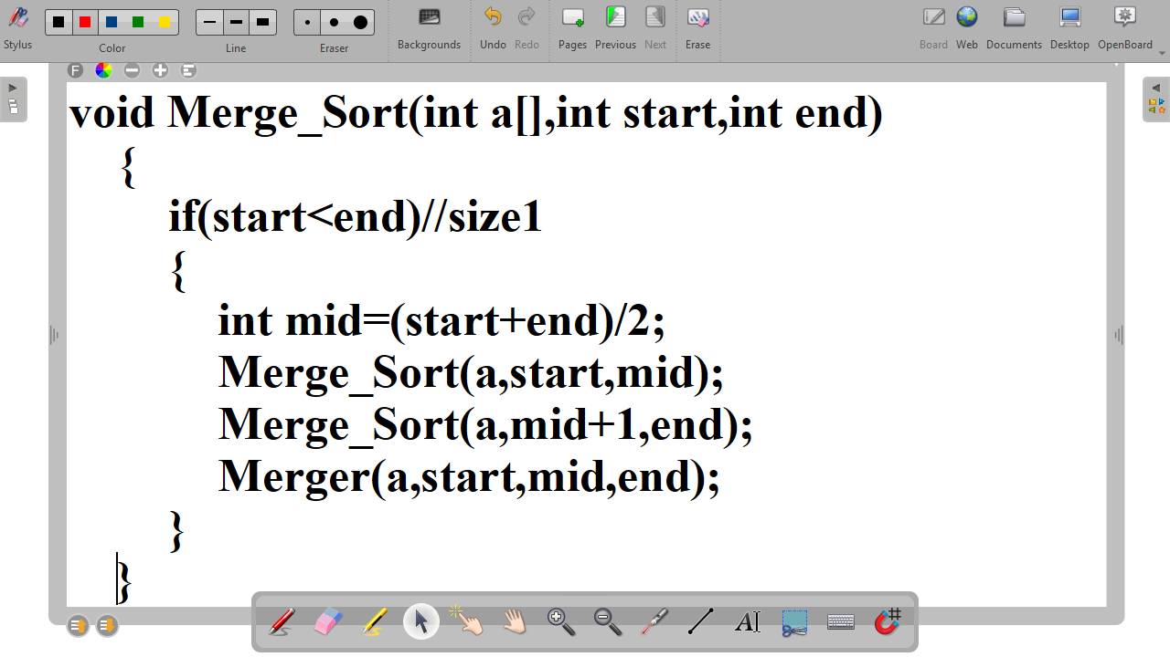
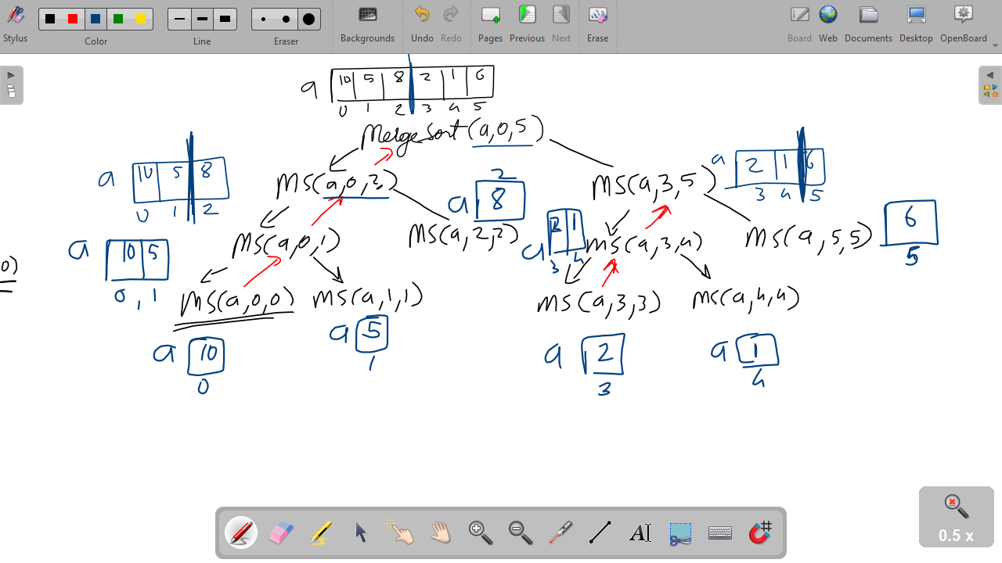
package Sorting_Examples;

public class Sorting_Algorithms
{
static void Merger(int a[],int start,int mid,int end)
{
int i=start;//start of block 1
int j=mid+1;//start of block2
int t_index=start;//for temp array
int temp[]=new int[a.length];
while(i<=mid && j<=end)
{
if(a[i]<a[j])
temp[t_index++]=a[i++];//copy and go to next
else
temp[t_index++]=a[j++];//copy and go to next
}
while(i<=mid)
temp[t_index++]=a[i++];//copy and go to next
while(j<=end)
temp[t_index++]=a[j++];//copy and go to next
//recopy to a
for(i=start;i<=end;i++)
a[i]=temp[i];
}

static void Merge_Sort(int a[],int start,int end)
{
if(start<end)//size1
{
int mid=(start+end)/2;
Merge_Sort(a,start,mid);
Merge_Sort(a,mid+1,end);
Merger(a,start,mid,end);
}
}
static void print_array(int a[])
{
System.out.print("\nArray has:");
for(int i:a)
System.out.print(i+",");
}

public static void main(String[] args) {
int a[]={99,11,66,22,88,77,33,55,44,};
print_array(a);
Merge_Sort(a,0,a.length-1);
print_array(a);
}

}

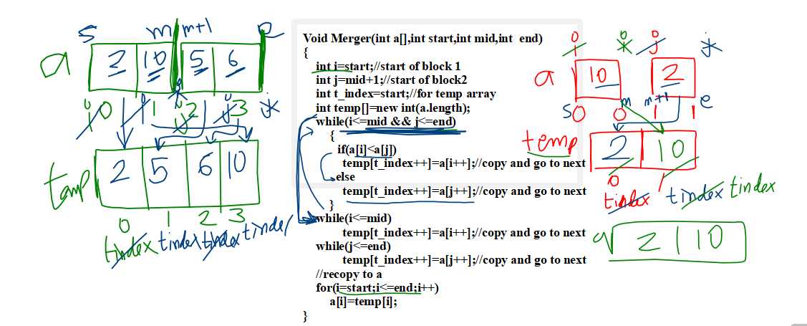
static void Quick_Sort(int a[],int start,int end)
{
int i,j,pivot;
i=start;j=end;
pivot=start;
while(i<j)
{
while(a[j]>a[pivot])//As pivot is at the start, sorting will be done from the end.
j--;
if(i<j)
{
int t=a[i];a[i]=a[j];a[j]=t;
}
}
if(i<end)//not over
Quick_Sort(a,i+1,end);
}
package Sorting_Examples;

public class Sorting_Algorithms
{
static void Merger(int a[],int start,int mid,int end)
{
int i=start;//start of block 1
int j=mid+1;//start of block2
int t_index=start;//for temp array
int temp[]=new int[a.length];
while(i<=mid && j<=end)
{
if(a[i]<a[j])
temp[t_index++]=a[i++];//copy and go to next
else
temp[t_index++]=a[j++];//copy and go to next
}
while(i<=mid)
temp[t_index++]=a[i++];//copy and go to next
while(j<=end)
temp[t_index++]=a[j++];//copy and go to next
//recopy to a
for(i=start;i<=end;i++)
a[i]=temp[i];
}

static void Merge_Sort(int a[],int start,int end)
{
if(start<end)//size1
{
int mid=(start+end)/2;
Merge_Sort(a,start,mid);
Merge_Sort(a,mid+1,end);
Merger(a,start,mid,end);
}
}
static void Quick_Sort(int a[],int start,int end)
{
int i,j,pivot;
i=start;j=end;
pivot=start;
while(i<j)
{
while(a[j]>a[pivot])//As pivot is at the start, sorting will be done from the end.
j--;
if(i<j)
{
int t=a[i];a[i]=a[j];a[j]=t;
}
}
if(i<end)//not over
Quick_Sort(a,i+1,end);
}
static void Quick_Sort2(int a[],int start,int end)
{
int i,j,pivot;
i=start;j=end;
pivot=end;
while(i<j)
{
while(a[i]<a[pivot])//As pivot is at the start, sorting will be done from the end.
i++;
if(i<j)
{
int t=a[i];a[i]=a[j];a[j]=t;
}
}
if(start<j)//Has not reached the stop
Quick_Sort2(a,start,j-1
);
}
static void Insertion_Sort(int a[])
{
int i,j,new_element;
for(i=0;i<a.length-1;i++)//n-1 passes fr sorting
{
new_element=a[i+1];//new inserted
j=i+1;
while(j>0 && a[j-1]>new_element)
{
a[j]=a[j-1];//move back
j--;//search next
}
a[j]=new_element;
}
}

static void print_array(int a[])
{
System.out.print("\nArray has:");
for(int i:a)
System.out.print(i+",");
}

public static void main(String[] args) {
int a[]={99,11,66,22,88,77,33,55,44};
print_array(a);
//Merge_Sort(a,0,a.length-1);
//Quick_Sort(a,0,a.length-1);
//Quick_Sort2(a,0,a.length-1);
Insertion_Sort(a);
print_array(a);
}

}

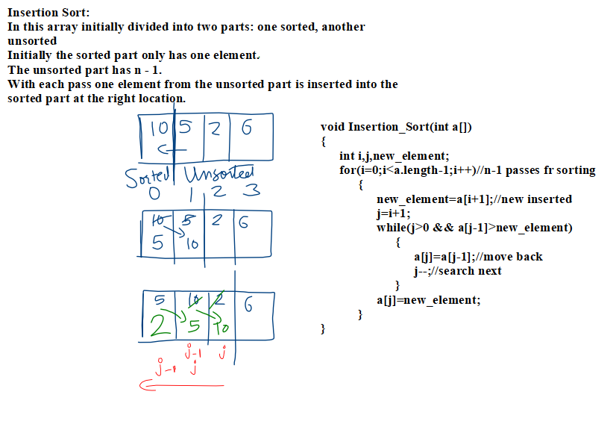
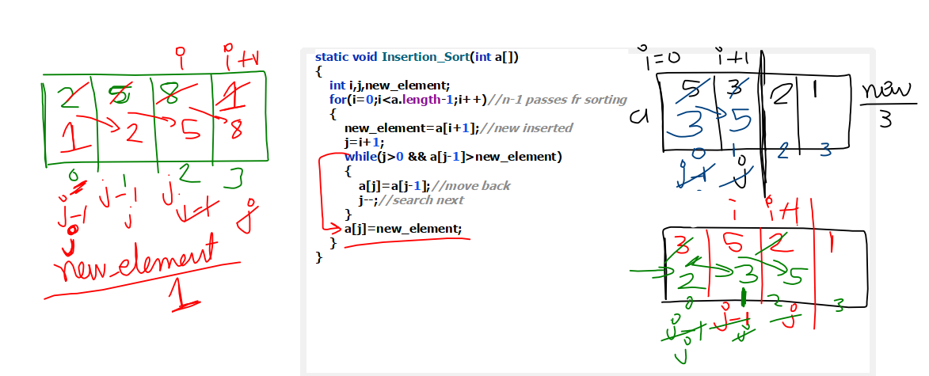
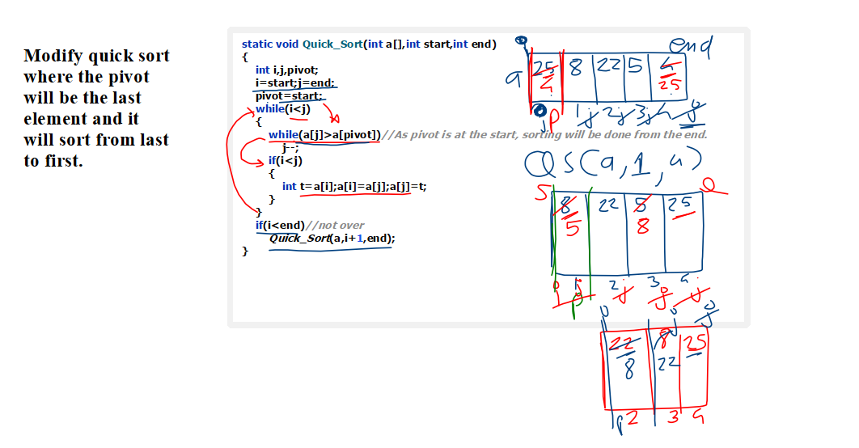
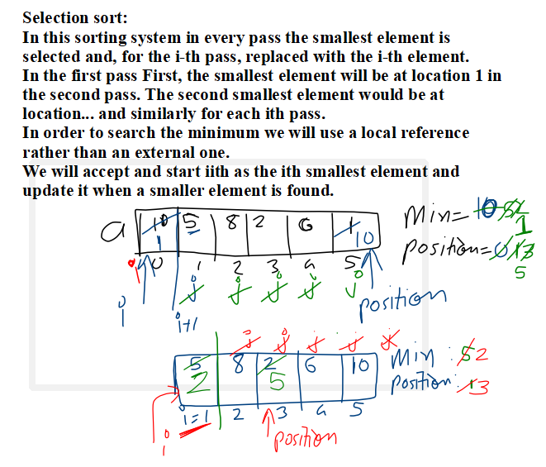

static void Bubble_Sort(int a[]) {
int pass=0;
for (int i = 0; i < a.length - 1; i++)
{ for(int j=0;j<a.length-1;j++)
{
pass++;
if(a[j]>a[j+1])
{
int t=a[j];a[j]=a[j+1];a[j+1]=t;
}
System.out.println(pass);
}

}
}

