Data structure is a study of different structures which have the ability to store data and give access to it in the most appropriate, easy, and fast manner as per the application.

mobile--updates---Last one on the top. Technically LIFO: Stack
messages----list of messages---queue-----priority queue
----endless scroll--reel/yt---Linked List
update:----social media---friend---tree
travel---map---graph

Types of data structures
On memory: static and dynamic
Static
Memory is allocated at compile time
Memory needed is predicted by the coder/developer. (fix)
The allocation is very simple. c++:int a[100];
Memory, once allocated, cannot be changed. As an end result underflow or overflow can happen.
ex:Buffet lunch or dinner.
Most of the time stack, queue, and graph are static.

Dynamic
Memory is allocated at run time
Memory needed is on demand. We can ask for more or we can remove it if not needed.
Since it is dynamic at runtime, it needs special commands, pointers, etc.
c++: int *p=new int(10);
Since memory allocation is done on demand at runtime, utilization of memory is very good in dynamic
ex:Having food at home
Most of the time trees and linked lists are dynamic.

On access, linear and non-linear
Linear, sequential in nature: data is accessed one after another.
Simple to code because simple in nature
Slow in access and information retrieval
ex:stack,queue,linked list

Nonlinear data is either accessed directly(hashing/graph) or using some kind of guiding function(tree) to take out the data.
A bit complex to code because it will have its own way of accessing
Extremely fast in access but needs programming attention.
ex:tree/graph
ADT:
List of operations one must code in order to have a standard implementation of a data structure
Example: if we have to implement a stack, one must implement `push`, `pop`, `peak`, `is empty`, `is full`, and `print stack` compulsorily.

Every data structure (stack, queue, linked list, tree, and graph) has its own set of ADTs one must follow under the heading of standardization.

ADT also supports two pillars out of the four pillars of object-oriented programming.

Abstraction:Ability to hide complex implementation and give the simplest view to the user, whatever is required
example:Explaining the working of a car or the starting of a car
Menu in hotel:Give information on what it has not how it is made.
Encapsulation:
Process of combining data along with an operation on one data as a single unit
example:Swiggy and Zomato orders ,panipuri

Inheritance:
Accepting properties from pre-existing to create something new .
example:youYour language, your religion, your surname, your native

Polymorphism. :Ability to exist in multiple forms
example:water,you:hello

ADT targets these pillars in its own way:
Encapsulation, because each method clearly operates on internal data.
Abstraction, because methods can directly be called.
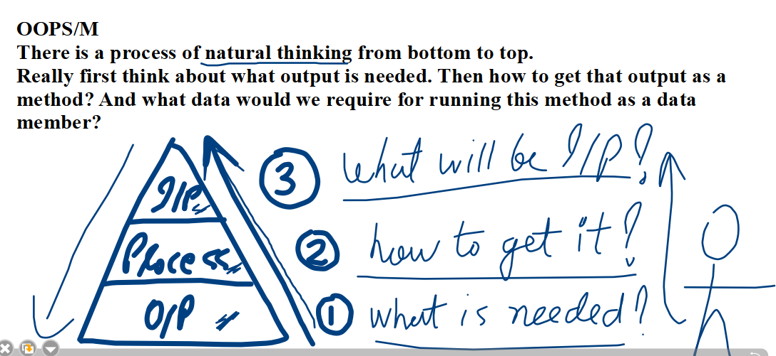
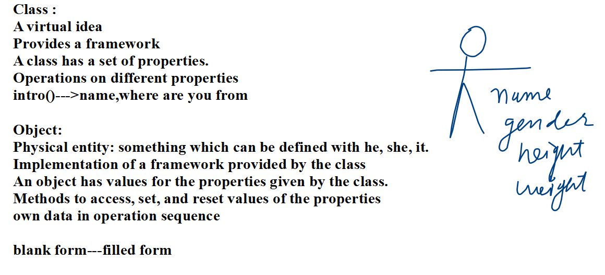
DS--->ADT(Custom coding )---To understand their actual working
Collection Based implementation:If the question is not to code a structure but to utilize a ds or some parallel data structure in some application, you are not supposed to code an ADT. You are supposed to use an internal pre-coded collection of that ADT.
If the question is directly to do code (stack, queue, linked list, tree, and graph), by default an ADT implementation would be needed.
If the question in an interview talks about using a stack, queue, linked list, tree, or graph, and asks to perform so-and-so, it is a collection-based implementation.
In the third case they will just give you what to do. You are supposed to pick up the data structure, implement, and give that output. This is the most challenging part.

