**Program 5 (Code)**

Program to create a binary file with name and roll number. Search for a given roll number and display the name, if not found, display appropriate messages.

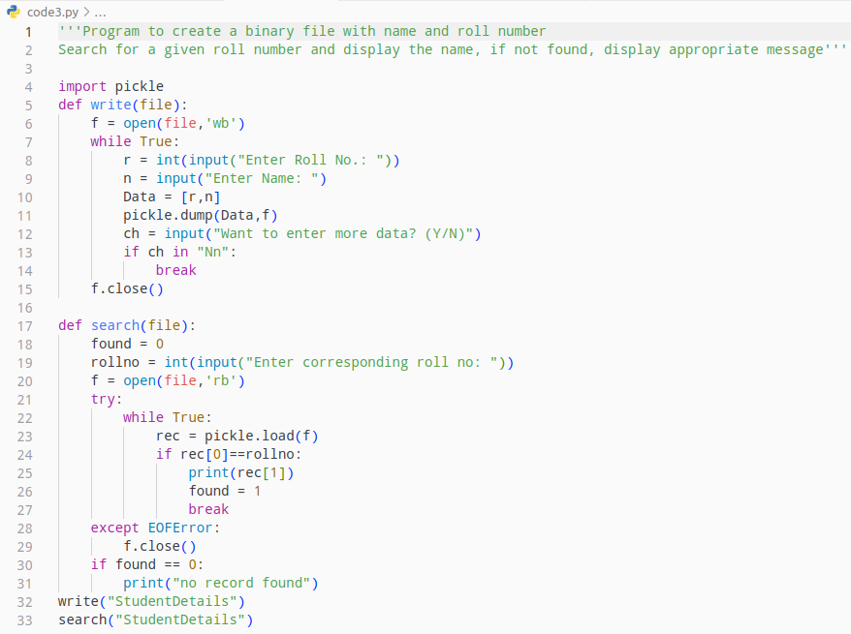

**Program 5 (Output)**

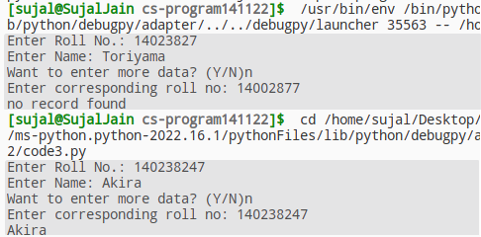

**Program 6 (Code)**

Program to create a binary file with roll number, name and marks. Input a roll number and update the marks.

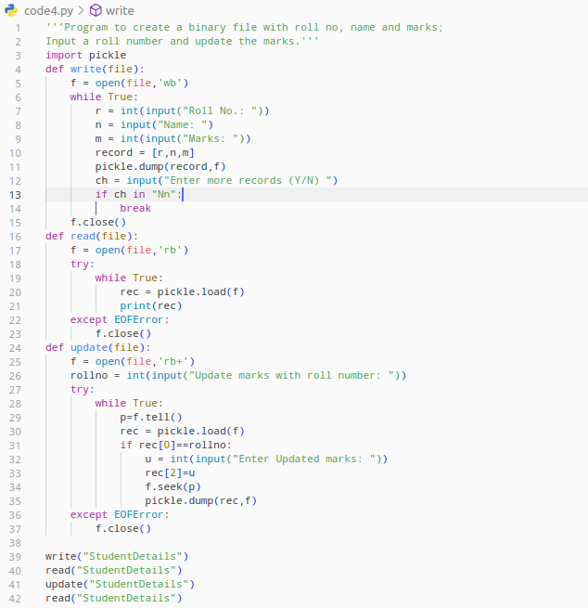

**Program 6 (Output)**

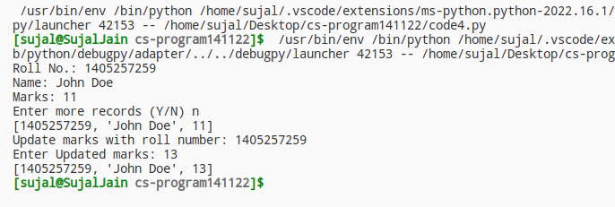

**Program 7**

Program to generate a random number between 1 and 6 (Dice simulator)

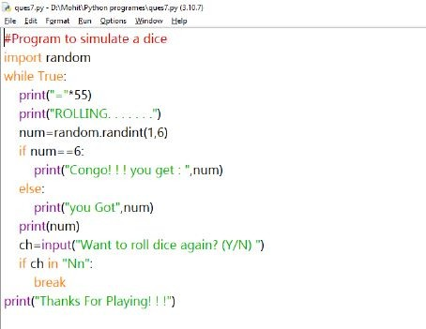

**Program 7 (Output)**

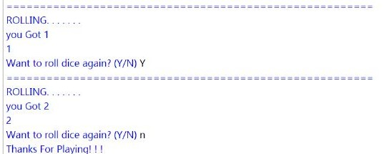

**Program 8 (Code)**

Program to create a CSV file by entering user – id and password, read and search the password for given user – id.

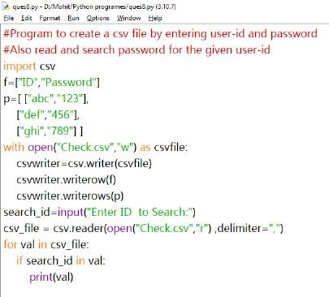

**Program 8 (Output)**

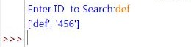

**Program 17 (Code)**

Program to show constituting methods in Python to add, display and remove a name from a given stack of name of countries.

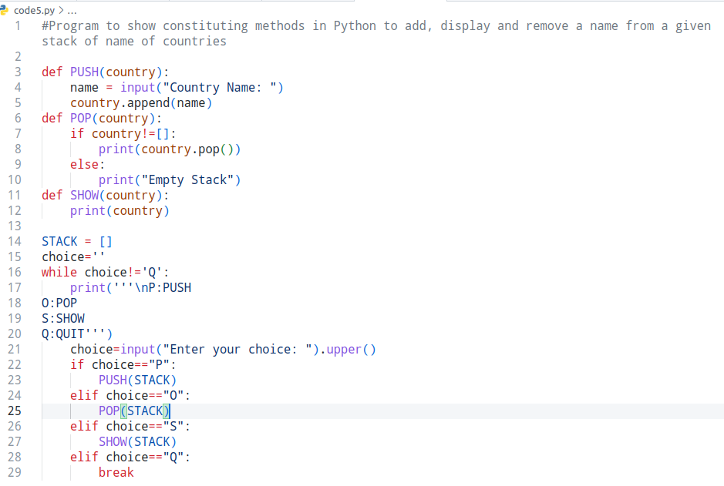

**Program 17 (Output)**

