Design Document — Hotel Room Booking System
---
1. Problem Understanding & Assumptions
Rooms are booked for date ranges (check-in to check-out). Two bookings on the
same room conflict if their date ranges overlap. I'm treating "overlap" using
half-open intervals: booking A (checkIn_A, checkOut_A) and booking B
(checkIn_B, checkOut_B) overlap only if checkIn_A < checkOut_B AND
checkIn_B < checkOut_A. This means if one guest checks out on the same day
another checks in, that is NOT a conflict — the room is free that day.

The hardest part of this problem isn't the overlap logic itself, it's making
sure two guests can't both book the same room for the same dates if they hit
"book" at the same moment. A simple "check then insert" approach fails here,
because two requests can both pass the check before either one inserts.

Assumptions I'm making:
  - Single hotel, fixed number of rooms (no multi-property support needed).
  - Bookings are whole-day granularity, not specific check-in times.
  - One booking = exactly one room, one guest.
  - Only "CONFIRMED" bookings block a room; cancelled bookings free the dates
immediately.
  - No payment flow — booking = reservation, not a payment transaction.

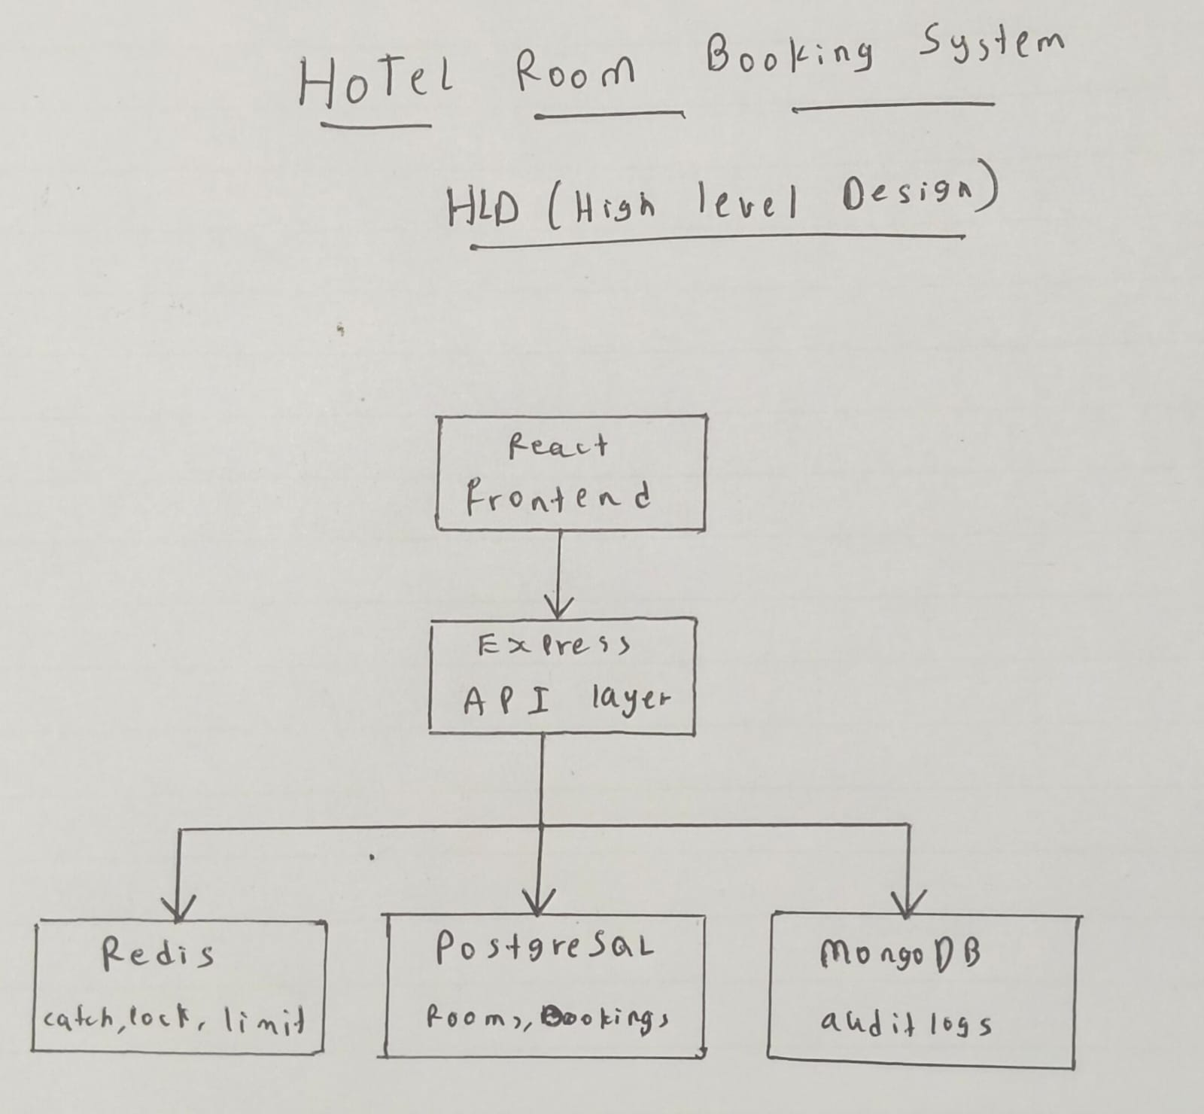
2. High-Level Design (HLD)

Flow for a booking request:
  - Client sends check-in/check-out + roomId with JWT.
  - API validates the token and the input.
  - API checks Redis cache for a quick availability read (optional fast path).
  - API opens a PostgreSQL transaction, locks the room row, re-checks overlap,
inserts the booking, commits.
  - API invalidates the Redis cache for that room.
  - API writes an audit log entry to MongoDB (does not block the response if
this fails).
  - API returns success or a conflict error.

3. Database Schema
Why split across two databases: bookings need strict consistency and
relationships (a booking always ties to one real room and one real user, and
must never contradict another booking) — that's what PostgreSQL is built for.
Audit/activity logs are just an append-only stream of events I need for
tracking and debugging, with no relational integrity requirements and high
write volume — MongoDB fits that better and keeps this traffic off my
transactional tables.
PostgreSQL — users
  - id (PK), email (unique), password_hash, role (guest/admin), created_at
PostgreSQL — rooms
  - id (PK), room_number (unique), type, capacity, price_per_night, is_active
PostgreSQL — bookings
  - id (PK), room_id (FK -> rooms), user_id (FK -> users), check_in, check_out,
status (CONFIRMED/CANCELLED), created_at
  - Index on (room_id, check_in, check_out) for fast overlap lookups.
  - Index on (user_id) for "my bookings" queries.
MongoDB — activity_logs
  - type, userId, roomId, requestedRange {checkIn, checkOut}, outcome
(CONFIRMED/CONFLICT/ERROR), timestamp
---
4. API Contract
Method | Endpoint | Auth | Purpose
POST | /api/auth/register | none | create account
POST | /api/auth/login | none | login, returns JWT
GET | /api/rooms | optional | list rooms (paginated, cached)
GET | /api/rooms/:id/availability | optional | check availability for dates
POST | /api/bookings | guest | create booking (concurrency-critical)
GET | /api/bookings/me | guest | view own bookings (paginated)
PATCH | /api/bookings/:id/cancel | guest | cancel own booking
POST | /api/rooms | admin | create room
PATCH | /api/rooms/:id | admin | update/deactivate room
GET | /api/admin/logs | admin | view activity logs (paginated)

Error responses (consistent shape):
`{ error: "<type>", message?: "...", details?: \\\[...] }`
  - 400 validation error, 401 unauthorized, 403 forbidden, 404 not found,
409 conflict (overlapping booking), 500 internal error (never a raw stack
trace to the client).
---
5. Redis Usage Plan
What I cache: the room list and room-availability reads, since those are
the most frequently hit endpoints (guests repeatedly search/browse before
booking).
TTL & invalidation: short TTL (30–60 seconds) as a baseline, and I
actively invalidate the cache entry for a room the moment a booking is
created or cancelled for it — so stale "available" reads don't linger past a
real change.
Locking: I use Redis for a short-lived distributed lock per room
(`lock:room:{id}`, SET NX with a few seconds' expiry) as a first line of
defense — it fails fast under heavy contention so I'm not piling up database
connections waiting on row locks. It is NOT what guarantees correctness by
itself; that comes from the database transaction (see section 6).
Rate limiting: the booking-creation endpoint (and login) are rate-limited
per user/IP using Redis, so a single client can't spam booking attempts or
brute-force login.
---
6. Concurrency Solution (Most Important Part)
The core guarantee: when two requests try to book the same room for
overlapping dates at nearly the same time, exactly one must succeed and the
other must be rejected — never two confirmed overlapping bookings.
My approach: wrap the booking-creation logic in a single PostgreSQL
transaction that:
  - Runs `SELECT id FROM rooms WHERE id = $roomId FOR UPDATE` — this locks the
room's row for the duration of the transaction.
  - While holding that lock, re-checks for any CONFIRMED booking on that room
that overlaps the requested dates.
  - If a conflict is found, it rolls back and returns a 409.
  - If not, it inserts the new booking and commits.
Because the row lock is taken first, a second concurrent request for the
same room has to wait until the first transaction finishes (commit or
rollback) before it can even read the up-to-date booking list. So by the
time the second transaction runs its overlap check, it will see the first
guest's newly inserted booking and correctly reject itself. This is what
prevents the race condition — the two transactions are serialized per room,
not run truly in parallel against stale data.
I also use a Redis lock ahead of the database transaction as an added
safeguard/optimization, but I'm not relying on it for correctness — only the
database transaction actually guarantees no double-booking, since Redis
locks can fail or expire without the same durability guarantees a database
transaction gives me.
---
7. Security Approach
  - Authentication: JWT issued on login, required on all booking-mutating
endpoints; a separate check enforces admin-only routes by role.
  - Passwords: hashed with bcrypt before storage, never returned in responses.
  - Validation: every request body is validated server-side (never trusting
the frontend) — reject invalid input with a 400 and clear field errors.
  - Injection prevention: parameterized SQL queries only, and schema
validation on the Mongo side — no raw string-built queries.
  - Secrets: database URLs, JWT secret, etc. are all in environment variables,
never hard-coded or committed to the repo.
  - Rate limiting: applied to the booking-creation and login endpoints to
reduce abuse.
---
8. Known Limitations & Trade-offs
  - No payment integration — out of scope for this assignment, booking is a
reservation only.
  - The Redis lock's expiry is a fixed short window; if a transaction ever ran
unusually long it could theoretically expire early, but the actual
correctness guarantee doesn't depend on it — it depends on the database
transaction lock.
  - Single-hotel, fixed-room-count design keeps the schema simple; a real
multi-property system would need a hotel_id on rooms and more complex
authorization.
  - With more time, I would add: read replicas for the room-list endpoint,
more granular audit-log querying/filtering for admins, and email/SMS
confirmation instead of just logging the event.

